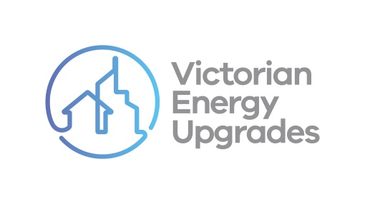

VEU program compliance checklist

Contracting with consumers

Instructions for use

The compliance checklist on the following page is part of a series for accredited persons and scheme participants to use as they engage in a variety of common activities under the Victorian [Energy Upgrades (VEU) program. It outlines some of the main obligations created by the VEU code of conduct (‘the code’).](https://www.legislation.vic.gov.au/as-made/statutory-rules/victorian-energy-efficiency-target-amendment-code-conduct-regulations-2022)

It has been supplied as a template to assist businesses contracting with consumers for upgrades as part of the VEU program. It can be used to help them identify some necessary steps and behaviours they must or must not do. It can also be used as one form of documentary evidence about different business’ compliance with the code. The content of this document is intended to be included in other branded products. It is not designed to inform consumers about the VEU program.

If being used in other branded products, users:

|  |  |
| --- | --- |
| Can… | Can’t… |
| * Change the font, structure and format of the document | ✗ Include the commission’s branding or the Essential Services Commission logo |
| * Include their own brand colours, logos and styles | ✗ Change any of the content of the document |
| * Add relevant obligations under the code of conduct to your checklist | ✗ Present only some of the content (i.e. it must be made available in full) |
| * Add evidence the consumer agrees activities have   taken place (e.g. their signature) | |

*It is the responsibility of accredited persons and scheme participants to comply with the Code of Conduct at Schedule 6 to the Victorian Energy Efficiency Target Regulations 2018. This checklist is a template prepared by the Essential Services Commission for general guidance only, it does not constitute legal or other professional advice and should not be relied on as a statement of the law.*

|  |  |  |
| --- | --- | --- |
| **Victorian Energy Upgrades program Compliance checklist CONTRACTING WITH CONSUMERS** | *<insert company logo>* |  |
| *As part of entering into a contract or before carrying out an upgrade for a consumer under the VEU program, I…* | | |
| gave the consumer a statement of their rights in relation to the contract  *This statement contained information regarding their rights under the VEU program legislation and Australian Consumer Law (Victoria).* | | Y / N |
| gave the consumer clear and accurate information about the terms and conditions of the contract  *This includes information on standard fees and charges, payment terms, what happens if they miss payments, and cooling-off periods.* | | Y / N |
| outlined the schedule of all activities that are part of the upgrade | | Y / N |
| gave the consumer information about all the persons who will deliver any part of the upgrade  *This includes their full name, business telephone number, business email address and the name of the accredited person I’m acting on behalf of (if relevant).* | | Y / N |
| confirmed the consumer understood the upgrade | | Y / N |
| confirmed and documented the consumer's consent to the upgrade | | Y / N |
| completed all the tasks in this checklist before starting the upgrade | | Y / N |
| Name:  …...…………………………………………  Address:  ………………………………………………  *(consumer)* | Name:  .……………………………………………  Signed:  ……………………………………………  *(lead generator/marketer)* | |
| VEU Activity:  ……………………..………………………. | Name of accredited person:  ……………………………………………  *(AP who will create VEECs* for the activity) | |