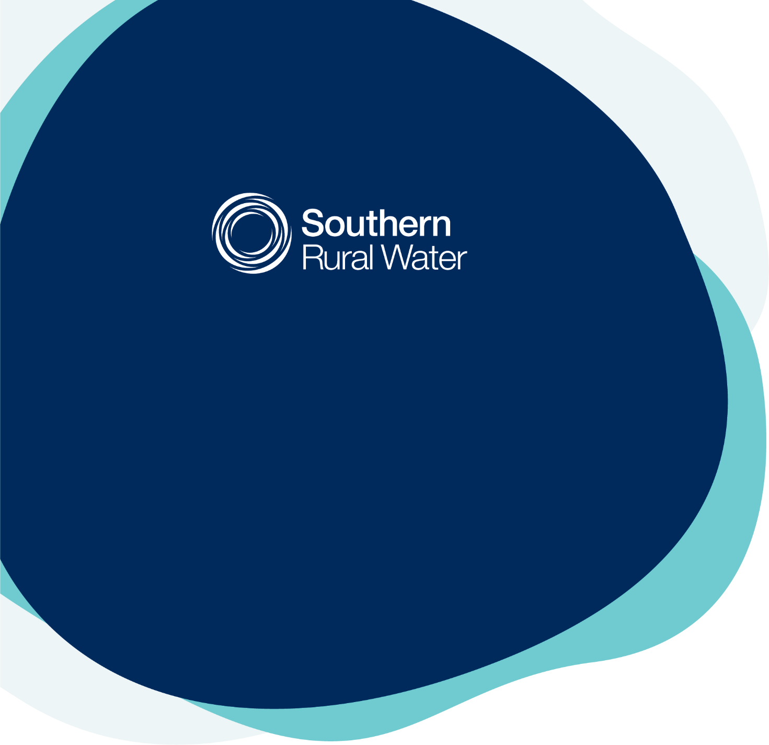
Price Submission 2023

Acknowledging Traditional Owners
Southern Rural Water (SRW) acknowledges and recognises Aboriginal people as the Traditional Owners and Custodians of the land and waters on which we work and live, and we respect their deep and ongoing connection to Country. We are committed to honouring the knowledge, aspirations, and ongoing connection to Country of Aboriginal Victorians in our operations, water planning activities and decision-making. We understand the mutual benefit of working in partnership and seek to embed this ethos into everything we do.

Contents
Acknowledging Traditional Owners 2
Content locator 4
Foreword 5
Board assurance 6
A note from the Customer Reference Group 7
Executive summary 8
1. Introduction 10
2. Management 15
3. Performance 21
4. Risk 34
5. Engagement 47
6. Outcomes 60
7. Operating expenditure 69
8. Capital expenditure 76
9. Revenue 96
10. Pricing 106
11. PREMO conclusion 116
Abbreviations 117
Appendices 118

Content locator
The following provides details on where the information requested in the Essential Service Commission’s (ESC) guidance paper can be found in this submission:
Guidance paper requirement | Section | Details
3.1. Managing risk | 4 | p34-46
3.2. Regulatory period | 1 | p10
3.3. Customer engagement | 5 | p47-59  Appendix F p128
3.4. Outcomes | 6 | p60-68  Appendix C p122-125
3.5. Service standards relating to reliability and faults | 6 | p61 & 66
3.6. Guaranteed service levels | 6 | p66
3.7. Revenue requirement | 9 | p96-105
3.8. Forecast operating expenditure | 7 | p69-75  Methodology p15-18  Historic Section 3 p23
3.9. Forecast capital expenditure | 8 | p76-95  Methodology p15-18  Historic Section 3 p23-24
3.10. Return on regulatory asset base | 9 | p101
3.11. Forecast regulatory asset base | 9 | p102-103
3.12. Regulatory depreciation | 9 | p102
3.13. Cost of debt | 9 | p101
3.14. PREMO rating | 11 | Overall p116  (p19-20, 32-33, 46, 57-59 & 67-68)
3.15. Return on equity | 9 | p101
3.16. Tax allowance | 9 | p104
3.17. Demand | 9 | p104
3.18. Form of price control | 10 | p106
3.19. Prices and tariff structures | 10 | p108
3.20. Adjusting prices | 10 | p114-115
3.21. New customer contributions | 10 | New charges p110
3.22. Financial position | 7,8 & 9 | p71, 95, 96 & 103
3.23.1 Exec summary | Foreword | p8
3.23.2. Board attestation | Foreword | p6
3.23.9. Additional requirements – non prescribed services | 9 | p100

Foreword
We are pleased to submit Southern Rural Water’s (SRW) Price Submission 2023, setting out our service levels and pricing for the next five years.
We are committed to providing great value to our customers and community. During the past 15 years, SRW has invested in large capital-intensive modernisation works in each irrigation district. This has created opportunities for customers to increase efficiencies, expand profitability and generate state-wide employment benefits. It has resulted in significant uplift in water supply reliability, which means customers have been able to increase on-farm productivity and are better able to remain profitable during dry periods. This investment is continuing into this next pricing period with further works in the Macalister and Werribee irrigation districts.
Our investment has been carefully planned to generate long term benefits – funded in a way that is fair and sustainable. So, while some of our irrigation customers will see limited price increases to help fund modernisation, more than 86% of customers will see price increases capped at the Consumer Price Index (CPI).
Price Submission 2023 enables us to continue to:
- drive resilience;
- improve service delivery;
- increase the total amount of water available for production;
- foster enhanced farm productivity;
- facilitate increased agricultural output and regional economic production;
- protect waterway and estuarine health;
- maintain better assets; and
- improve safety (reduced risk).
In parallel we will continue our important work to:
- continue to modernise assets in the Macalister and Werribee districts;
- maintain our assets and work with private dam owners, to facilitate dam safety across southern Victoria;
- pursue our goal of net zero carbon emissions by 2025;
- foster community wellbeing through the provision of recreation facilities; and
- help reconnect Aboriginal communities to water for cultural, economic, customary, and spiritual purposes.
We look forward to working alongside our customers, stakeholders, community, and government to bring this plan to fruition, delivering great value for customers and community through excellence in rural water management.
Joanne Butterworth-Gray  Chair | Cameron FitzGerald  Managing Director

Board assurance
As at 19 September 2022, the directors of Southern Rural Water, having made such reasonable inquiries of management as we considered necessary (or having satisfied ourselves that we have no query), attest that, to the best of our knowledge, for the purpose of proposing prices for the Essential Services Commission’s 2023 Price Submission:
- Information and documentation provided in the price submission and relied upon to support Southern Rural Water’s price submission is reasonably based, complete and accurate in all material respects.
- Financial and demand forecasts are the business’s best estimates and supporting information is available to justify the assumptions and methodologies used.
- The price submission satisfies the requirements of the 2022 Water Price Review Guidance paper issued by the Essential Services Commission in all material respects.

Joanne Butterworth-Gray  Chair | Cameron FitzGerald  Managing Director
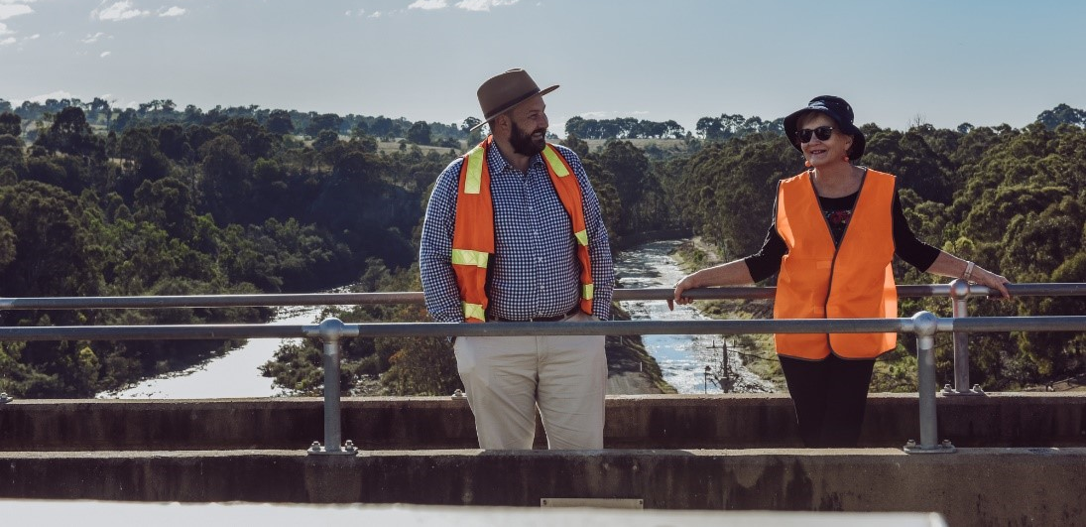

A note from the Customer Reference Group

Executive summary
Purpose | This submission sets out SRW’s proposed service levels and prices for the regulatory period 1 July 2023 to 30 June 2028.
Headline price movement | More than 86% of customers will see price increases capped at no more than CPI:  The variation between customer groups is reflective of the capital investment SRW has been making in the modernisation of each of our irrigation districts and the business in general.  The bulk entitlement (BE) prices are indicative only and will be based on real costs calculated in accordance with the respective BE orders.
  Customer group | Customers (approx.) |  | Price change
   | Number | % | + CPI per year
  Groundwater & Rivers | 8,624 | 85.0 | 0.0%
  Bacchus Marsh Irrigation District | 130 | 1.3 | 0.0%
  Werribee Irrigation District | 244 | 2.4 | 1.0%
  Macalister Irrigation Area | 1,140 | 11.2 | 1.5%
  Latrobe BEs (est) | 5 | 0.0 | 1.5%
  Werribee and Maribyrnong BEs (est) | 4 | 0.0 | 1.9%
CAPEX | Capital expenditure (CAPEX) is based on our 25-year CAPEX plan and focusses on delivering critical asset renewals and ongoing modernisation, and works to support our compliance obligations (i.e., dam safety). The proposed CAPEX for the regulatory period is $125 million.
OPEX | Our operating expenditure (OPEX) considers customer expectations and increased business obligations, along with desired productivity improvements and savings, leading to an OPEX budget of $24.6 million in 2023-24.
Productivity | Our efficiency measures will deliver productivity savings of 1% per annum.
Engagement | The Price Submission 2023 has been developed through a tailored engagement program, designed to enable SRW to understand the priorities of our customers.
Outcomes | Our submission is based on maintaining existing service levels and providing the following customer outcomes:  - reliable water supply;  - great customer service;  - sustainable water;  - valued community member; and  - fair and reasonable prices.
PREMO rating | We are proposing an overall PREMO rating of STANDARD based on the following:
  - Performance | Standard – very confident
  - Risk | Standard – very confident
  - Engagement | Advanced - satisfied
  - Management | Standard – very confident
  - Outcomes | Advanced - satisfied
Conclusion | SRW offers a prudent and efficient price submission that has been tested with our customers and provides the best value for our customers.
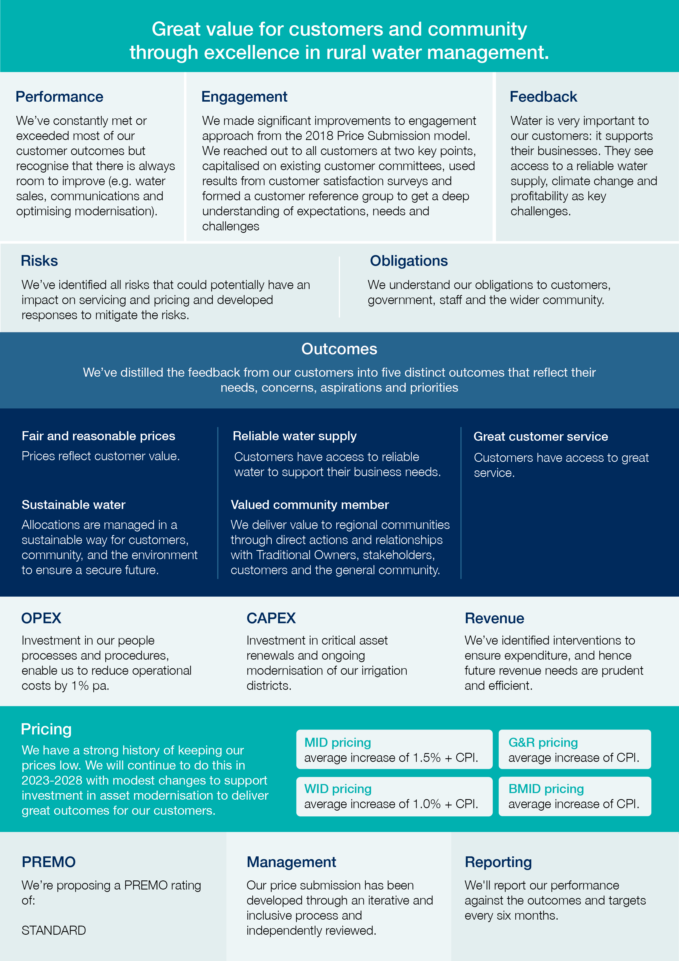
- Introduction

Key messages
We provide great value for customers and communities through excellence in rural water management.

- This price submission sets out SRW’s proposed service levels and pricing for 2023-2028.
- We are a rural water corporation with more than 86% of the water that we provide being used for agricultural purposes and over 90% of our customers being farmers.
- Our investments and services support a food and fibre sector that contributes more than $14.2 billion to the economy each year.
- We have a proven history of prudent and efficient expenditure by maintaining a low cost base which will continue throughout the 2023-2028 period.

Purpose
This submission sets out SRW’s proposed service levels and pricing for 2023-2028. It has been developed in accordance with the Essential Services Commission (ESC) guidelines.

Regulatory period
The submission is for the five-year regulatory period commencing 1 July 2023.

About us
SRW is a state-owned rural water corporation.
More than 86% of the water that we provide is used for agricultural purposes with over 90% of our customers being farmers. Our services support a food and fibre sector that contributes more than $14.2 billion to the economy each year, contributing to GDP, job creation and trade.
We also supply water to power generators and urban water corporations while working with the Victorian Environmental Water Holder, catchment management authorities and Melbourne Water to manage the release of environmental flows.
We service an area of 88,000 square kilometres, stretching from the South Australian border to the New South Wales border and from the Great Dividing Range to the Victorian coastline.
We recognise the important role we play as stewards of water resources, ensuring that we manage them sustainably for the long term.
We hold $1.85 billion in assets and employ around 160 people. With business centres located in Maffra, Werribee and Warrnambool, and small offices across our regions, we remain closely connected to our customers.
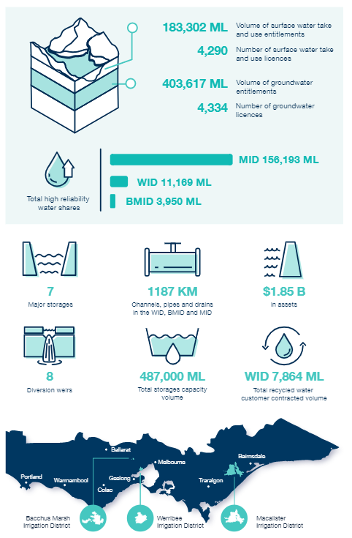

Providing great value
SRW’s vision is to provide great value for customers and community through excellence in rural water management.
We do this with a focus on our ability to anticipate and adapt to the challenges driven by shifts in climate, population, technology, and market forces.
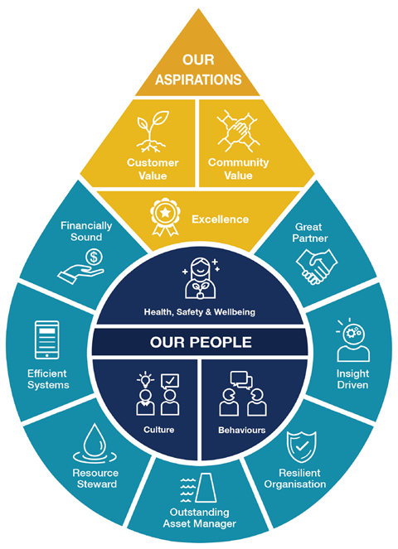
Underlying our vision are:
- Our aspirations: This is what drives us, providing depth to our vision. Our success is defined by our aspirations of customer value through outstanding service, community value to help our regions thrive and excellence in everything we do by empowering our people to deliver results.
- Our people: This is how we work at SRW. Our people are at the heart of everything we do. Our people enable us to deliver on our aspirations by building the foundations.
- Our foundations: This is how we make it happen at SRW. The elements of our business that equip us to succeed and enable us to deliver our aspirations, from being a great partner to being financially sound.

Our people
Our people are at the heart of everything we do. Our people enable us to deliver the services we provide to our customers. During the price submission engagement we were repeatedly told by our customers that they value our people, particularly our field staff and ‘front of house’ staff who provide great customer service. We recognise that our people are critical in the successful delivery of this price submission.
Our culture continues to be key feature of SRW as we seek to transition to a modernised and values-driven way of working, generating thriving, sustainable, and tangible success across the business.
In 2022 we reviewed our People Plan in the context of our changing environment. This plan is a critical enabler for delivering on SRW’s vision. It seeks to enhance employee capability and professional development and is focussed on customer service delivery excellence.

Investing in the future
During the past 15 years, SRW has invested in large capital-intensive modernisation works in each irrigation district. By the end of 2024, we expect to have completed $218 million worth of modernisation projects.
This investment creates opportunities for customers to increase on-farm efficiencies, expand profitability and generate state-wide economic benefits. At the same time, it improves delivery efficiency, reduces water losses and helps to build ongoing resilience by making more water available to our customer. For instance, in the BMID, delivery efficiency has increased from 60% in 2015-16 to 84% in 2021-22, meaning that the amount of water lost in delivery has reduced from 40% to just 16%, increasing the amount of water available for our customers.
Through modernisation, we have been able to fulfil 100% of the orders received in all three irrigation districts in 2021-22 and are working towards creating new water shares from the water savings that have been achieved.
By working in partnership with both state and federal governments, SRW and our customers are paying less than half the capital cost of modernisation.

Table 1 – Our investment in modernisation
District | Works | SRW/ customers  $m | Victorian  Government  $m | Federal Government  $m | Total investment  $m
Macalister Irrigation Area | Leading works | 4 |  |  | 4
Macalister Irrigation Area | Phase 1A | 19 | 16 |  | 35
Macalister Irrigation Area | Phase 1B | 25 | 20 | 20 | 65
Macalister Irrigation Area | Phase 2* | 21 | 10 | 31 | 62
Macalister Irrigation Area | MID Sub total | 69 | 46 | 51 | 166
Bacchus Marsh Irrigation District and Werribee Irrigation District | WID (stages 1,2,3 + BMID) | 15 | 15 |  | 30
 | WID (stage 4 and 5)* | 11 |  | 11 | 22
 | WID / BMID Sub total | 26 | 15 | 11 | 52
Total investment $m |  | 95 | 61 | 62 | 218
*Project underway but not complete.

- Management

Key messages
SRW's board and management are fully committed to deliver on this plan.

- Our board has been fully engaged from the start, setting the strategic framework for the development of the price submission, and attesting to the submission.
- Industry experts Aither, Bartley Consulting and KBR have assisted to ensure the quality of our submission.
- Our submission demonstrates prudent and efficient expenditure with minimum price increases and 1% productivity savings per annum.
- We are very confident that our PREMO rating for management is standard.

Our approach
This submission builds on SRW’s existing planning processes, and a history of close engagement with our customers.
It has involved input from our board, executives, senior management, subject matter experts, consultants, independently facilitated Customer Reference Group (CRG), three customer committees, our broader customer base, and key stakeholders.
We have followed an iterative process involving extensive consultation with customers and stakeholders, supported by rigorous technical assessments, leading to what we submit is an offering that delivers genuine value-for-money based on prudent and efficient expenditure leading to minimal price increases.
In preparing our price submission, we have considered our:
- obligations such as those contained in the Water Industry Act 1994 Statement of Obligations, Letters of Expectation, government policy etc.;
- existing corporate strategy and associated plans;
- customer views and what’s important to them;
- performance during Price Submission 2018;
- risks; and
- revenue requirements based on our proposed operational and capital spend.
These have led to the development of a series of outcome statements, centred largely on customer feedback (see Section 6) which are then reflected in our operating expenditure forecast (see Section 7) and our capital expenditure program (see Section 8), both of which have been subject to detailed review by our executive and board.
Within this context we have developed six foundations which are integral to both our modernisation program and our price submission. These are listed in the following table.

Table 2 – Sustainable pricing foundations
Foundations | Overview
We are investors in the profitability of our customers now and into the future | During the past 15 years, SRW with state and federal government support, has invested in large capital-intensive modernisation works in each of its irrigation districts. We have developed well-founded business cases with strong positive cost/benefit ratios. Through our partnerships, customers pay less than half of the capital cost of modernisation upgrades to their systems.
Profitability rather than affordability matters most to irrigator customers | Our irrigation customers are complex and sophisticated businesses that are driven to optimise profitability and are willing to engage with us on investment decisions that can improve their productivity in return for higher irrigation prices. This differs from residential customers where affordability, associated with cost-of-living pressures, is of primary concern.
We operate efficiently and control our costs | We have a strong history of keeping our prices low with no real price rises for irrigation customers during the past 10 years. We are making a conscious effort to keep prices low by delivering flat prices for 86% of customers (i.e., groundwater and rivers customers and Bacchus Marsh Irrigation District customers). We have identified interventions to ensure expenditure is prudent and efficient and targeted those investments that provide a strong value proposition for customers.
Decisions on government grant funding were predicated on customer co-contributions via annual charges | All approved business cases that received government funding explicitly outlined the contributions that would be made by our customers. Price increases are the primary mechanism by which customers make this contribution. Our customers understand our approach to modernisation and have provided upfront support through previous pricing consultation processes.
We require sustainable revenue streams to repay our borrowings | SRW has funded our contributions to modernisation works through borrowings rather than tariff increases to date. By 2024-25 our balance sheet borrowings are expected to be $94.5 million. We require a sustainable revenue stream to cover interest and principal repayments on these borrowings. Increasing prices is the primary mechanism by which SRW can achieve this.
We are undertaking genuine consultation on pricing outcomes | We continue to implement a comprehensive customer engagement plan to understand customer expectations with respect to pricing, risk, and value. The outcomes of this engagement are instrumental in determining our preferred pricing proposal.

Sustainable outcomes
Our investment has been carefully planned to generate long-term benefits – funded in a way that is fair and sustainable.
Ultimately, our price submission supports our long-term pathway to financial sustainability built on a program of prudent and efficient expenditure.
Appendix E provides a snapshot of our pathway to long-term financial sustainability. This has been developed as a response to a 25-year capital plan that sets out the key projects and maintenance required over the longer term. It is evident through this work that the current financial trajectory is untenable without intervention, therefore the plan outlines a range of actions that ensure the long-term financial sustainability of the business. This price submission has been developed consistent with the metrics outlined on this one-page plan and enable us to track our performance over time. It has been developed through significant and ongoing engagement with our board.

Corporate engagement

Board input
The price submission has featured on board agendas since March 2021 with all material assumptions and settings impacting our pricing and financial outcomes having been discussed with the board. The board has also been kept up to date on specific engagement processes and outcomes associated with this submission.
The board participated in a major strategic workshop in November 2021 which has provided direction for the price submission. It has progressively reviewed key elements of the price submission and endorsed the final submission for lodgement with the ESC.
Appendix D provides a full listing of board considerations.
The board will monitor price and service outcomes, as well as the delivery of improvement initiatives, via quarterly strategy reporting.

Management input
We commenced our internal review, starting off in September 2021 with discussions with our senior managers about our performance, key drivers for the future and initiatives we could consider both in the lead-up to and during the next regulatory period. Our executive leadership team was involved in these discussions and has since progressively reviewed key elements of the price submission with a particular focus on our capital and operational expenditure.

Quality assurance
In preparing our price submission, SRW has been supported by several technical experts:
- Aither: tariffs and pricing;
- Bartley Consulting with Stanford Marketing and Gillian Hayman Facilitation and Project Services: engagement, communications, and facilitation; and
- KBR: capital planning and CAPEX business cases.
This assistance, combined with the regular reviews by the board and executive team, gives us the confidence of submitting a comprehensive and well-founded price submission that will deliver value to our customers.

Prudent and efficient expenditure
SRW has a history of managing its costs and setting prices based on prudent and efficient expenditure and will continue to do so during the next regulatory period.
During the period we are proposing a 1% productivity savings per annum, which coming off an already efficient base, demonstrates prudent expenditure (see Section 7 for more detail).
Our CAPEX is tightly controlled where all major projects are subject to business cases and all expenditure has been rigorously reviewed against our asset management and risk management frameworks to minimise discretionary spending while ensuring we meet our obligations (i.e. compliance and committed projects). The engagement of KBR has added another level of rigour to the assessment in the development of our CAPEX program.
Successive reviews by our executive has validated key projects (see Section 8). We have prudently programmed uncertain works by extending some outside the regulatory period and smoothed high-cost operational programs.

Productivity
SRW has been investing in its operational and business processes through extensive modernisation. This is enabling us to commit to a 1% productivity saving to our OPEX as well as the ability to absorb additional obligations like compliance activities and reduced carbon emissions within existing OPEX budgets.

Proposed PREMO rating for management
We are very confident that our PREMO rating for management is standard, based on the following assessment:
Management aspect | Rating
To what extent has the business demonstrated how its proposed prices reflect only prudent and efficient expenditure?
SRW has a history of managing its costs and setting prices based on prudent and efficient expenditure. We continue to provide productivity efficiency savings of 1% pa over the regulatory period. CAPEX is tightly controlled where all major projects are subject to business cases and all expenditure has been rigorously reviewed against our asset management and risk management frameworks to minimise discretionary spending while ensuring we meet our obligations (i.e., compliance and committed projects). Consultants have aided in this work with KBR reviewing CAPEX forecasts. | Standard-confident
To what extent has the business justified its commitment to cost efficiency or productivity improvements?
SRW has been investing in its operational and business processes, through extensive modernisation. This has enabling us to commit to a 1% operational saving as well as the ability to absorb additional obligations like compliance activities and reduced carbon emissions within existing OPEX budgets.  SRW has invested in technology to improve business processes, efficiency, and productivity. | Standard- very confident
To what extent has the business justified or provided assurance about the quality of the submission, including the quality of supporting information on forecast costs or projects?
SRW is conscious of the importance of its price submission and its implications on its customers and our ongoing financial sustainability. We have sought assistance for several specialist consultancies to help provide assurance of the quality and inputs to the submission and accompanying documents.  KBR was engaged to review our capital program and the business cases for major projects.  Aither was engaged to independently review our submission from an ‘ESC lens’, including a review of:  - the functionality and inputs into the pricing model;  - the development of our tariff structure; and  - the consistency and completeness of the submission.  Bartley consulting (et al) assisted with our engagement program.  In addition, the Customer Experience Experts (CSBA) were engaged to undertake a parallel review of customer sentiment and satisfaction while our executive team undertook a rigorous review of future operational costs.  Collectively, the consultants not only assisted but challenged SRW on its approach, forecasting and the development of our price submission. | Standard- very confident
To what extent has the business provided evidence that there is senior level, including board level, ownership and commitment to its submission and its outcomes?
The board has been kept regularly informed of progress with the price submission since May 2021 (see Appendix D).  The board has worked closely with management to review the financial sustainability for the organisation and the development of a 25-year prioritised CAPEX program, both of which have been integral to the development for the price submission.  This approach of regular engagement and review between management and board has ensured alignment and a commitment to the price submission.  The initial scoping of the price submission included consultation with senior leadership. This collaborative/consultative approach has continued throughout the development of the price submission and has achieved alignment and commitment to the price submission from senior leadership/across all business areas. | Advanced- very confident
To what extent has the business demonstrated its price submission is an “open book”?
SRW has adopted an open and transparent process for the development of its price submission.  Our capital program has been prioritised with a focus on supporting prudent and efficient expenditure. Business cases are available for the top 10 projects, with KBR having reviewed the entire program for completeness.  We have adopted a straight-line depreciation approach.  The submission addresses all the requirements of the guidance paper and is considered by Aither as being complete for submission to the ESC. | Standard-confident

- Performance

Key messages
SRW has a proven track record of delivering high quality affordable services to our customers.

- We have consistently met or exceeded most of the outcomes in Price Submission 2018. Those outcomes that we have not met have not resulted in any customer service level impacts.
- We enjoy a close working relationship with our customers, with more than three-quarters of our customers satisfied with the service we provide.
- We have successfully delivered an expanded CAPEX program on the back of additional funding which enabled the $62 million MID2030 Phase 2 project to commence in the 2018-23 regulatory period.
- Prices have remained consistent with Price Submission 2018.
- We are very confident that our PREMO rating for performance is standard.

Customer outcomes
Our service measures were developed in consultation with our customers, to focus on measuring what’s important to them. They are reflected in our Customer Charter, including:
- our operating performance and service standards;
- our charges and billing arrangements;
- our commitments about maintenance, repair and replacement of the infrastructure that delivers water;
- how to order water; and
- how and when customers can give us feedback on our performance.
In 2021-22, we met or exceeded targets for 14 out of 20 indicators, with a further five being close to or largely met. High rainfall and the introduction of new infrastructure has impacted our ability to achieve some of our targets. However, the successful commissioning of new infrastructure will lead to improvements in the future. Higher rainfall led to a record low demand for water where, in the Macalister Irrigation Area, customers ordered 50% less water than in 2020-21. The low demand generated some operational difficulties (e.g., channel pool performance and delivery efficiencies were negatively impacted as proportionally more water was needed to be conveyed through the system to meet low water delivery volumes) but it did not impact customers with all orders fulfilled.
The only area where we did not meet or largely met our target was in the area of water sales. This was due to the formal legislative process of converting the audited water savings (achieved through modernisation) to entitlements (which can be allocated). However, even given this, the unseasonably wet year resulted in little demand for such water.
Overall, we were able to maintain customer service levels throughout 2021-22 despite not all targets having been met.

A summary of our performance during the first four years of Price Submission 2018 is provided in the following tables.
Table 3 – Performance rating
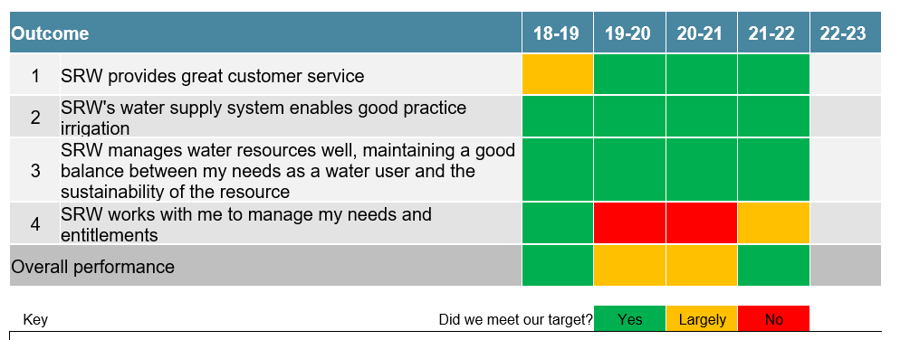
Table 4 – Performance summary
Outcome | Performance
SRW provides great customer service | Despite ongoing disruptions to our business due to COVID-19, we have continued to exceed our target for processing applications with more than 90% of all applications in recent years completed on time.
SRW's water supply system enables good practice irrigation | The transition from manually operated irrigation systems to automated systems has presented some challenges. However, our staff have been proactive, contacting customers to find solutions to enable good irrigation practices. The net result is that while we have experienced some operational difficulties which are reflected in our performance measures, our customers have not been impacted as we have continued to provide close to 100% of all orders.
SRW manages water resources well | We have consistently met or exceeded all our targets in this area.  We have harvested water in accordance with agreed rates, giving customers greater access to water, while managing our releases to minimise losses.
SRW works with me to manage my needs and entitlements | COVID-19 had a significant impact on our ability to engage with our customers in the field which has limited our ability to promote water trading between customers. Similarly, our ability to offer more water for sale has been limited in recent years due to delays in getting the water savings from modernisation validated before the water can be sold.  Notwithstanding these challenges, there has been minimal demand for additional water in recent years due to the unseasonably wet conditions. So, while we may not have met some of our targets, this has not had a material effect on our customers.

Operating expenditure
Since setting the benchmark in 2017, SRW has experienced a significant increase to business costs (including real wages growth, higher compliance costs from an uplift in health and safety, cyber security arrangements and significant increases to insurance costs) which have resulted in our operating cost base exceeding the benchmark allowance. While this increase in costs has been partly offset through operating cost management in the latter part of the current regulatory period (e.g., productivity improvements from investments in technology and irrigation modernisation, along with lower operating costs such as less business travel and off-site training cost), an aggregate increase to our operating cost base has occurred from a benchmark allowance in 2022-23 of $23.4 million to our equivalent forecast of $24.5 million. In the context of significant cost pressure faced during the current regulatory period, SRW has assessed an increase in operating costs of this scale as Standard performance.

Figure 1 – OPEX outcomes

Capital expenditure
SRW has conducted a historically significant capital expenditure program across the current price submission period. Large investments in technology and infrastructure modernisation works have occurred in each irrigation district, and these projects have underpinned the increase in expenditure against the benchmark allowance.

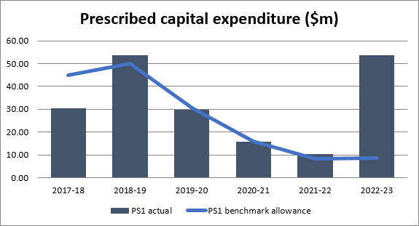
Figure 2 – CAPEX outcomes

Table 5 – CAPEX actual vs forecast
 | 2018-19 | 2019-20 | 2020-21 | 2021-22 | 2022-23
CAPEX actual (from Corporate Plan) | $53.8m | $29.8m | $15.7m | $10.5m | $53.8m
CAPEX forecast (from Price Submission 2018) | $49.8m | $30.7m | $16.0m | $8.3m | $8.7m

The actual expenditure is consistent with the 2018-23 price submission benchmark allowance (expected expenditure) across the first four years of the regulatory period. The 2018-23 price submission included $10.6 million towards the MID2030 Phase 2 project (as agreed with the Macalister Customer Consultative Committee), while the project scope, approvals and funding arrangements were sought and finalised. This approach was adopted to provide price stability, by avoiding the likelihood of otherwise reducing prices in 2018-23 regulatory period or having a steeper increase in the future when plans for the final stage of modernisation were finalised. The $62.6 million project commenced upon receipt of $41.3 million of external grant funding from the state and federal governments in FY20 and $39.4 million will be delivered in the 2018-23 regulatory period. This is the primary reason for the significant increase in expenditure in 2022-23. Note, the increase in expenditure is before the application of grant funding, which is 66% of the project value. Therefore, SRW’s customer contribution in the 2018-23 regulatory period is $13.0 million (33% of $39.4 million), which is comparable to the $10.6 million that was forecast in the 2018 Price Submission.
Another significant contributor to the increase in expenditure in 2022-23 is the $22 million WID Modernisation Stages 4 and 5 project. The project was brought forward upon receipt of grant funding (50% of the project value) and $8.7 million (including grant funding) will be delivered in the 2018-23 regulatory period, enabling completion of modernisation for the Werribee Irrigation District. The scope of this project and funding arrangements had not been determined at the time of Price Submission 2018 development. Further assessment of our actual capital expenditure verse the Price Submission 2018 forecast follows.

Top 10 projects: Price Submission 2018 forecast
Capital expenditure on our 10 largest projects that were forecast in our Price Submission 2018, as described below, accounted for more than 70% of the total expenditure during the regulatory period.
Table 6 – Top 10 projects: Price Submission 2018
Project title | 2018-19 | 2019-20 | 2020-21 | 2021-22 | 2022-23 | Total in period ($m)
MID Modernisation Phase 1b | $20.0 | $11.8 | $6.2 | - | - | $38.0
WID Modernisation Stages 1-3 | $8.2 | $3.9 | - | - | - | $12.0
MID Modernisation Phase 2 | $0.3 | $2.1 | $4.3 | $3.3 | $0.7 | $10.6
BMID Modernisation | $2.9 | $1.7 | - | - | - | $4.5
Maffra Weir operating gear | $1.3 | $1.1 | - | - | - | $2.4
MID channel bank renewal | $0.4 | $0.4 | $0.4 | $0.4 | $0.4 | $2.0
Glenmaggie spillway gate repainting | $0.2 | $0.6 | - | $0.2 | $0.6 | $1.5
Asset management system upgrade | $1.0 | $0.1 | - | - | - | $1.1
GW&R meter replacements | $0.2 | $0.2 | $0.2 | $0.2 | $0.2 | $1.0
Werribee office redevelopment | $1.0 | - | - | - | - | $1.0

The following tables compare the forecast capital expenditure for these 10 largest projects, as presented in our Price Submission 2018, to the actual expenditure for the regulatory period. Commentary is provided where an expenditure variance exists.
Project name | MID Modernisation Phase 1b
Total project value forecast | $61 million ($38 million within price period) – 64% grant funded
Total project value actual | $65 million ($47 million within price period) – 60% grant funded. The actual expenditure was higher than forecast because a greater proportion of the project was delivered in 2018-19 rather than 2017-18. The total project value was $4 million higher than forecast due to the inclusion of additional scope that provided further system operational benefits.
Timing / Status | Commenced FY2017, completed FY2021
Cost driver | Improvement/compliance
Outcome | Reliable water supply, sustainable water
Description | Replacement of open channels with gravity pipeline coupled with automation in the lower channel system to modernise the Southern Tinamba irrigation supply zone within the Macalister Irrigation District.

Project name | WID Modernisation Stages 1 - 3
Total project value forecast | $20.9 million ($12 million within price period) – 50% grant funded
Total project value actual | $20.0 million ($10.8 million within price period).
Timing / status | Commenced FY17, completed FY21
Cost driver | Improvement/compliance
Outcome | Reliable water supply, sustainable water
Description | Replacement of open channels with pipelines to modernise the first three stages of the Werribee Irrigation District.

Project name | MID Modernisation Phase 2
Total project value forecast | $40. million (nominal estimate only, $10.6 million customer contribution within period) – grant funding was yet to be secured
Total project value actual | $62.6 million ($39.4 million within price period) - 66% grant funded. $10.6 million towards this final stage of modernisation was forecast within the price period (as agreed with the Macalister Customer Consultative Committee), while the project scope, approvals and funding arrangements were sought and finalised. This approach was adopted to provide price stability, by avoiding the likelihood of otherwise reducing prices in 2018-23 regulatory period or having a steeper increase in the future when plans for the final stage of modernisation were finalised. The project commenced upon receipt of grant funding in FY20. The increase expenditure is before the application of grant funding, which is 66%. Therefore, SRW’s customer contribution in the 2018-23 regulatory period is $13.0 million, against a forecast of $10.6 million.
Timing / status | Commenced FY20, complete FY24.
Cost driver | Improvement/compliance
Outcome | Reliable water supply, sustainable water
Description | Pipeline replacing open channel and high-use meter outlet replacements throughout the Macalister Irrigation District

Project name | BMID Modernisation
Total project value forecast | $8.9 million ($4.5 million within price period) – 50% grant funded
Total project value actual | $9.9 million ($5.7 million within price period). Actual costs exceeded the forecast due to scope changes during design development, construction market conditions that saw limited interest in the works (despite a procurement strategy to package stages and increase the scale of works), and construction cost variations.
Timing / status | Commenced FY17, completed FY21
Cost driver | Improvement/compliance
Outcome | Reliable water supply, sustainable water
Description | Replacement of open channels with pipelines to modernise the Bacchus Marsh Irrigation District

Project name | Maffra Weir operating gear
Total project value forecast | $2.4 million
Total project value actual | $3.9 million. Higher actual costs were incurred on account of increased scope during the design phase (opportunities to efficiently complete additional renewal activities were identified and adopted), COVID-19 impacts (project delivery delays and supply chain impacts), and onsite modification of pre-manufactured items (to integrate with the existing weir structure and to meet access and operational performance standards and requirements).
Timing / status | Commenced FY17, completed FY22.
Cost driver | Renewal
Outcome | Reliable water supply, sustainable water
Description | Replacement of outdated and non-compliant operating gear that is used to lift the spillway gates, as well as replacement of the operating bridge.

Project name | MID channel bank renewal
Total project value forecast | $2 million
Total project value actual | $0.5 million. The program was deferred during development of SRW’s Strategic Asset Management Plan and asset criticality framework, to develop a targeted program for addressing channel erosion. The program budget was also reduced following reprioritisation to accommodate additional MID Modernisation Phase 1B works.
Timing / status | Commenced FY22, continuing FY23
Cost driver | Renewal
Outcome | Reliable water supply, sustainable water
Description | Repair of MID Sale main channel from erosion damage.

Project name | Glenmaggie spillway gate repainting
Total project value forecast | $1.5 million
Total project value actual | $0
Timing / status | Not commenced – deferred due to reprioritisation of higher risk projects, including Siphon No. 1. Project is forecast to commence in 2024-25 at a cost of $2.3m.
Cost driver | Renewal
Outcome | Reliable water supply, sustainable water
Description | Repainting gates to extend asset life

Project name | Asset management system upgrade
Total project value forecast | $1.1 million
Total project value actual | $125,000 (cost to date)
Timing / status | Deferred until the 2023-28 regulatory period while other ICT enterprise projects are developed (data management and finance system upgrade). Deferral seeks to ensure the asset information software can be integrated with our broader enterprise systems. SRW’s asset information strategy has been developed (which the software system is an integral part of) and implementation is ongoing. The cost to date ($125,000) will not be recovered in the RAB until the project is commissioned in the 2023-28 regulatory period.
Cost driver | Renewal
Outcome | Reliable water supply, sustainable water
Description | Replacement of our asset information system software

Project name | GW&R meter replacements
Total project value forecast | $1 million
Total project value actual | $1 million
Timing / status | Commenced FY18, completed FY23.
Cost driver | Renewal
Outcome | Sustainable water, great service
Description | Replacement of groundwater and river (GW&R) meters with patent approved meters.

Project name | Werribee office redevelopment
Total project value forecast | $1 million
Total project value actual | $2.6 million. The initial forecast was based on a modest rebuild, through the project development, a more substantive rebuild was required to future proof and meet the needs of our growing footprint in the west. The redevelopment cost was offset directly by asset sales revenue, associated with surplus land at the same site.
Timing / status | Commenced FY18, completed FY19
Cost driver | Renewal
Outcome | Great customer service
Description | Redevelopment of the Werribee office and depot to provide a contemporary work environment for our staff to meet the current and future needs of the business.

Top 10 projects – 2018-2022 actual
The 10 largest projects that were delivered or commenced in the 2018-22 regulatory period included six of the projects described above, namely, MID Modernisation Phase 1b, WID Modernisation Stages 1-3, MID Modernisation Phase 2, BMID Modernisation, Maffra Weir operating gear, GW&R meter replacements and the Werribee office redevelopment. Other significant projects delivered or commenced in the 2018-22 regulatory period, are presented in the following tables. The commentary includes the rationale for inclusion of the project in the 2018-23 regulatory period.

Project name | MID Siphon No. 1
Total project value | $1.4 million
Timing / status | Commenced FY20, Completed FY21
Cost driver | Renewal
Outcome | Reliable water supply, sustainable water
Description | Following a failure and subsequent repair, a detailed inspection revealed Siphon 1 on the Main Southern Channel as an extreme risk of repeated failure. The siphon was subsequently replaced with a flume.

Project name | WID Modernisation Stages 4 & 5
Total project value | $22 million ($8.7 million within period) – 50% grant funded. Project brought forward upon receipt of grant funding that will enable completion of modernisation for the Werribee Irrigation District. Funding had not been secured at the time of Price Submission 2018 development.
Timing / status | Commenced FY22, continuing to FY25.
Cost driver | Improvement/compliance
Outcome | Reliable water supply, sustainable water
Description | Replacement of open channels with pipelines to modernise the first three stages of the Werribee Irrigation District

Project name | Main Northern Channel Siphon No. 2
Total project value | $3.4 million ($2.5 million within period) – 50% grant funded. Project brought forward after condition assessment identified poor condition of this critical asset, and upon receipt of grant.
Timing / status | Commenced FY21 to be completed FY24. Business case approved (Gate 2). Detail design in progress. Construction commencing in 2022-23.
Cost driver | Renewal
Outcome | Reliable water supply, sustainable water
Description | Replace high risk siphon on the Main Northern Channel

Project name | Main Southern Channel Siphon No. 2
Total project value | $1.5 million ($1.2 million within period) – 50% grant funded. Project brought forward after condition assessment identified poor condition of this critical asset, and upon receipt of grant.
Timing / status | Commenced FY21 to be completed FY24. Business case approved (Gate 2). Detail design in progress. Construction commencing in 2022-23.
Cost driver | Renewal
Outcome | Reliable water supply, sustainable water
Description | Replace high-risk siphon on the Main Southern Channel

Customer sentiment
SRW enjoys a close working relationship with its customers, reinforced through its customer committees (Macalister Customer Consultative Committee and the Werribee and Bacchus March Customer Consultative Committee) and the Southern Groundwater and Rivers Forum with whom we meet regularly throughout the year. The customer committees provide valuable feedback on our performance and matters of concern to our customers.
SRW commissioned CSBA to conduct its customer satisfaction survey in 2019 and again in 2022. A total of 883 customers were interviewed in 2022, while 1,000 completed the survey in 2019.
The surveys revealed a high level of customer satisfaction with 76% overall indicating that SRW is living up to customer expectations. Customers in irrigation districts are generally more satisfied with our service (82%) which is directly linked to greater exposure to our staff and the active role we play in delivering their water.
Groundwater and rivers customers, still express a high level of satisfaction with the services we provide, (78% for groundwater customers and 70% for surfacewater customers). We support our groundwater and rivers customers in different ways; through building knowledge of unregulated resources to inform licensing decisions, managing rosters and restrictions and advocating for policy to support their enterprises. These actions are less overt and therefore groundwater and rivers customers do not always understand what services are linked to their fees.
The survey results show that 76% of customers believe SRW provides good value for service, a slight increase from 2019. Only 13% do not believe we offer a good value service, the remaining 11% responded that they did not know. Again, customers in the irrigation districts report the highest level of satisfaction, with 81% believing we offer a good value an increase of 2% on the 2019 results.

Table 7 – Customer satisfaction survey 2022
Experience | Insight
Overall experience | SRW is living up to customer expectations (76%) – particularly irrigation customers (82%). However, more than 30% of Werribee and Bacchus Marsh customers are dissatisfied.
Water supply and access | Customers were generally satisfied with the water supply. Delivering correct volume of water when needed is the top attribute driving overall satisfaction with water supply and access. SRW rates well (8.0) overall for this – noting surface water and Bacchus Marsh have lower scores (7.5).
Customer service | Almost a third (32%) of all customers are ‘extremely satisfied’ – slightly less than 2019.  Key drivers for satisfaction with customer service include response in reasonable timeframe and status updates on queries. A variety of payment options has become more important since 2019 (up from 8.2 to 8.4) – particularly for groundwater customers.
Listening communicating and consulting | Satisfaction (8-10) with communication decreased slightly from 2019 (from 67% to 64%). Mostly due to a larger proportion responding ‘NA’.
Value for service | Similar to 2019, customers think SRW provides a good value service (75%).

Proposed PREMO rating for performance
We are very confident that our PREMO rating for performance is standard based on the following assessment:
Performance aspect | Rating
To what extent has the business demonstrated delivery of its customer outcomes commitment over the current regulatory period? Did its customers get what they paid for?
SRW has consistently met or exceeded most of its customer outcomes over the regulatory period. There has been a significant improvement in the processing of applications. While some operational targets have proved challenging, this has not impacted customers with delivery targets being met on a regular basis. We have struggled to sell additional water entitlements. However there has been very little demand for additional water. SRW is continuing the processing of water sales such that additional water can be offered to the market when demand returns.  We note the ESC’s observation of SRW 2020-21 performance ‘SRW was one of the businesses that is more critical in its self-assessment. It has clearly explained its performance to its customers and reported its performance back to its customers promptly and prominently on its website, showing ownership of its outcome’s performance.’ | Advanced- very confident
How does actual operating expenditure across the current period compare with the established benchmark allowance, and to what extent has the business rationalised any discrepancies?
Since setting the benchmark in 2017, SRW has experienced a significant increase to business costs (including real wages growth, higher compliance costs from an uplift in health and safety, cyber security arrangements and increases to insurance costs) which has resulted in our operating cost base exceeding the benchmark allowance. While this increase in costs has been partly offset through operating cost management in the latter part of the current regulatory period (e.g. productivity improvements from investments in technology and irrigation modernisation, along with lower operating costs such as less business travel and off-site training cost), an aggregate increase to our operating cost base has occurred from a benchmark allowance in 2022-23 of $23.4 million to our equivalent forecast of $24.2 million.  In the context of significant cost pressure faced during the current regulatory period, SRW has assessed an increase in operating costs of this scale as Standard performance. | Standard- satisfied
How does actual capital expenditure across the current period compare with the established benchmark allowance, and to what extent has the business rationalised any discrepancies?
SRW has conducted a historically significant capital expenditure program across the current price submission period. Large investments in technology and infrastructure modernisation works have occurred in each irrigation district, and these projects have underpinned the strong expenditure performance against the benchmark allowance.  The receipt of $41 million in state and federal government funding enabled the commencement of the $62 million MID2030 Phase 2 project, which contributed to the actual capital expenditure exceeding the benchmark allowance. | Standard- satisfied
To what extent does customer sentiment demonstrate satisfaction in the business’s performance over the current regulatory period? Are customers happy with the value they receive from their water business?
Our surveys and engagement activities reveal over three quarters of our customer base are happy with the service we provide. Our recent customer satisfaction survey, conducted in 2022, supports this where:  - 76% of all customers (including 82% of irrigation customers) confirmed SRW was living up to expectations; and  - 76% of all customers indicated SRW provides a good value service.  Within our irrigation districts, 85% of customers within the Macalister Irrigation District are happy with the level of service, while on average, two-thirds of customers across the Werribee and Bacchus Marsh areas report being satisfied with the level of service.  Feedback from our groundwater and river customers, 78% of groundwater customers and 70% of surfacewater customers indicating that we are living up to their expectations. This is likely driven by a lack of understanding around the reason they need to pay licence fees for groundwater and river water ‘on their land’ i.e managing the resources, providing fair access for all licences and advocating for policy reform.  While appreciating the high customer satisfaction scores obtained through surveys, SRW remains focussed on continuing to improve post-modernisation reliability in our irrigation districts and customer understanding of our role in resource management across all our services. | Standard- very confident

- Risk

Key messages
SRW seeks to minimise risk to ourselves, our customers, and the communities within which we operate.

- We have a mature risk management framework consistent with ISO 31000:2018, that enables us to fully understand our risks.
- We have identified potentially significant risks and developed plans to manage/mitigate their impacts on prices and services.
- To minimise risks, we developed business cases for all major projects and deferred some projects where the scope and timing is uncertain.
- In allocating risk, we have considered the party in the best position to manage the risk.
- We are very confident that our PREMO rating for risk is standard.

Risk management
Our work on risk management continues to be consistent with the International Standard ISO 31000:2018 and requirements under the Statement of Obligations. Appropriate controls and treatments have been established to manage each risk. Risks are recorded in a comprehensive risk register. We review these on an ongoing basis. Consequence assessment considers each risk against six themes: people, financial sustainability, reputation, third party losses, customers, and environment.
An annual risk review is conducted and presented to the board in June each year. Strategic risks are individually reviewed at board committee level throughout the year, allowing for a comprehensive presentation by risk owners, and a thorough examination of the topic by the board committee. An attestation by the Managing Director to each board meeting and to the Audit, Risk and Governance Committee, includes risk occurrence for the month, changes to individual risk ratings, changes to risk mitigation strategies, and any emerging risks which may have been identified.
In addition to the risk mitigation tools identified in Appendix D of the guidelines, SRW has established a range of initiatives aimed at minimising the risks. These measures are summarised on the following pages for the more significant risks.

Risk identification
SRW has undertaken a review of risks that could impact service delivery and or pricing. This has included consideration of, among other things, our existing corporate strategic risk register, DELWP’s list of key state-level emergency risks to the water sector and the prompts contained in the ESC Guidance Paper. Our corporate strategic risks have formed the basis of the analysis and where we can we have linked our corporate risks throughout this section.
Key risks to service levels and pricing are summarised in the following table.

Table 8 – Price submission risks
Risk category | Significance to price submission | Potential risks to prices and services
Inflow risk | Significant risks | Nil
Inflow risk | Potential risks | Impact of climate change (corporate risk)
Demand forecasting risk | Significant risks | Nil
Demand forecasting risk | Potential risks | Variable demand
Operational risks | Significant risks | Distribution failure, Water quality, natural disasters, OPEX
Operational risks | Potential risks | Headworks supply failure (corporate risk), Environmental damage due to over extraction from an aquifer (corporate risk)  Occupational health and safety (corporate risk)
Construction risks | Significant risks | Construction and CAPEX risks
Construction risks | Potential risks | Nil
Regulatory and policy risks | Significant risks | Policy / regulatory changes
Regulatory and policy risks | Potential risks | Align and meet shareholder expectations (corporate risk)
Financial risks | Significant risks | Significant increase in CPI, long-term sustainability, water sales, revenue shortfall
Financial risks | Potential risks | Energy costs, EBA/wages, OPEX, customer affordability
Business risks | Significant risks | Cyber security, pandemic
Business risks | Potential risks | Financial mismanagement (corporate risk), loss of scale (corporate risk)  Terrorism (corporate risk)

Significant risks
The following tables describe the more significant risks and how we plan to manage them to minimise the potential impacts to customers and prices.
Risk | Distribution failure
The risk | SRW operates an extensive network of pipes, channels, and pumps to supply water to customers. While we have been undertaking an extensive modernisation program, we are still managing an aging asset portfolio that is prone to failure.
Controls and mitigation | - We have forecast $71 million in renewal capital expenditure budget (see Section 8).  - The allocation is based on our Asset Management System (AMS) having regard to asset age, type, conditions, life expectancy and criticality.  - AMS is compliant with Asset Management Accountability Framework set by government.
Monitoring | Performance outcomes have been established to monitor the impact of failures on customers (see Section 6).
Risk allocation | SRW bears the risk of failure to our distribution network, we set performance measures around supply outages. In line with this, the renewals program has been extensively reviewed, with a focus on critical assets, to avoid the adoption of an overly conservative approach to renewal investment.  The program is well below depreciation levels reflecting our ongoing commitment to get the most out of our assets and avoid premature replacement.  The deterioration of assets takes time, so we do not expect a sudden upsurge in failures.
Residual risk level | Moderate risk given the aging nature of our infrastructure.

Risk | Water quality
The risk | SRW provides raw water. It does not treat the water it manages or licences, nor does it guarantee water quality. It is up to customers to determine whether the water is fit for purpose. However, there are times when we alert customers to water quality issues and rare occasions when we suspend supply (e.g., high blue green algae levels, chemical spills, and poor-quality recycled water from the Western Treatment Plant (WTP))
Controls and mitigation | - Safe drinking water and blue green algae monitoring program.  - Melbourne Water (MWC) monitors the quality of water from WTP and advises SRW and customers accordingly.  - SRW has scheduled meetings with MWC to monitor water quality particularly blue green algae from WTP and advocate for customers where they impact their business.
Monitoring | Performance outcomes have been established to monitor the impact of water quality on customers (see Section 6).
Risk allocation | Our customers bear the risk associated with suitable water quality, although SRW seeks to mitigate the risk by:  - Providing readily available customer information regarding the nature of the water quality risk within their service area.  - Water quality monitoring systems including blue green algae monitoring program.  - For recycled water customers in Werribee, SRW receives regular monitoring advice on water quality from MWC. A bulk water supply agreement is in place which sets out water quality Service Level Agreement (SLA). Those water quality parameters that are not covered as an SLA (I.e. blue green algae, dicamba) form part of a notification process from MWC to SRW and are communicated to customers.
Residual risk level | Moderate risk given that the frequency of events.

Risk | Climate change and natural disasters
The risk | In recent decades Victoria’s climate has become warmer and drier and will continue to change. Climate projections indicate there will be a decline in annual rainfall, considerably more very hot days, longer fire seasons with an increase in very high fire danger days and more extreme rainfall and storm events.  Extreme weather poses one of the most significant risks to the water industry, with SRW susceptible to floods and fires that can impact service delivery and increase costs. For example, repairs to infrastructure on the Thomson and Macalister rivers after the 2007 floods cost $4.5 million while the recent Thomson River flood caused damage at Cowwarr weir in the order of $0.8 million).  On top of this, there is the potential for earthquakes and other natural disasters.  The Royal Commission into National Natural Disasters (2020) highlights natural hazards have already increased and intensified. We could expect at least one such event during the regulatory period. While SRW did receive state government disaster relief for recent damage at Cowwarr weir, historically SRW accepts these risks and seeks to manage the resulting financial costs by reviewing and reprioritising expenditure.  In the event of a catastrophic natural disaster, we would expect government disaster relief for any uninsurable costs.
Controls and mitigation | - Vulnerable assets well maintained and monitored:  - Dams and weirs within ‘limit of tolerability’ set by the Australian National Committee on Large Dams (ANCOLD) guidelines  - Other assets ‘as low as reasonably practicable’ (ALARP)  - Emergency management framework  - Dam Safety Emergency Plans for all large dams and high-hazard structures.  - Seek disaster funding relief when available.  - Maintain insurances (annual liability and property premiums in the region of $0.5 million per annum)  - Climate adaptation plan
Monitoring | Performance outcomes have been established to monitor our ability to supply customers which will include interruptions caused by natural disasters (see Section 6).
Risk allocation | SRW bears the risk of natural disasters with the potential of having to debt fund residual costs.
Residual risk level | Low given the likely frequency and historic ability to manage any unforeseen costs via insurance, government, and a re-allocation of benchmark allowances.

Risk | OPEX
The risk | SRW is proposing an OPEX budget of $121 million over the regulatory period.  This assumes a productivity savings of 1% per annum.  See Section 7 for more details on OPEX.  Like many parts of the government sector, SRW has experienced an escalation of compliance activities and associated costs. Community and government expectations generally increase our obligations over time, and this steady increase to compliance and service obligations is expected to continue throughout the next regulatory period which may result in an increase to our OPEX budget.
Controls | - Operational cost estimates based on historical trends.  - Material changes (e.g., ICT compliance such as cyber security uplift) have been subject to review.  - Development and implementation of an efficiency improvement program, designed to drive efficiency gains which enable both underlying reduction to operational costs of 1% as well as capacity to meet any additional compliance or service obligations.
Monitoring | Operational expenditure is monitored through regular financial reporting to senior management and the board.
Risk allocation | SRW bears the risk of operational expenditure. We already operate under a prudent and efficient model where operational expenditure is tightly controlled and are committed to finding savings to cover any increases in expenditure.
Residual risk | Moderate risk given the prudent and efficient budgetary framework, noting that government compliance obligations are often imposed at short notice.

Risk | Construction and CAPEX
The risk | SRW is proposing a $125 million CAPEX program over the regulatory period, comprising $54 million in modernisation and $71 million in renewals.  See Section 8 for more details on CAPEX.  The capacity to complete capital works projects has been affected by COVID-19 restrictions and capacity restraints in the current regulatory period. SRW expects these conditions to continue for at least the early part of the next regulatory period.
Controls | - Business cases have been prepared for the top 10 projects.  - P50 cost estimates have been prepared for the top 10 projects.  - Projects have been subject to a rigorous risk-based prioritisation assessment with a focus on compliance and committed projects.  - Projects that lack certainty/business cases have been deferred.  - Project reprioritisation.  - Increased borrowings to be offset in future submissions.  - Contract controls to ensure contractors manage (and are accountable for) delivery risks.  - KBR was engaged to support business case development.
Monitoring | Capital delivery will be monitored via detailed reports to senior management and the board’s Asset Governance Committee. Capital expenditure is monitored through regular financial reporting to the board.
Risk allocation | SRW bears the initial risk of the program, noting that there is the ability to defer or re-scope projects.
Residual risk | Moderate risk given the extent of (asset planning) preparatory work undertaken by SRW, and the shovel-ready nature of all large projects (business case completed by start of regulatory period). We also note SRW’s capacity to manage the risk through our ability to reprioritise/rescope projects.

Risk | CPI
The risk | The RBA Statement on Monetary Policy (May 2022) reports that the consumer price inflation in Australia has picked up markedly since the middle of 2021. The headline inflation is forecast to peak at around 6% and the underlying rate at 4.75% in the second half of 2022. As some of the current cost pressures reflect supply bottlenecks domestically and abroad and are likely to moderate over time, headline and underlying inflation are forecast to return to the top of the 2%-3% range by 2024 with higher labour costs expected to become the primary driver of inflation outcomes later in the forecast period.  The pricing model determined by the ESC allows a ‘pass-through’ of inflation as part of the real, CPI plus, model. While the pricing model theoretically insulates SRW from higher inflation, there remain several risk exposures for SRW to manage:  - The headline CPI rate may not be representative of cost increases experienced by SRW. In the current regulatory period, this has particularly been the case for employee and construction costs  - Cost of living and cost of business pressures create a reputational context hereby SRW is either directed (by government) or decides (noting customer capacity to pay) not to pass on the full CPI plus price increase.
Controls | - Employee entitlement management to avoid real wage growth.  - Introduction of centralised procurement and increasing use of aggregated purchasing arrangements (such as state government purchase contracts).  - Ongoing productivity identification program and associated operating cost reduction activities.  - Regular consultation with customers to best understand pricing matters that are directly affecting our customer base (rather than rely on nationally compiled statistics).
Monitoring | The impacts of CPI will be monitored via regular financial reporting to senior management and the board.
Risk allocation | Customers bear the risk of increases in CPI. In recognition of the uncertainty, SRW is proposing price increases no higher than CPI (plus an additional 1% and 1.5% in the WID and MID) across the regulatory period. Our intent is to charge customers using the CPI plus model inherent to the ESC’s price regulatory approach and as a result, the risk of higher prices from inflation is held by SRW’s customers.  Consistent with the ESC pricing model, should SRW’s cost management controls deliver an operating cost base lower than the rate of inflation during the upcoming regulatory period, a lower price to customers from this performance will be passed through to customers in the next regulatory period (from 1 July 2028).
Residual risk | The net risk to customer pricing and service levels is moderate given the uncertainty that prevails and our capping of most prices at CPI.

Risk | Water sales
The risk | SRW has identified up to 24 GL of potential water savings from modernisation. These savings could be converted to shares and sold. The process for converting the savings to shares is complex and is subject to approval from the Minister for Water. Part of the premise behind modernisation was that the water savings would be made available to customers.  There is potential for a change in state policy that could lead to some of the water being allocated to uses other than for production. There is also the potential for a lack of demand or depressed pricing. Hence, SRW has budgeted 1 GL valued at $2.5 million of water savings to be made available each year during the regulatory period. This is based on previous sales records and demand and willingness to pay assessments that suggest $2,500 per ML of permanent water share is reasonable.
Controls | - Validate the water savings as soon as practicable.  - Agree a water sales plan with the Ministers
Monitoring | Performance outcomes have been established to monitor water sales (see Section 6).
Risk allocation | SRW bears the risk of a reduction in water sales and would need to review OPEX and/or CAPEX to cover the loss in revenue.
Residual risk | Moderate risk given the relatively conservative approach being adopted for the amount of water to be made available.

Risk | Long-term sustainability
The risk | SRW is challenged with managing an aging asset base and a gap in renewal funds to maintain and replace the assets. We have developed a 25-year plan to ensure our long-term financial sustainability, that acknowledges these challenges and plots targets for the pricing period and through to the year 2047.
Controls | - Price increases above CPI to maintain assets (see Section 9)  - Modernisation (see Section 8)  - Water sales (see Section 9)  - Optimised asset management (see Section 8)  - Efficiency and productivity savings (see Section 7)
Monitoring | The financial sustainability of the organisation is of paramount importance to the board and is reviewed on a regular basis.
Risk allocation | The 25-year sustainability plan includes a series of interventions, including sustained (i.e., annual) price increases in our irrigation districts of 1%-2% (+CPI) and productivity savings of 0.75%-1%.
Residual risk | There is a high level of risk, especially when pursuing real price increases of 1% in an inflationary period.

Risk | Cyber security
The risk | Cyber security failure at a global scale is among the top 10 risks that have worsened since the start of the pandemic.  DELWP has identified that critical infrastructure is highly likely to remain a priority target for cybercriminals, but because of current measures in place are unlikely to have a significant impact on the water sector. Notwithstanding this, it is listed as an extreme risk.  At a national level, the Australian Critical Infrastructure Resilience Strategy sets the framework for enhancing the security and resilience of Australia’s critical infrastructure assets. The Victorian Government's Critical Infrastructure Resilience Strategy and DELWP’s Water Sector Resilience Plan provide guidance at a state level.
Controls | Cyber Response Plan, Business Continuity Plan, Disaster Recovery Plan
Monitoring | Best of breed tools to detect, protect, prevent and monitor at all levels of possible threat vectors
Risk allocation | SRW bears the reputational risk, through loss of sensitive data, or loss of critical application
Residual risk | Residual risk is Low, due to key infrastructure being stored at a secure data centre, and the use of cyber protection tools

Risk | Pandemic
The risk | COVID-19 has had a direct impact on our operations. The Global Risks Report indicates that despite management strategies (including vaccination), more infectious variants will continue to emerge. The collateral health impacts globally include the emergence of further variants, mental health deterioration and potential increase in other diseases (including malaria and tuberculosis). The threat of COVID-19 and other disease is likely to extend into the regulatory period.  Notwithstanding the significant impact that COVID-19 has had on the global community, SRW has been able to effectively respond with minimal disruption to services. Increased costs have been offset by savings (e.g., transport and travel).
Controls | - Corporate Incident Management Plan  - Business Continuity Plan  - Pandemic Management Plan
Monitoring | Management will monitor and report to board any significant changes to our pandemic response.
Risk allocation | We are not allocating any additional resources to the speculative risk of a pandemic but would seek to manage the risk in accordance with existing business systems. Hence, SRW bears the risk of a pandemic.
Residual risk | Our performance to date indicates that we have systems in place to effectively manage a pandemic with the risk to prices or services of any such risk as being relatively low.

Other risks
SRW considered a range of other risks but assessed them as not posing a significant risk to prices or services. Some of these are described in the following sections.

Inflows
Inflow risk is defined as an inability for water businesses to meet customer demand due to extended low rainfall and inflows. Rural water supply and management is based on a system of entitlements for which our customers pay a fixed fee regardless of delivery/access. Within this, our role is to maximise the value of and access to those entitlements for our customers.

Unlike an urban water retailer, our customers have a far broader range of options than we do for managing their own water supply risk. Some examples of this are:
- having multiple sources of water (for example groundwater and surface water);
- constructing on-farm storages to harvest water for use at a later time;
- investing in efficient irrigation systems; and
- making decisions about water application timing, crop type, and other business decisions such as purchasing stock feed rather than irrigating pasture.
Notwithstanding this, at times we partner with our customers to support them in improving their water security to manage times of shortfall.
Within regulated systems our ability to harvest water is governed by the design of our assets and the bulk entitlement arrangements which set out our obligations to divert (where possible), store and release water. To manage the inflow risk, we manage our storages to ensure water can be available when it’s most valued, and use annual seasonal allocations based on volume in storage, inflows and climate outlook to manage customers’ expectations and allow them time to implement different on-farm strategies.
Modernisation provides us with an additional buffer through minimising losses in the system and the creation of water savings to underpin future reliability.
In unregulated systems, we have less control. However, to ensure access to entitlements is maximised, we limit the timing and volume of water customers can access through rosters and restrictions when flows are low.
More broadly we operate within a licensing framework that ensures water is allocated and managed sustainably.
Hence, the net risk to pricing and service levels is minimal.

Demand forecasting
As indicated above, our customers own the entitlements to the water. Their access to water is effectively capped at these entitlements (after adjusting for storage levels). Hence the demand for water is capped.
Unlike urban systems, most of our revenue is based on fixed price tariffs where customers pay, based on their share entitlement or allocation, irrespective of the amount of water used. Hence our revenues remain relatively static irrespective of demand levels as we are not subject to the fluctuations of a take and use system.
Customers can gain access to additional water through market trades or purchasing more water when we make it available.
Hence, the net risk to pricing and service levels is minimal.

Revenue shortfall
Despite our best efforts to model future revenue, there is the potential for a shortfall due to several factors, including a lack of water demand, lack of water share sales and unpaid accounts. We operate a hybrid model of both fixed and variable fees so that even in periods of low supply, revenues remain relatively stable. For instance, the 2022 irrigation season saw water demand down by 40% with revenues down by just -4.2%.
Hence, the net risk to pricing and service levels is minimal.

Policy and regulatory change
SRW is bound by a range of regulatory requirements as well as our Statement of Obligations, Letters of Expectation, and government policy. Our price submission has been designed to accommodate recent changes such as those to carbon emissions, cultural water, and compliance. Whilst detailed plans for delivery are not yet developed, we have factored these into our model and expect that other changes could be accommodated via a review of our operating budget.
Hence, the net risk to revenue and service levels is minimal.

Business
We are unlikely to see a significant loss in revenue due to new technology or a change in the competitive landscape. While some customers may reduce their water demand through improvements, it is expected that any unused entitlements could be taken up by others in the district. Irrespective our charges will remain fixed based on entitlement rather than usage.
Hence, the net risk to pricing and service levels is minimal.

Energy prices
SRW does not operate any water or wastewater treatment plants, so is a relatively low consumer of electricity when compared to other corporations. We have solar generating capacity at our larger sites. It is expected that changes in electricity costs will be able to be accommodated within existing OPEX parameters.
SRW has a relatively large vehicle fleet but is transitioning toward a more fuel efficient fleet as part of our net zero carbon emission targets. Once again, it is expected that changes in fuel costs will be able to be accommodated within existing OPEX parameters.
Hence, the net risk to pricing and service levels is minimal.

Proposed PREMO rating for risk
We are very confident that our PREMO rating for risk is standard, based on the following assessment:
Risk aspect | Rating
To what extent has the business demonstrated a robust process for identifying risk, and how it has decided who should bear these risks? i.e., such that customers are not paying more than they need to.
Our risk management is consistent with ISO 31000:2018 and requirements under the Statement of Obligations. Appropriate controls and treatments have been established to manage each risk. We review these on an ongoing basis. The risks are regularly reviewed and considered including potential new risks. A specific review was conducted in preparing the price submission, having regard to risks associated with inflows, demand, operations, construction, regulations, finances, and business risks. It did not identify any material changes in our risks or approach to managing risks but noted the following:  - most of our revenue is derived from entitlement charges which means we have low exposure to seasonal variations (e.g., millennial drought and the recent wet seasons) that could otherwise lead to revenues;  - capital projects are supported by comprehensive business cases which have considered the potential for increased construction costs;  - capital projects have been prioritised through a risk prioritisation framework to ensure that only those projects that need to be undertaken during the regulatory period are considered included in the price submission; and  - we are a low-energy user and, with extensive solar assets, and have minimal exposure to rising energy prices.  Refer to Section 4 outlining our risk response. | Standard- very confident
To what extent does the proposed guaranteed service level (GSL) scheme provide incentives for the business to be accountable for the quality of services delivered, and provide incentives to deliver valued services efficiently?
Not applicable: SRW is a rural water corporation and as such is not obliged to propose guaranteed service level (GSL). | N.A

- Engagement

Key messages
SRW has a history of close customer connection and an understanding of their needs built over more than two decades. This means we can engage in deep discussion around the issues that matter to them, and the implications of pricing changes.

- Engagement was designed to enable all customers to be involved in the price submission, in different ways and at different points throughout the process.
- The biennial customer survey, completed in early 2022, provided an additional source of rich information on what customers value and how satisfied they are with the services we provide.
- Feedback was consistent with the findings from the Price Submission 2018 with customers indicating that reliability, sustainability and keeping prices as low as reasonable are of most importance to them.
- Most of our customers are business enterprises where profitability rather than affordability is paramount.
- We are satisfied that our PREMO rating for engagement is advanced.

Our approach
Customer engagement has been part of SRW since our creation. We are a product of customer rate protests in 1991, which predicated the disestablishment of the Rural Water Corporation and creation of regionally based rural water businesses with close customer relationships. This legacy is our history, and in this context, we have an inherent incentive to maintain close relationships with our customers.
Our approach was founded on capitalising on our existing customer channels, particularly our customer consultative committees and biennial customer satisfaction survey findings, and then sought to expand on this to give all customers an opportunity to be involved in the price submission process at different points. We enhanced our engagement effort and significantly improved our reach from the Price Submission 2018.
We appointed a dedicated, independently facilitated Customer Reference Group to increase customer knowledge, insight and transparency into the price submission process and ensure decisions directly reflect well-considered customer views. The group consisted of customers from a variety of locations and enterprise backgrounds, as well as the Victorian Environmental Water Holder and worked alongside SRW throughout the process.
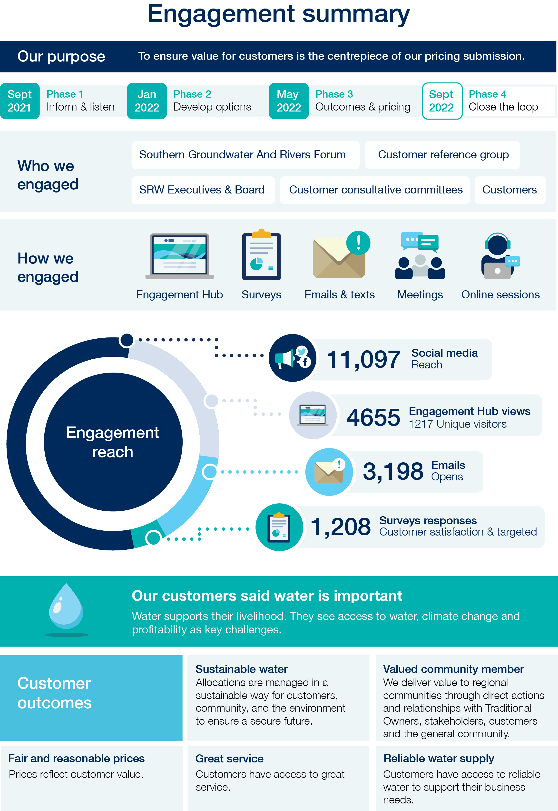Engagement process
SRW enjoys a strong ongoing connection with our customers and meet regularly with customer consultative committees that represent the three irrigation districts, and the Southern Groundwater and Rivers Forum, who represent unregulated river and groundwater users. This provides a strong foundation on which to build further.
Further foundational information is obtained via biennial customer satisfaction telephone surveys that link directly to the service and value we provide. These are undertaken by a third party and usually reach around 1,000 randomly selected customers.
We began deliberate and targeted engagement planning in early 2021. Our aim was to build upon the Price Submission 2018 to achieve broader, deeper engagement.
In establishing the approach, process, and scope of our engagement efforts we took into account the ESC guidance, as well as our foundational understanding of our customers and the parallel technical process. The following diagram shows our engagement performance in relation to the timing, content, and form.
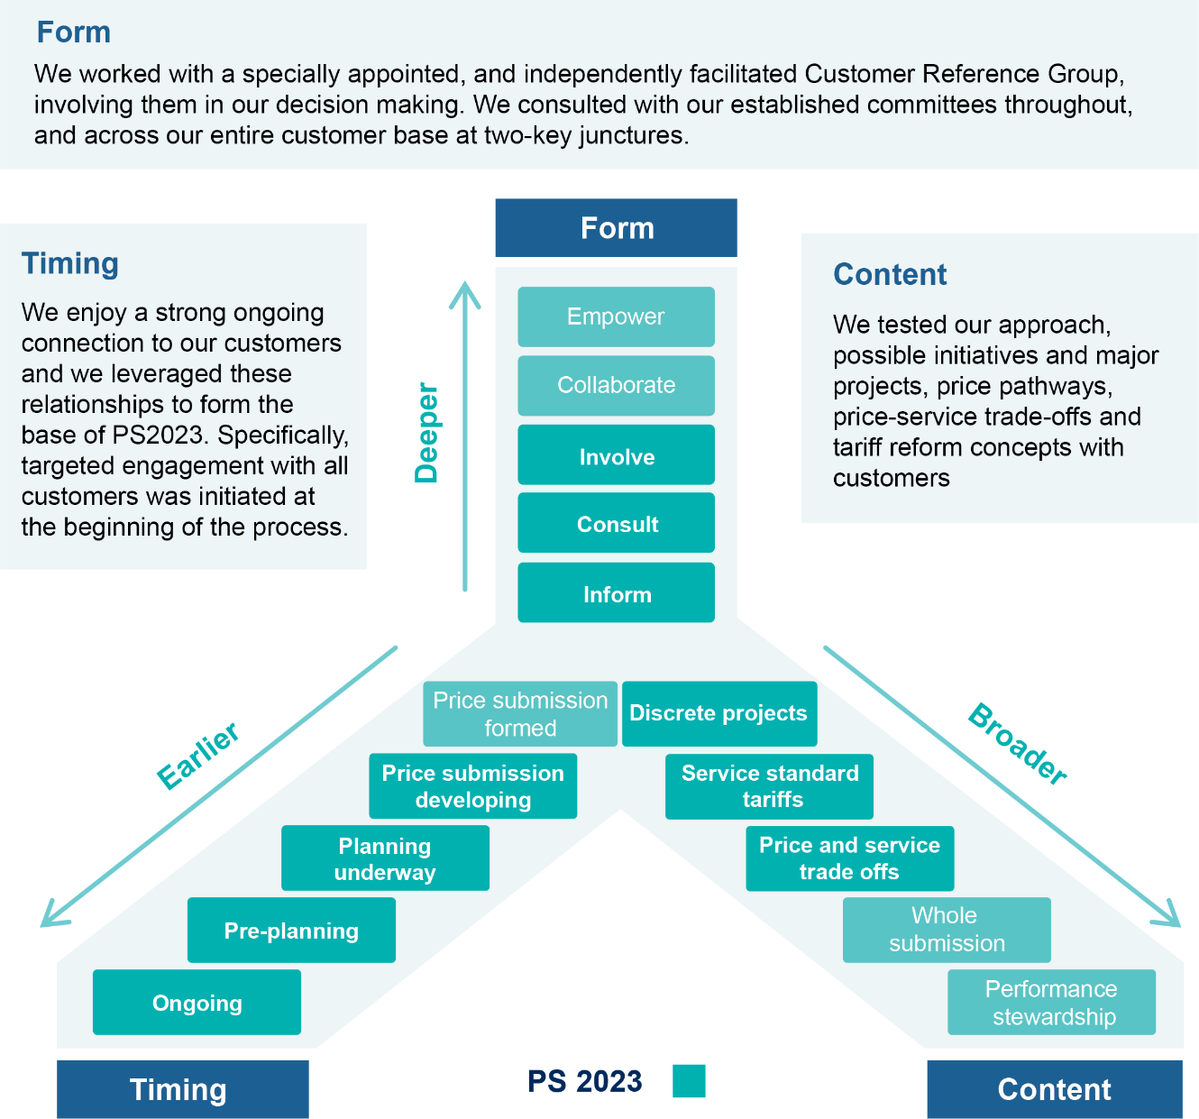
Figure 3 – Engagement approach

We developed a phased, tiered approach based on four clearly defined phases of the price submission development and different levels of engagement (using the IAP2 spectrum) for different ‘groups’ of customers outlined below.

Table 9 – Engagement approach across phases of development
 | Phase 1  Informing and listening | Phase 2  Price-service design | Phase 3  Testing and prioritising | Phase 4  Reporting back
Independently facilitated Customer Reference Group | Involve | Involve | Involve | Involve
Customer consultative committees (incl. SGRF) | Consult | Consult | Consult | Consult
All SRW customers | Consult | Inform | Consult | Inform
Special interest groups (i.e., Traditional Owners) | Consult | Inform | Consult | Inform

SRW engaged external consultants to provide expertise and support to the engagement process. We worked collaboratively with Bartley Consulting in association with Stanford Marketing and Gillian Hayman Facilitation and Project Services to enhance our draft engagement framework, design communication materials and support engagement efforts through the delivery of surveys, workshops, and meeting facilitation. The same consultants also prepared a comprehensive engagement report which documents our process, actions and results (see Appendix F).
The approach was guided by a set of principles:
- engagement aligns with SRWs strategic aspirations;
- we use best practice engagement methods;
- engagement is inclusive;
- engagement is meaningful; and
- engagement is transparent and inclusive.
We used a variety of methods and media to engage with our customer base to maximise the ideas and feedback. These included:
- Leveraging strong, existing relationships, information, and activities such as our existing customer committees, relationships between customers and our operational staff and customer service team.
- Initiating specific and targeted activities to broaden and strengthen our reach such as the establishment of a specially appointed Customer Reference Group and the online engagement hub, as well as customer-wide surveys and face-to-face sessions.
The purpose of appointing an independently facilitated Customer Reference Group was to increase customer knowledge, insight and transparency into the price submission process and ensure decisions directly reflect well-considered customer views.

Engaging with First Nations people and vulnerable communities
We do not have data indicating whether a customer identifies as a First Nations individual. To maximise participation of all customers, we provided a number of different ways for individuals to participate and promoted them broadly. All Registered Aboriginal Parties (RAP) within our area of operation were informed of our process directly, provided updates and invited to engage directly with us.
One RAP responded and provided direct feedback which has been considered, noting that they do not pay for their entitlement and therefore did not express a view that directly related to the price submission.
SRW currently have a policy that supports that waiving of tariffs for water licenced for cultural use. Currently, two RAPs hold significant entitlements for cultural uses, which are the result of working in partnership over significant period of time, which has provided a level of clarity around their goals and aspirations. We continue to build on our foundations with other RAPs to develop stronger relationships to support self-determination with tangible outcomes.
Acknowledging that our customers do not rely on water for basic human needs (i.e., we do not licence or provide treated water for human consumption), rather they have a commercial interest in accessing water to sustain or grow a business, our approach to engaging with vulnerable individuals was difficult.
We sought representation from the Rural Financial Counselling Services in both the east and west of the state, however they were unable to participate. We did however receive feedback regarding our approach to debt recovery and now have a great understanding of the areas we can focus on, and the steps we can take to help our customers. This feedback related to improving visibility into the hardship provisions available to customers, building better relationships with Rural Financial Counselling Services and being mindful of the impact of debt collection on individuals or businesses in financial hardship. Addressing these matters will support the outcomes of this price submission.

Scope
The scope and depth of engagement varied according to the audience. Discussions were deeper and more detailed with the Customer Reference Group, while engagement with the entire customer base was focussed at two key junctures: Phase 1 (informing and listening) beginning in October 2021 and Phase 3 (testing and prioritisation) in May 2022.
This Customer Reference Group met on five occasions over eight months and discussed a number of topics and concepts including:
- customer value, expectations and challenges;
- SRW’s operational initiatives and capital priorities and their potential impacts on customers;
- service levels and customer outcomes;
- proposed pricing pathways for each customer base;
- tariff reform concepts;
- timing, format, approach audiences for engagement; and
- content of communication materials.
Most of the matters were also raised with existing customer consultative committees. We maintained connection with these groups at all points throughout the price submission development.
During Phase 1 we promoted a survey to all our customers with the objectives to:
- profile SRW customers’ current and future needs and expectations;
- understand customer and community expectations of SRW to help identify service offerings and priorities; and
- establish customer awareness, and value derived from Price Submission 2018.
The Phase 3 survey focussed on testing customers’ preferences and priorities in relation to SRW’s draft price proposals and service outcomes. The scenarios were developed from Phase 1 customer feedback and Phase 2 initial testing with SRW’s Customer Reference Group, its customer consultative committees and Southern Groundwater and River Forum members.
The survey objectives were to:
- test customers’ support or otherwise for SRW’s proposed price increases (baseline or other options) according to their water source; and
- establish the importance of SRW’s proposed core price/service outcomes with customers and identify the areas SRW should focus on in line with each proposed outcome.
Throughout Phase 3 we also invited key customers including bulk entitlement holders and Traditional Owners to engage with us one-to-one focussing on value, proposed pricing pathways, our ongoing relationship, and mutual outcomes.
As noted earlier, the results from the biennial customer satisfaction survey provided another key feedback mechanism. We drew on information gathered from both the most recent survey, designed with the price submission development in mind, and completed by 883 randomly selected customers as well as the previous survey completed by 1,000 customers in 2019. This provided valuable information regarding the value for service, our performance, and expectations.

Feedback

Customer feedback

Value
In general, our customers are happy with the level of service we provide, and believe we offer good value for money. Acknowledging the broad range of customers, the various uses of water, size of enterprise and the different interactions they have with SRW, some of the findings from surveys and discussions are contradictory, however, on balance most of our customers value and appreciate SRW’s provision of water, customer service and level of communication and are seeking similar outcomes for the future.
Our customers told us that they want to see us make continuous improvements to ensure we continue to provide the same if not better access to water while keeping costs as low as reasonable.
The sentiment around pricing is clear and consistent, which led to the core outcome: fair and reasonable prices.
We tested more specifically what was important to our customers. Overwhelmingly, access to water, having a reliable water supply in the future and having a reliable water supply now were the most important matters. These link directly to the proposed outcomes of reliable water supply and sustainable water.
Being easy to deal with and having responsive customer service also scored highly, informing the outcome: great service. Aligned with this outcome is feedback that we seek ways to do things better, more efficiently, more effectively.
The survey included a section dedicated to some of the less overt aspects of our business such as advocacy, improving environmental outcomes, supporting reconciliation, climate adaptation, having a positive social impact and supporting customer experiencing hardship. While there are varying levels of support amongst these different aspects, overall the vast majority (more than 80%) think it is important that SRW contributes to broader community outcomes as well. This links directly to the outcome: valued community member.

Price
We tested a range of price pathways with each customer group as well as some tariff reform concepts.
Feedback in the Macalister Irrigation District showed that on balance customers preferred an increase of around 1.3 % plus CPI acknowledging the service trade-offs, however there was notable support for an increase as high as 3.1% plus CPI.
In the Werribee Irrigation District, we tested price pathways between 0.3% plus CPI and 1.7% plus CPI, with most of the feedback from surveys suggesting we could aim for an increase of around 1.5% plus CPI.
In the Bacchus Marsh Irrigation District, we tested price pathways between CPI and 0.2% + CPI but received feedback that any increase was a concern.
We advised groundwater and rivers customers that we were considering prices capped at CPI which drew concern with some questioning why we charge at all.

Responding to feedback
Our customers provided valuable feedback on what’s important to them and what they want from SRW. This feedback has been directly fed into our submission and distilled this into five key outcomes (see Section 6).
Through our engagement program we tested the tariff options below. The following provides a summary of the feedback on possible initiatives.

Table 10 – Tariff response
We asked customers if they supported | Customer response | We are now proposing
Greater investment in MID salinity program | Similar numbers favour/oppose greater investment in the salinity program across all engagement platforms, so our proposal seeks to find the middle ground | SRW will continue to operate the program, but aim for greater efficiency
Differential pricing where customers paid more for larger outlets | Mostly opposed to differential pricing, however we believe this may change as modernisation progresses | SRW will maintain a uniform outlet price but explore differential pricing options for PS28
Combine recycled and river water to a ‘single product’ | Through the surveys 75% supported merging the products. WBMCCC and individuals in attendance at open houses also support this proposal | SRW to pursue managing recycled and river water as a single product
Greater investment in WID drainage | Most opposed paying more for drainage services despite a request for improved drainage, so our proposal seeks to find a middle ground | SRW will continue to maintain drains within existing budgets but for greater efficiency opportunities and partnerships with Melbourne Water, Council etc
Higher application fees for more complex applications | Survey results suggested a slight majority oppose high fees for more complex applications, however deeper discussions with the CRG and SGRF members suggested a greater level of support | We have identified a cost/revenue discrepancy in our applications business. We are proposing different tariff mechanisms to recover costs, and will monitor the cost of complex applications for consideration in the next price submission

The following provides a summary of the feedback on prices and our response to them.
Table 11 – Pricing Response
We asked our customers,  if they supported | Customer response | SRW proposal
G&R price increases of:  CPI only | Responses varied, with some customers seeking price reductions or just a CPI increase | We need greater investment in compliance which can (in part) be offset by productivity savings, resulting in proposed price increases of:  - CPI only per annum
BMID price increases of:  0.0% – 0.2% + CPI pa | General opposition to any price increase | We need to fund past CAPEX which can (in part) be offset by productivity savings, resulting in proposed price increases of:  - CPI only per annum
WID price increases of:  0.3 to 1.7% + CPI pa. | Very strong support for options with a 1.0% to 1.3% price increase, although it is acknowledged that some did not support any increase. | We need to fund past and future modernisation CAPEX which can (in part) be offset by productivity savings, resulting in proposed price increases of:  - 1.0% + CPI per annum
MID price increases of:  1.3 – 3.1% + CPI pa. | Majority support for minimal price increases, but with notable (40% of survey respondents) support for increases over 2% | We need to fund past and future modernisation CAPEX which can (in part) be offset by productivity savings, resulting in proposed price increases of:  - 1.5% + CPI per annum
Latrobe bulk entitlement price increases of:  1.5% (approx.) + CPI pa | General support, knowing the increase is primarily to fund dam safety works | We need to fund CAPEX but will consult in accordance with the bulk entitlement instrument, expecting price increases of around:  - 1.5% + CPI per annum
Werribee and Maribyrnong bulk entitlement price increases of 1.9% (approx.) + CPI pa | General support, knowing the increase is primarily to fund dam safety works | We need to fund CAPEX but will consult in accordance with the bulk entitlement instrument, expecting price increases of around:  - 1.9% + CPI per annum

Unmet expectations
Our customers have provided us with some invaluable feedback and as much as we have endeavoured to respond to all of it within our price submission, there are some aspects that are more difficult to agree upon.

Value
Some customers queried the need for price increases. During face-to-face meetings it became apparent that some of our customers don’t have a full appreciation of the role we play and showed greater acceptance of price proposals once they were explained in more detail. The discussions highlighted the need for SRW to be more transparent, through varied communication channels about the activities we undertake, including the provision of maintenance updates to our customers.

CPI
A number of customers queried why we were looking to include CPI in our pricing. In the past SRW has frozen some prices, especially in the groundwater and rivers space. However, as we are facing increasing costs and rising inflation rates it is simply not sustainable to continue to freeze prices. Hence, our proposal is to include CPI in future pricing but apply it as a cap. In other words, we wear the cost if our costs exceed CPI, conversely the customers enjoy the benefits of reduced price increases if our costs are below CPI. This will be considered on an annual basis through our annual tariff review.

No fees
Some groundwater and rivers customers question why we charge fees, again citing that they do not see any service or value from SRW. Once again this highlights the need for SRW to increase awareness of the services we provide.

Drainage works
Some customers in the Werribee Irrigation District and Macalister Irrigation Area raised concerns about drainage wanting SRW to invest more effort in this space. However, they were unwilling to pay additional costs in improving drainage. SRW now proposes to work with customers and various agencies (e.g., West Gippsland Catchment Management Authority, Melbourne Water and councils) to understand how we can optimise drainage services within existing our current operational budget.

Recreation facilities
SRW operates several recreational facilities which we maintain, in accordance with a state-wide practice, via a charge to our urban water customers. We also include a small fee on our Macalister Irrigation District irrigators to cover 4% of the costs of maintaining our recreational facilities in Gippsland. Gippsland Water has sought a review of the current population-based distribution model, suggesting that the costs should be levied on all bulk entitlement holders, but, principally the power companies as they have a broad customer base. There are no provisions in the bulk entitlement orders to impose such a fee. The power companies have not agreed to fund recreational facilities. As such, SRW is proposing to maintain the existing arrangements but has instigated discussions and will continue to engage with other bulk entitlement holders to confirm whether they would be prepared to share some of these costs. However, through the engagement process with Gippsland Water in particular, SRW has also critically reviewed the operational expenditure and reduced costs by 10%.

Other expectations
There will invariably be times when we may not meet customer expectations. Our intention is to monitor any such feedback and seek to minimise any differences. The customer consultative committees have provided a great forum in the past to discuss ideas and resolve outstanding issues, only strategic and operational matters. It is envisaged that any unmet expectations in the future will be discussed with these committees in the hope of reaching agreed outcomes.

Proposed PREMO rating for engagement
We are satisfied that our PREMO rating for engagement is advanced, based on the following assessment and the evidence provided in Appendix F – Engagement Report:
Engagement Aspect | Rating
To what extent has the business justified how the form of engagement suits the content of consultation, the circumstances facing the water business and its customers?
SRW has a well-established engagement program built upon regular meetings with its three customer consultative committees and the Southern Groundwater and Rivers Forum, which are chaired by customers, regular surveys including the 2022 customer satisfaction survey, and a strong presence 'in the field'. This provides valuable insight into our customers and a strong platform on which we were able to develop a tailored engagement program, reflecting the needs and circumstances of our various customer groups.  To improve on our engagement efforts from the Price Submission 2018, we formed a Customer Reference Group (IAP2 level of ‘Involve’), consulted all customers at two key junctures via surveys and public meetings and established an online engagement hub.  We targeted, bespoke engagement was undertaken with bulk entitlement holders (i.e., other water corporations, power companies and the Victorian Environmental Water Holder), Traditional Owners and industry representatives.  Out engagement approach also took into consideration the limitations of the COVID-19 pandemic.  The engagement has shaped our strategic direction and planning through to 2028, feeding directly into our outcome statements and pricing. | Advanced- confident
To what extent has the business demonstrated that it provided appropriate instruction and information to customers about the purpose, form, and content of the customer engagement?
SRW worked collaboratively with external consultants to formulate the approach and produce the information throughout the process to ensure it was fit for purpose.  SRW advised all customers about the purpose and process of the price submission via several means including a fact sheet in all customers’ bills, direct SMS, and email (where details are known to SRW).  An online engagement hub (linked to our corporate website) was established to keep all customers up to date and to provide feedback at any point. This had mixed success, but customers were also provided with a phone number and a dedicated email address to contact SRW.  At key points throughout we used direct SMS, email, unpaid and paid social media as well as traditional media to promote the call for involvement and feedback.  All information and feedback points available to customers were included in each piece of communications material developed. | Advanced- satisfied
To what extent has the business demonstrated that the matters it has engaged on are those that have the most influence on the services provided to customers and prices charged?
Our engagement framework was developed in collaboration with external consultants to complement the phased development of our price submission. This means that feedback provided by customers in Phase 1 directly influenced the outcomes in Phase 2 and beyond.  We engaged with the Customer Reference Group and the customer consultative committees through each phase of the submission development as a touch point to collect more information and data, but also test ideas and approach. This meant we had a deep understanding of our customers’ expectations and how they related to pricing and tariffs. | Advanced- confident
To what extent has the business explained how it decided when to carry out its engagement?
The engagement was guided by a set of principles; it aligns with our strategic aspirations, we apply best practice, it’s inclusive, meaningful, and transparent.  SRW engaged the services of external consultants to help refine our approach to engagement which was based on early and consistent engagement that aligned to the four different development phases: ‘Informing and listening’, ‘Option design and prioritisation’, ‘Testing’ and ‘Closing the loop’.  The approach was tailored and agile, to ensure we could respond quickly to the difficulties of COVID-19, and informed by the views of the Customer Reference Group, comprised of customers representing each customer base (MID, WID, BMID and G&R) as well as the Victorian Environmental Water Holder.  While our specific engagement program may be different to some of the large urban water corporations, it represents our commitment to an ongoing engagement and relationship with our customers where it’s not just about providing water but it’s about managing the water, which our customers effectively own through water licences, shares, and bulk entitlements. We are not just a service provider but partner with our customers to lead to more productive outcomes.  The benefits of this approach are demonstrated through results from our 2022 Customer Satisfaction Survey where we retained a satisfaction rating of 76% of customers saying we meet expectations through the challenges presented by the pandemic. | Advanced- satisfied
To what extent has the business demonstrated how its engagement with customers has influenced its submission?
The customer outcomes, performance measures and new initiatives have been directly and heavily influenced by the findings from Phase 1: Informing & Listening.  We drew on feedback from the previous biennial customer satisfaction survey, workshop discussions with the Customer Reference Group as well as the customer consultative committees and outcomes from a customer wide survey (which was open for four months).  This told us what customer think we do well, where we can improve, as well as what challenges they are facing, what is important to them and where we should focus. This directly informed the customer outcomes and measures.  Engagement in both Phases 1 and 3 was low, and most findings would not be considered statistically significant. We relied on feedback from the core groups – the Customer Reference Group and the customer consultative committee – which may not be representative of our broad customer base. | Advanced- confident
To what extent has the business demonstrated that its engagement was inclusive of consumers experiencing vulnerability?
SRW provides water for agricultural, urban, and commercial customers. This means that the cost of water is important to their profitability and business viability.  Engagement was inclusive for all customers including those experiencing financial hardship, and through direct engagement with the Rural Financial Counselling Services around how SRW manages and deals with the non-payment of bills.  All surveys allowed for anonymity, and there were several ways in which people could contact us throughout.  Currently agricultural enterprises are generally prosperous; however, we do acknowledge that periods of drought, flood or other hardships can occur. | Standard- satisfied
To what extent has the business demonstrated that its engagement was inclusive of First Nations people?
The engagement was inclusive for all customers, and several different ways to provide feedback were available.  SRW has strong relationships with some Registered Aboriginal Parties (RAP) within our area of operation, and we leveraged those, and the discussion through which two allocations for cultural water (which are exempt from fees) were granted to engage around water and water pricing for Traditional Owners.  Each RAP was informed of the price submission process via newsletter and provided with the same information as our direct customers, as well as the invitation for one-to-one discussions around water pricing and the aspirations of Traditional Owners. | Standard- very confident

- Outcomes

Key messages
SRW's outcomes are designed to ensure that our customer needs continue to be met.

- The outcomes reflect customer and stakeholder priorities, namely: a reliable water supply, sustainable water, great service, valued community member and fair prices.
- Performance measures and targets have been developed in response to customer priorities to provide reliable and sustainable water with good service at a fair price.
- The performance results will be published at least twice yearly.
- Our expenditure program is directly tied to the outcome with much of the CAPEX devoted to providing reliable and sustainable water with OPEX designed to support service delivery.
- We are satisfied that our PREMO rating for outcomes is advanced.

Outcomes
The outcomes proposed directly reflect the views, concerns and priorities of our customers as heard through our ongoing engagement programs and the additional engagement conducted specifically to inform this submission.
Our customers have provided us with valuable feedback on what’s important to them and what they want from SRW. We have repeatedly heard that reliability, profitability, sustainability, service and value are of upmost importance to our customers. We have distilled this into five key outcomes:
- Reliable water supply: Customers have access to reliable water to support their business needs.
- Sustainable water: Allocations are managed in a sustainable way for customers, community, and the environment to ensure a secure future.
- Great service: Customers have access to great service.
- Valued community member: We deliver value to regional communities through direct actions and relationships with Traditional Owners, stakeholders, customers and the general community.
- Fair and reasonable prices: Prices reflect customer value.
Each outcome is supported by measures and targets. Some performance measures have been carried over from Price Submission 2018 with revised performance targets, however many have been significantly refined or are new. All are informed by discussion and feedback from customers via consultative committees, surveys and to a greater and deeper extent the Customer Reference Group.
We are proposing no real price increases for 86% of SRW customers. The cost implications to customers for achieving these outcomes are minimal. For those customers with a proposed price increase, this is largely based on the recovery of costs associated with historic modernisation investment. We are committed to ongoing productivity efficiencies of 1% per annum, and assume any other operational savings accrued will be re-directed to cover the costs associated with increasing customer expectations and obligations.
Given the very different nature of water security and influences on water quality in our different systems, we have refined the customer outcomes to allow for those differences. Also, given the diverse nature of our customer enterprises, we are focussed on offering service in the way that best suits individual customer groups while keeping prices as low as possible.
The outcomes have been expanded into a series of outcome statements, as set out on the following pages.

Reliable water supply
Reliable water supply | Response
What’s the outcome we are seeking? | Customers have access to reliable water supplies to support their business needs.
What did our customers say? | Our customers have told us that access to a reliable supply of quality water when it is needed is critical to their business, both now and into the future. Having modern and efficient assets enable us to provide a reliable service, while ensuring that we allocate water within sustainable limits will enable us to provide water security into the future.
SRW commitment | SRW is committed to maintaining efficient infrastructure and management systems capable of supplying a reliable source of water.
How will we measure this? | Our proposed performance measures and targets focus on:  - Orders delivered at time agreed – MID, BMID & WID  - Orders delivered without interruption - MID, BMID & WID  - Quality water supplied - WID.  - Orders delivered – bulk entitlement holders  - Further details on the measures and targets are provided in Appendix C.
What will we do to achieve it? | We can do this by:  - continuing to modernise our assets and optimise;  - working with recycled water providers to provide a suitable product;  - more effective asset management;  - enhancing ordering and delivery processes to better meet our customers’ needs;  - managing drains and salinity bores, where provided, to promote productivity; and  - being a resilient organisation, capable of effectively responding to challenges
How does it come together to deliver a result? | Our capital plan is designed to improve the reliability of our delivery systems, through the replacement of aging infrastructure with a more modern delivery system. Our success in achieving this will be monitored through a set of measures that have been refined to focus on customer outcomes (i.e., did we deliver suitable water when we said we would with minimum disruption).
How much will it cost/save? | The costs of achieving this outcome are reflected in our capital delivery plan. The works we are undertaking to modernise our districts is having a direct benefit to our ability to deliver reliable water supply. This investment will not only provide more reliable water, but it will also enable us to operate our systems more efficiently leading to productivity savings documented in Table 14.
How will it impact prices? | Given the strong capital focus of this outcome, there will be real price increases in the MID (1.5% pa) and WID (1% pa) to contribute to past and future investments The outcome does not impact prices in the BMID and groundwater and rivers operations where limited capital investment is planned.

Sustainable water
Sustainable water | Response
What’s the outcome we are seeking? | Allocations are managed in a sustainable way for customers, community, and the environment to ensure a secure future
What did our customers say? | Our customers have told us that access to water is their biggest challenge over the next five years with some expressing concerns about the challenges of drought, climate change and the long-term availability of water. There is going to be the need to balance the economic, social, and environmental values of water in an uncertain future.  One of the key ways we can provide greater certainty is to secure untapped resources for our customers and the environment.
SRW commitment | SRW is committed to effective resource management that maximises the water available for consumptive use, community, and the environment.
How will we measure this? | Our proposed performance measures and targets focus on:  - Investigation of unauthorised use - All  - Release of additional water entitlements – MID, BMID & WID  - Delivery efficiency – MID, BMID & WID  - Environmental flows delivered – BEs  Further details on the measures and targets are provided in Appendix C.
What will we do to achieve it? | We can do this by:  - Optimising water savings from modernisation and offering them to the market  - Promoting access to available ground and surface water opportunities  - Exploring opportunities to access recycled water  - Exploring opportunities to establish new markets/districts  - Promoting trade and alternative uses of water  - Adapting to the impacts of climate change on future resources  - Consider holding some of the water savings in a resilience pool.
How does it come together to deliver a result? | This outcome is very much about our decision-making processes. It is about being insightful and having the right policies and procedures in place to manage water in a sustainable way, be it for economic, environmental, cultural, or social purposes. Our performance measures are designed specifically to gauge our success in delivering on these outcomes, more precisely are we on top of compliance issues, have we delivered water in accordance with our obligations to the environment and were we efficient.
How much will it cost/save? | The costs of delivering this outcome are primarily reflected in our operational budget where we are committed to drive 1% productivity savings while still delivering on this outcome. The modernisation projects in our irrigation districts have already seen considerable increases in water delivery efficiency. These savings can in turn be audited, validated and offered to customers through our water sales.  The introduction of taggle meters across our groundwater and rivers customer base is enabling a much more rigorous review of water usage and subsequent compliance. This is also reducing the number of meter reads per year leading to productivity savings as detailed in Table 14.
How will impact prices | This outcome does not have a discernible impact on prices, although the selling of additional water shares and entitlements is supporting the customer contribution to fund modernisation and minimising annual real price increase to 1.5% pa in MID.

Great service
Great service | Response
What’s the outcome we are seeking? | Customers have access to great service.
What did our customers say? | Our customers have told us of the desire for SRW to be an efficient and cost-effective organisation. They have asked us to focus on our core purpose and to maintain existing standards of service.  To provide great service, it is critical that we aim for optimum efficiency, where our people are supported with the right systems, processes, and technology to deliver great service to our customers.
SRW commitment | SRW is committed to providing professional and prompt service to our diverse customers in their preferred manner.
How will we measure this? | Our proposed performance measures and targets focus on:  - Customer complaints - All  - Complaints managed quickly - All  - Applications completed within set timeframes – G&R  - Drainage management – MID & WID  - Drain maintenance – MID & WID  - Further details on the measures and targets are provided in Appendix C.
What will we do to achieve it? | We can do this by:  - Developing a deep understanding of our customers  - Embracing technology  - Excelling in customer communications  - Providing timely and accurate response  - Ensuring we have a skilled and engaged workforce  - Advocating on behalf of our customers.
How does it come together to deliver a result? | This outcome is very much about how we deal and respond to our customers. It is very much about developing our people, listening, understanding, actioning, and having the right systems in place so that we can respond to our customers in a positive way. Our performance measures are designed specifically to track these outcomes.
How much will it cost/save? | The costs of delivering this outcome are primarily reflected in our operational budget where we are committed to drive 1% productivity savings across our OPEX while still delivering on this outcome. See  Table 14 14 for more details of the productivity savings.
How will impact prices | This outcome does not have a discernible impact on prices. Any operational savings accrued will be re-directed to cover the costs associated with increasing customer expectations and obligations as detailed in Table 14

Valued community member
Valued community member | Response
What’s the outcome we are seeking? | We deliver value to regional communities through direct action and relationships with Traditional Owners, stakeholders, customers and the general community.
What did our customers say? | SRW has strong relationships with its customers and stakeholders. Our customers have told us that they value their relationship with SRW and appreciate our efforts to advocate on their behalf. Stakeholders have also told us that they value our partnerships and the opportunity to work together. While some customers have expressed concern about our involvement in some areas (e.g., climate change, environmental and traditional owners), government and societal expectations are placing greater focus on these areas.
SRW commitment | SRW is committed to being a good corporate citizen, partnering with our customers and the community to facilitate the health of the regions in which we operate.
How will we measure this? | Our proposed performance measures and targets focus on:  - Emission reductions – All  - Environmental flows – bulk entitlement holders  - Harvesting – bulk entitlement holders  - Further details on the measures and targets are provided in Appendix C.
What will we do to achieve it? | We can do this by:  - Providing clean water that can be treated by urban water corporation for human consumption.  - Providing recreational facilities at designated storages.  - Respecting Traditional Owner values of the lands and water which we manage.  - Operating in a manner that is safe for our employees, visitors, and customers.  - Minimising our impacts on climate and the environment.  - Working alongside the communities where we operate to promote economic growth and vitality.
How does it come together to deliver a result? | This outcome is very much about the role we play in the broader society, how we interact with stakeholders and how we respond to community expectations (e.g., climate change, environmental and Traditional Owners), government and societal expectations are placing greater focus on these areas. It is very much about having the right policies in place and responding in a positive way. Our performance measures are designed specifically to track these outcomes, particularly our emissions and our managing of environmental flows.
How much will it cost/save? | The costs of delivering this outcome are primarily reflected in our operational budget where we are committed to drive 1% productivity savings while still delivering on this outcome. There will also be some small capital costs (e.g., solar installation) but these will be offset by longer-term energy savings. We are also looking to partner with other water businesses to meet our emissions reductions.  Table 14 provides an overview of savings to our fleet which will support our emissions targets.
How will impact prices | This outcome does not have a discernible impact on prices. Any operational savings accrued will be re-directed to cover the costs associated with increasing customer expectations and obligations.

Fair and reasonable prices
Fair and reasonable  prices | Response
What’s the outcome we are seeking? | Prices reflect customer value.
What did our customers say? | Our customers have told us that prices are a concern to them. In fact, this was the number one priority identified by irrigation customers. SRW has maintained a program of limited price increases and in some cases price reductions and freezes. However, we manage an asset portfolio with a replacement cost of approximately $1.85 billion where the current revenue steam leads to a gap in the financial sustainability of the business.
SRW commitment | SRW is committed to modernising our business with minimal price increases.
How will we measure this? | Prices will be consistent with Price Submission 2023.
What will we do to achieve it? | We can do this by:  - optimising procurement to minimise costs;  - isolating costs to avoid cross subsidisation;  - seeking cost recovery on complex transactions;  - introducing ‘user pay’ tariffs (e.g., pre-application fee, site visit fee);  - introducing additional fees to recoup increasing costs (e.g., advertising fees); and  - aligning capital investment with customer risk appetite.
How does it come together to deliver a result? | This outcome is very much ensuring we have prices that our expenditure is prudent and efficient so that we can maintain our commitment to the price pathways contained in our submission. Our performance measures are designed specifically to track price pathways.
How much will it cost/save? | This will result in different costs and savings across the business but with the intent of ensuring costs are both prudent and efficient and that our prices provide value to our customers.
How will impact prices | This ensures prices are capped in the MID at 1.5% +CPI, WID at 1%+CPI, BMID and G&R at CPI (per annum).

Reporting
SRW currently provides an annual performance report to the ESC and publishes this on our website for customers. Our intention is to:
- produce this report twice a year;
- table it for discussion at our customer consultative committees;
- post it on our website and seek public comments on the report and the outcomes; and
- incorporate comments from the mid-year review and report any potential changes (as required through customer feedback and agreed through engagement with our customer committees) in the annual report.

Underperformance
It is recognised that we may not always meet our targets (e.g., water sales in 2022).
A key factor in determining underperformance will be to consider whether the matter has material consequences (i.e., will it lead to a change in prices, will it result in lower service standards etc). This will help us to decide whether we need to intervene or take action to ensure we meet out desired targets.
Reviewing our performance twice a year will provide greater capacity to identify performance levels.
The mid-year and end of year reports will be tabled with our board.

Service standards relating to reliability and faults
SRW is a rural water corporation and while we are committed to attending to faults as soon as reasonably practicable and will monitor this through our performance outcomes, we are not proposing a series of service standards as per the ESC’s urban water customer service code.
We are, however, proposing a set of performance measures and targets built around the outcomes of providing ‘Reliable water’ and ‘Great service’.

Guaranteed service levels
SRW is committed to providing great value to our customers. As we are a rural water corporation, we are not proposing a series of Guaranteed Service Levels (as are required for urban water corporations).

Proposed PREMO rating for outcomes
We are satisfied that our PREMO rating for outcomes is advanced, based on the following assessment:
Outcomes aspect | Rating
Has the business provided evidence that the outcomes proposed have considered the views, concerns, and priorities of customers?
The proposed outcomes directly reflect the views, concerns, and priorities of our customers. Their genesis lies in our ongoing engagement with our customers (through our customer consultative committee and satisfaction surveys).  We have taken the opportunity to review and re-test the outcomes from our previous price submission with our customers. This has confirmed that many of the outcomes continue to be a priority for our customers.  Through our customer consultative committees, the Customer Reference Group and surveys in late 2021 we sought further information from our customers on what they value, consolidating all of this into a series of proposed outcomes which we then tested again through our customer consultative committees, the Customer Reference Group, surveys and a series of community meetings in May 2022.  Our customers have consistently told us that having a reliable supply of water, access to more water and fair pricing are important to them. They have also spoken of the need for good service and to a lesser extent our role in the community through fostering economic growth, resource management and responding to climate change. This feedback has been incorporated directly into our proposed outcomes.  Hence some of the measures and targets established in Price Submission 2018 remain equally valid where our customers want reliability and certainty. Conversely some new measures and targets are proposed where we seek to drive a change in our performance and better outcomes for our customers. | Advanced- satisfied
Has the business provided sufficient explanation of how the outcomes it has proposed align to the forecast expenditure requested?
Through modernisation, SRW has focussed on improving reliability and saving water. We have done this while minimising costs to our customers by pursuing government grants and joint funding opportunities. SRW will continue this journey through this next period, pursuing government contributions to finalise modernisation while seeking to capitalise on the benefits of modernisation: greater reliability, more water, great service, and all at a fair price.  Likewise, targets around efficiency of process, particularly for customer applications, continues to help drive a responsive, customer focussed approach to delivering statutory requirements.  Our forecast expenditure is made up of ‘business as usual’ activities and improvement activities that are clearly aligned to provide reliable and sustainable water supplies and great service to our customers. Efficiency is supported by not only our pursuant of capital funding partners but our desire to capitalise on the productivity savings in our operations and in the field.  The engagement program highlighted the need to review our investment program to deliver better outcomes, especially in the areas of drainage and realising the benefits of modernisation to provide a more reliable service to our customers.  Our capital program has been prioritised on the back of a 25-year capital program, designed to support the financial sustainability of the business and ensure that forecast expenditure requests tie directly to customer needs and our compliance obligations. | Standard-very confident
Has the business proposed outputs to support each of its outcomes, which are measurable, robust, and deliverable?
Considering customer feedback, SRW has built upon the outcomes described in the previous price period to develop a set of outcomes which are measurable, robust, and deliverable. The focus is on outcomes that go direct to customer service. In doing so, we have dropped some outcomes which are more operationally focussed in favour of those that go direct to customer experience. | Advanced- confident
Has the business provided evidence that the outputs it has proposed are reasonable measures of performance against stated outcomes?
As indicated above, we developed the outcomes through extensive engagement with our customers. We have rounded out this process through discussion with the Customer Reference Group to confirm that the measures and targets are meaningful to our customers and will deliver on the outcomes. | Advanced- satisfied
Has the business demonstrated a process to measure performance against each outcome and to inform customers?
Our customers have told us that they would like to know more about us, what we are doing and how we are performing. We are exploring better ways to communicate with our customers.  Each outcome is supported by deliverable outputs with SMART targets. The objectives are a combination of objective business data and subjective customer sentiment.  We plan to go beyond annual reporting and are committed to providing quarterly operational reports to our customer committees, along with a mid-year and end of year performance report to all our customers. Customers will be invited to provide comments on the report with the feedback being incorporated in our annual performance report to the ESC. | Advanced- satisfied
- Operating expenditure

Key messages
SRW continues a track record of prudent and efficient expenditure.

- We are proposing a total operational budget of $121 million over the regulatory period.
- Operational cost savings will be delivered through our ongoing efficiency program under-pinning our proposed 1% productivity cost saving.
- Our prudent expenditure results in 86% of customer price’s capped at CPI with the remaining experiencing increase of between 1.0 and 1.5% plus CPI per annum.

Baseline controllable expenditure
2021-22 baseline controllable expenditure is representative of SRW’s efficient cost of operation across all service lines, as illustrated by a consistent expenditure pattern in the current regulatory period (see Figure 4).
Table 12 – Baseline expenditure
Expenditure | $M
2021-22 actual expenditure | 26.7
Less non-controllable expenditure | 1.9
Baseline controllable expenditure | 24.8
Less one-offs or non-recurring | 0.1
Plus, new obligations | 0.4
Less cost savings and efficiency gains | 0.5 – 1.2
Equals baseline for 2022-23 | 24.2

Figure 4 – Controllable expenditure

Non-controllable expenditure
Consistent with past regulatory periods, our assessment of non-controllable expenditure for the purpose of the baseline operating cost assessment is limited to:
- environmental contribution levies set by the government ($0.55m in 2021-22);
- regulatory fees charges by the Essential Services Commission ($0.05m in 2021-22);
- the expected cost of recycled water purchased from Melbourne Water in order to deliver recycled water volumes order by customers in the Werribee Irrigation District ($1m in 2021-22); and
- the expected cost of capital works performed at Yallourn and Narracan weirs which is immediately recoverable from the applicable bulk entitlement holders ($0.34m in 2021-22).

New obligations
In addition to the non-controllable expenditure, there are some new obligations that are driving an increase to our ongoing operating costs. These are associated with cyber security and water resource compliance. Additional expenditure of $0.4 million per annum is incorporated into the 2023-28 operating cost benchmark to deliver these new obligations, which ensure compliance with government expectations as per below:
- Cyber security: the Office of Victorian Information Commissioner (OVIC) has a requirement to implement the Victorian Protection Data Security Framework (VPDSF). In addition to this, we are required to implement the DELWP Water Industry Strategic Cyber plan.
- Water resource compliance: The Victorian Government has increased rural water corporations’ responsibilities in water resource compliance. In May 2020 the Minister for Water appointed Mr Des Pearson, Victoria’s former Auditor-General to review the compliance and enforcement frameworks of DELWP and water corporations with non-urban customers, to ensure they are aligned to the government’s zero tolerance approach to unauthorised take.

One-offs or non-recurring
During this period we have experienced legal and consultancy costs associated with a significant groundwater and rivers regulatory issue that is higher than our long-term average. As such, a deduction of $100 000 has been made from the baseline. Our expectation is that this will return to costs more consistent with our long-term average.

Normally recurring expenses that did not occur
No significant one-off or non-recurring items were identified for the 2021-22 baseline year.

Cost savings and efficiency gains
A 1% per annum productivity saving resulting in reduced OPEX across the period from a combination of the way we deliver our services and conduct our operations has been included in the benchmark operating cost allowance. Compounding across the regulatory period, this represents a reduction to controllable operating costs of $0.5m – 1.2m per year over time.

Forecast expenditure assumptions

Cost increases
Other than a minor increase in compliance costs for cyber security and water resource compliance, future operating cost expenditure analysis has not identified any significant non-inflationary matters that will prompt an increase to the efficient cost of our operations. Maintenance of real operating costs for our major service lines is expected across the 2023-28 regulatory period.

Figure 5 – Controllable operating expenditure
An analysis of our individual expenditure over the past five years and forecast costs for the following items supports the continuation of 2021-22 actual expenditure as an appropriate baseline for future efficient controllable operating costs. Figure 5 shows the projected controllable operating expenditure to 2032-33.
We are forecasting our labour costs to be consistent with the 1% productivity savings, as detailed in Table 14 across the period as represented in Figure 6. There will be a repurposing and upskilling of staff to meet new obligations.

Figure 6 – Forecast labour
Other controllable costs such as electricity and chemicals are relatively non-material for SRW are we are forecasting a continuation of current costs for these.

Non-controllable costs
The incidence of non-controllable costs projected for the 2023-28 regulatory period is consistent with those items deducted from 2021-22 baseline operating expenditure in table below.
Table 13 – Non-controllable costs
$M | 2023-24 | 2024-25 | 2025-26 | 2026-27 | 2027-28
Environmental contribution levy | $0.56m | $0.56m | $0.56m | $0.56m | $0.56m
Regulatory fees | $0.03m | $0.03m | $0.03m | $0.03m | $0.03m
Recycled water (Werribee Irrigation District) | $1.21m | $1.21m | $1.21m | $1.21m | $1.21m
Narracan and Yallourn capital works | $2.70m | $2.41m | $0.73m | $1.63m | $0.81m
Total | $4.50m | $4.21m | $2.53m | $3.43m | $2.61m

Share costs
SRW has followed the ESC’s guidance regarding the allocation of shared costs and continues to utilise within our system a series of rules that are designed to allocate shared costs on a causation basis, and where a causal relationship cannot be reasonably established, allocate the cost using metrics that management consider provide a strong positive correlation to the utilisation of the shared cost (such as direct expenditure and customer numbers).

Efficiency improvements
SRW has identified efficiency improvements of between $0.5 to $1.2 million per annum that could be made during the regulatory period. These improvements will be used to deliver the 1% productivity savings, and to manage any modest changes to obligations or cost changes in-excess of inflation which may occur during the regulatory period.
Over the five-year period we will realise $3.6 million in productivity savings, these improvements, as outlined in Table 14 will be progressively realised as our investments in technology and modernisation are rolled out over the regulatory period.

Table 14 – Efficiency improvements
Item | Initiative | Savings  (p/a) | Expected  timing
Reduce meter reading | The introduction of taggle (remote meter reading) offers an opportunity to reduce the number of meter reads per year from two to one. Realisation of actual savings will require some work practice restructure to convert a 5-10% individual productivity improvement into staff reduction (via natural attrition) or reallocation to additional compliance activities. | $100K | 2024-25
Werribee irrigation O&M efficiencies | SRW currently employs eight full time staff to perform operations, maintenance and planning for the Werribee and Bacchus Marsh irrigation districts. Piping of the Werribee district directly reduces the scale of field maintenance and time spent manually operating these districts. Access to these opportunities is dependent upon project delivery (Werribee modernisation) and transitioning of workforce to support the changed operational environment. | $200K to $400K | 2025-26
Macalister irrigation O&M efficiencies | Completion of Phase 1B (Tinamba delivery system) and part-completion of Phase 2 (Newry delivery system) provides an opportunity for improved system planning and reduced manual operations. Access to these opportunities is dependent upon project delivery and transitioning of workforce to support the changed operational environment. | $100K to $200K | 2024-25
Customer service and applications processing | An increased capacity for customer self-service is emerging from the implementation and ongoing improvements to the MySRW portal. Bill payment is being improved (including immediate payment gateway for applications) and customer account information will be available online. We expect less customer enquiries following the roll-out of these improvements. | $50k to $150K | 2025-26
Standby reform | A re-arrangement of overnight standby has the potential to reduce the number of staff paid at standby rate (for on-call work) from ~10 each night, to four duty staff.  Staff that remain on standby may need to be equipped with a broader skills base in order to effectively triage in-coming calls/alarms/incidents. | $75 to $200K | 2024-25
Travel and vehicle reduction | We expect that many work practice changes will remain once COVID-19 restrictions are fully removed. While we are likely to see a return of some travel costs, pre-COVID expectations to attend in-person meetings with agencies, customers and at other SRW offices has altered, and we are targeting a smaller vehicle fleet associated with lower business travel conducted by our staff.  While vehicle reform is challenging, especially when it involves the removal of directly assigned vehicles (a designated car for a position), the current saving proposal (10%) assumes that less travel occurs, rather than a step down in the number of vehicles held by SRW. | $150K | 2024-25
Asset management | Contemporary asset management systems allowing better scheduling of works to avoid responsive maintenance. Better asset condition monitoring to support. Possible reduction in one staff member. | $100K | 2024-25

Improved customer value
We have worked closely with our customers throughout the development of the price submission to understand what they value and what is important to them, which has led to the development of our outcomes and performance measures (see Section 6).
Through this price submission we are proposing ways to reduce our costs through productivity savings. These efficiency savings are largely driven off the back of our modernisation projects and improvements to our technology, which will enable us to continue to deliver what our customers value. Section 6 provides further details on our outcomes and how they will be achieved, and the costs and savings associated with each.
- Capital expenditure

Key messages
SRW continues a track record of prudent and efficient expenditure.

- Based on our obligations (compliance and committed projects), customer feedback and risks we plan to invest $125 million in capital projects, with $56 million (or 45%) invested in our top 10 projects including $37 million to be spent on completing two modernisation projects.
- CAPEX is based on P50 estimates with risks of project delays and cost overruns to be managed through contractual agreements with service providers.
- Several forecast capital expenditure projects also provide opportunity for operating cost efficiencies and productivity benefits.
- Our prudent expenditure results in 86% of customers price’s capped at CPI with the remaining experiencing increase of between 1% and 1.5% plus CPI.

Forecast summary
We plan to invest $125 million in capital works over the 2023-28 regulatory period. The key drivers of this investment are renewal and compliance. This expenditure includes $19 million of grant funding from government and $13 million of funding provided by the sale of water entitlements to customers. Therefore, only $93 million is sought to be recovered from customers through the regulatory asset base.
This proposed capital expenditure represents a minor increase of $11 million on the 2018-23 price submission benchmark allowance, but a forecast 24% reduction on the projected actual capital expenditure for the 2018-23 period. The 2018-23 price submission benchmark allowance included $10.6 million towards the $62 million MID2030 Phase 2 project (as agreed with the Macalister Customer Consultative Committee), while project approvals and funding arrangements were sought and finalised. This approach was adopted to provide price stability, by avoiding the likelihood of otherwise reducing prices in 2018-23 regulatory period or having a steeper increase in the future when plans for the final stage of modernisation were finalised. The project commenced upon receipt of $41 million of external grant funding from the state and federal governments in FY20 and $39 million will be delivered in the 2018-23 regulatory period, of which, $13.0 million will be funded by SRW’s customers (33% of $39 million).
Continuation of a large capital expenditure program of $125 million reflects the further work that we have undertaken to understand the condition of our assets, the risks and our compliance obligations. This work has revealed that higher capital investment is required to continue to meet the outcomes desired.
The forecast capital expenditure in 2023-24 (year one of the 2023-28 regulatory period) is considerably higher than the following four years. This is due largely to the two major modernisation projects which are continuing and together have a value of $37 million within the period, with $30 million expected to be spent in 2023-24.

Figure 7 – Capital expenditure forecast

Table 15 – Forecast CAPEX
$M | 2023-24 | 2024-25 | 2025-26 | 2026-27 | 2027-28
Improvements / compliance | $35.0m | $11.0m | $2.6m | $4.0m | $1.6m
Renewals | $13.4m | $14.2m | $14.2m | $15.8m | $13.4m

Capital planning assumptions and prioritisation methodology
We undertook a detailed review of our capital investment requirements, which has informed the development of this capital expenditure forecast. This included a review of all assets, a program of asset inspections and condition assessments and rationing investment based on a set of criteria, including our goal of reducing our current asset backlog. This data is then captured in our 25-year capital plan. Finally, our Capital Prioritisation Tool has been used to develop and optimise the capital program, which has been reviewed and endorsed by our Capital Investment Review Team.
The Capital Prioritisation Tool generates capital plan proposals/scenarios based on risk and a value driver, using the following prioritisation steps before asset management strategies (including deferrals) are considered. Expenditure was prioritised and included in the capital forecast for this regulatory period based on the following criteria:
- An existing project was underway prior to the commencement of the regulatory period, this should be completed.
- Capital works of a value under $150,000. This setting assists in developing annual minor asset renewals programs.
- Included based on compliance/safety if the works were to meet a compliance or safety obligation, including legal duties, state government requirements (Statement of Obligations, guidelines, and policies), business requirements (such as security and privacy) and relevant industry-based guidelines (such as ANCOLD).
- Included based on risk if the risk rating of the asset/works was high or above.
- Included based on customer benefit if the customer benefit was rated high or above.
The following table demonstrates the share of the capital expenditure forecast attributable to each of these cases.
The required capital expenditure is based on a P50 estimate, which has been developed for capital project business case estimates in accordance with the Australian Government guidelines on deterministic contingency for projects under $25 million. This method models the expected outcomes of project cost risk items to generate 50th percentile (P50) and 90th percentile (P90) project estimates, thereby developing a fit-for-purpose contingency estimate for each capital project business case. This demonstrates SRW’s industry-standard approach to cost risk management.
Table 16 – CAPEX based on prioritisation criteria
Prioritisation criteria | Total value over regulatory period
Existing projects already commenced and yet to be completed | $43.3m
New projects in 2023-28 regulatory period
Renewal program works under $150,000 | $22.3m
Risk | $29.5m
Compliance/Safety | $25.7m
Additional customer benefit | $4.3m
Total | $125.1m

Existing projects
The largest contributing criteria is the existing projects, this is due largely to the two major modernisation projects which are continuing from the previous regulatory period and together have a value of $37 million within the period.
Five of the top 10 projects which are discussed further below are existing projects.
Other key existing projects that are continuing into this regulatory period include:
- GW&R modernisation, including automated meter reading and meter surround safety upgrade program.
- MID – Redevelopment of the Eastern Irrigation depot back office to provide a meeting room and suitable facilities to perform the expanding variety of technical tasks, and to provide safe and efficient storage of essential equipment.
- Renewal Program Works – This includes typical programs of works which are ongoing, small in value (less than $150k per works project) and renewal based. These types of works include fencing, facilities, security, access tracks, tree removal and condition assessments.

Risk
Risk was a key reason for projects being included, including four of the Top 10 projects which are discussed further below.
Other examples of projects or programs that were included based on risk are channel reconstruction for erosion, regulator replacements, and leak repairs.

Compliance or safety
Capital investment projects were included in the program if they were required to meet a compliance or safety objective. This can differ from the cost driver, that is, a project may have been included based on compliance/safety but still have a renewal cost driver. For example, renewing safe access has been included based on safety requirement but remains a renewal project. Other examples of capital works included based on compliance or safety include: ANCOLD requirements, ICT projects, safe access, electrical works and safety systems, inspections, and surveys.

Additional customer benefit
Some items did not meet the criteria for any of the above. However, they were expected to provide a high customer benefit and were therefore included. These include projects such as SCADA and ICT enhancements.
Another example is the Glenmaggie spillway gate bulkhead project (design phase only). The project will provide the ability to operate and paint spillway gates with minimal customer disruption. Currently, gate painting requires the storage level to be lowered below the sill level, which can require active lowering of the storage. The bulkhead project will also eliminate the risk of demobilisation during gate painting, which currently occurs if the storage level rises. SRW propose to include the capital costs of the design phase only due to current project uncertainty.

Capital rationing
In addition to the above, we also undertook customer consultation which further informed consideration of excluding some projects based on reducing the capital expenditure spend to mitigate price impacts. Options were presented to customers and their feedback provided based on the cost/risk trade-off informed the final selection of the capital expenditure program.

Major (Top-10) capital projects
An overview of each of our top 10 projects by total capital value (in millions) is outlined in the tables on the following pages.
Business cases are available for these projects. Four of the projects are in delivery (either construction contracts have been awarded or detail design is in progress). All other projects are ready for delivery (business case prepared).
The total capital expenditure for the top 10 major projects represents around 51% of the planned capital expenditure over the five-year regulatory period. All other capital projects are included in the capital programs, which are described in the subsequent section of this chapter.

Table 17 – Top 10 projects
Project title | Cost driver | 2023-24 | 2024-25 | 2025-26 | 2026-27 | 2027-28 | Total in period ($m) | Total project value ($m)
MID Modernisation Phase 2 | Improvements / Compliance | $20.3 | $3.6 | - | - | - | $23.9 | $62.6
WID Modernisation Stages 4 & 5 | Improvements / Compliance | $9.8 | $3.4 | - | - | - | $13.1 | $22.0
GW&R Meter Upgrade | Renewals | $2.1 | $2.1 | $2.0 | - | - | $6.2 | $6.2
Melton Reservoir Spillway Left Training Wall Upgrade | Improvements / Compliance | - | $0.3 | $0.7 | $1.4 | - | $2.4 | $2.4
Main Southern Carrier Tunnel No. 5 Remediation | Renewals | $0.2 | $0.6 | $0.8 | $1.7 | - | $3.3 | $3.3
Glenmaggie Spillway Gate Repainting | Renewals | - | $0.5 | $0.7 | $0.2 | $0.9 | $2.3 | $2.3
Southern Main Carrier Concrete Flume Joint Repair | Renewals | $0.1 | $0.3 | $0.3 | $0.3 | $0.3 | $1.4 | $1.4
Blue Rock Isolating Butterfly Valve Replacement | Improvements / Compliance | $1.0 | - | - | - | - | $1.0 | $1.1
Main Northern Channel Siphon No. 2 | Renewals | $1.6 | - | - | - | - | $1.6 | $3.4
Main Southern Channel Siphon No. 2 | Renewals | $0.7 | - | - | - | - | $0.7 | $1.5

Project Name | MID Modernisation Phase 2
Total project value | $62.6m ($23.9m within period) – 66% grant funded
Timing / status | Commenced FY20, to be completed FY25. Construction contracts awarded (Gate 4)
Service category | Pipelines
Asset category | Pipelines
System / customer group | Macalister Irrigation District
Cost driver | Improvement/compliance
Outcome | Reliable water supply, sustainable water
Risk / compliance / customer rating | N/A – already commenced prior to regulatory period
Description | Pipeline replacing open channel and high-use meter outlet replacements throughout the Macalister Irrigation District
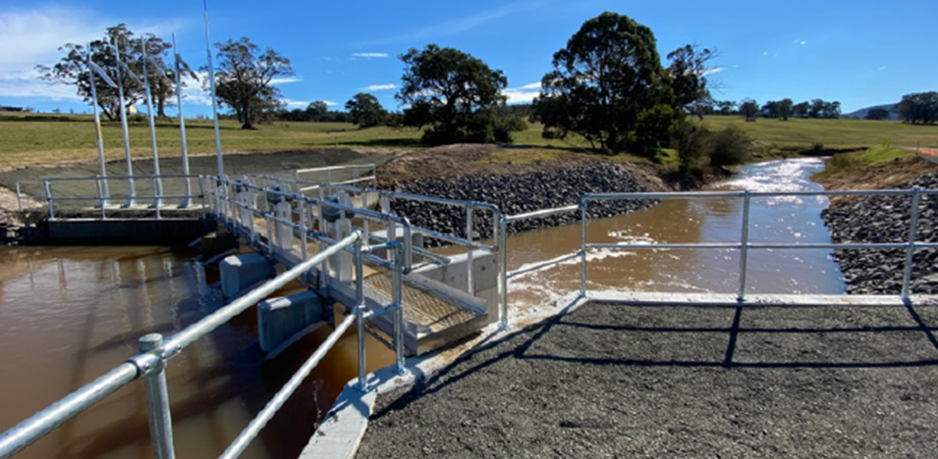

Project name | WID Modernisation Stages 4 & 5
Total project value | $22 million ($13.1 million within period) – 50% grant funded
Timing / status | Commenced FY21, to be completed FY25. Material supply and construction contracts awarded (Gate 4)
Service category | Pipelines
Asset category | Pipelines
System / customer group | Werribee Irrigation District
Cost driver | Improvement/compliance
Outcome | Reliable water supply, sustainable water
Risk / compliance / customer rating | N/A – already commenced prior to regulatory period
Description | Replacement of open channels with pipelines in the yet to be modernised stages 4 and 5 of the Werribee Irrigation District
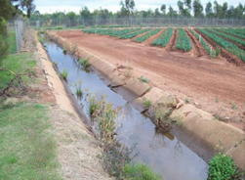

Project name | Groundwater and River Meter Upgrade
Total project value | $6.2 million
Timing / status | FY24 to FY28. Business case prepared (Gate 2)
Service category | Groundwater
Asset category | Customer outlets
System / customer group | Groundwater and Rivers
Cost driver | Improvement/compliance
Outcome | Sustainable water, great service
Risk / compliance / customer rating | Included based on compliance
Description | Replacement of groundwater and river meters with patent approved meters

Project name | Melton Reservoir Spillway Left Training Wall Upgrade
Total project value | $2.4 million
Timing / status | FY25 to FY27. Concept design and options analysis complete. Business case prepared (Gate 2)
Service category | Headworks
Asset category | Headworks spillway
System / customer group | Werribee system
Cost driver | Renewal
Outcome | Reliable water supply, sustainable water
Risk / compliance / customer rating | Included based on Risk – rated High
Description | Upgrade to address the risk of collapse of the spillway training wall
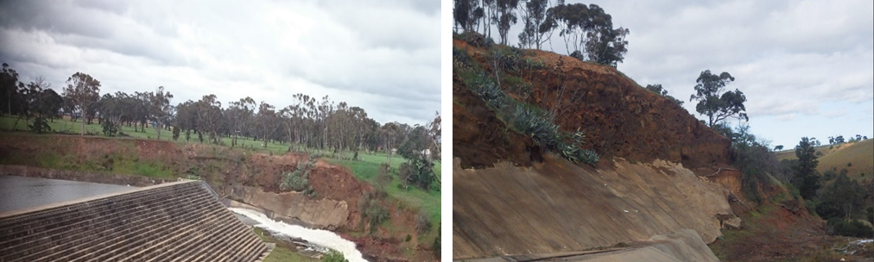

Project name | Main Southern Carrier Tunnel No. 5 Remediation
Total project value | $3.3 million
Timing / status | FY24 to FY26. Options analysis complete. Business case prepared (Gate 2)
Service category | Channels
Asset category | Siphons
System / customer group | Macalister Irrigation District
Cost driver | Renewal
Outcome | Reliable water supply, sustainable water
Risk / compliance / customer rating | Included based on Risk – rated High
Description | Tunnel remediation to address high water loss from the Main Southern Carrier in main distribution link within the MID
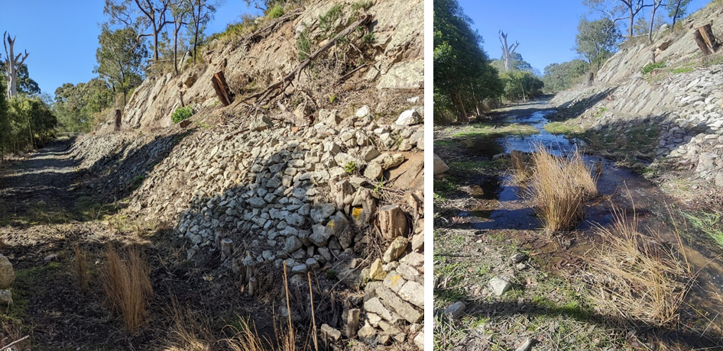

Project name | Glenmaggie Spillway Gate Repainting
Total project value | $2.3 million
Timing / status | FY25 to FY28. Business case prepared (Gate 2)
Service category | Headworks
Asset category | Headworks spillway
System / customer group | Macalister System
Cost driver | Renewal
Outcome | Reliable water supply, sustainable water
Risk / compliance / customer rating | Included based on Risk – rated High
Description | Repainting gates 1-3 and 6-8 (required every 15-20 years)

Project name | Southern Main Carrier Concrete Flume Joint Repair
Total project value | $1.4 million
Timing / status | FY24 to FY28. Business case prepared (Gate 2)
Service category | Channels
Asset category | Flumes
System / customer group | Macalister Irrigation District
Cost driver | Renewal
Outcome | Reliable water supply, sustainable water
Risk / compliance / customer rating | Included based on Risk – rated High
Description | Works to address high-risk failing concrete flume joints
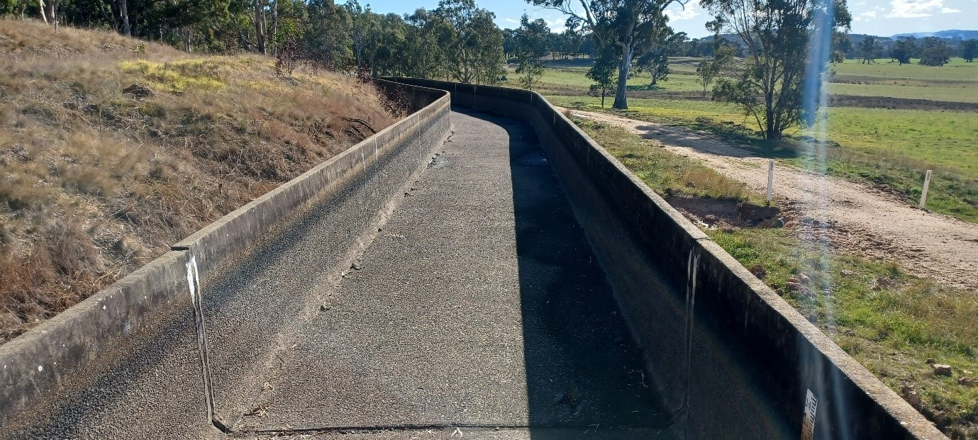

Project name | Blue Rock Isolating Butterfly Valve Replacement
Total project value | $1.1 million ($1.0 million within period)
Timing / status | FY22 to FY24. Options assessment complete. Business case prepared (Gate 2)
Service category | Headworks
Asset category | Headworks embankment
System / customer group | Latrobe System
Cost driver | Renewal
Outcome | Reliable water supply, sustainable water
Risk / compliance / customer rating | N/A – already commenced prior to regulatory period (high-risk)
Description | Replacement of a leaking critical supply valve, to facilitate isolation of outlet conduit for safe and effective operation and maintenance activities and reduce risk of failure
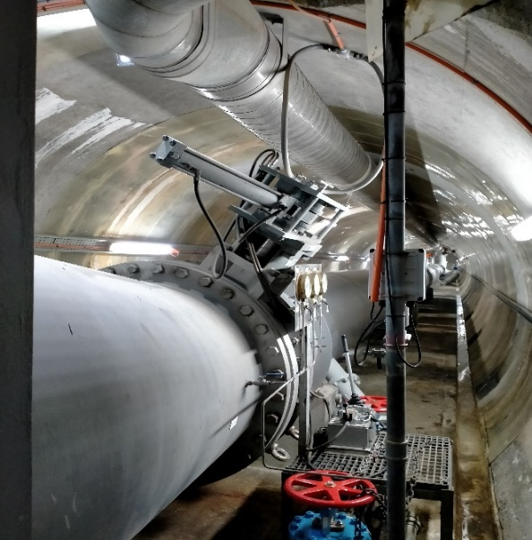

Project name | Main Northern Channel Siphon No. 2
Total project value | $3.4 million ($1.6 million within period) – 50% grant funded
Timing / status | Commenced FY21 to be completed FY24. Business case approved (Gate 2). Detail design in progress.
Service category | Channels
Asset category | Channels
System / customer group | Macalister Irrigation District
Cost driver | Renewal
Outcome | Reliable water supply, sustainable water
Risk / compliance / customer rating | N/A – already commenced prior to regulatory period (high-risk)
Description | Replace high risk siphon on the Main Northern Channel
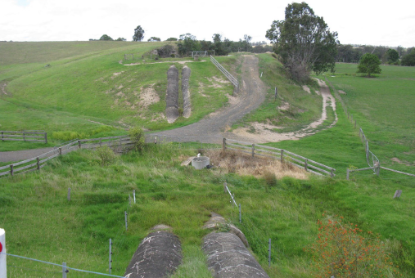

Project name | Main Southern Channel Siphon No. 2
Total project value | $1.5 million ($0.7 million within period) – 50% grant funded
Timing / status | Commenced FY21 to be completed FY24. Business case approved (Gate 2). Detail design in progress.
Service category | Channels
Asset category | Channels
System / customer group | Macalister Irrigation District
Cost driver | Renewal
Outcome | Reliable water supply, sustainable water
Risk / compliance / customer rating | N/A – already commenced prior to regulatory period (high-risk)
Description | Replace high risk siphon on the Main Southern Channel
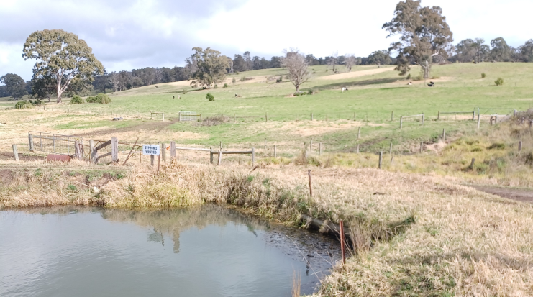

Capital programs
In addition to our top 10 projects, we have a number of programs that will ensure ongoing delivery of service to ensure we meet our customer outcomes. The major capital programs are summarised in the following table with a connection to how they deliver on our customer outcomes:
Table 18 – Major capital programs
Supporting Customer Outcomes | Objectives | Program and cost driver | Five-year total $m
- Reliable water supply  - Sustainable water | To maintain asset base in working order to provide a reliable and sustainable water supply. | Irrigation distribution (Renewals) | $20.0
- Reliable water supply  - Sustainable water | To ensure an appropriate balance between maximising asset lifespan and managing the risk of asset failure. | Dams and Storages (Renewals) | $18.9
- Reliable water supply  - Sustainable water |  | Groundwater and Rivers (Renewals) | $0.4
- Reliable water supply  - Sustainable water | To invest in upgrades to improve compliance (various including ANCOLD, regulatory standards, safety, etc), operational efficiency and SRW’s ability to meet current levels of service into the future. | Dams and Storages (Improvement/Compliance) | $4.0
- Reliable water supply  - Sustainable water |  | Irrigation distribution (Improvement/Compliance) | $1.3
- Reliable water supply  - Sustainable water |  | Groundwater and Rivers (Improvement/Compliance) | $0.4
- Great service  - Reliable water supply  - Sustainable water | To ensure plant and equipment is sufficient to provide efficient field based and office activities | Shared Services (Renewals) | $8.1
- Great service  - Reliable water supply  - Sustainable water | To ensure IT infrastructure supports efficient planning and operational activities. Replace legacy systems no longer supported and replace obsolete hardware. | ICT (Renewals) | $1.3
 |  | ICT (Improvement/Compliance) | $7.9
- Reliable water supply  - Sustainable water | To address those channel sections which, as they deteriorate, present a risk to the reliability and efficiency of SRW’s service. | MID Channel Reconstruction (Renewals) | $5.8
- Reliable water supply  - Sustainable water | To address the regulator fleet (which is approaching end of life) in an efficient manner that maximizes asset lifespan and manages the risk of asset failure. | MID Regulator Replacement (Renewals) | $1.2

ICT capital program
SRW is undergoing a significant re-positioning of its ICT services to meet customer expectations and align to our risk management framework, in particular cyber security. Our customers are expecting a more modern level of service with respect to how they interact with us and the quality and timeliness of information they receive. This has culminated in our ICT renewals and improvement/compliance programs which to support customer expectations and government requirements will address four overarching areas. They are:
- improved customer service, representing 24% of the overall ICT capital program;
- operating efficiencies, representing 34% of the overall ICT capital program;
- government (security) requirements, representing 14% of the total overall capital program; and
- software and hardware redundancy, representing 28% of the overall ICT capital program.

Further details regarding these sub-programs are presented in the following tables.
Program name | Improved customer service
Total project value | $2.2 million
Major projects, timing and status | SRW Website Upgrade (FY22 to FY28, Gate 5 in progress (enhancements ongoing))  Information Management (FY24 to FY28, Gate 2 business case prepared)  Data Management Upgrade (FY23 to FY28, Gate 2 business case prepared)  Application Programming Interface (API) Platform (FY25 to FY26, Gate 1, options assessment pending)  Digital SRW (FY22 to FY28, Gate 5 in progress, enhancements ongoing)  Off Premise Global Storage - Phase 2 (FY24 to FY28, Gate 2 business case prepared)
System / customer group | Shared
Cost driver | Improvement/compliance and renewals
Outcome | Great customer service, valued community member
Risk / compliance / customer rating | Compliance, customer enhancement
Description | Our customers advised (through the price submission engagement process) that improvements are required to enable efficient management of their accounts and the services that we provide. It is imperative that we increase our digital footprint and provide our customers with the ability to access data and self-serve functions.

Program name | Operating efficiencies
Total project value | $3.1 million
Major projects, timing and status | - LBEMS/WAMBEMS bulk entitlement management system replacement (FY22 to FY25, Gate 2 business case prepared)  - AI Business Automation (FY25 to FY28, Gate 2 business case prepared)  - TechOne Property & Rating Optimisation (FY24 to FY25, Gate 2, System Enhancement)  - TechOne Cloud Uplift (Core System Upgrade) (FY24 to FY25, Gate 2 business case prepared)  - TechOne Enhancements (FY24 to FY28, Gate 2 business case prepared)  - Asset Management System replacement (FY24 to FY25, Gate 2 business case and options analysis pending)  - Operating System & Environment Upgrades (FY22 to FY28, Gate 2, Business Case & Options Analysis Pending)
System / customer group | Shared
Cost driver | Improvement/compliance and renewals
Outcome | Great customer service, valued community member
Risk / compliance / customer rating | Compliance, high-risk
Description | Several of our core ICT systems are increasingly becoming unsupported and reliant on manual interventions to keep them operational. By upgrading systems, deploying new and modern solutions, and aligning processes to smarter operations, we will realise workforce efficiencies across several areas of its business.

Program Name | Government (security) requirements
Total project value | $1.3 million
Major projects, timing and status | - Security/Compliance Uplift (Critical Security Program) (FY22 to FY28, Gate 2 business case prepared)  - Move to Cloud (FY22 to FY28, Gate 2, Business Case prepared)  - VPDSF Critical Security Program (FY22 to FY27, Gate 2 business case prepared)
System / customer group | Shared
Cost driver | Improvement/compliance
Outcome | Great customer service, valued community member
Risk / compliance / customer rating | Compliance
Description | We complete annual security penetration tests that have consistently raised, on average, 100 concerns per annum over the past three years. We have remediated the highest risks concerns. The Commonwealth and Victorian governments now define cyber security standards that government organisations must meet to remain compliant. We must invest in our systems to secure our data, and to improve and standardise our business practices, to ensure we are compliant.

Program name | Software and hardware redundancy
Total project value | $2.5 million
Major projects, timing and status | - Software (FY22 to FY28, Gate 2 Business Case & Options Analysis Pending)  - Network Other (FY25 to FY28, Gate 2, Business Case & Options Analysis Pending)  - CCTV integration (FY24 to FY27, Gate 2, Business Case & Options Analysis Pending)  - Network Segmentation (FY22 to FY25, Gate 2 business case prepared, delivery in progress)  - Hardware (FY22 to FY28, Gate 2, Business Case & Options Analysis Pending)  - Mobile Phone Emergency Replacement (FY24 to FY28, Gate 2, Business Case prepared)
System / customer group | Shared
Cost driver | Improvement/compliance and renewals
Outcome | Great customer service, valued community member
Risk / compliance / customer rating | Compliance, high-risk
Description | We have identified that our IT network infrastructure is antiquated and susceptible to failure due to age. Without investment, we anticipate major impacts on our ability to operate and deliver service to our customers. This includes core software that we use to manage customer data. Hardware and software must be resilient and utilise a sustainable network environment to deliver the level of service expected by our customers.

Cost efficiencies and productivity benefits
The infrastructure investment budget proposed in this price submission will generate operating cost efficiencies and productivity benefits (refer to the OPEX efficiency improvements outlined in Table 14. We also expect to realise efficiencies through the delivery of infrastructure programs in previous regulatory periods. Some examples include:
- Modernisation of the Macalister Irrigation District and Werribee Irrigation District will generate significant water savings efficiencies through piped and automated distribution and delivery systems. The projects will also provide workforce productivity benefits and efficiencies with opportunities for improved system planning and a reduction to the scale of manual operations and field maintenance.
- Delivery of renewal projects as a series of rolling, multi-year renewals programs (MID Channel Reconstruction, MID Regulator Replacement, etc.):
  - The programs will be targeted and based on comprehensive condition assessment to ensure assets are treated due to condition rather than theoretical age.
  - The experience and learnings from renewal works in previous regulatory periods will be leveraged to inform the methodology and scope to ensure the most cost-efficient solution/s are implemented.
  - The longevity of these programs will enable ongoing learnings to be realised and applied through the life of the program.
  - Reduces the risk of climatic interruptions.
  - Workforce efficiencies will be realised as multi-year programs will reduce procurement administration and management, and program management efficiencies will be realised and applied through the life of the program.
- Water savings efficiencies through reduction of leaks in critical distribution assets, including Southern Main Carrier Concrete Flume Joint Repair project, and the Tunnel No. 5 renewal project. These projects are expected to deliver water savings in the order of 4000 ML per annum.
- MID regulator replacement program is expected to provide workforce productivity benefits and cost savings. This contemporary asset management approach will allow better scheduling of works to avoid responsive maintenance. This will reduce operator travel and out of hours call outs due to failed infrastructure.
- Automation of our asset base to enable workforce operational efficiencies to be realised, such as a reduction in the number of manual meter reads.

Capacity to deliver
Based on our previous experience we have strong evidence to support that we have the capacity to deliver our proposed capital expenditure program over this regulatory period. While the proposed capital expenditure represents a 24% reduction on the projected actual capital expenditure of the previous period, we will continue to pursue opportunities to support the successful delivery of the proposed program. We will leverage strategic procurement opportunities, including the development of rolling multi-year programs for the delivery of renewal projects. This will generate significant procurement and project management efficiencies.
Furthermore, approximately $39.8 million (38% of the capital expenditure program) is associated with existing projects that are well progressed. $35.5 million is associated with the MID and WID Modernisation projects, which have already been designed and tendered.
Capability to deliver capital expenditure is bolstered by having a large portion of the spend forecast within well-developed projects (tendered and ready for delivery) in the first two years of the price submission. The capex program forecasts an even spend profile following the initial high activity due to the carry-over of the established modernisation projects.

Capital forecast
SRW’s proposed capital forecast for the next two regulatory periods is summarised in the following table.
Table 19 – 10-year capital forecast
Period | Total capital expenditure | Gov’t funded | Customer /SRW funded | Gifted assets | Proceeds from asset sales | Written down value of assets disposed | Net capital spend
2022-23 | 52.9 | 12.1 | 2.7 | 0.0 | 0.8 | 0.0 | 37.2
2023-4 | 48.4 | 13.8 | 2.5 | 0.0 | 0.8 | 0.0 | 31.3
2024-5 | 25.3 | 4.4 | 2.5 | 0.0 | 0.8 | 0.0 | 17.6
2025-6 | 16.8 | 0.4 | 2.5 | 0.0 | 0.8 | 0.0 | 13.0
2026-7 | 19.6 | 0.0 | 2.5 | 0.0 | 0.8 | 0.0 | 16.3
2027-8 | 15.1 | 0.0 | 2.5 | 0.0 | 0.8 | 0.0 | 11.7
2028-9 | 14.5 | 0.0 | 2.5 | 0.0 | 0.8 | 0.0 | 11.2
2029-30 | 14.5 | 0.0 | 2.5 | 0.0 | 0.8 | 0.0 | 11.2
2030-1 | 15.2 | 0.0 | 2.5 | 0.0 | 0.8 | 0.0 | 11.9
2031-2 | 18.7 | 0.0 | 2.5 | 0.0 | 0.8 | 0.0 | 15.4
2032-3 | 13.1 | 0.0 | 2.5 | 0.0 | 0.8 | 0.0 | 9.8

- Revenue

Key messages
SRW continues a track record of prudent and efficient expenditure.

- Our required revenue has been estimated using the building block approach.
- Expenditure and hence revenue requirements are aligned to customer expectation and our performance outcomes.
- Forecast revenue requirement is $177.1 million over the regulatory period. This comprises building block components of $131.5 million from operating costs and $45.7 million for the return on and of existing and future capital expenditure.
- Our return on assets is based on a standard PREMO rating.
- Our long-term expectation is for a continuation of the price increases consistent with the 2023-28 period consistent with our 25-year asset management plans.

Revenue requirement
Our required revenue for the next regulatory period has been estimated using the building block approach set out in the guidelines:
- prudent and efficient forecast operating expenditure (see Section 7);
- prudent and efficient forecast capital expenditure (see Section 8); and
- return on the regulatory asset base (RAB), including the ‘roll forward’ of the RAB, the cost of debt and return on equity (see later in this Section).
Table 20 summarises SRW’s total revenue requirement for each year of the next regulatory period, along with the following period through to 2032-33. Our estimates beyond the next regulatory period are based on our 25-year capital plan and a continuation of operational costs, as more information becomes available over this next period could change.
Table 20 – 10-year revenue requirement
Price period | Financial year | Estimate
This price period | 2023-4 | 34.8
 | 2024-5 | 35.7
 | 2025-6 | 34.7
 | 2026-7 | 36.0
 | 2027-8 | 36.0
Next price period | 2028-9 | 37.5
 | 2029-30 | 36.0
 | 2030-1 | 36.3
 | 2031-2 | 37.3
 | 2032-3 | 38.6

Revenue trends
We are expecting a consistent level of capital expenditure in the period of 2023-28 of approximately $125 million, up from $114 million forecast actuals for the 2018-23 period. From 2023, only minor increases in operating costs, from some modest increases to compliance obligations, are forecast for the following five years. We also expect to continue to deliver cost savings via internal productivity improvements throughout the 2023-28 period.
SRW has significant carried forward tax loss and does not expect to make any tax payments in the foreseeable future.
The forecast increase in infrastructure investment for 2023-28 in part reflects our balanced risk approach to include works where the timing is most certain for the coming regulatory period.
The revenue requirement from 2023-28 is estimated to be $177.1 million.
The capital program beyond 2028 involves greater uncertainty, related to timing of works linked to growth forecasts and renewals investment requirements. New innovations and asset management strategies may present lower cost solutions or enable the extension of useable asset lives. We plan to continue to refine the infrastructure investment forecast during the 2023-28 regulatory period to ensure it is efficient and keeps price impacts to a minimum.

Revenue assumptions

Quantities
The quantities on which our revenue is forecast are generally stable across the planning period with only moderate adjustments to reflect our proposed sale of water entitlements.
This stability reflects the entitlement-based nature of our services including:
- Eastern irrigation: delivery volumes of 147 GLs per annum being approximately the same as the last 10-year average.
- Groundwater and rivers application fees: applications for new groundwater and surface water licences are subject to ongoing volatility (influenced by factors such as seasonal conditions and government policy). Going forward, we have projected a similar workload as 2021-22.
- Werribee and Bacchus Marsh irrigation: delivery of river water entitlements consistent with business as usual. It is anticipated there will be sufficient carry-over to meet customer water supply needs. No delivery of metropolitan water or other emergency supply water is planned.

Construction costs
Our future capital budgets assume infrastructure construction costs will increase at CPI.

Staffing
Our staffing levels are expected to be consistent with those of 2021-22 i.e., 135 prescribed FTE. (See Figure 6.)

Labour rates
Future labour rates are currently subject to negotiation as part of enterprise bargaining arrangements. This bargaining is due to conclude by March 2023.
SRW is not proposing a real increase in labour rates within its enterprise bargaining log of claim, nor does a real increase in labour rates form part of this revenue proposal.

Electricity costs
As most of our water supply is gravity-fed our electricity costs are largely for office use and accordingly represent a minor expense for the corporation. We have recently installed solar cells at several of our major facilities (including Maffra and Werribee offices) which has effectively reduced our electricity costs at these facilities by around 50%. We expect to manage electricity price movements within our general basket of external costs.

Fuel prices
While we have an extensive fleet of 130 vehicles, we have not adjusted budgets for any real change to fuel prices. As part of our commitment to zero net carbon emissions by 2025 and to reducing costs we are looking to reduce the size of our fleet and move to more energy efficient vehicles. These savings are included in our productivity improvements. Further we expect to manage any cost change within our general basket of external costs.

Revenue sensitivity
As a rural water corporation, we do not operate in a conventional utility regime – where the utility supplies water to meet the demand of its customers. Rather our customers own their entitlements, and our role is to deliver the water available to them under those entitlements when they order it or in the case of groundwater and rivers customers to ensure that the entitlements are exercised in accordance with conditions imposed to protect the environment and other users.
Consequently, most of our revenue is derived from charges for water entitlements and is not dependent on how much water is available to or used by the holders of those entitlements.

Macalister Irrigation District
The Macalister Irrigation District water usage accounts for approximately 12% of our revenue. This plan assumes ‘average’ water allocations and water deliveries based on recent years that is 147,500 ML of water deliveries. A repeat of 2006-07 the worst year on record would see usage limited to 50% of high reliability water entitlement – around 72,000 ML.
This would decrease our revenue by $720,000 which we would need to recover through future tariff increases.

Werribee Irrigation District
Our pricing for the Werribee Irrigation District does not include a variable usage charge for river water supplied against water shares. This recognises the highly variable nature of the Werribee catchment. As part of our Price Submission 2018, we consulted with our customers on the possibility of reintroducing a usage charge and this option was rejected.
Long-term recycled water contracts have been established for Werribee customers and these contracts include a 50% ‘take or pay’ obligation. However, on average we expect to deliver to customers 65% of contracted volume and water pricing has been established on this basis. Should conditions be wetter than average it is likely that our revenue will be limited to the 50% take or pay obligation and pricing will fail to recover our costs by approximately $200,000. In a dry year we will recoup this deficit as deliveries will exceed 65%.
This plan is based on 65% recycled water usage which generates a break-even result.

Bacchus Marsh Irrigation District
As with Werribee our pricing for the Bacchus Marsh Irrigation District does not include a variable usage charge for river water supplied against water shares.
This recognises the highly variable nature of the Werribee catchment. As part of our previous price submission in 2018, we consulted with our customers on the possibility of reintroducing a usage charge and this option was rejected.

Groundwater and rivers applications
Applications for new groundwater and surface water licences are subject to ongoing volatility (influenced by factors such as seasonal conditions). We believe the level of revenue at risk from the budgeted $900,000 is $25,000 associated with groundwater and rivers field compliance.
Our annual tariffs for groundwater and surface water licences comprise a fixed charge per licence and an entitlement component (per ML). This does not expose us to any revenue risk from seasonal conditions.

Latrobe Werribee and Maribyrnong bulk entitlements
Our headworks business operates storages on behalf of bulk entitlement holders. Our charges are based on the actual costs of operating and maintaining those storages – and so do not expose us to any revenue risk from seasonal conditions.

Modernisation works
Our financial projections are based on significant modernisation works occurring in the Macalister, Werribee and Bacchus Marsh irrigation districts. Since 2013 programs of just over $218 million have been supported by the Victorian Government the Commonwealth Government and our irrigation customers. Macalister works are funded for Phase 2 to deliver upgrades for Newry customers and two-thirds of Werribee and Bacchus Marsh funding has been secured.
As the final third contribution towards Werribee and Bacchus Marsh ($24 million) has not been secured we have not included this part of the modernisation works within the price submission.

Financial scenarios planning – Macalister modernisation
A submission to government has been made for part-funding of the final phase of the MID 2030 to deliver improvements to the Nuntin area. These works will complete the transformation of water supply to automated supply with contemporary assets.
Should this submission be successful SRW will increase its debt to fund the Macalister customer 50% contribution towards the $10 million program of works.

Non-prescribed services
In addition to the activities and costs described by this submission, we also incur costs and recover revenue associated with a range of non-prescribed activities, including:
- leased properties;
- providing secretarial support and services on behalf of the Victorian Drillers’ Licensing Board;
- consulting services in dam safety management;
- selling of native vegetation offsets; and
- specific funded projects on behalf of government.
The financial transactions associated with these activities are recorded within separate segments within our finance system. Costs for these activities are not included in our baseline operating expenditure or regulatory asset base, or otherwise included in our calculated revenue requirement.
We have not included any revenue from future asset sales (land and water sales) within this submission, as this is not a prescribed activity. However, we have used proceeds from sales to offset modernisation costs and as such reduce the proposed price increases in particular for the MID customers.
We are also investigating opportunities for renewable energy generation, which is outside the scope of this submission.

Forecast expenditure

Forecast operating expenditure
Please refer to Section 7 for our operational expenditure forecast.

Forecast capital expenditure
Please refer to Section 8 for our capital expenditure forecast.

Return on regulatory asset base

Real Rate of Return (RRR)
The RRR incorporated into the calculation of revenue requirement is determined using the prescribed formula set ESC’s PREMO model, and incorporates the following inputs for SRW:
Table 21 – Real rate of return inputs
 | 2023-24 | 2024-25 | 2025-26 | 2026-27 | 2027-28
Forecast inflation | 3.0% | 3.0% | 3.0% | 3.0% | 3.0%
Current interest rate | 3.8% | 3.8% | 3.8% | 3.8% | 3.8%
Cost of debt (10-year trailing average) | 4.6% | 4.2% | 4.1% | 3.9% | 3.8%
Cost of debt - real | 1.5% | 1.2% | 1.0% | 0.9% | 0.8%
Return on equity | 4.1% | 4.1% | 4.1% | 4.1% | 4.1%
Real Rate of Return | 2.6% | 2.4% | 2.3% | 2.2% | 2.1%
Forecast inflation and cost of debt are set by the ESC.
We have provided an assessment of our PREMO rating throughout this submission. In summary, we are proposing an overall PREMO rating of Standard (in accordance with Table 4 of the guidelines), with a return on equity of 4.1% based on the return for a standard submission.
The resulting RRR calculated is considered to provide sufficient revenue to enable the corporation to meet its cost of debt obligations, enable modest project expenditure upon research, innovation and regional development, as well as facilitate some additional debt repayment (in addition to that enabled by revenue from regulatory depreciation).
The 10-year term maturity rate received by the corporation in June 2022 was 5.4% (inclusive of government imposed financial levies), and this rate is higher than the prescribed rate of 3.75% set by the ESC RRR model. As we expect this increase to interest rates will endure for much of the 2023-28 regulatory period, we anticipate an increase in RRR is likely to occur within the upcoming regulatory period. Should this occur, our revenue determination will increase at that time. The following analysis illustrates the sensitivities associated with the cost of debt assumption within the RRR proposal.

Table 22 – Proposed revenue requirement
 | 2023-24 | 2024-25 | 2025-26 | 2026-27 | 2027-28
Proposed revenue requirement | $34.8m | $35.7m | $34.7m | $36.0m | $36.0m
Revenue requirement: 2022-23 cost of debt continues | $34.9m | $36.0m | $35.2m | $36.7m | $36.9m
Increase on proposed revenue requirement | 0.4% | 0.9% | 1.5% | 2.0% | 2.6%
Revenue requirement: 2022-23 cost of debt plus 1% | $34.9m | $36.1m | $35.3m | $37.0m | $37.3m
Increase on proposed revenue requirement | 0.4% | 1.1% | 2.0% | 2.7% | 3.6%

Regulatory depreciation
We have used a straight-line depreciation profile which utilises the following asset lives for the calculation of a return of capital expenditure (regulatory depreciation) within our proposed revenue requirement:
Table 23 – Asset depreciation
Asset | Years
Water infrastructure | 50
Meters (groundwater and rivers) | 15
General tools and equipment | 10
Computer equipment and software | 10

Together with the proposed revenue requirement from the RRR, a prudent amount of debt repayment is enabled by the revenue requirement provided by regulatory depreciation which has been generated from these asset lives.

Forecast regulatory asset base
Our RAB reflects our capital expenditure (less regulatory depreciation, contributions and/or asset disposals) and is designed to achieve the lowest cost of delivering on service outcomes, considering a long-term planning horizon.

Starting RAB
Our starting RAB is calculated as follows:
Table 24 – RAB at 1 July 2023
RAB as at 1 July 2018 | 60.7
+ Actual capital expenditure (gross) 2018-19 to 2021-22 | 110.6
+ Forecast capital expenditure (gross) 2022-23 | 52.9
– Actual contributions 2018-19 to 2021-22 | 72.3
– Forecast contributions 2022-23** | 14.9
– Forecast regulatory depreciation 2018-19 to 2022-23*– | 29.2
– Proceeds from disposal of assets 2018-19 to 2021-22 | 4.7
– Forecast proceeds from disposal of assets | 0.8
= Opening RAB 1 July 2023 | 102.3

Projected RAB
Our forecast RAB is as follows:
Table 25 – Forecast RAB
Period | Financial year | RAB
Closing value for the RAB at 30 June 2022 |  | 102.3
Opening value of the RAB at | 2023-4 | 128.9
Opening value of the RAB at | 2024-5 | 140.8
Opening value of the RAB at | 2025-6 | 148.0
Opening value of the RAB at | 2026-7 | 157.9
Opening value of the RAB at | 2027-8 | 162.7
Next price period | 2028-9 | 166.5
Next price period | 2029-30 | 169.8
Next price period | 2030-1 | 173.0
Next price period | 2031-2 | 178.9
Next price period | 2032-3 | 179.3

RAB components

Figure 8 – RAB components

Government contributions
Section 8 summarises provides details of the extent of government funding towards our capital activities.

Customer contributions
Customer contributions represents the expected proceeds from the sale of created water entitlements in the Macalister Irrigation District.

Disposal of assets
Asset disposals forecast are limited to the ongoing trade of motor vehicles.

Tax
SRW has significant carried forward tax loss and does not expect to make any tax payments in the foreseeable future. No tax allowance is included within the proposed requirement.

Demand
The bulk of our revenue comes from fixed entitlements, which means that our quantities are static and our exposure to revenue variability is low.
We have forecast a minor increase in water entitlements within the Macalister Irrigation District as a result of the sale of water shares (1,000 ML per year). These created water shares result from water savings that we expect to validate following the completion of irrigation modernisation works. No additional operating costs occur from the creation of new water shares.
This means that, within the context of a revenue cap, actual tariffs for each water share will be lower as we increase the number of entitlements.
Our estimated revenue and expenditure associated with processing applications is consistent with recent activity, and with our previous submissions.
Recycled water volumes are based on the most recent contracts, and we propose that this revenue will again be regulated by pricing principles.

- Pricing

Key messages
SRW offers fair value-based pricing, recognising that profitability rather than affordability matters most to our customers.

- Minor changes to the tariff structure are proposed to reflect operational efficiencies and introduction of new fees to reflect increasing costs (e.g., advertising fee for applications).
- Prices are directly aligned to proposed expenditure so that we can deliver on the outcomes agree with our customers.
- More than 86% of customers will see price increases capped at CPI.
- The remaining customers will incur real increases of 1.0 to 1.5%, largely to pay for the investment in modernisation.
- Fees for bulk entitlement holders will be based on pricing-principles and applied in accordance with Bulk Entitlement Orders, so they are charged the actual costs of managing water on their behalf as specified by the Ministerial directed bulk entitlement order.

Form of price control
We propose to make some adjustment to our price control to reflect productivity savings, different levels of capital investment across customer groups, uncertainty around CPI and to provide more flexibility for tariff reform, especially in the area of miscellaneous services. These include:
- additional tariffs for our groundwater and rivers customers; and
- move our bulk entitlement customers from a revenue cap to a cost reimbursement model consistent with the Bulk Entitlement Orders.
The following figure shows a breakdown of our price control.

Figure 9 – Form of price control

Consultation
In early 2022, SRW sought customer feedback on a range of options and potential tariffs. We initially discussed the options with the Customer Reference Group and customer committees. An online survey and series of public meetings were held to gain feedback from all customers. Table 28 summarises the options, feedback and SRW’s response, highlighting that SRW proposed tariffs fall within the bounds of those we engaged on.
In addition to this, SRW conducted one-on-one discussions with each of our bulk entitlement holders, who are provided in the following tables.
Table 26 – Bulk entitlements for Latrobe and Thomson
Entitlement holder | Blue Rock | Lake Glenmaggie | Lake Narracan
Gippsland Water | 17%
Government (drought reserve) | 18.87%
Power stations | 52.50% | 0% | 100%
Southern Rural Water | 2.10% | 100% | 0%
Victorian Environmental Water Holder | 9.45% | 0% | 0%

Table 27 – Bulk Entitlements for Werribee and Maribyrnong
Entitlement | Pykes Creek | Melton | Merrimu |  | Rosslyn
 |  |  | Capacity | Inflows
Greater Western Water | 0% | 0% | 80% | 80% | 86%
Melbourne Water | 0% | 0% | 0% | 0% | 9.5%
Southern Rural Water | 100% | 100% | 20% | 10% | 4.5%
Environmental entitlement | 0% | 0% | 0% | 10% | 0%

Charges for our BEs are based on cost reimbursement arrangements set by the bulk entitlement agreements determined by the State, these are in the proportion of the entitlement holders.
Charges for our BEs are based on cost reimbursement arrangements set by the bulk entitlement agreements determined by the State, these are in the proportion of the entitlement holders.

Tariffs

Tariff forecasts
Headline price movements are reflected in the table on the following page. Appendix A provides a detailed list of prices and tariffs including forecasts through to 2028.
Table 28 – Headline price movements
We asked our customers,  if they supported | Customer response | SRW proposal
G&R price increases of:  CPI only | Responses varied, with some customers seeking price reductions or just a CPI increase | We need greater investment in compliance which can (in part) be offset by productivity savings, resulting in proposed price increases of:  - CPI only per annum.
BMID price increases of:  0.0% – 0.2% + CPI pa | General opposition to any price increase | We need to fund past CAPEX which can (in part) be offset by productivity savings, resulting in proposed price increases of:  - CPI only per annum.
WID price increases of:  0.5 to 1.3% + CPI pa. | Very strong support for options with a 1.0% to 1.3% price increase, although it is acknowledged that some did not support any increase. | We need to fund past and future modernisation CAPEX which can (in part) be offset by productivity savings, resulting in proposed price increases of:  - 1.0% + CPI per annum.
MID price increases of:  1.3 – 3.1% + CPI pa. | General support for minimal price increases, but with notable support for a 3.1% increase. | We need to fund past and future modernisation CAPEX which can (in part) be offset by productivity savings, resulting in proposed price increases of:  - 1.5% + CPI per annum.
Latrobe BE price increases of:  1.5% (approx.) + CPI pa | General support, knowing the increase is primarily to fund dam safety works. | We need to fund CAPEX but will consult in accordance with the BE instrument, expecting price increases of around:  - 1.5% + CPI per annum.
Werribee and Maribyrnong BE price increases of 1.9% (approx.) + CPI pa | General support, knowing the increase is primarily to fund dam safety works. | We need to fund CAPEX but will consult in accordance with the BE instrument, expecting price increases of around:  - 1.9% + CPI per annum.

Indicative bill impacts
Bills will vary, having regard to service mix and specific tariffs.
The following table provides examples of typical bills for Macalister and Werribee customers through to 2028:
Table 29 – Indicative bills
Customer group |  |  | 2022-23 | 2023-24  (+ CPI) | 2024-25  (+ CPI) | 2025-26  (+ CPI) | 2026-27  (+ CPI) | 2027-28  (+ CPI)
MIA |  | $ | 10,000 | 10,150 | 10,302 | 10,457 | 10,614 | 10,773
 |  | $ | 50,000 | 50,750 | 51,511 | 52,284 | 53,068 | 53,864
 |  | $ | 100,000 | 101,500 | 103,023 | 104,568 | 106,136 | 107,728
 | WID | $ | 10,000 | 10,100 | 10,201 | 10,303 | 10,406 | 10,510
 |  | $ | 50,000 | 50,500 | 51,005 | 51,515 | 52,030 | 52,551
 |  | $ | 100,000 | 101,000 | 102,010 | 103,030 | 104,060 | 105,101

We have not included typical bill movements for Bacchus Marsh Irrigation District and groundwater and rivers customers as these prices will be capped at CPI which is unknown.

Tariff strategy and changes
SRW plans to retain much of its existing tariff structure. However, we are looking to make some refinements due largely to the historic under-recovery of costs associated with applications. It is important that we reconcile this difference to ensure we can continue to provide the level of service and value our customers expect.
On average, since 2019-20 the discrepancy between revenue and cost for applications is approximately $200,000 or thereabouts 20% of the associated applications cost base.
The proposed charges are described in a paper prepared by Aither and are summarised in the following table.
The new charges outlined below, are once-off charges and will not be applied without knowledge and consent. These charges may relate to individuals who are not yet SRW customers, or those customers undertaking an application. Details of charges will be published on our website and shared with existing customers.

Table 30 – New charges
New charge | Rationale
Pre-application fee | We are facing an ever-increasing number of queries from potential customers advice on the application process, or information to inform their application (including but not limited to water availability, trading advice, technical assessment requirements). Sometimes, these result in applications but often they do not. They can take up many hours of staff time.  SRW proposes to introduce a pre-application fee at $150/hr per staff member to:  - attend meetings that for any particular proposal involve more than two hours in total (including travel time).  - undertake field inspections outside our irrigation districts.
Site visits | SRW has an extensive footprint, providing services right across southern Victoria. While we operate a series of regional offices, some of our customers are still located quite some distance from our offices.  From time to time customers make a request that we attend their property for any number of reasons. If this does not relate to general operations such as meter maintenance, or pre-application advice (which incurs a separate fee) we need to recover costs associated with significant time and travel.  SRW proposes to introduce a site visit fee at $150/hr to:  - attend customer sites that involve more than two hours in total (including travel time).
Peer review fee | SRW has previously had a technical analysis fee. This fee was charged where it was deemed necessary to have an application peer reviewed. We are facing an increasing number of more complex applications that require external peer review.  SRW proposes to re-introduce a peer review fee at cost to:  - offset the costs of engaging consultants to review technical reports.
Public advertising fee | Under legislation take and use licence applications require public consultation such as advertising in local newspapers and public meetings. To date SRW has absorbed these costs. Current advertising costs range from $600 to over $2,000 depending on the media outlet and the extent of advertising.  Many local councils charge an additional fee which is outside the regulations for advertising planning applications.  SRW proposes to introduce a new miscellaneous charge to cover advertising and costs associated with convening public meetings where the actual costs is a direct cost passed on to the applicant.

In addition to the new tariffs proposed above, SRW considered a number of other tariffs, however through our customer engagement we established we needed to do further work before we could consider implementation. As such we are not pursuing these tariffs in this regulatory period but will review for consideration as part of its next price submission: Price Submission 2028.

Table 31 – Tariffs to be considered for PS28
Customers | Fee | Details
Irrigation district customers | Differential outlet charge | SRW’s costs to maintain outlets vary with manual outlets requiring greater monitoring time while automation outlets have higher ongoing maintenance costs. Modernisation is also leading to a reduction in outlets by approximately one third which further reduces maintenance revenues.  SRW will monitor this over the course of Price Submission 2023 and consider, as part of Price Submission 2028, whether to introduce differential tariffs based on the size and type of outlet, reflecting the true cost of maintaining the outlet (e.g. automated v manual) and the service that it provides to customers (e.g. remote v manual operations).
Irrigation district customers | Delivery cancellations (within 24 hours of scheduled delivery) | Customers need to order irrigation water in advance: they cannot simply take it when they want it. Some are lodging orders well in advance to ensure they secure their orders. SRW is experiencing an increasing rate of cancelled orders or customers simply not taking the water, despite having ordered it. Customers only pay for the water they take rather than the water they order. As a result, the water can be ‘wasted’, impeding other customers ability to place an order and resulting in lost revenue.  We will monitor this over the course of price submission and seek to determine the most appropriate way to manage this, and consider as a part of the Price Submission 2028 the introduction of a late cancellation fee
Groundwater and river customers | Licence renewal fee | In the past, SRW has had a licence renewal fee. This fee was suspended as part of Price Submission 2018 with renewal costs absorbed into the annual licence fee on the basis that licences were automatically renewed on request. With a greater government focus on compliance and the Water Act 1989 giving the Minister the power to request additional information/consideration, there is the potential for our renewal costs to increase.  SRW will monitor this over the course of Price Submission 2023 and reconsider, as part of Price Submission 2028, the introduction of the fee or an increase of annual licensing fees to cover licence renewal costs.
Groundwater and river customers | Complex application fee | SRW is receiving an increasing number of more complex applications. Often these involve extensive community engagement and technical review and are the subject to hearings (e.g., VCAT hearings EES panels etc). The costs on considering these applications is significantly greater than the fees we recoup.  SRW will monitor this over the course of Price Submission 2023 and consider, as part of Price Submission 2028, the introduction of a revise fee structure or hourly charge for more complex applications.

Major tariff increases (10%)
In line with price increases proposed in this submission, SRW are not proposing any real price changes of more than 10% across the regulatory period.

Miscellaneous charges

Existing charges
SRW is proposing to maintain the following miscellaneous charges:
Table 32 – Existing miscellaneous charges
Charge | Details
Issue of take and use or underground disposal licence | An application made in accordance with section 51 or section 76 of the Water Act 1989
Amendment/amalgamation of licence | An application made in accordance with section 59A or section 73A of the Water Act 1989
Transfer of licence | An application made in accordance with section 62 or section 74 of the Water Act 1989
Construction licence | An application made in accordance with section 67 of the Water Act 1989
Information statement | An application made in accordance with section 158 of the Water Act 1989

These prices will be based on actual costs calculated on the basis of the aggregate of:
- direct third party or contractor invoice cost;
- direct marginal internal costs, including labour, materials, and transport costs; and
- a fair contribution to overheads.

Modified charges
SRW is proposing to modify the following charges.

Bulk entitlement charges
The bulk entitlement orders require entitlement holders to pay an annual storage management charge based on formulas set out in the individual orders. The costs are based on pricing principles. SRW is required to provide an annual estimate of costs. The entitlement holder may refer any such costs to the ESC.
The current arrangements work well but the 5% price cap creates difficulties with fluctuations in CAPEX spending. For instance, we are unable to recoup the costs or must seek separate ESC approval for major capital projects even when the bulk entitlement holders agree to the need for the works. During our engagement the bulk entitlement holders agreed to the removal of the cap provided SRW advises them of intended works in accordance with the notification requirements in the bulk entitlement orders.
The intention is to:
- delete the cap and apply the charges in accordance with the various bulk entitlement orders;
- base the charges on cost reimbursement model; and
- move these charges from the schedule of rural prices to the list of miscellaneous charges to reflect they are based on pricing principles.

Latrobe Resource Management Fee
The bulk entitlement orders provide for the taking of a resource management fee.
Consistent with the BE arrangements, the intention is to:
- retain this charge in accordance with bulk entitlement orders;
- base the charges on cost recovery; and
- move these charges from the schedule of rural prices to the list of miscellaneous charges to reflect they are based on pricing principles.

Recreation facilities
SRW operates a number of recreational facilities across our service area that provide great value to the communities that we serve. We do not charge a usage or access fee but rather levy a charge on our urban water customers and to a lesser extent Macalister Irrigation District irrigators to maintain these facilities. This approach is consistent with state-wide practice and the model used by Goulburn Murray Water to provide facilities at Lake Eildon and other storages. It has been in place over successive water plans and price submissions and is intended to provide a proxy for the beneficiary pays model.
Greater Western Water is charged the full cost of providing facilities at Merrimu Reservoir, Pykes Creek and Melton Reservoir. Gippsland Water is charged 96% of the costs of providing facilities at Lake Glenmaggie, Cowwarr Weir, and Blue Rock Lake, with Macalister Irrigation District irrigators funding the remaining 4%.
The arrangements in the east are based on previous work where it was estimate that Macalister Irrigation District residents make up approximately 4% of the regional population and SRW is able to charge them directly to maintain the facilities. The remaining population are principally Gippsland Water customers, rather than SRW customers, hence the costs are passed on to Gippsland Water.
Through our engagement, Gippsland Water has sought a review of the arrangements, based on feedback from their customers, suggesting that the costs should be levied on other bulk entitlement holders, principally the power companies. There are no provisions in the bulk entitlement orders to impose such a fee on the bulk entitlement holders. Nonetheless, SRW has instigated discussions with the bulk entitlement holders to confirm whether they would be prepared to share some of these costs.
In the interim, SRW is proposing to maintain the existing arrangements but has agree to:
- review the application of shared services and corporate overheads on recreation facilities;
- review the OPEX costs of maintaining recreation facilities;
- cap the Recreational facilities charge on Gippsland Water at $446,000 ($real 2022-23) + CPI per annum; and
- unless otherwise agreed limit the annual increase in recreational facility charges to CPI.
The proposal for this price period is to:
- retain this charge;
- base the charges on pricing principles of cost reimbursement; and
- move these charges from the schedule of rural prices to the list of miscellaneous charges to reflect they are based on pricing principles.

Recycled water scheme
SRW operates a recycle water scheme, providing water from Melbourne Water’s Western Treatment Plant (WTP) to customers in Werribee South.
This water is provided at cost in accordance with contracts with Melbourne Water.
The intention is to:
- retain this charge;
- base the charges on our agreed sustainable pricing foundations (see Section 2); and
- move these charges from the schedule of rural prices to the list of miscellaneous charges to reflect they are based on pricing principles.

Adjusting prices

Price adjustment mechanisms
SRW has a long history of close and effective engagement with customer consultative committees – particularly through our annual planning and pricing processes. We work with customers annually in setting tariffs within our revenue cap.
In setting our annual prices, we have regard for our annual budgets, as well as our longer-term financial plans. Customers provide input on, for example, whether tariff changes should be smoothed, adjusted in a single year, or deferred to later years. These decisions often reflect regional economic circumstances which may change from year to year.
The effectiveness of our annual pricing and our close customer engagement is demonstrated by our pricing outcomes across past water plans and price submissions.
For the 2023-28 period, we are proposing the following:
Table 33 – Price adjustment
Customer group | Adjustment
Groundwater and Rivers | Cap any increases to CPI to cover increasing operational costs.
BMID | Cap any increases to CPI to cover increasing operational costs.
MID | Increase prices by 1.5% year on year (as contribution towards modernisation projects and thereby reducing future price increases) plus an additional amount capped at CPI to cover increasing operational costs.
WID | Increase prices by 1.0% year on year (as contribution towards modernisation projects and thereby reducing future price increases) plus an additional amount capped at CPI to cover increasing operational costs.
Bulk entitlement holders | Pass through the real costs, as set out in the relevant BE order where annual estimates are provided in advance. We are removing the 5% price increase cap which makes it difficult to manage and pass-through one-off capital costs.

Unforeseen events
It is difficult to identify uncertain and unforeseen events. However, they could include infrastructure failures and natural disasters, along with changes in licensing fees paid by SRW to other authorities, the costs of major capital project costs and changes in statutory and regulatory obligations.
Should such an event arise, we will review the circumstances and if we are unable to absorb the financial implications of such an event, we will apply to the ESC for an adjustment to:
- the ESC’s determination;
- our schedule of prices; and/or
- our revenue requirements (to reflect cost changes).

New customer contributions
SRW is a rural water corporation and as such we are not proposing new customer contributions.

- PREMO conclusion

Key messages
We are very confident that our submission is at the higher end of STANDARD, where we are:

- very confident that our performance rating is standard;
- very confident that our risk rating is standard;
- satisfied that our engagement rating is advanced;
- very confident that our management rating is standard; and
- satisfied that our outcome rating is advanced.

SRW is committed to providing great value to customers. We have invested in our infrastructure and service, creating opportunities for customers to increase efficiencies, expand profitability and generate state-wide employment benefits. Our proposal provides for the prudent and efficient use of resources to continue these endeavours.
With an overall score of 13.44 and having regard to the preceding sections we are very confident of proposing a PREMO rating of Standard:
- While having faced some challenges in delivering on our OPEX and CAPEX, we have nonetheless delivered on most of our Price Submission 2018 commitments and constantly met or exceeded most of our customer outcomes (with 76% of customers recently indicating that we are living up to their expectations), we are very confident that our performance rating is standard at 2.50.
- With mature risk management and capital planning processes in place, along with low exposure to emerging risk (e.g., climate change, drought impacts on revenues and rising energy costs), we are very confident that our risk rating is standard at 2.50.
- Consistent with the existing close relationship with our customers and the implementation of a tailored engagement program that provided opportunities for all customers from right across southern Victoria, to provide input into the price submission, we are satisfied that our engagement rating is advanced at 2.89.
- With full board support for our submission which has been developed with the assistance of leading consultants (Aither, KBR and Bartley Consulting), SRW continues its journey of managing costs and setting prices based on prudent and efficient expenditure, we are very confident that our management rating is standard at 2.60.
- With the outcomes reflecting the priorities of our customers: (i.e., reliable water supply: sustainable water; great service; valued community member: and fair and reasonable prices), we are satisfied that our outcome rating is advanced at 2.95.

Abbreviations
BMID – Bacchus Marsh Irrigation District
CCC – Customer Consultative Committees
CPI – Consumer Price Index
CRG – Customer Reference Group
DELWP – Department of Environment Land Water and Planning
ESC – Essential Services Commission
G&R – Groundwater and Rivers (the licensing function of SRW)
Guidance Paper - 2023 Water Price Review Guidance paper issued by the ESC on 26 October 2021
M - Million
MIA – Macalister Irrigation Area
MID – Macalister Irrigation District
ML – Megalitres
PREMO – Performance, Risk, Engagement, Management & Outcomes
Regulatory period – unless otherwise stated is financial years of 2023-4 to 2027-28, inclusive
SRW – Southern Rural Water, the trading name of Gippsland and Southern Rural Water
Submission – SRW Price Submission 2023
VEWH - Victorian Environmental Water Holder
WID – Werribee Irrigation District

Appendices
Appendix A – Tariff Schedule 2023-4

Appendix B – PREMO ratings

Appendix C - Performance measures and targets

Appendix D - Board engagement

Appendix E – Pathway to financial sustainability

Appendix F – Engagement report

Appendix A – Tariff Schedule 2023-4
Individual tariffs will be inserted once they are finalised. They will be based on the following price pathways plus any adjustments noted in the submission.
Groundwater & Rivers | CPI only per annum
Bacchus Marsh Irrigation District | CPI only per annum
Werribee Irrigation District | CPI + 1.0% per annum
Macalister Irrigation Area | CPI + 1.5% per annum
Latrobe bulk entitlements (est) | CPI + 1.5% per annum
Werribee and Maribyrnong bulk entitlements (est) | CPI + 1.9% per annum

Appendix B – PREMO ratings
Performance | 2.81
To what extent has the business demonstrated delivery of its customer outcomes commitment over the current regulatory period? Did its customers get what they paid for? | 3.50
How does actual operating expenditure across the current period compare with the established benchmark allowance, and to what extent has the business rationalised any discrepancies? | 2.50
How does actual capital expenditure across the current period compare with the established benchmark allowance, and to what extent has the business rationalised any discrepancies? | 2.50
To what extent does customer sentiment demonstrate satisfaction in the business’s performance over the current regulatory period? Are customers happy with the value they receive from their water business? | 2.75
Risk | 2.50
To what extent has the business demonstrated a robust process for identifying risk, and how it has decided who should bear these risks? (i.e. customers not paying more than they need to.) | 2.50
To what extent does the proposed guaranteed service level scheme provide incentives for the business to be accountable for the quality of services delivered, and provide incentives to deliver valued services efficiently? | N/A
Engagement | 2.86
To what extent has the business justified how the form of engagement suits the content of consultation, the circumstances facing the water business and its customers? | 3.25
To what extent has the business demonstrated that it provided appropriate instruction and information to customers about the purpose, form, and content of the customer engagement? | 3.00
To what extent has the business demonstrated that the matters it has engaged on are those that have the most influence on the services provided to customers and prices charged? | 3.25
To what extent has the business explained how it decided when to carry out its engagement? | 3.00
To what extent has the business demonstrated how its engagement with customers has influenced its submission? | 3.00
To what extent has the business demonstrated that its engagement was inclusive of consumers experiencing vulnerability? | 2.00
To what extent has the business demonstrated that its engagement was inclusive of First Nations people? | 2.50
Management | 2.60
To what extent has the business demonstrated how its proposed prices reflect only prudent and efficient expenditure? | 2.25
To what extent has the business justified its commitment to cost efficiency or productivity improvements? | 2.50
To what extent has the business justified or provided assurance about the quality of the submission, including the quality of supporting information on forecast costs or projects? | 2.50
To what extent has the business provided evidence that there is senior level, including board level, ownership and commitment to its submission and its outcomes? | 3.50
To what extent has the business demonstrated its price submission is an ‘open book’? | 2.25
Outcomes | 3.10
Has the business provided evidence that the outcomes proposed have considered the views, concerns, and priorities of customers? | 3.25
Has the business provided sufficient explanation of how the outcomes it has proposed align to the forecast expenditure requested? | 2.50
Has the business proposed outputs to support each of its outcomes, which are measurable, robust, and deliverable? | 3.25
Has the business provided evidence that the outputs it has proposed are reasonable measures of performance against stated outcomes? | 3.25
Has the business demonstrated a process to measure performance against each outcome and to inform customers? | 3.25
Total average score | 13.87

Appendix C - Performance measures and targets
Notes for this table, where the measures are new we have included a N/A for the current regulatory period.
Customers | Output | Why | Measure | 20-21 | 21-22 | 22-23 | 23-24 | 24-25 | 25-26 | 26-27 | 27-28
 |  |  |  | PS 18 |  |  | PS 23
Reliable water supply
Districts | Orders delivered at time agreed | Customers want a reliable service. This is a MRD reporting requirement | Percentage of all orders delivered on day that was confirmed | N/A | N/A | N/A | 95% | 95% | 95% | 95% | 95%
MID | Orders delivered without interruption | Customers want a reliable service | Total number of unplanned disruptions of 10+ days | N/A | N/A | N/A | 0 | 0 | 0 | 0 | 0
WID | Quality water supplied | Customers want a reliable supply of quality water: historical problems with salinity and blue green algae | Number of times p/a that recycled water cannot be supplied for 5 consecutive days due to high salinity (≤1,800) or blue green algae | N/A | N/A | N/A | 2 | 2 | 2 | 2 | 2
WID | Orders delivered without interruption | Customers want a reliable service | Total number of unplanned disruptions of 3+ days | N/A | N/A | N/A | 1 | 1 | 1 | 0 | 0
BMID | Orders delivered without interruption | Customers want a reliable service | Total number of unplanned disruptions of 3+ days | N/A | N/A | N/A | 1 | 1 | 1 | 0 | 0
Bulk entitlements | Orders delivered | Customers want a reliable service | Orders delivered as per bulk entitlement order | N/A | N/A | N/A | 100% | 100% | 100% | 100% | 100%

Customers | Output | Why | Measure | 20-21 | 21-22 | 22-23 | 23-24 | 24-25 | 25-26 | 26-27 | 27-28
 |  |  |  | PS 18 |  |  | PS 23
Sustainable water
All | Investigation of unauthorised use | Check for unauthorised use of water: compliance is a government priority | Percentage of all reported/observed incidents investigated within 1 week | N/A | N/A | N/A | 100% | 100% | 100% | 100% | 100%
MID | Release of additional water entitlements | Sell the water savings from modernisation | Megalitres of permanent water offered for sale but with any sale subject to the reserve being reached, | 800 | 7300 | 800 | 1000 | 1000 | 1000 | 1000 | 1000
MID | Delivery efficiency | Water released into the system that is delivered to customers | Percentage of water released that is delivered to customers | 85% | 85% | 85% | 85% | 85% | 90% | 90% | 90%
BMID | Release of additional water entitlements | Sell the water savings from modernisation | Megalitres of permanent water offered for sale but with any sale subject to the reserve being reached | 167 | 0 | 0 | 0 | 0 | 0 | 0 | 0
BMID | Delivery efficiency | Water released into the system that is delivered to customers | Percentage of water released that is delivered to customers | 80% | 80% | 80% | 80% | 80% | 85% | 85% | 85%
WID | Release of additional water entitlements | Sell the water savings from modernisation | Megalitres of permanent water offered for sale but with any sale subject to the reserve being reached | 533 | 0 | 0 | 0 | 0 | 0 | 0 | 0
WID | Delivery efficiency | Water released into the system that is delivered to customers | Percentage of water released that is delivered to customers | 80% | 80% | 80% | 80% | 80% | 85% | 85% | 85%
Bulk entitlements | Environmental flows delivered | Provide water to the environment | Percentage of orders delivered | N/A | N/A | N/A | 100% | 100% | 100% | 100% | 100%

Customers | Output | Why | Measure | 20-21 | 21-22 | 22-23 | 23-24 | 24-25 | 25-26 | 26-27 | 27-28
 |  |  |  | PS 18 |  |  | PS 23
Great service
All | Customer complaints | We want satisfied customers | Number of complaints per 1,000 customers | N/A | N/A | N/A | <2 | <2 | <2 | <1 | <1
All | Complaints managed quickly | Customers want a prompt and reliable service | Percentage of all complaints responded to within ten business days | N/A | N/A | N/A | 90% | 90% | 95% | 95% | 95%
G&R | Applications completed within set timeframes. | Customers want a prompt and reliable service. (MRD requirement) | Applications that do not require public notification completed within: | 90% | 90% | 90% | 90% | 90% | 90% | 90% | 90%
G&R | Applications completed within set timeframes. |  | - allocation trades, divide a water share, take, and Use licences: three days
G&R | Applications completed within set timeframes. |  | - licence, transfers, water share transfers, information statements, subdivisions: seven days
G&R | Applications completed within set timeframes. |  | - farm dam licences: 60 days
MID | Drains - MID | Drainage is a problem for customers that we need to focus on | Number of rainfall events at a frequency of more than 1:50 resulting in complaints of water being on properties for more than 24 hours | N/A | N/A | N/A | 5 | 4 | 3 | 2 | 1
MID | Drains – MID | Drainage is a problem for customers that we need to focus on | Proportion of priority drains maintained on annual basis | N/A | N/A | N/A | 10% | 15% | 20% | 25% | 25%
WID | Drains - WID | Drainage is a problem for customers that we need to focus on | For rainfall events at a frequency of more than 1:50, resulting in complaints of water being on properties for more than 24 hours | N/A | N/A | N/A | 5 | 4 | 3 | 2 | 1
WID | Drains – WID | Drainage is a problem for customers that we need to focus on | Proportion of priority drains maintained on annual basis | N/A | N/A | N/A | 10% | 15% | 20% | 25% | 25%

Customers | Output | Why | Measure | 20-21 | 21-22 | 22-23 | 23-24 | 24-25 | 25-26 | 26-27 | 27-28
 |  |  |  | PS 18 |  |  | PS 23
Community value
All | Emission reductions | We are committed to net zero by 2025. (MRD requirement) | Net tonnes CO2 emissions | N/A | N/A | N/A | 800 | 800 | 0 | 0 | 0
Bulk entitlements | Environmental flows | We are committed to protecting the health of our rivers | Environmental flows are released in accordance with bulk entitlements obligations | N/A | N/A | N/A | 100% | 100% | 100% | 100% | 100%
Bulk entitlements | Headworks management | To indicate whether we are meeting our obligations to harvest and release water from our storages | Percentage of times obligations are met | 95% | 95% | 95% | 95% | 95% | 95% | 95% | 95%

Appendix D – Board engagement
Board meeting | Date | Paper # | Title | Purpose
 | March 2021 | 8.1 | Price submission - preparing our next price submission | To provide the board with an overview of preparation for the Price Submission 2023 and initiate a discussion on key decision points.
 | June  2021 | 12.1 | Price submission Engagement Framework | To provide the board with an overview of our approach to the development of the Price Submission 2023.
 | September 2021 |  | PS18 annual performance review | The ESC requires us to provide a review of our performance each year. We have provided a copy of the review for board noting.
 | October 2021 |  | Board strategy workshop | To commence our annual strategic planning process by identifying the next suite of high value strategic initiatives to support the delivery of our vision of great value for customers and community through excellence in rural water management.
 | December 2021 | 8.1 | Board strategy outcomes | To provide an overview of the outcomes from the board strategy workshop and define next steps as part of our 2022-23 corporate plan development.
 | February 2022 | 8.3 | Price submission options paper | This report provides an overview of the price submission engagement to date and the options that have been developed for the next phase of customer engagement.
 | March 2022 |  | Price submission price Strategies | To update the board on our price submission deliberations.
 | May  2022 | 8.1 | Price submission update | To update the board on the development of SRW’s price submission.
 | June  2022 | 8.1 | Price submission engagement and performance | To provide the board with an update of engagement activities and high-level themes which has informed the proposed performance measures being considered for SRW’s price submission.
 | June  2022 | 4.1 | Price submission summary for DELWP | To provide the board with the proposed price submission summary, including headline price movements and the PREMO assessment, to be submitted to DELWP.
 | August 2022 | 9.3 | Price submission first draft | To provide the board with a first draft of our proposed price submission, noting that we are still finalising some areas such as the detailed CAPEX and Engagement reports.
 | September 2022 | 4.1 | Price submission attestation | To provide the board with our full price submission for approval.

Appendix E – Pathway to financial sustainability

Appendix F – Engagement report
This engagement report was prepared by external consultants and represents the complete engagement process. Report on following page.

Price Submission 2023 – Engagement Report

For

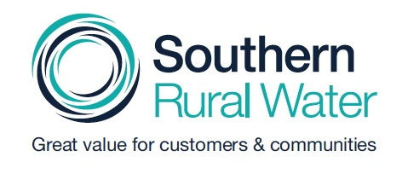

By

Bartley Consulting Pty Ltd
02 August 2022

© Bartley Consulting Pty Ltd, 2022
ABN 87 084 786 550 ACN 084 786 550
This document may only be used for the purpose for which it was commissioned and in accordance with the terms of engagement for the commission. Unauthorised use of this document in any form whatsoever is prohibited.

Bartley Consulting Pty Ltd
PO Box 2105
Hawthorn Vic 3122

www.bartley.com.au

Document Details
Title
02 August 2022 | Engagement Report SRW PS2023 (FINAL).docx
Prepared by Helen Bartley, Gillian Hayman and Carolyn Stanford

Distribution
Status | Issued to | Organisation | Date | Format
FINAL | Penny Winbanks | Southern Rural Water | 02 August 2022 | PDF by email

Contents
Glossary 133
1 Executive summary 134
2 Background 135
2.1 Context 135
2.2 SRW’s key stakeholders 136
2.3 Price Submission 2023 136
2.4 Overarching purpose 137
3 Engagement framework and plan 138
3.1 SRW’s engagement framework 138
3.2 Engagement plan 139
3.3 Building on PS2018 140
4 Informing and consulting via an Engagement Hub 142
4.1 Context 142
4.2 Engagement Hub purpose 143
4.3 Choice of engagement platform 143
4.4 Information contained on the Engagement Hub 143
4.5 Customer and stakeholder interaction with the Engagement Hub 144
5 Informing: PS2023 communications 145
5.1 Fact sheets 145
5.2 Frequently Asked Questions (FAQs) 146
5.3 Social media posts 147
5.4 Blogs 147
5.5 Videos 147
5.6 Other communications 148
6 Survey consultations with customers and the wider community 149
6.1 Phase 1 customer and community survey 149
6.1.1 Survey purpose and objectives 149
6.1.2 Survey overview 149
6.1.3 SRW’s efforts to engage 149
6.1.4 Survey response 150
6.1.5 Survey findings 150
6.1.6 How did SRW use the survey outcomes? 151
6.2 Phase 3 customer survey 151
6.2.1 Survey purpose 151
6.2.2 Survey overview 151
6.2.3 SRW’s efforts to engage 152
6.2.4 Survey response 152
6.2.5 Survey findings 152
6.2.6 How did SRW use the survey outcomes? 153
7 Involving customers through the CRG 155
7.1 CRG purpose 155
7.2 Recruitment 155
7.3 CRG membership and representation 156
7.4 CRG meetings 157
7.4.1 Overview 157
7.5 How did SRW use CRG feedback? 157
7.6 CRG members’ feedback on their role 158
8 Other engagement activities 159
9 Summarising SRW’s phased approach 160
9.1 Phase 1: Informing and listening 160
9.1.1 Purpose 160
9.1.2 Overview of Phase 1 engagement activities 161
9.2 Phase 2: Price-service design 161
9.2.1 Overarching purpose 161
9.2.2 CRG Workshop 3 161
9.2.3 CCC and SGRF and other stakeholder engagement 162
9.2.4 Engagement Hub 162
9.2.5 Communication materials 162
9.3 Phase 3: Testing and prioritising 162
9.3.1 Purpose 162
9.3.2 Overview of Phase 3 engagement activities 162
9.4 Phase 4: Reporting back 163
9.4.1 Purpose 163
9.4.2 Feedback to partners and stakeholders 163
9.4.3 CRG Workshop 5 163
10 Reflections 164
10.1 CRG feedback 164
10.1.1 Overall comments shared with the SRW team at the final meeting 164
10.1.2 Overall comments shared with the SRW team at the final meeting 164
10.2 Feedback from SRW 167
10.3 Feedback from BC Team 169
Appendix A: PREMO framework 173
Appendix B: PS2023 engagement principles 174
Appendix C: Engagement Hub FAQs 175

Glossary
Short form | Long form
BC Team | Bartley Consulting Team (including Bartley Consulting, Stanford Marketing and Gillian Hayman Facilitation and Project Services)
CCC | Customer Consultative Committee
CRG | Independently facilitated Customer Reference Group
DELWP | Department of Environment, Land, Water and Planning
ESC | Essential Services Commission
G&R | Groundwater and Rivers
IAP2 | International Association for Public Participation
MCCC | Macalister Customer Consultative Committee
PS2018 | Southern Rural Water Price Submission 2018-2023
PS2023 | Southern Rural Water Price Submission 2023-2028
RFCS | Rural Financial Counselling Service
SGRF | Southern Groundwater and Rivers Forum
SRW | Southern Rural Water
ToR | Terms of Reference (for the CRG)
VEWH | Victorian Environmental Water Holder
VFF | Victorian Farmers’ Federation
WBMCCC | Werribee Bacchus Marsh Customer Consultative Committee

Executive summary
Southern Rural Water (SRW) commenced its engagement planning for its Price Submission 2023 (PS2023) early in 2021. SRW’s aim was to build upon its Price Submission 2018 (PS2018) “leading” rating to achieve broader and deeper engagement. SRW set out to improve its engagement from its 2018 efforts by specifically involving customers in its decision-making and setting of priorities, consistent with Essential Services Commission current expectations.
SRW developed an approach for its PS2023 engagement based on four clearly defined engagement phases:
- Phase 1: Informing and listening (August 2021 to October 2021)
- Phase 2: Price-service design (November 2021 to January 2022)
- Phase 3: Testing and prioritising (February 2021 to May 2022)
- Phase 4: Reporting back (June 2022 to August 2022)
Despite the challenges presented by the COVID-19 pandemic, SRW provided numerous opportunities for customers and other stakeholders to contribute to its PS2023. It advertised its engagement activities widely through traditional and social media, text messages and emails as well as through its stakeholder networks and via word of mouth through its various customer and stakeholder networks. SRW directly engaged with more than 200 customers and other stakeholders through its Customer Reference Group (CRG) established specifically for its PS2023, its Customer Consultative Committees (CCCs) and Southern Rivers and Groundwater Forum (SGRF) and two PS2023-specific surveys. Additionally, it put considerable effort into keeping customers and stakeholders informed of its PS2023 activities which included establishing and maintaining a dedicated engagement space on the internet – the PS2023 Engagement Hub.
SRW engaged Bartley Consulting, in association with Stanford Marketing and Gillian Hayman Facilitation and Project Services (the BC Team), to provide expertise and support its PS2023 engagement. Specifically, the BC Team worked closely with SRW to gather evidence of customers’, stakeholders’ and partners’ service and pricing needs, expectations and preferences, having regard to the ESC’s PREMO Framework, to facilitate its CRG and develop its PS2023 communications. The BC Team was subsequently contracted to prepare this engagement report covering SRW engagement activities from August 2021 through until August 2022.
Additionally, this report includes an informal evaluation of SRW’s engagement from the perspectives of its CRG members, the SRW PS2023 team and the BC Team. Overall, SRW has demonstrated a strong commitment to genuine engagement with its customers, stakeholders and wider community and has listened to their feedback in developing its PS2023. This is despite the COVID-19 constraints and uncertainties, and wider challenges engaging with customers and the community attributed to general engagement fatigue, as well as limited interest in the cost of water relative to other financial pressures affecting customers. Compared with SRW’s PS2018 engagement, we consider that SRW has significantly improved its engagement particularly in its communications and efforts to consult and involve customers in decision-making and setting priorities.

Background

Context
Southern Rural Water (SRW) operates under the Victorian Government’s Department of Environment, Land, Water and Planning (DELWP). SRW is governed by a Board of Directors appointed by the Minister for Water.
SRW services 88,000 square kilometres, or 37% of Victoria from the South Australian border to the New South Wales border, and from the Great Dividing Range to the Victorian coast.
Figure 0-1 SRW’s region
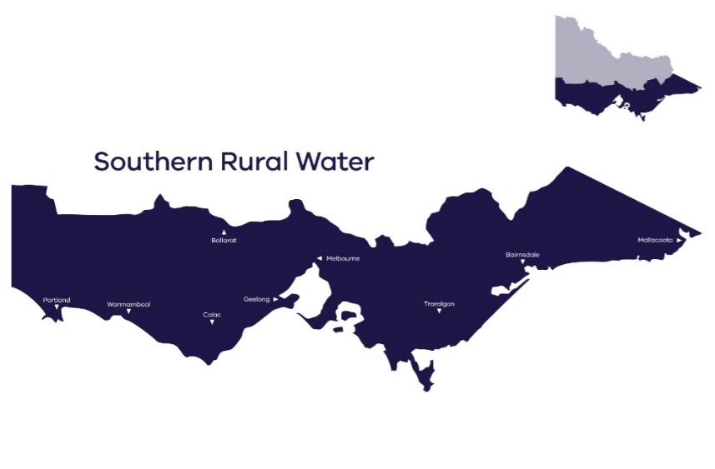
Within its region, SRW operates irrigation districts and manages ‘take and use’ licences from waterways, licences relating to catchment dams, farm dam registrations, seven major dams and eight diversion weirs. SRW manages Victoria's largest groundwater operation and second largest non-metropolitan headworks business.
SRW delivers and licences water primarily for use in food and fibre production, electricity generation and urban water consumption through urban water corporations which treat the water before supplying it to towns and cities. SRW services around 12,000 customers and is committed to ensuring it provides great value services to them, as indicated in its Corporate Vision Statement:
“Great value for customers and community through excellence in rural water management.”
To deliver this vision SRW aspires to provide:
“Customer value through outstanding services; community value to help [its] region thrive, and excellence in everything [it does] by empowering its people to deliver results.”
SRW’s Corporate Strategy further details these aspirations, and envisages it has succeeded in achieving its aspirations at a high level by:
- Providing outstanding service (Customer value)
- Contributing to thriving regional communities (Community value)
- Empowering its people to deliver results (Excellence)

SRW’s key stakeholders
SRW broadly defines its key stakeholders as:
- Partners and stakeholders, which include agricultural organisations, catchment management authorities, local government, state government departments and agencies, water corporations, the Victorian Environmental Water Holder and Traditional Owners.
- Customers, which includes all members of SRW’s broad customer base (who receive a bill from SRW), and customer representatives including CCC, SGRF and CRG members.
SRW’s customer numbers by district and according to their licence type are summarised in the following table.
Table 0-1: SRW approximate customer numbers
SRW Customer group | Number of customers
Macalister Irrigation Area | 1,140
Werribee Irrigation District | 244
Bacchus Marsh Irrigation District | 130
Groundwater licence holders | 4,334
Surface water licence holders | 4,290
Bulk entitlement holders | 9
TOTAL customers | 10,147

Price Submission 2023
SRW’s next pricing period is for 2023-2028. SRW is required to lodge its Price Submission (PS2023) with the Essential Services Commission (ESC) in September 2022. In May 2016 the ESC published a new Framework (the PREMO Framework) which places strong emphasis on customer engagement to inform water corporations’ Price Submissions. SRW applied the PREMO Framework to its 2018 to 2023 Price Submission (PS2018) and subsequently the ESC agreed with SRW’s overall self-rating of its application of the PREMO Framework as “Advanced”, and its engagement as “Leading”. The ESC noted:
“Informed by its engagement program, Southern Rural Water is proposing improvements in service outcomes. This includes in areas such as the consistency of irrigation flow rates, additional water availability, providing for real-time water usage information, and expanding online information and payment options for customers. This, along with generally flat or falling prices demonstrate Southern Rural Water’s commitment to delivering better value to customers, consistent with an ‘Advanced’ PREMO rating for Outcomes.”
SRW is aiming to engage more broadly than it achieved in for its PS2018. Hence SRW committed to early and open engagement with its customers, partners and stakeholders, and the community to inform its PS2023. To this end, SRW developed a draft Price Submission Engagement Framework, involving four phases as a starting point for its engagement activities.
In August 2021, SRW appointed Bartley Consulting in association with Stanford Marketing and Gillian Hayman Facilitation and Project Services (BC Team) to provide expert engagement, facilitation and communications services in relation to SRW’s Price Submission. The BC Team has worked with SRW over the last 12 months to plan and deliver SRW’s engagement activities and is now pleased to provide SRW with a report detailing the program of work over that period and the outcomes of SRW’s engagement activities.
SRW set out to improve its engagement from its 2018 efforts by specifically involving customers in its decision-making and setting of priorities, consistent with Essential Services Commission expectations.

Overarching purpose
Specifically, the Bartley Consulting team worked with SRW to gather evidence of customers’, stakeholders’ and partners’ service and pricing needs, expectations, and preferences, having regard to the ESC’s PREMO Framework.
In particular, SRW wanted to be appropriately resourced to improve the quality of its Price Submission, by involving customers in its decision-making and setting of priorities, consistent with the ESC expectations (compliance).

Engagement framework and plan

SRW’s engagement framework
Early in 2021, SRW prepared an engagement framework which the SRW Board supported. This framework (shown in Figure 3-1 below) forms the basis of SRW’s engagement activities, indicative timing (when SRW prepared the framework) and milestones.
Figure 0-2: SRW’s engagement framework
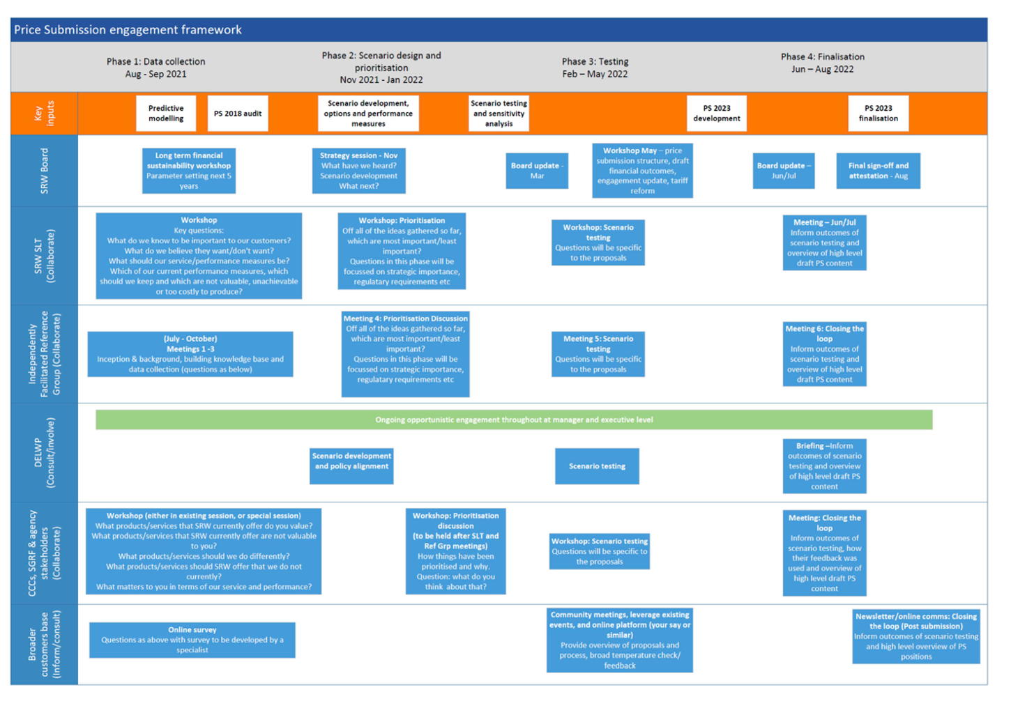
Importantly, SRW:
- Developed a structured and phased approach to its engagement, comprising four phases:
  - Informing customers and listening to stakeholders to identify their SRW needs and priorities
  - Developing price-service scenarios
  - Testing these price-service scenarios with customers to determine their preferences
  - Finalising price-service proposals and informing customers and stakeholders to close the loop
- Identified key stakeholder groups and its desired level of engagement with each group:
  - SRW Board - collaborate
  - SRW Senior Leadership Team (SLT) – collaborate
  - Independently facilitated CRG – collaborate
  - DEWLP – consult/involve
  - CCCs, SGRF and agency stakeholders – collaborate
  - Broader customer base – inform/consult
- Described broad engagement activities for each phase and stakeholder group and indicative timing.
This report focuses on SRW’s engagement with the Independently Facilitated Reference Group (subsequently renamed Customer Reference Group - CRG) and engagement with SRW’s broad customer base in line with our contract with SRW.

Engagement plan
The BC Team was responsible for preparing an engagement plan. SRW’s engagement framework formed the basis of the engagement plan. The detailed engagement plan remained an internal working document for SRW and was further developed and adapted to suit each Phase, particularly as the continually changing impacts of the COVID-19 pandemic and associated restrictions meant that initial plans for face-to-face engagement in 2021 had to be adapted to online methods.
Key elements of the engagement plan, beyond the stated purpose of engagement (see Section 1.3 of this report), that guided the delivery of SRW’s engagement activities were:
- Agreeing on some good practice engagement principles to guide SRW’s engagement activities and against which SRW could ultimately assess its engagement
- Defining and describing the elements of SRW’s PS2023 and engagement activities that customers and stakeholders could control (the negotiables), and the elements which were not negotiable
- The risks and risk-mitigation strategies
- Roles and responsibilities
- Planned communication and engagement activities for each Phase
A two-page engagement plan overview was produced and published on the SRW Engagement Hub and shared with stakeholders, including the CRG. A copy is shown below in Figure 3-2.
Figure 0-3: PS2023 engagement plan overview
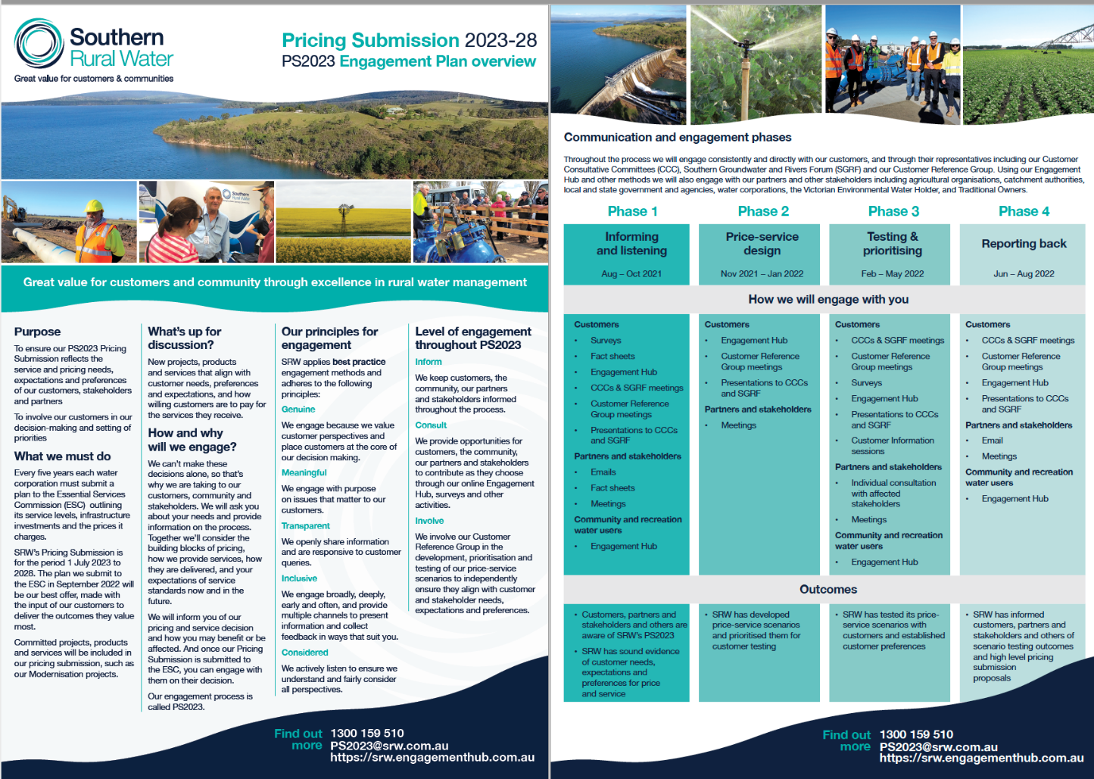

Building on PS2018
As illustrated in Figure 3-3, for PS2023 SRW has engaged more broadly and on a larger scale than it did for PS2018. SRW considered feedback from its PS2018 engagement detailed in the engagement report prepared by Currie Communications, and decided to broaden its engagement activities for PS2023 to reach a more diverse range of customers and stakeholders. The table below outlines the key difference between SRW’s PS2018 and PS2023 approaches.
Figure 0-4: Comparison between SRW’s PS2018 and PS2023 engagement activities
Group and engagement activity | PS2018 | PS2023
Ongoing strategic and tactical discussions with CCCs and SGRF outside of the direct PS engagement program | ü | ü
Ongoing informal discussions and relationships with customers via field staff and project groups etc | ü | ü
Biennial survey of customers (Customer Satisfaction Survey) to provide context | ü | ü
Customer and stakeholder representatives through a PS-specific CRG | N/A | ü
Customers, community and other stakeholders through a dedicated PS online Engagement Hub | N/A | ü
Consultation through specific customer and community surveys | - Small scale phone interviews to test price-service proposals (n= 6) | - Online survey open-to all customers and the community to understand customer values, expectations and challenges (n= 194)  - Online customer survey to test price-service proposals (n= 73)
Qualitative feedback from customers and community | - Three customer focus groups (n= 14): Bacchus Marsh (n=7), Sale (n=4) Warrnambool (n=3) | - Five “open-house” face-to face sessions across SRW’s region to test price-service proposals  (n= 20 customers)  - Two online focus sessions to test price-service proposals  (n= 4 customers)
Traditional Owners | N/A | - Newsletter from SRW Managing Director providing PS2023 contextual information and the basic process (n=6)  - A letter to inform of PS2023 was sent to groups (n= 6)  - An email invitation to participate in targeted discussions on PS2023 (n=6)  - Targeted discussion (n=1) to understand needs and values and test price-service proposals
Bulk entitlement holders | N/A | - Targeted discussions (n=9) to understand their needs and values and test price-service proposals
Other water corporations (as licence holders) | N/A | - Emails informing and inviting targeted discussions (n=7) to understand their needs and values and test price-service proposals
Vulnerable customer support service | N/A | - Independently conducted semi structured online interview (n=1) with the Rural Financial Counselling Service (RFCS in association with SGW customer engagement  - One CRG member is also an RFCS Board member

Informing and consulting via an Engagement Hub

Context
In establishing this engagement framework, SRW was keen to increase its customer engagement through the use of technology.
COVID-19 restrictions were in place for the early phases of engagement. This limited SRW’s opportunity to engage in person across the regions. Communicating through technology was important given these circumstances.
Whilst SRW had a number of existing engagement tools, such as its website and customer newsletters, a social media presence and contact details of individual customers, these different engagement tools serve different communication purposes. For example, SMS and email can be used for individualised messaging whereas social media and SRW’s website are platforms for more generic information dissemination about the Price Submission or directing interested people to an online engagement platform.
Throughout PS2023 SRW continued to leverage existing communication channels where possible. In addition, SRW was keen to invest in a trial of a dedicated online engagement platform to centralise its PS2023 activities.
The ‘Engagement Hub’ platform was chosen as the online tool to hold all the information related to PS2023. The platform was updated throughout the duration of the project. A screenshot of the Engagement Hub can be seen in Figure 4-1.
Figure 0-5: PS2023 Engagement Hub landing page, June 2022
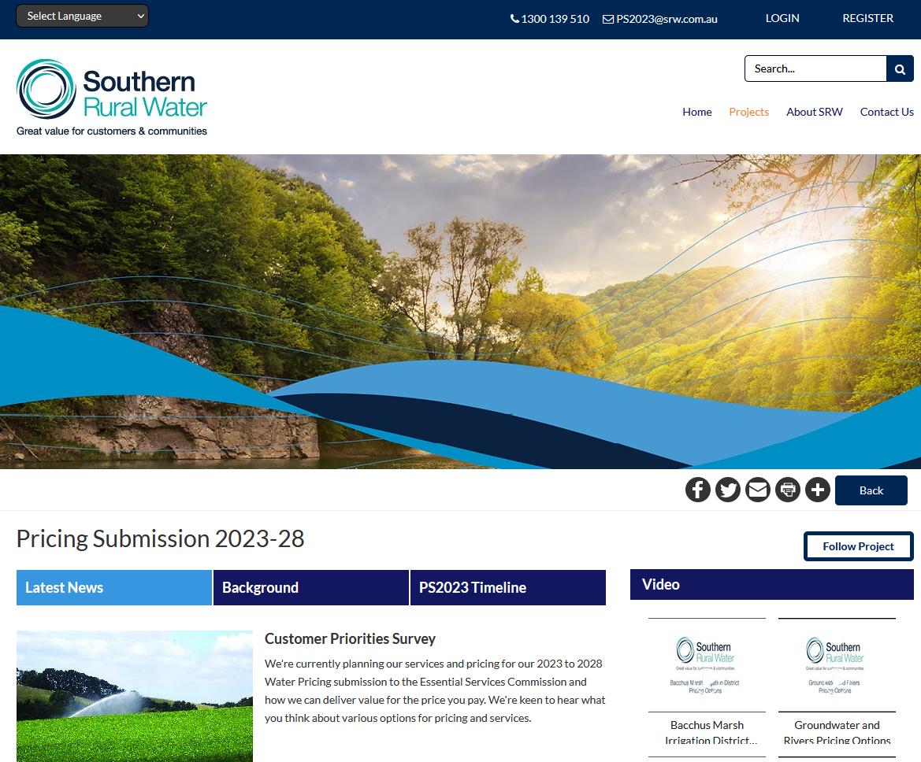

Engagement Hub purpose
The purpose of the Engagement Hub was to provide customers, community, partners and stakeholders with a portal to centralise public facing information and facilitate engagement activities related to PS2023. The Engagement Hub is a toolbox for managing stakeholder engagement and engagement materials. It also allows stakeholders to participate at a level that suits them, ranging from it being a centralised information source through to a platform where stakeholders can register to participate in discussions and receive notifications of information updates and activities. Those who engage more informally without registering can still view content and vote on polls.
PS2023 provided SRW with an opportunity to trial the value of an online engagement platform, with a view that beyond PS2023 it could be used more broadly to engage on other matters.

Choice of engagement platform
The BC Team provided advice and recommendations for the engagement platform at the outset of the project. SRW decided on the Engagement Hub platform as it was simple to use and interact with and could be retained beyond the PS2023 project for future SRW engagement activities if it was established to be a successful tool for engaging with SRW customers.
The BC Team facilitated the contractual arrangements and implemented the engagement platform with SRW input, including training and ongoing administration.
The BC Team built the content on the Engagement Hub. It was also their role to monitor and maintain content on the engagement platform including adding and removing content.

Information contained on the Engagement Hub
The Engagement Hub was used to disseminate communication materials and live updates about activities and information throughout the PS2023 engagement period. Customers were encouraged to sign up to the Engagement Hub to follow SRW’s PS2023 activities as they progressed through the four phases.
Details of the content posted on the Engagement Hub were listed in Chapter 4. Additionally, the Engagement Hub was used to:
- Promote the Phase 1 and Phase 3 customer surveys (see Chapter 6)
- Provide customers and the community with news about SRW’s other engagement activities and events such as its open-house sessions
- Provide a booking and registration process for SRW’s open-house sessions
- Initiate online discussion, although attempts to encourage discussion among Engagement Hub users were unsuccessful
- House published documents (in addition to the communications materials mentioned in Chapter 4) that could be of interest to customers in relation to SRW’s PS2023
- Provide statistical information on PS2023 information dissemination and engagement

Customer and stakeholder interaction with the Engagement Hub
The following table details customer and stakeholder interaction with the Engagement Hub between 20 September 2021 when it was launched and the end of 19 July 2022. It is evident from these statistics that the Engagement Hub has potential as an information source, given the number of page views and the reasonable number of unique visitors. However, the statistics suggest that visitors are reluctant to register or engage further. The small number of registrations and engaged stakeholders is likely to be due to a combination of factors such as:
- Lack of interest in engaging further
- Lack of awareness or understanding of the purpose of registering
- Lack of familiarity and trust in such platforms
- Lack of digital skills
- General engagement fatigue as noted elsewhere in this report
Table 0-2: Engagement Hub interaction measures
Measure | Meaning | Number
Total page views | The number of pages viewed by users within the PS2023 Engagement Hub “project” | 4,919 views
Total unique visitors in portal | The number of visitors who visited the PS2023 Engagement Bub (excluding project administrator visits) | 1,302 customers/  stakeholders
Total aware stakeholders | Registered users who viewed content in the PS2023 project but had not taken any action on the Engagement Hub platform | 70 customers/  stakeholders
Total informed stakeholders | Visitors (unregistered users) and registered users who have been active on the hub including viewing/downloading a document, watching a video, reading FAQs or latest news items | 75 customers/  stakeholders
Total engaged stakeholders | The number of unique registered users who have actively participated in Engagement Hub activities including completing a survey or quick poll, registered for an event, made a comment or reply on interactive mapping, interactive image, ideas wall, extended ideas wall, or a forum | 9 customers/  stakeholders

Informing: PS2023 communications
In preparing its Engagement Framework and Request for Proposal for its PS2023 engagement SRW identified some requirements for communications collateral as follows:
- Generally informing customers about PS2023 (informing)
- Informing customers about specific PS2023 proposals (informing)
- Informing customers about SRW’s engagement activities (informing)
- Seeking customer reactions to proposals, values and their desired outcomes (consulting and involving)
- Facilitating specific engagement activities (e.g. agenda, posters and interactive presentations for real or virtual “open house” engagement activities)
In particular, collateral was required for diverse audiences from customers and other stakeholders to staff and the Board. The BC Team worked closely with SRW to develop visually engaging and easily understandable communications materials customised for different audiences and purposes for each engagement phase and activity.
As previously mentioned, the BC Team facilitated the establishment of the Engagement Hub for SRW to house and share PS2023 information (see Section 4).
The various forms of communications materials produced for and by SRW are listed below and on the following pages.

Fact sheets
The BC Team worked closely with SRW throughout all Phases to produce Fact Sheets aimed at informing customers, the community and other stakeholders on various aspects of SRW’s PS2023 as detailed in Table 5-1.
In general, SRW and/or the BC Team would identify the need for a Fact Sheet. SRW would provide the initial content which the BC Team would review with a “customer-friendly lens”, design and layout in a visually appealing format, and produce the final versions for SRW.
Table 0-3: PS2023 fact sheets
When published | Fact Sheet Title | Brief description | Distribution
Phase 1 | Price Submission 2023-28 | One page fact sheet with timeline for each phase and a brief description of a Price Submission and SRW’s engagement plans | - Engagement Hub  - CRG
Phase 1 | Price Submission 2023-28 | One page fact sheet with timeline for each phase and a brief description of a Price Submission and SRW’s engagement plans, a brief description of the Phase 1 customer survey and a QR code with a survey link | - Engagement Hub  - Customer Bills  - CRG
Phase 1 | PS2023 Engagement Plan overview | Two-page overview of SRW’s Engagement Plan describing SRW’s engagement activities by Phase | - Engagement Hub
Phase 2 | Customer and Community Survey | Two-page overview of the Phase 1 Customer and Community Survey and results | - Engagement Hub
Phase 3 | Building the price proposals | Three pages describing how SRW calculates its pricing proposals based on operating and capital expenditure costs | - Engagement Hub  - Hard copies available at Open House Sessions
Phase 3 | Proposed Customer Outcomes | One page describing SRW’s proposed Customer Outcomes and how they were developed from customer views via SRW’s CCCs, SGRF and CRG, surveys and meetings | - Engagement Hub
Phase 3 | BMID Pricing Options | Two pages providing an overview of proposed price increases and indicative bill impacts | - Engagement Hub  - Open-house session  - Excerpts were included in presentation to the CRG, CCCs and SGRF
Phase 3 | MIA Pricing Options | Two pages providing an overview of proposed price increases and indicative bill impacts | - Engagement Hub  - Open-house session  - Excerpts were included in presentation to the CRG, CCCs and SGRF
Phase 3 | WID Pricing Options | Two pages providing an overview of proposed price increases and indicative bill impacts | - Engagement Hub  - Open-house session  - Excerpts were included in presentation to the CRG, CCCs and SGRF
Phase 3 | G&R Pricing Options | Two pages providing an overview of proposed price increases and indicative bill impacts | - Engagement Hub  - Open-house session  - Excerpts were included in presentation to the CRG, CCCs and SGRF
Phase 4 | Closing the loop: Price Submission 2023-2028 | A 13-page document summarising SRW’s engagement, what it heard from customers and its proposed price-service outcomes | - Engagement Hub  - Stakeholders including CRG, CCCs and SGRF

Frequently Asked Questions (FAQs)
SRW and the BC Team identified questions that customers were likely to ask, based on FAQs on SRW’s website, awareness of issues commonly raised by customers directly or through SRW’s CCCs, SGRF and social media and a review of FAQs on other water corporations’ websites. SRW provided content to respond to the questions and the BC Team reviewed and collated them and added them to the Engagement Hub. FAQs covered the following:
- General questions
- Current price submission
- How prices are set
- What happened last time?
- Engagement questions
- What happens next
A full list is included in Appendix C.

Social media posts
SRW’s social media posts were managed by SRW, they are listed in Table 5-2 for completeness.
Table 0-4: SRW’s PS2023 social media posts
Phase | Date | Platform | Purpose
Phase 1 | 26 October 2021 | Facebook  Twitter | Promote the Phase 1 survey, and the Engagement Hub
Phase 1 | 4 November 2021 | Facebook | Announcement of SRW’s PS2023 with a link to the Engagement Hub
Phase 1 | 15 December 2021 | Facebook  Twitter | “Your opinion matters” to promote the Phase 1 survey, and the Engagement Hub
Phase 1 | 29 December 2021 | Facebook  Twitter | “Your opinion matters” to promote the Phase 1 survey, and the Engagement Hub
Phase 1-2 | 24 March 2022 | Facebook  Twitter | Communicating feedback from the Phase 1 survey and advertising next steps in SRW’s PS2023 process
Phase 3 | 10 May 2022 | Facebook  Twitter | Promotion of SRW’s face-to-face and online community engagement activities to test SRW’s price-service proposals
Phase 3 | 12 May 2022 | Facebook | Promotion of SRW’s face-to-face and online community engagement activities to test SRW’s price-service proposals
Phase 3 | 16 May 2022 | Facebook | Announcing SRW’s customer consultation session in Bacchus Marsh

Blogs
At key stages throughout SRW’s PS2023, SRW produced a blog which it posted on the Engagement Hub’s “Latest News” section which would trigger an email to registered customers to keep them informed of SRW’s activities. SRW produced and posted the following blogs.
Table 0-5: SRW’s PS2023 Engagement Hub “Latest News” posts
Phase | Date posted | Purpose
Phase 1 | 20 September 2021 | Promote PS2023 (and launch of the Engagement Hub)
Phase 1 | 8 October 2021 | Promote the Phase 1 survey
Phase 1 | 02 March 2022 | Inform completion of Phase 1 consultation
Phase 1-2 | 25 March 2022 | Inform Phase 1 survey results
Phase 3 | 06 May 2022 | Promote pricing proposal fact sheets
Phase 3 | 16 May 2022 | Promote Phase 2 survey

Videos
To support SRW’s Phase 3 engagement, Stanford Marketing (in a separate consultancy for SRW) produced four five-minute YouTube videos introduced by the SRW Managing Director and describing SRW’s pricing options with one video for each irrigation district (BMID, MIA and WID) and Groundwater and Rivers (G&R) customers.
The videos were fully narrated with a voiceover describing the pricing options for each district, to support engagement with stakeholders with low literacy and/or vision.
The videos were available on the Engagement Hub and were used at the open house sessions to provide customers with broad introductory information and an overview of the pricing proposals if customers preferred to watch and listen, rather than read.

Other communications
Additionally, SRW used the following communication channels to inform customers of its PS2023 engagement activities:
- Notices on the front page of its website (e.g., to promote the Phase 1 survey)
- SRW e-newsletter
- Information included with the October 2021 customer bill
- Word of mouth through SRW customer service and field staff
- Word of mouth to customers through CCC and SGRF members
- Use of communication channels managed by others. For example, notification of surveys on Agriculture Victoria’s weekly e-newsletter and dairy industry publications and e-newsletters

Survey consultations with customers and the wider community
Apart from SRW’s business as usual customer consultation and engagement activities, SRW’s specific PS2023 customer consultation activities occurred during Phases 1 and 3. An overview of these surveys is included in this section, while a more detailed description of the surveys and their findings were separately reported to SRW and the wider community through information sheets.

Phase 1 customer and community survey

Survey purpose and objectives
The first survey was carried out for SRW to better understand the plans and long-term water needs of customers and the community to help it determine the most appropriate mix of services and prices that will deliver value for customers, the community, partners and stakeholders.
Building on the overarching purpose, the survey objectives were to:
- Profile SRW customers’ current activities and long-term plans to contextualise their current and future needs and expectations of SRW
- Understand customer and community current and longer-term needs and expectations of SRW to help identify SRW service offerings and priorities
- Establish customer awareness, and value derived from PS2018 initiatives given some of these are ongoing and may need to be reprioritised
- Establish customer and community interest in being kept informed about SRW’s Price Submission and the extent they wish to engage (e.g., receive information, access an online communications platform, participate in further research)

Survey overview
All SRW customers and community members were eligible to participate in the survey.
To work within its budget constraints and reach as broad and audience as possible, SRW opted for an online survey.
The online survey was initially open from 12 October 2021 to the end of November 2021, then due to the low response was extended to 4 January 2022.
Bartley Consulting managed the survey design, analysis and reporting of results for SRW, while SRW was responsible for the survey promotion.

SRW’s efforts to engage
SRW used multiple methods to promote the survey to customers over the three months that the survey was open, and these methods are listed below. It is reasonable to conclude that all customers would have been made aware of the survey via one or more of the methods adopted by SRW to encourage customers to participate in the survey.
SRW used the following methods to promote the survey
- An SMS invitation containing a link to the survey
- An email invitation to customers whose email address was registered with SRW
- Direct communication through SRW’s CCCs and its SGRF, its CRG, encouraging them to promote the survey among their networks, such as dairy industry newsletters and statewide agricultural newsletters, to reach as broad an audience as possible
- SRW’s PS2023 Engagement Hub, and website
- Ongoing social media promotions (Facebook and Twitter)
- A link to the survey in SRW’s annual customer bill that reaches all customers (October 2021) round of customer bills
- A QR code embedded in a mini poster at regional field days where SRW had a presence
Approximately 75% of SRW’s customers have provided SRW with an email address and/or a mobile phone number. All customers would have received a bill for water in October 2021.

Survey response
Over the survey period 194 customers and wider community members responded to the survey. It took them an average of around eight minutes to complete.
- 118 customers and wider community members completed the survey in full, including 107 customers and 11 wider community members (64% of those who commenced the survey)
Whilst the survey response is low relative to SRW’s customer numbers, as mentioned above SRW put considerable effort into informing customers of its PS2023 and opportunities for customers to engage, including promoting the survey.
Whilst engagement fatigue may have contributed to the low response rate, it is reasonable to assume that most customers who wanted to contribute, or had strong views had a reasonable opportunity to do so via the survey.

Survey findings
The key findings from this survey are as follows:
- Water is important for SRW customers’ livelihood, especially among irrigation district customers
- Most customers (>90%) expect to still be operating their properties in five years
  - With most anticipating they will need the same volume of water or more water in the next five years (36% anticipating greater water needs)
- Access to water is a key challenge for SRW customers, coupled with climate change, profitability and affordability of water
- Most have been significantly affected by climate factors such as drought, as well as labour shortages
- While significant proportions of customers commend SRW for its communication, service provision and customer service others indicate SRW needs to reduce costs to customers and better manage their water supply and access
- Key customer priorities are ensuring fair and reasonable prices and charges for services as well as access to water:
  - The focus for irrigation district customers is for SRW to ensure fair and reasonable prices
  - The focus for other customers is having a highly reliable water supply
The relatively low response to this survey also highlighted challenges for SRW engaging with customers to ensure their needs and preferences were appropriately considered in PS2023, and the need to combine the findings from this survey with other evidence of customer and community preferences.

How did SRW use the survey outcomes?
Survey findings were reported through a two-page information sheet, shown in Figure 6-1. This document was available to customers through the Engagement Hub and directly shared with the CCCs, SGRF and the CRG. Survey findings were shared with the CRG to help the group understand the diversity of SRW’s customers, their needs and values and to use these insights to inform their own views when considering SRW’s pricing pathways against customer values. SRW also directly used the survey feedback to help refine its understanding of customer values and develop initial price-service options.
Figure 0-6: PS2023 Customer & Community Survey summary of findings
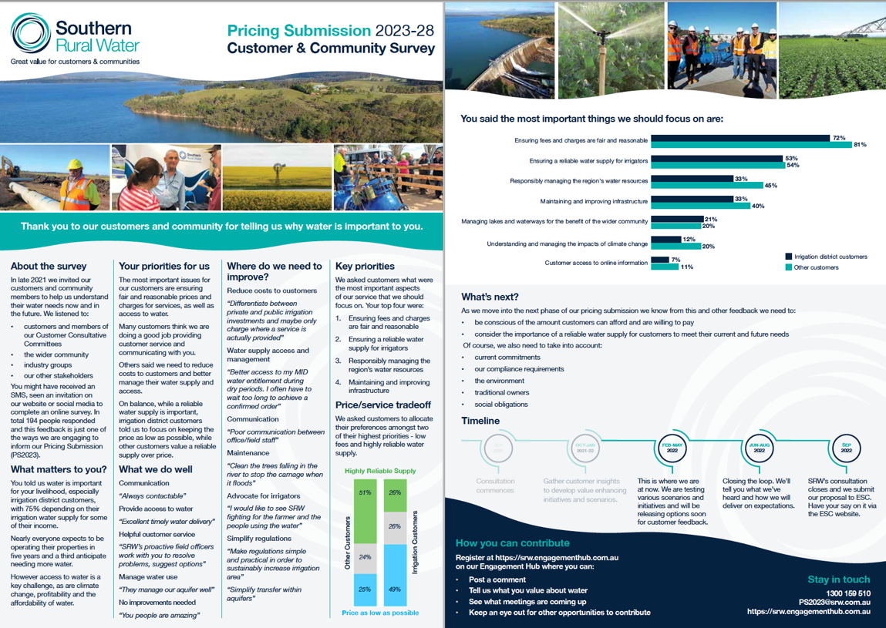

Phase 3 customer survey

Survey purpose
The Phase 3 survey focused on testing customers’ preferences and priorities in relation to SRW’s draft price proposals and service outcomes. The scenarios were developed from Phase 1 customer feedback and Phase 2 initial testing with SRW’s CRG, its CCC and SGRF members.
The survey objectives were to:
- Test customers’ support or otherwise for SRW’s proposed price increases (baseline or other options) according to their water source, i.e.:
  - Separately testing BMID, MIA, WID and G&R customers preferences
- Establish the importance of SRW’s proposed core price/service outcomes with customers; and identify the areas SRW should focus on in line with each proposed outcome.

Survey overview
This survey was aimed at SRW customers only. All customers were eligible to participate in the survey.
As with the Phase 1 survey, to work within its budget constraints, SRW opted for an online survey. An online survey also made sense as a means of gathering customer feedback in conjunction with SRW’s face-to-face and online consultation sessions.
The online survey was open from 12 May 2022 to 31 May 2022 inclusive.
Bartley Consulting managed the survey design, analysis and reporting of results for SRW, while SRW was responsible for the survey promotion.

SRW’s efforts to engage
As with the survey conducted in Phase 1 of PS2023, SRW used a range of methods to maximise the opportunity for customers to provide feedback, including:
- Direct SMS invitations to all customers with a mobile number and/or an email address registered with SRW to participate in the survey (i.e., approximately 75% of SRW’s customers)
- Its various Price Submission face-to-face and online consultation sessions
- Through a QR code and survey link on its customer Engagement Hub
- Promotion to customers through CRG, CCC, and SGRF members
- Promotion through both unpaid and paid targeted social media posts and traditional media
To ensure customers had sufficient information to provide considered feedback, SRW with assistance from the BC Team produced fact sheets and videos explaining its price service proposals in detail for each district and G&R customers. The fact sheets and videos were uploaded onto SRW’s Engagement Hub and links to the fact sheets were embedded in the questionnaire.

Survey response
Despite SRW’s considerable effort to engage customers during this phase, the response rate was low. Over the survey period, 132 individuals clicked on the survey link and the following irrigation and G&R customers provided feedback on SRW’s pricing options:
- 5 BMID customers
- 27 MIA customers
- 8 WID customers
- 53 G&R customers (including 31 who are also district customers)
Among the above customers, 73 customers provided top-line feedback on SRW’s proposed core price/service outcomes – and among this group of 73 customers, 42 provided more detailed feedback.

Survey findings
The key findings from the Phase 3 survey are as follows.
Table 0-6: Summary of customers’ pricing-service preferences by customer group
Customer group | On balance preferences
BMID (n=5) | - SRW to reduce the proposed increase to CPI only  - Little support for SRW price rises to pay for further service improvements in the district
MID (n=27) | - SRW to aim for an average 1.3% per annum increase +CPI (based on options A, B and C combined)  - No preference for paying more to ensure ongoing operations and maintenance of the salinity mitigation program (50%/50% each way) (n=24)  - Do not support SRW applying differential pricing whereby customers with modernised assets pay a premium for the benefits they receive (n=24)
WID (n=8) | - SRW to aim for the proposed baseline average 1.5% per annum increase +CPI  - Support SRW combining the operation of river water and recycled water in the district  - Do not support paying more for improved drainage
G&R (n=53) | - Divided support for SRW’s proposal to maintain current service levels, resulting in a CPI only increase (with many customers wanting no increase as per comments)  - Do not support higher application fees for complex applications

How did SRW use the survey outcomes?
The outcomes from the Phase 3 survey, with CRG and other stakeholder feedback helped SRW finalise its pricing proposal ensuring its price-service proposals were consistent with customer needs and values. SRW produced a table summarising its proposals, customer feedback and responses, which we have adapted and included below as Table 6-2. This table demonstrates the link between SRW’s engagement and its proposals.
For added transparency, SRW shared this feedback with the CRG in the final workshop.
Table 0-7: Summary of customers’ pricing-service preferences by customer group
SRW asked customers if they supported… | Customers response | SRW is proposing …
G&R price increases of:  CPI only | Responses varied, with some customers seeking price reductions or just a CPI increase | SRW needs greater investment in compliance which can (in part) be offset by productivity savings, resulting in proposed price increases of CPI only per annum
BMID price increases of:  0.0% – 0.2% + CPI pa | General opposition to any price increase | SRW needs to fund past CAPEX which can (in part) be offset by productivity savings, resulting in proposed price increases of CPI only per annum.
WID price increases of:  0.3 to 1.7% + CPI pa. | Strong support for options with a 1.0% to 1.3% price increase, although it is acknowledged that some did not support any increase. | SRW needs to fund past and future modernisation CAPEX which can (in part) be offset by productivity savings, resulting in proposed price increases of 1.0% + CPI per annum.
MID price increases of:  1.3 – 3.1% + CPI pa. | Majority support for minimal price increases, but with notable (40% of survey respondents) support for increases over 2%. | SRW needs to fund past and future modernisation CAPEX which can (in part) be offset by productivity savings, resulting in proposed price increases of 1.5% + CPI per annum.
Latrobe BE price increases of:  1.5% (approx.) + CPI pa | General support, knowing the increase is primarily to fund dam safety works. | SRW needs to fund CAPEX but will consult in accordance with the BE instrument, expecting price increases of around 1.5% + CPI per annum.
Werribee and Maribyrnong BE price increases of 1.9% (approx.) + CPI pa | General support, knowing the increase is primarily to fund dam safety works. | SRW needs to fund CAPEX but will consult in accordance with the BE instrument, expecting price increases of around 1.9% + CPI per annum.

In relation to tariffs:
Table 0-8: Summary of customer preferences and SRW’s tariff responses
SRW asked customers if they supported… | Customer response | SRW is proposing …
Greater investment in MID salinity program | Similar numbers favour/oppose greater investment in the salinity program across all engagement platforms | SRW’s proposal seeks to find the middle ground so it will continue to operate the program, but aim for greater efficiency
Differential pricing where customers paid more for larger outlets | Mostly opposed to differential pricing | SRW believes the customer response may change as modernisation progresses  SRW will maintain a uniform outlet price but explore differential pricing options for PS28
Combine recycled and river water to a ‘single product’ | Through the surveys 75% supported merging the products. WBMCCC and individuals in attendance at open houses also supported this proposal | SRW will pursue managing recycled and river water as a single product
Greater investment in WID drainage | Most opposed paying more for drainage services despite a request for improved drainage | SRW’s proposal seeks to find the middle ground so it will continue to maintain drains within existing budgets but for greater efficiency opportunities and partnerships with Melbourne Water, Councils, etc.
Higher application fees for more complex applications | Survey results suggested a slight majority oppose high fees for more complex applications, however deeper discussions with the CRG and SGRF members suggested a greater level of support | SRW identified a cost/revenue discrepancy in its applications business. It is proposing a different tariff mechanism to recover costs, and will monitor the cost of complex applications for consideration in its next Price Submission

Involving customers through the CRG

CRG purpose
A key part of SRW’s engagement framework included the establishment of an independently facilitated Customer Reference Group. The aim of this group was to:
“… build a deeper relationship and understanding with a representative group of customers through the process”
Importantly, the CRG was formed to allow for direct and deep engagement with a small number of customers. The group was committed to attending and worked well together, providing honest and direct feedback. This feedback was valued by SRW which took on board comments and suggestions made by the CRG to shape the PS2023 process and outcomes.
In September 2021 SRW, with input from the BC Team, prepared Terms of Reference (ToR) for the CRG, which further articulated the group’s purpose as follows:
• To increase customer knowledge, insight and transparency into SRW’s Price Submission process; and
• To ensure SRW’s Price Submission decisions directly reflect well-considered customer views
In establishing the CRG, SRW was seeking support from a customer representative group to help:
- Identify, discuss and prioritise initiatives to support customer value
- Critically assess the benefits to customers of its proposals
- Learn from members’ experiences about the value of water to those customers they represent
Through engagement with the CRG, SRW was aiming to:
- Ensure its Price Submission is supported by informed, considered, balanced ideas and feedback
- Ensure customer outcomes presented in the final Price Submission reflect customer sentiment
- Have a deeper understanding of what its customers value and where SRW can add value
- Instil transparent price submission processes and decisions
- Establish an informed base of ‘thought leaders’ to help with its price submission

Recruitment
SRW recruited customers to join the CRG in October 2021.
As outlined in the ToR SRW sought a “representative group of customers”, who could provide “well-considered” customer views. To achieve a representative customer group SRW was keen to ensure as much diversity as possible among members in the group with respect to their:
- Enterprise type (irrigator, stock and domestic user, environmental water interests)
- Water source (irrigation water, groundwater and rivers)
- Location across SRW’s region (including representation from SRW’s three irrigation districts and G&R customers)
- Demographics (age, gender, life-stage)
- Formal and informal affiliations with different water user groups, and ability to draw on these affiliations to provide a broader perspective as a CRG member
To achieve such diversity SRW aimed to recruit a group of up to sixteen customers and customer representatives including eight to ten customers. A group this size would remain sufficiently large to provide a range of perspectives if some members were not able to attend all meetings, but small enough to allow for constructive discussion, as a whole or in subgroups during meetings.
SRW initially identified potential members with the assistance of its regional field staff who were asked to nominate customers they considered would be interested, and able to provide useful, productive feedback. This process generated a list of twenty-eight potential customers. From this list SRW selected an initial sample of around eight to ten customers representing the diversity described above.
SRW contacted this group by phone seeking their expression of interest. They were then emailed a PS2023 Fact Sheet (see Section 5-1) and a draft version of the ToR to provide clarity about the role and commitment required. As not all members of the originally selected group accepted the invitation after considering the materials, SRW team members then worked through the list to achieve the required number and diversity of customers.
Additionally, SRW invited the following customer representative groups to nominate a representative to join the CRG to strengthen their engagement on SRW’s PS2023.
- Bacchus Marsh, Macalister and Werribee CCCs
- SGRF
- Victorian Farmers Federation
- Gippsland Food and Fibre
- Food and Fibre Great South Coast
- Rural Financial Counselling Services, Gippsland and Western Victoria
SRW noted it would separately engage with stakeholders such as government agencies, vulnerable customers, other water corporations, local government and Traditional Owners.

CRG membership and representation
Ultimately, the CRG comprised the following eight representatives:
Table 0-9: CRG membership
CRG member | Region | Affiliations | Interests
Raelene Hanratty | Gippsland | MCCC Chair, RFCS – Gippsland, Board member and Deputy Chair | Dairy, MIA
Erin Peelman | Werribee | WBM CCC Chair | Horticulture, WID
Ross Ingram | East Gippsland | SGRF Chair | Vegetable grower
Chris Schreurs | South Gippsland | Grower | Vegetables
John Said | Werribee | Vegetable producer and industry representative | Horticulture
Peter Delahunty | SW Victoria | Dairy farmer, VFF Water Council | Vegetables
Keith Chambers | Statewide | Victorian Environmental Water Holder | Environmental
Basil Ryan | SW Victoria | Water Committee Chair, Food & Fibre Great South Coast | Industry association

Notwithstanding Raelene Hanratty’s role as an RFCS board member, SRW also approached the RFCS directly to provide a voice to customers who may be experiencing financial hardship. However, the RFCS advised it did not have sufficient resources to commit a staff member to a role on the CRG.

CRG meetings

Overview
The agendas were developed with specific tasks in mind and the level of engagement was clearly defined. Each meeting was independently facilitated by a BC Team member. The CRG met on five occasions. All meetings ran to time and minutes were circulated in a timely manner.
Due to COVID-19 restrictions meetings were conducted online (Zoom platform) initially and continued this way due to the geographic spread of participants. If a CRG member was unable to attend, in some cases they offered a ‘proxy’.
Attendance at meetings varied between four and eight members attending each meeting. Apologies were noted and, in some cases, out of session discussions were conducted and fed into the meeting for consideration.
The following table summarises the purpose of each meeting (informing, consulting, involving) and includes a brief description of the key agenda items.
Table 0-10: CRG meetings for PS2023
Phase | Workshop | Informing | Consulting | Involving
1 | 1 | - Understand who is on the CRG  - CRG role & purpose, including Terms of Reference  - SRW PS2023 plans  - SRW PS2018 (what happened last time) | - CRG terms of reference  - SRW proposed PS2023 engagement approach  - Expectations of PS2023 engagement | - Not applicable for this Phase
1 | 2 | - Feedback on customer survey (to date)  - The "givens"/ "known-knowns” for PS2023 | - Explore what customers value about their SRW water supply and access, including the possibility of testing tariff options with customers more broadly | - Agreeing on elements of customer value  - Request to CRG to promote the survey amongst fellow customers
2 | 3 | - Present progress on pricing options | - Receive feedback on draft pricing options | - Input into how pricing options could be taken to customers for feedback
3 | 4 | - Present further progress on pricing options and the communication of these to customers  - Update proposed customer engagement plan | - Receive feedback on draft pricing options | - Input into broader customer engagement plan
4 | 5 | - Reporting on Phase 3 community consultation  - Delivery of pricing recommendations, performance measures and reasoning | - Receive feedback on the pricing recommendation  - Reflections on the CRG & PS2023 process | - Key messages were received as to how to communicate the PS2023 outcomes to the broader customer base

How did SRW use CRG feedback?
Feedback provided by the CRG was critical to SRW’s development of its price-service options, defining customer value and planning of broader customer engagement activities. The CRG had a vital role testing the way SRW’s proposals and related messages were communicated to the broader customer base. The clear and direct feedback provided from the CRG influenced communication materials and provided confidence for the project team to move into the next stages of development.
For example, CRG feedback directly resulted in changes to the way content was presented in SRW communications and the matters that SRW directly tested with its broader customer base.

CRG members’ feedback on their role
At the final meeting, the BC Team facilitated an in-camera discussion with CRG members to gather their feedback on the involvement in the CRG. Those who were not present at the final meeting were invited to feedback by email. All eight members provided feedback.
Specifically, we asked members:
- What has stood out over the time you have been involved with the CRG?
- Has anything not worked so well or frustrated you about the process?
- What were the key areas/parts of the Price Submission process that you feel you were able to influence?
- Would you recommend a similar consultative approach for SRW next time? What would you do differently?
- Would you be involved in such a process again? Why?
- Any other comments you would like to make about your involvement in the CRG?
The feedback from group members was constructive and will help to inform the method of engagement for future Price Submission processes. The key points were:
- CRG members valued the process and their involvement
- CRG members felt SRW genuinely listened to them
- They appreciated the group represented a diversity of SRW’s customers (geographically, water use etc.) and learnt about the issues faced in other SRW supply areas
However, they also agreed:
- The process was too long, while appreciating that SRW’s Price Submission was complex
- Limited input from Bacchus Marsh customers was particularly disappointing, despite efforts to engage with them
We have included more detailed feedback from the CRG in Chapter 10 of this report where we reflect on SRW’s PS2023 engagement overall.

Other engagement activities
To inform its PS2023, SRW undertook various other engagement activities outside the BC Team’s scope of work. These included:
- Managing Director briefings to SRW shareholders and DELWP
- Regular briefings to and feedback from SRW’s CCCs and SGRF
- Correspondence to Traditional Owner groups advising them of PS2023 and subsequent meetings with all Traditional Owner Groups in SRW’s region to obtain their feedback on PS2023
- Five face-to-face open-house sessions and two on-line sessions to inform customers and test price-service proposals with them
- Meetings with bulk water customers and licenced urban water corporations
- Regular updates and feedback sessions with the SRW Board, SRW’s Strategic Leadership Team and staff in general

Summarising SRW’s phased approach
As previously indicated, SRW’s overall engagement was divided into phases as illustrated in Figure 9-1. This phased approach was clearly defined and communicated to stakeholders to ensure that they understood the approach and timeframes associated with the project.
Figure 0-7: Overview of SRW’s communication and engagement phases
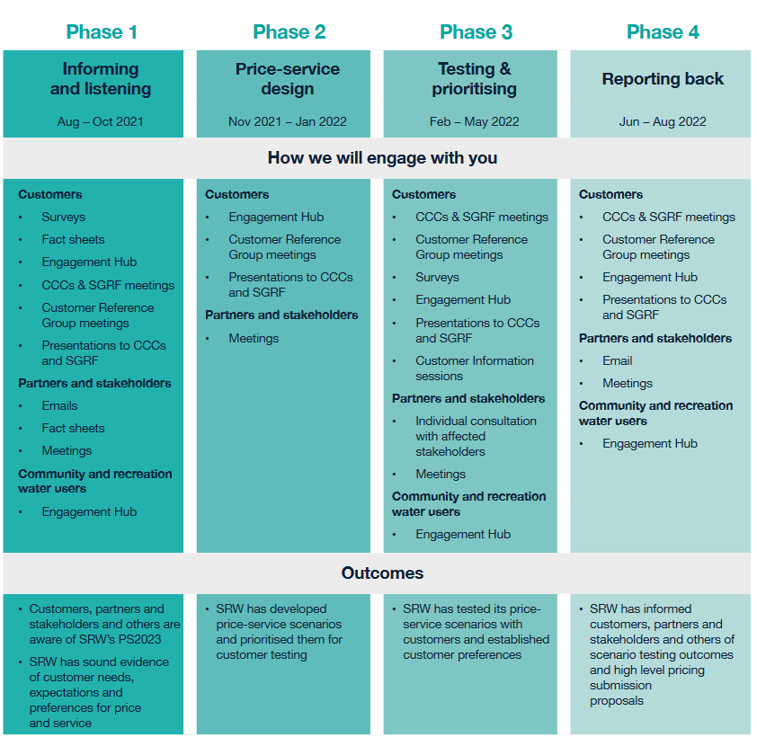

Phase 1: Informing and listening

Purpose
Consistent with SRW’s engagement framework the focus of SRW’s engagement activities during Phase 1 was twofold:
- To inform customers and stakeholders of SRW’s PS2023 purpose and processes and how customers can input into SRW’s PS2023
- To listen to customers and stakeholders to:
  - Understand customer and community needs and preferences to help determine the most appropriate mix of services and prices that will deliver value for customers, the community and stakeholders
  - Establish customer and community interest in being kept informed about SRW’s PS2023

Overview of Phase 1 engagement activities
The following table details SRW’s Phase 1 engagement activities, which were predominantly aimed at informing customers, the community and stakeholders, and consulting with them to understand their needs and preferences.
Table 0-11: Summary of SRW’s Phase 1 engagement activities
- Group | How SRW informed | How SRW listened
General customer base | Engagement Hub  Information Sheet | PS2023 survey (consult)  SRW Biennial Customer Satisfaction Survey (consult)
CCCs/SG&R Forum | Information Sheet | Meetings (consult and involve)
Independently facilitated CRG | Information sheet  Workshops (2) | Workshops (consult and involve)
Partners and stakeholders | SRW MD email  Information sheet  Workshops | Workshops (consult and involve)
Wider community | Collateral to inform target audience distributed via SRW’s social media  Use of targeted external partner newsletters | PS2023 Survey (consult)
SRW people | SRW’s usual internal communications methods  Meetings, presentations, workshops | Meetings, presentations, workshops (consult and involve)
SRW Board | Presentations to Board | Board workshops (empower)

Phase 2: Price-service design

Overarching purpose
This was predominantly an internal phase for SRW in which feedback was collated from the customer survey, CRG and other sources to develop price and service options. Initial testing was undertaken with the CRG, and to a lesser extent with CCCs to understand the broad acceptance of the options and explore ideas for Phase 3 engagement with SRW’s broader customer base.

CRG Workshop 3
Workshop 3 took place in February 2022 with eight members in attendance on Zoom. The group was supported by two SRW representatives and two BC Team members, a facilitator and note taker.
- To discuss and agree with the CRG (involve) SRW’s possible service outcomes
- To inform the CRG of SRW’s financial context
- To explore (involve) price/service options with the CRG
- To explain (inform) the elements of the price/service options that are “negotiables” with customers
- To consult with the CRG on suitable approaches for broader customer engagement on SRW’s pricing options
The CRG members had direct input into further clarifying the service outcomes. They noted seven key points to build into the core elements of SRW’s pricing pathways and discussed in detail the trade-offs within the pricing pathways. The CRG also contributed ideas on how to take this complex information to SRW’s wider customer base.

CCC and SGRF and other stakeholder engagement
SRW also obtained input from CCC and SGRF members during scheduled meetings. SRW provided CCC and SGRF members with updates on its Price Submission progress and sought their input as SRW developed its pricing pathways.

Engagement Hub
A Fact Sheet summarising the survey outcomes (Figure 6-1) was posted on the Engagement Hub to close the loop on Phase 1 as well as indicate priorities for the development of service outcomes and pricing pathways.

Communication materials
The post survey fact sheet (Figure 6-1) explaining the survey outcomes and the development of slide decks to explain the service outcomes and pricing pathways within the meetings described above were the key communications materials developed during Phase 2.

Phase 3: Testing and prioritising

Purpose
From Phase 2 feedback SRW developed pricing proposals and service outcome options. The purpose of Phase 3 engagement activities was to seek customer and stakeholder feedback on those proposals.

Overview of Phase 3 engagement activities
This was the most intense phase of engagement for PS2023. The following table outlines the groups targeted by SRW and how SRW informed them of its options and consulted with them /involved them to refine and finalise its price-service proposals.
Table 0-12: Summary of SRW’s Phase 3 engagement activities
- Group | How SRW informed | How SRW listened
General customer base | Engagement Hub  Information Sheets  Videos  Updated FAQs | PS2023 survey 2 (consult)  5 face to face open house sessions across SRW’s region plus 2 online sessions to inform and consult directly with customers on SRW’s pricing and service options (inform and consult)
CCCs and SGRF | Information sheets  Presentations | Meetings to review and refine pricing and service options (consult and involve)
Independently facilitated CRG | Information sheets  Workshop Presentations | Workshop to review and refine pricing and service options (consult and involve)
Partners and stakeholders | Information sheets  Direct discussions | Briefing to DELWP and the Minister for Water’s office
Wider community | Collateral to inform target audience distributed via SRW’s social media  Use of targeted external partner newsletters | N/A
Traditional Owner groups | Letters to inform of PS2023 was sent to six groups | Discussion with GlaWAC to understand needs and values and test price-service proposals
Bulk entitlement holders | Information sheets | Targeted discussions to understand needs and values and test price-service proposals
Other water corporations | Information sheets | Targeted discussions to understand needs and values and test price-service proposals
SRW people | SRW’s internal communications methods  Meetings, presentations, workshops (consult and involve) | Meetings, presentations, workshops (consult and involve)
SRW Board | Presentations to Board to input into and approve pricing and service pathways | Board workshops (empower)

Phase 4: Reporting back

Purpose
Phase 4 focused on informing customers, partners, stakeholders and others of the outcomes from the testing of pricing and service pathways and aimed to demonstrate how their input shaped SRW’s Price Submission.

Feedback to partners and stakeholders
SRW provided DELWP and other key stakeholders with a summary of its proposed PS2023 and other agencies in late June 2022. This summary included:
- Headline annual price movements (excluding CPI).
- Typical average bills for 2023-28.
- Top ten major projects for the 2023-28 price period.
- Main findings from customer and community engagement.
- SRW’s proposed self-assessment PREMO rating.

CRG Workshop 5
At the final CRG meeting in July 2022 members were presented with a summary of SRW’s proposed PS2023 and provided feedback on this. Group members were also asked to comment on SRW’s draft ‘Closing the Loop: Price Submission 2023-28’ document which summarises customer and stakeholder feedback throughout the four phases of SRW’s PS2023 preparation, the outcomes from the engagement and SRW’s resulting commitments to customers. CRG members did not have any comments on the document.
Workshop 5 was also an opportunity for the SRW Managing Director to thank CRG members for their contribution and for members to reflect on their experience since the CRG first met in 2021.

Reflections
In Section 7.6 we reported on the CRG’s feedback on their role. In this Section we present more detailed feedback from CRG members, SRW and our own reflections.

CRG feedback

Overall comments shared with the SRW team at the final meeting
After the SRW Managing Director thanked CRG members, they used the opportunity to share their views with SRW. The following quotes [with emphasis added] illustrate the positive feedback from participants. Participants enjoyed the experience and recognised its value:
- “It was a worthwhile and positive exercise, doing it through COVID was interesting.”
- “The process was extremely professional.”
- “Everyone seems to have got some alignment, a great process and well done.”
- “It was great to do this by Zoom, we live hundreds of kilometres apart.”
Importantly, members clearly valued the opportunity to learn from each other and appreciate different customers’ issues across SRW’s region:
- “It was beneficial hearing what others in other regions are going through, it was fantastic and thank you for organising it.”
- “It has been interesting learning from other people in different districts and understand the pain barriers.”
- “You have done your best to engage as many as you could, we can’t say you didn’t try.”
- “It has been an interesting experience we are spread out and we are all different. It was great to have shared our thoughts with no backlash, in a “very safe space”– I’m probably going to miss.”
- “The discussions opened up different conversations we hadn’t thought about in our districts, that’s been beneficial – we have all been in the same loop – Great job guys.”

Overall comments shared with the SRW team at the final meeting
The last session in Meeting 5 was held in camera (i.e. SRW left the meeting so participants could provide candid feedback on their experience). Additionally, we emailed CRG members who were not able to attend the final session for their feedback. The feedback in this session summarises their feedback.
What has stood out over the time you have been involved with the CRG?
Table 0-13: Features of members’ involvement
Theme | CRG quotes
SRW was open to feedback | - The ease with which information has been given and our ability to give feedback, we were all given the opportunity to respond  - SRW were open to feedback and were genuinely interested in our feedback and hopefully that contributed to the outcome  - I was especially pleased with SRW interest in CRG members opinions and engagement, this has not always been the case
Clarity and ease of the process | - The overall effectiveness of the process  - The process clearly spelt from the beginning; the objective was clear about developing a reviewed pricing strategy  - The community CRG members were a very reasonable group – raised issues but also listened to SRW feedback. That contributed to a smooth CRG that was able to progress through the discussion  - It kept progressing. We didn’t get too bogged down or stuck on issues  - SRW information, facilitation etc was clear
Diversity of views | - It was good that we are all from different districts and do things differently we are now all on the same page, whatever the process was to recruit the group, it’s a big tick, we got there  - The diversity of irrigators from different parts of Victoria were able to put forward what they thought was important to them
Complexity of the Price Submission process | - I underestimated the complexity of it all given the different regions, different water and infrastructure
Reaching an outcome | - We understand you need to invest to keep a business viable – SRW is no different especially in high input areas (MID, BMID, WID)  - We have a price rise and we know how will it affect us
Method of engagement | - The facilitation/SRW’s methods of engagement is also a reason for that effective working relationship
Has anything not worked so well or frustrated you about the process?
Table 0-14: Issues with the process
Theme | CRG quotes
Lack of response from broader customer base | - Frustrating we didn’t get the responses (from the broader customer base) that we needed and deserved. We’ve given up our time to help the PS along for all customers and people haven’t responded when given the opportunity. I’m frustrated my community didn’t respond.  - Farmers are known for not doing surveys and we get bombarded with surveys and they get ignored unfortunately  - It is getting harder to engage with community at every level  - The CRG reps covered a big area with lots of differences, and I probably didn’t see how/when/if SRW engaged at the more local level, noting it seemed the broader customer engagement was challenging.
The process took a long time | - The process took a long time, bureaucracy. Government has to go through the consultations  - The process was a bit long – give us a list of the issues - less time on the background. First two meetings could have been swallowed into one  - Far too long - it didn’t need to be so long  - I was surprised that it took so long  - It seemed a little slow early, i.e. not much info the CRG was really inputting on at the first, maybe second(?) meeting I attended, but quickly got going into the detail. There is always a get up and going process though, so sometimes takes time.
Longer lead time required to engage with other customers in CRG members networks | - We needed more time to engage our industry groups and customers. The timing around Christmas to get the surveys out was tricky  - We want to engage people before we do the survey, it’s important to get industry groups on board and have us review the survey questions, at least give us a chance to get people responding
Online environment | - The zoom meetings I find difficult because there is less interaction and hence debate and scrutiny  NB: in overall comments the online meetings were noted as a strength

What were the key areas/parts of the price submission process that you feel you were able to influence?
Table 0-15: Areas of influence
Theme | CRG quotes
We influenced how information was presented to customers | - It was more about how you tell people than what you tell them  - The way they influenced the presentations – I didn’t understand the water droplets graphic, they changed those
The outcome was predetermined | - They had that predetermined to be honest
Maintaining field staff | - Field staff are important in groundwater areas, I hope I influenced that
Understanding each other’s requirements (SRW & customers) | - It’s a stuffed up [water] system but by understanding the system we can do some more work to help fix it

Would you recommend a similar consultative approach for SRW next time? What would you do differently?
Table 0-16: Considerations for future Price Submissions
Theme | CRG quotes
Yes, a streamlined version | - Yes but it was a contracted process, so shrink it  - I’m interested in the bottom line not the bureaucracy. I’m being selfish because I’m busy  - I do appreciate the process and it achieved what it set out to do
Engage earlier to prepare stakeholders | - Engage industry bodies earlier  - CCC chairs - engage us earlier to talk to committee members – to reduce the intro sessions, rather than brainstorming the problems, more consultation with the committee
Lack of engagement at Bacchus Marsh | - Did not do much for BM because they did not do the engagement – hard to know what to do  - Trust needed in BM
If it’s still relevant approach, things will change in 5 years | - Issues will change

Feedback from SRW
We asked the four SRW PS2023 people we worked with the following questions:
- What have been the strengths of your (SRW’s) approach?
- What would you do differently next time around?
- Have you achieved what you set out to achieve?
- Do you have any other feedback?
The key reflections we received are summarised in the following table:
Table 0-175: SRW’s reflections on its PS2022 engagement
Theme | Comments [emphasis added]
Strengths of approach | Leveraging others’ knowledge and collaborating  - “The collaborative approach with the BC team, this has allowed us to really challenge our proposed approach and adapt and change to achieve better, more customer focussed processes and outcomes”  - “Another strength is leveraging the knowledge of our field staff and those closest to customers in the heavy engagement phase.”  Breadth of reach  - “Incorporating as many different channels for engagement to maximise involvement as we can, not relying on existing channels as much”  - “Capitalised on existing networks and channels, especially our existing CCCs and SGRF”  - “Bolstered our existing [networks] with the CRG. Really focussed on getting information out to our broader customer base through socials, direct messaging etc.”
Next time … | Start earlier  - “Perhaps start some of the PS specific engagement even earlier in the lead-up to leverage things like field days, farmers markets or similar.”  - “Start the process earlier”  - “Seek feedback on values etc in the middle of the year so as to give us more time later to discuss options.”  Continue to increase breadth and depth of engagement  - “Try to get out and about in the community a bit more.”  - “A bit more time and focus on the BE holders too – I think with our more focussed engagement approach throughout the period, next time will be a little different.”  - “I would also engage a bit more fulsomely with our SLT, it has been pretty light touch for most and quite intense for others.”  - “Have more conversations about willingness to pay, tariff options and trade offs.”  - “Maybe a bit more time with the CRG really testing ideas, but somewhat challenging with different customer groups.”  Capitalise on knowledge gained from this Price Submission  - “Now that we have greater insight into what our customers respond to and what they want to interact with us, I’d focus our attention on those methods more.”
Achieved desired outcomes? | Unanimously yes …  - “Yes, we went into this wanting to extend our reach, improve on our efforts in 2017 and test out new ways of engaging with customers (i.e. the Engagement Hub, using socials more) and we’ve done that.”  - “Yes, I think we have a good understanding of what our customers [want]. They are not uniform, there were differences of opinion, the challenge is how we cater for these differences.”  - “Yes, we have managed to leverage existing committees and bolster further, we heard from a broader range of customers and have been able to tailor our submission to meet their expectations, in particular around drainage management and water quality in the west.”
Other feedback | The value of connections with customers  - “Ensuring that our program and approach is driven by our staff is so important to us, because we value the connection we have built with our customers.”  - “The members of the CRG were such an invaluable source of knowledge and provided a great link to customers. They really went above and beyond the ask, and stepped up to work alongside us in this process, providing feedback, guidance, promoting our events and surveys etc.”  Teamwork  - “Working with the BC Team to really enhance and challenge us was so beneficial.”  - “Overall, I am really pleased with what we achieved. The whole team, including BC Team really put in a lot of effort to get to our customers and provide information in a meaningful way.”  Leveraging opportunities to engage  - “In addition to starting the process earlier, look for opportunities to leverage more off other initiatives (e.g. CCC/forum, customer survey, field events etc).”  - “COVID and the tyranny of distance were challenging but I think our approach actually provided a lot more opportunities for customers to have been involved than if we had adopted a more face to face approach.”  - “Our customers are changing and are more used to technology – we should recognise this next time.”  Need to continue engaging with customers  - “Our engagement uncovered a few ‘niggles’, highlighting that we need to listen and communicate with our customers on a more ongoing basis. It also highlighted that many customers do not know what we do, can do and can’t do and in this context questioned why they should be ‘paying for water’. Maybe we need to invest more in discussing with our customers what we do?”  Sense of achievement  - “We can also look at what more we could have done, but if I go back to this time last year, I’m not sure I would have thought we’d get to this position!”

Feedback from BC Team
Independent of SRW, the BC Team met to discuss their views of SRW’s PS2023 engagement and we offer the following reflections:
- Planning
A strength of SRW’s PS2023 approach has been its early development of an engagement framework which framed its approach. From our perspective the framework, followed by shared planning of engagement activities resulted in:
- Strong early engagement with the CRG
- SRW’s engagement adhering to its originally proposed schedule
- Resourcing and budget
- SRW was constrained to a relatively modest budget for its price submission and we support prudent use of budget for such purposes
- However, budget limitations impacted the methods that could be used to engage with SRW’s broader customer base in Phase 1 and Phase 3, limiting the choice of data collection methods to online surveys.
  - Response rates to online surveys are generally quite low (less than 5% of those who are invited to participate), although an incentive can make a difference.
  - We did explore the idea of coordinating the PS2023 customer surveys with SRW’s biennial customer satisfaction survey in which customers are interviewed by phone.
  - Phone surveys generally have a much higher response rate than online surveys and we would have liked to either append some core questions to the survey or with the customer’s permission collect their contact details to later invite them to participate in PS2023 surveys.
- SRW therefore needs to consider these factors in any planning its engagement for future price submissions.
- Engagement Hub
- While the Engagement Hub had significant potential to be used as an interactive engagement tool, its main use in relation to PS2023 was as an information tool.
  - As an information platform, information could be easily and quickly changed when needed.
  - As mentioned in Section 4.5, the Engagement Hub has potential as an information source, given the number of page views and the reasonable number of unique visitors. However, the statistics suggest that visitors are reluctant to register or engage further.
  - We do not think SRW should give up on an Engagement Hub just because of these statistics; for example, it may have significant value on a small projects in which customers have a strong vested interest to contribute. However, we believe engagement should occur on customers’ terms, and for an Engagement Hub to truly succeed in its aim customers must have a genuine desire to engage with it beyond being a source of information.
- If SRW chooses to make more use of the Engagement Hub in the future, we suggest the following:
  - Whilst the Engagement Hub site layout appeared functional and attractive to us, future use of the site would benefit from user feedback from users to assess its functionality from their perspective.
  - Giving the Engagement Hub a greater strategic focus, e.g. by involving communications decision-makers and project teams from the outset to develop direction for use of the Engagement Hub as an integral component of project communications and engagement.
  - Greater internal and external promotion of the platform to encourage people to visit it and register, for instance increased mention of the Engagement Hub on SRW’s social media. We note SRW only posted on five occasions in the eight-month duration of the engagement. We suggest social posts should have been a minimum of once a week on PS2023 with links to drive customers to the Engagement Hub. Additionally, SRW could increase promotion of the Engagement Hub on its website, on bills, field days, events, word of mouth, etc.
  - SRW should allow more lead time between promotion of events and when they were scheduled to maximise opportunities to increase attendance.
- CRG
Formation and composition of the CRG, for future CRGs
- Is this the best engagement model for SRW? SRW should explore other engagement models (e.g. consider other water corporations’ approaches) to help it evaluate the suitability of its current approach.
- If SRW was to proceed with a reference group model for its next price submission it should recruit more widely, to ensure “a reasonable customer perspective” is maintained to counterbalance the perspectives of those who know the business well.
- We have observed through our broader work increasing engagement fatigue (with many organisations seeking participants to engage on a range of issues sometimes asking too much or asking too often). We are not criticising SRW for this but note it as a general issue that is adding to the challenge of recruiting people to participate in meaningful engagement activities. To some extent this issue is addressed through appropriate remuneration and demonstrating value, but community capacity building is perhaps more important - increasing the pool of interested customers.
CRG meeting arrangements
- We question whether engagement could have been stronger if the CRG had been able to meet face to face. However, we acknowledge the constraints of COVID particularly in 2021 and the challenge of bringing together a geographically dispersed group.
- If SRW was to adopt a similar model in the future, it could consider a hybrid approach, alternating the location of face-to-face meetings across its region and allowing those who live too far away to join remotely.
SRW - CRG engagement
- SRW’s commitment to the CRG was strong and evident in:
  - The MD’s attendance at key stages such as welcoming the group at the first meeting and thanking them at the end
  - Senior management and SRW’s pricing specialist attended all meetings where they were required and we commend them for genuinely listening to the group, in contrast to other organisations’ engagement activities (outside the water sector) where we have observed management talking at stakeholders in the belief they are genuinely engaging
  - Timely provision of meeting agendas and other information
  - Responsiveness to CRG members’ questions
  - Maintaining contact with CRG members between meetings and allowing proxies to attend as requested
  - Adapting the agenda after Meeting 1 feedback that CRG members wanted a better balance between being informed and providing input to SRW’s PS2023
- We commend SRW on its acknowledgement of the need to convey sometimes complex information in an easy-to-understand customer friendly format. SRW clearly demonstrated this to us in the evolution of its four pricing fact sheets which it initially presented to us as relatively technical documents, but through collaboration they became clear and easy to follow fact sheets for customers. SRW also adapted this information to present as videos which allowed for different ways to consume the content
- The evolution of SRW’s PS2023 which is consistent with CRG feedback
- BC Team and SRW working relationship
Members of the BC Team agree it has been a pleasure to work with SRW on its PS2023:
- We feel there is a lot of trust and mutual respect between our team and SRW’s PS2023 team. This allowed for critical thinking and constructive discussions to occur in a supportive space which ultimately improved the engagement
- Each person’s role is well defined, and each member of the team has brought different skills and experiences to SRW’s PS2023 engagement, and we feel these skills have been valued by SRW
- The two teams have met regularly online (on average fortnightly) since August 2021. We have set agendas and minutes are taken. The meeting atmosphere at all times has been professional yet warm and friendly
- SRW arranged an online space for document sharing, which worked well as a resource library
  - However, we made limited use of the shared space for working on documents, as we found it more efficient to work offline, or collaborate through Zoom
- Streamlining engagement
Most Victorian water corporations undertake significant customer and stakeholder engagement to develop their Price Submissions. Some consumer advocates, such as those representing customers experiencing vulnerability and some Traditional Owner groups are being asked to contribute to multiple Price Submissions. Energy distributors also seek input from the same consumer representatives and stakeholder groups to inform their electricity distribution and gas access arrangement price reviews. These demands place considerable financial pressure on their organisations’ resources and contribute to growing fatigue among consumer representatives and stakeholders.
For example, the RFCS was not able to resource a position on SRW’s SRG, yet they were happy to participate in in a shared interview to provide simultaneous feedback to South Gippsland Water and SRW. This interview included a discussion on vulnerabilities in the South Gippsland region, issues affecting RFCS clients and how water corporations could better support customers experiencing vulnerability.[1]
Similarly, Catchment Management Authorities commonly have regular interaction with Traditional Owners and may be able to assist water corporations in their engagement with Traditional Owners. Traditional Owners may also have an interest across more than one water corporation’s region and be more willing to engage by providing broad feedback that applies to multiple water corporations.
To reduce the engagement burden on consumer representatives and stakeholders, we suggest water corporations need to work closely in planning their engagement and where possible collaborate to obtain feedback, and on the stakeholder’s own terms.

Appendix A: PREMO framework
The Essential Services Commission will assess SRW’s price submission based on the following five “PREMO” principles:
- Performance – This assesses water business performance against the achievement of outcomes (the “O” in PREMO) proposed in previous price submissions.
- Risk – This assesses whether expenditure proposals reflect a reasonable allocation of risks between customers and the water business, with a particular focus on avoiding gold plating.
- Engagement – This is a critical element of the framework. The ESC expects earlier deeper and broader engagement to ensure proposed outcomes are comprehensively aligned to customer expectations.
- Management accountability – This assesses the quality of submission, ownership, and commitment to customer value by management and appropriate justification and assurance.
- Outcomes – This assesses what customers value, aligned to expenditure forecasts. The intent for these is to be set as stretch targets. These will form the basis for ongoing reporting to customers and drive assessment of the ‘P’ in PREMO for the subsequent price submission.
Each element of PREMO is rated as Basic, Standard, Advanced or Leading and the average score across all elements becomes the basis for ESC’s overall assessment.

Appendix B: PS2023 engagement principles
SRW’s PS2023 engagement aligns with its strategic aspirations and in particular:
- Customers have choice and flexibility in how they engage on PS2023
- SRW actively listens, learns and acts on customers’ views
- SRW proactively makes improvements to benefit customers’ productivity
SRW applies best practice engagement methods, informed by:
- The International Association for Public Participation (IAP2) quality assurance standard considers the ESC’s Water Pricing Framework and Approach and learnings from Farrier Swier’s 2019 independent review
SRW’s engagement is inclusive engagement such that customers, stakeholders and community can choose how and when they engage
SRW’s engagement is meaningful
- Customers, community partners and stakeholders derive value from engaging with SRW
- Considers existing knowledge about customers’ needs and preferences to the current purpose to reduce the risk of over-engagement and fatigue
- The extent that any assumed knowledge of customers’ needs and preferences needs to be tested or retested is assessed against the importance of updating that information to better inform SRW’s PS2023
SRW’s engagement processes and decisions emerging from its engagement activities are transparent and inclusive
SRW’s engagement planning, facilitation and communications is based on a collaboration between SRW, its customers and its consultants who also have regard to the above principles

Appendix C: Engagement Hub FAQs
General questions
- Who is SRW?
- What do we do?
Current price submission
- Who decides what is important?
- Will prices go up this time?
- When does the new pricing come into effect?
- When do you start doing any proposed work or initiatives?
- How long is the consultation period?
How are prices set?
- Who sets the water prices?
- What is a Price Submission?
- Who is the Essential Services Commission?
- What is PREMO?
- Why is this price submission happening now?
- Who makes the final decision on the pricing?
- Who else is involved in setting the price?
- Does SRW charge the same price for all its customers
What happened last time?
- When was the last price submission done?
- How much did prices go up last time?
- What improvements have been made in the last five years?
- Who paid for the improvements?
Engagement questions
- Why are you engaging with customers?
- How can we get involved?
- How do we give feedback?
- Will you take on board our feedback?
- How are you engaging with stakeholders?
- Who are the stakeholders?
What happens next?
- What happens after SRW lodges its plan with the ESC?
- When will the determination/report be made?
- Will we be told when the report is available?
- Where will the report be so we can view it?
- Can we object to the pricing?
- When does the new pricing structure take effect?

Australian Government Department of Infrastructure; Regional Development and Cities, Cost Estimation Guidance – Guidance Note 3B – Deterministic Contingency Estimation; Version 1.0; August 2018.
SRW, 2021, Request for Proposal: SRW Price Submission 2023-2028 Expert services: Engagement, facilitation and communications, p. 1.
Essential Services Commission, October 2016, Water Pricing Framework and Approach https://www.esc.vic.gov.au/sites/default/files/documents/Water-Pricing-Framework-and-Approach-Final-Paper-Oct-2016.pdf See also Appendix A.
As mentioned by various water corporations during Essential Services Commission Price Submission 2023 Guidance discussions in 2021.
DEWLP, Southern Rural Water, available from https://www.water.vic.gov.au/water-industry-and-customers/know-your-water-corporation/southern-rural-water
SRW, Corporate Strategy, available from http://www.srw.com.au/wp-content/uploads/2020/10/Corporate-Strategy.pdf
Ibid.
Some water corporations are also SRW customers, but for most purposes including SRW’s PS2023 engagement, SRW considers them as partners.
As advised by SRW, in June 2022. Note ‘customer’ in this context corresponds to an individual licence. Some individuals hold multiple licences, and therefore SRW’s customer numbers are expressed in terms of individuals are less than the numbers shown in the table.
Essential Services Commission, October 2016, Water Pricing Framework and Approach https://www.esc.vic.gov.au/sites/default/files/documents/Water-Pricing-Framework-and-Approach-Final-Paper-Oct-2016.pdf
Essential Services Commission, Southern Rural Water final decision, 2018 Water Price Review, p. 25, https://www.esc.vic.gov.au/sites/default/files/documents/2018-water-price-review-southern-rural-water-final-decision-20180619-v2.pdf
Ibid., p. 26
See Chapter 3.
SRW has a full-size version available on request.
Following recruitment of the group and in discussions with Bartley Consulting, SRW amended its desired level of engagement to “involve”, which more realistically aligned with the CRG’s availability and expectations, especially given the technical nature of some information.
See Appendix B
Currie Communications, ESC Price Submission – Customer Consultation Report, May 2017, unpublished report.
Such as SRW’s biennial customer survey which gauges customer satisfaction with water delivery, licensing and communication, Community Consultation Committee’s and other ad-hoc research. Additional SRW’s BAU activities include: regular CCC and SGRF meetings, regional Board tours to meet customers and talk to customers, scheduled meetings with Bulk Entitlement holders, long standing one-to-one relationships between customers and operational staff; an in-house customer service team enabling customers to always interact directly with our staff; regular attendance at field days, where SRW staff can interact first hand with customers; and project specific customer engagement, e.g. on major modernisation, operational and strategic projects
Noting other methods, such as a telephone interview survey are considerably more expensive
SRW advised as of June 2022 it had 10,147 customers (see also note 7).
As mentioned by various water corporations during Essential Services Commission Price Submission 2023 Guidance discussions in 2021.
SRW, 2021, Request for Proposal: SRW Price Submission 2023-2028 Expert services: Engagement, facilitation and communications, p. 4.
SRW, 2021, Price Submission 2023 Customer Reference Group - Terms of Reference, p.1, unpublished document.
Ibid.
Ibid.
Including a one member who left the organisation in May 2022.
SRW was not keen to offer an incentive to customers to complete the survey and we respect SRW’s choice.
We note SRW offered to remunerate CRG participants, but most declined the offer.
International Association for Public Participation, Quality Assurance Standard for Community and Stakeholder Engagement, May 2015, https://iap2.org.au/wp-content/uploads/2019/07/IAP2_Quality_Assurance_Standard_2015.pdf
Farrier Swier, Victoria’s Water Sector: The PREMO Model for Economic Regulation, March 2019

