## Introduction

The commission is required to monitor and report on the competitiveness and efficiency of Victorian retail electricity and gas markets.[1]

We publish data on electricity and gas market offers for residential and small business customers each year. This includes trends in median electricity and gas offers across each of Victoria’s distribution zones and by retailer size.[2]

This data was previously released in the commission’s Victorian Energy Market Report (VEMR). The commission ceased publishing the VEMR in 2025. The commission’s reporting on the energy market is now centrally located on the [Victorian Energy Market Reporting Hub](https://www.esc.vic.gov.au/electricity-and-gas/victorian-energy-market-reporting-hub).

## Electricity

Figures below show flat rate electricity offers in the Jemena distribution zone.[3]

Figure 1 shows median residential electricity market offers rose by one per cent in 2024-25 compared to 2023-24.

**Figure 1: Median and range of residential flat rate electricity offers**(Source: VEC)

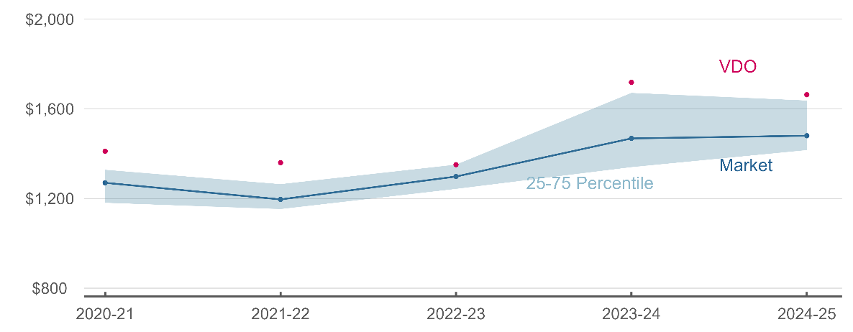

Figures 2 and 3 show that medium retailers continue to provide some of the cheapest offers in the residential market.

**Figure 2: Cheapest (10th percentile) residential flat rate electricity market offers, by   
retailer size** (Source: VEC)

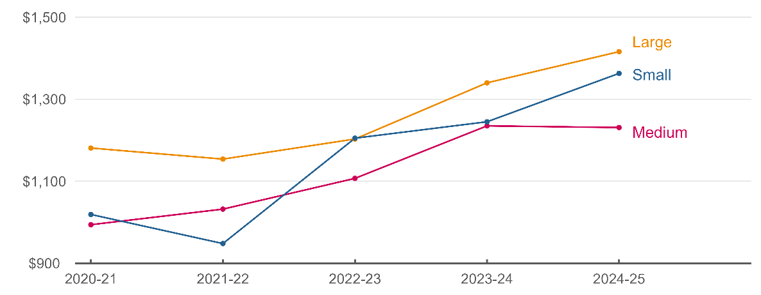

**Figure 3: Most expensive (90th percentile) residential flat rate electricity market offers, by retailer size** (Source: VEC)

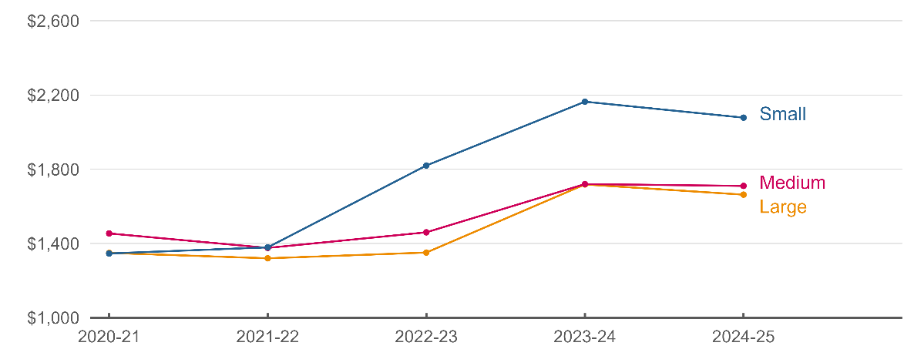

Figure 4 shows small business electricity market offers fell by two per cent in 2024-25 compared to 2023-24.

**Figure 4: Median and range of small business flat rate electricity offers**(Source: VEC)

## Gas

Figures below show residential gas market offers in the Australian Gas Networks distribution zone.[4]

Figure 5 shows median residential gas market offers rose by ten per cent in 2024-25 compared to 2023-24. Growth in gas offer prices continues to outstrip growth in electricity offer prices.

**Figure 5: Median residential gas offers, by offer type**(Source: VEC)

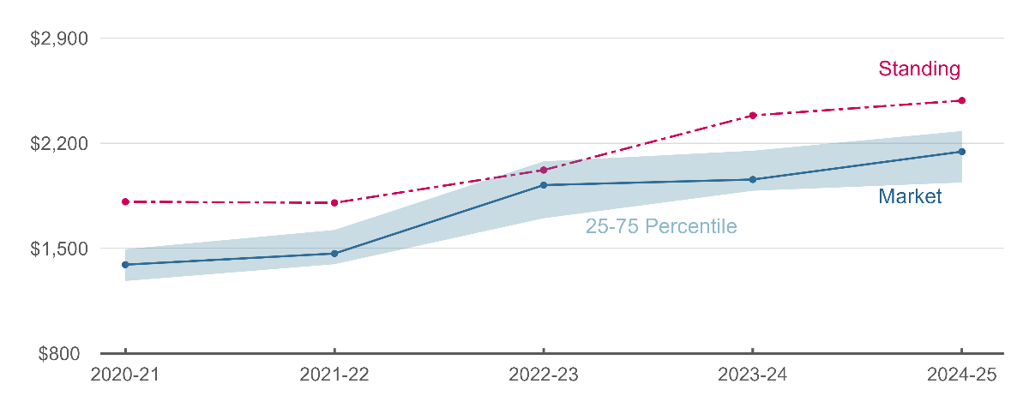

Like the electricity market, medium retailers provided the cheapest offers in the market   
(Figures 6 and 7).

**Figure 6: Cheapest (10th percentile) residential gas market offers, by retailer size**(Source: VEC)

**Figure 7: Most expensive (90th percentile) residential gas market offers, by retailer size**(Source: VEC)

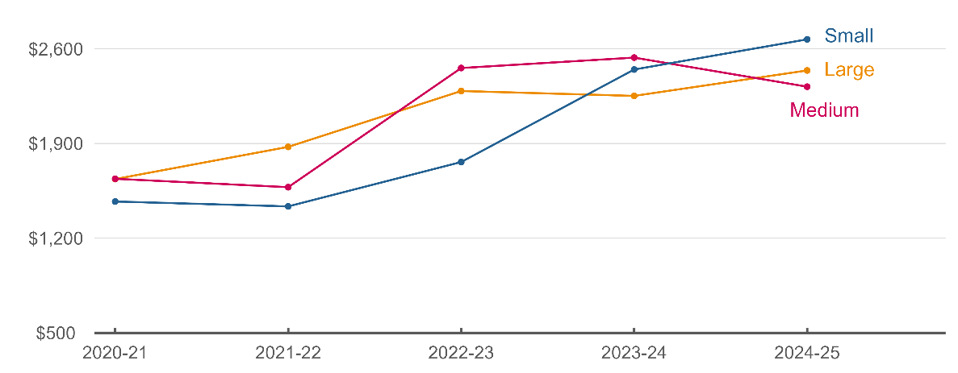

Figure 8 shows small business gas offers were stable in 2024-25 compared to 2023-24.

**Figure 8: Median and range of small business gas offers**(Source: VEC)

**Table 1: Residential electricity flat rate market offers, by distribution zone[5]**(Source: VEC)

|  |  |  |  |
| --- | --- | --- | --- |
|  | 25th percentile | Median | 75th percentile |
| **Jemena** | | | |
| 2020-21 | $1,181 | $1,270 | $1,328 |
| 2021-22 | $1,153 | $1,196 | $1,264 |
| 2022-23 | $1,243 | $1,298 | $1,351 |
| 2023-24 | $1,340 | $1,468 | $1,671 |
| 2024-25 | $1,416 | $1,480 | $1,637 |
| **Ausnet services** | | | |
| 2020-21 | $1,339 | $1,414 | $1,482 |
| 2021-22 | $1,307 | $1,338 | $1,421 |
| 2022-23 | $1,501 | $1,570 | $1,631 |
| 2023-24 | $1,592 | $1,740 | $1,983 |
| 2024-25 | $1,645 | $1,694 | $1,869 |
| **Citipower** | | | |
| 2020-21 | $1,103 | $1,201 | $1,269 |
| 2021-22 | $1,120 | $1,176 | $1,242 |
| 2022-23 | $1,188 | $1,244 | $1,292 |
| 2023-24 | $1,239 | $1,381 | $1,545 |
| 2024-25 | $1,245 | $1,303 | $1,456 |
| **Powercor** | | | |
| 2020-21 | $1,218 | $1,298 | $1,357 |
| 2021-22 | $1,189 | $1,226 | $1,304 |
| 2022-23 | $1,298 | $1,358 | $1,411 |
| 2023-24 | $1,398 | $1,546 | $1,741 |
| 2024-25 | $1,472 | $1,498 | $1,681 |
| **United Energy** | | | |
| 2020-21 | $1,169 | $1,253 | $1,319 |
| 2021-22 | $1,100 | $1,152 | $1,242 |
| 2022-23 | $1,217 | $1,273 | $1,323 |
| 2023-24 | $1,314 | $1,431 | $1,628 |
| 2024-25 | $1,342 | $1,389 | $1,553 |

**Table 2: Small business electricity flat rate market offers, by distribution zone[6]**(Source: VEC)

|  |  |  |  |
| --- | --- | --- | --- |
|  | 25th percentile | Median | 75th percentile |
| **Jemena** | | | |
| 2020-21 | $4,995 | $5,250 | $5,702 |
| 2021-22 | $4,818 | $5,215 | $5,365 |
| 2022-23 | $5,359 | $5,409 | $5,414 |
| 2023-24 | $6,734 | $6,873 | $7,090 |
| 2024-25 | $6,458 | $6,736 | $6,875 |
| **Ausnet services** | | | |
| 2020-21 | $6,054 | $6,634 | $7,958 |
| 2021-22 | $6,201 | $6,538 | $6,957 |
| 2022-23 | $7,428 | $7,593 | $7,659 |
| 2023-24 | $8,678 | $8,794 | $9,154 |
| 2024-25 | $7,935 | $8,167 | $8,525 |
| **Citipower** | | | |
| 2020-21 | $4,683 | $4,881 | $5,073 |
| 2021-22 | $4,531 | $4,741 | $4,881 |
| 2022-23 | $4,789 | $4,838 | $4,838 |
| 2023-24 | $5,849 | $5,971 | $6,158 |
| 2024-25 | $5,306 | $5,493 | $5,613 |
| **Powercor** | | | |
| 2020-21 | $4,756 | $5,041 | $5,195 |
| 2021-22 | $4,545 | $4,969 | $5,092 |
| 2022-23 | $5,137 | $5,189 | $5,191 |
| 2023-24 | $6,312 | $6,441 | $6,644 |
| 2024-25 | $5,821 | $6,047 | $6,127 |
| **United Energy** | | | |
| 2020-21 | $5,013 | $5,270 | $5,650 |
| 2021-22 | $4,636 | $4,776 | $5,100 |
| 2022-23 | $4,953 | $4,998 | $5,003 |
| 2023-24 | $6,140 | $6,309 | $6,507 |
| 2024-25 | $5,656 | $5,850 | $5,954 |

**Table 3: Residential gas market offers, by distribution zone[7]**(Source: VEC)

|  |  |  |  |
| --- | --- | --- | --- |
|  | 25th percentile | Median | 75th percentile |
| **Australian Gas Networks** | | | |
| 2020-21 | $1,282 | $1,391 | $1,494 |
| 2021-22 | $1,394 | $1,465 | $1,622 |
| 2022-23 | $1,700 | $1,921 | $2,079 |
| 2023-24 | $1,883 | $1,958 | $2,150 |
| 2024-25 | $1,938 | $2,144 | $2,281 |
| **Ausnet services** | | | |
| 2020-21 | $1,263 | $1,366 | $1,434 |
| 2021-22 | $1,381 | $1,486 | $1,581 |
| 2022-23 | $1,668 | $1,920 | $2,119 |
| 2023-24 | $1,879 | $2,016 | $2,180 |
| 2024-25 | $1,906 | $2,076 | $2,279 |
| **Multinet** | | | |
| 2020-21 | $1,261 | $1,372 | $1,439 |
| 2021-22 | $1,415 | $1,505 | $1,600 |
| 2022-23 | $1,679 | $1,964 | $2,091 |
| 2023-24 | $1,957 | $2,039 | $2,190 |
| 2024-25 | $2,004 | $2,150 | $2,301 |

**Table 4: Small business gas market offers, by distribution zone[8]**(Source: VEC)

|  |  |  |  |
| --- | --- | --- | --- |
|  | 25th percentile | Median | 75th percentile |
| **Australian Gas Networks** | | | |
| 2020-21 | $8,924 | $9,904 | $10,895 |
| 2021-22 | $9,463 | $10,066 | $11,149 |
| 2022-23 | $12,266 | $13,939 | $16,060 |
| 2023-24 | $14,196 | $16,562 | $17,414 |
| 2024-25 | $14,687 | $16,534 | $17,810 |
| **Ausnet services** | | | |
| 2020-21 | $8,188 | $9,124 | $10,239 |
| 2021-22 | $8,811 | $9,597 | $10,598 |
| 2022-23 | $11,450 | $13,559 | $15,432 |
| 2023-24 | $13,619 | $15,271 | $16,608 |
| 2024-25 | $13,929 | $15,034 | $17,117 |
| **Multinet** | | | |
| 2020-21 | $8,675 | $9,332 | $10,298 |
| 2021-22 | $9,008 | $9,760 | $10,997 |
| 2022-23 | $11,530 | $13,370 | $15,489 |
| 2023-24 | $13,696 | $16,054 | $16,627 |
| 2024-25 | $13,853 | $15,391 | $17,101 |

**Table 5: Size of retailers operating in Victoria (2024-25 residential electricity market)**

|  |  |  |
| --- | --- | --- |
| Large (>5% market share) | Medium (1-5% market share) | Small (<1% market share) |
| * AGL * EnergyAustralia * ENGIE * Lumo Energy * Origin Energy * Red Energy | * Alinta Energy * Dodo * Globird Energy * Momentum Energy * OVO Energy * Powershop * Sumo Power * Tango Energy * 1st Energy | * Amber Electric * CovaU * Diamond Energy * Energy Locals * Nectr * Progressive Green Energy * Real Utilities |

1. This resource meets the commission’s reporting obligations under section 10AAB of the *Essential Services Commission Act 2001*; section 39A of the *Electricity Industry Act 2000*; and section 47 of the *Gas Industry Act 2001*.
2. Eligible residential and small business customers received a Commonwealth contribution to their electricity account in 2024-25 as part of the Australian Government’s [*Energy Bill Relief Fund*](https://www.energy.gov.au/energy-bill-relief-fund). The offers data we report does not reflect this rebate.
3. In line with previous reports, we present electricity offers for the Jemena distribution zone as it represents a mix of suburban and country areas. See the Appendix for offers in other distribution zones.
4. In line with previous reports, we present gas offers for the Australian Gas Networks distribution zone. See the Appendix for offers in other distribution zones.
5. Results reflect representative bills based on a residential consumer using 4,000kWh over a year. The calculation uses the median offer with flat rate tariffs available in each financial year.
6. Results reflect representative bills based on a small business consumer using 20,000kWh over a year. The calculation uses the median offer with flat rate tariffs available in each financial year.
7. Results reflect representative bills based on a residential consumer using 54,400MJ over a year. The calculation uses the median market offer available in each financial year.
8. Results reflect representative bills based on a small business consumer using 500,000MJ over a year. The calculation uses the median market offer available in each financial year.