2026–27 Victorian Default Offer: Request for Comment Paper

Introduction
The Victorian Government introduced the Victorian Default Offer through a Governor in Council Order under section 13 of the Electricity Industry Act 2000 (pricing order). The Victorian Default Offer regulates standing offer prices for electricity in Victoria supplied and sold to domestic or small business customers.
The Essential Services Commission (commission) must determine new prices for the Victorian Default Offer that will apply from 1 July 2026 to 30 June 2027. This decision needs to be made by 24 May 2026. We refer to the new prices for standing offers as the 2026–27 Victorian Default Offer.
This Request for Comment Paper starts our consultation process for the 2026–27 Victorian Default Offer. It is intended to facilitate early engagement with industry and other interested parties as well as outline key milestones in our review timeline.
We invite submissions on the topics listed in Box 1.1 which are explored in detail throughout this paper. While we consider our overall method for setting the Victorian Default Offer to be
well-established, we are seeking targeted input from interested parties on potential refinements to specific components of the framework.

Box 1.1 2026–27 Victorian Default Offer consultation questions
Questions
General matters
    - Are there matters that you would like to raise, including methodological approaches to other cost components not mentioned in this paper?
Wholesale electricity costs
    - We propose to continue the approach adopted in our final 2025–26 Victorian Default Offer decision to account for the wholesale cost of exports within the Victorian Default Offer. This includes a forecast export volume weighted wholesale price, multiplied by small customer export volumes, and divided by total forecast consumption. Do you agree with this approach? If not, why, and what alternative approach should we consider?
    - We propose to continue to use data sourced from the Australian Energy Market Operator and the Australian Energy Regulator to inform our estimate of the wholesale cost of exports. Do you agree with these data sources? If not, why, and what alternative data sources should we consider?
Network costs
    - Given the objective of the Victorian Default Offer is to provide a simple, trusted and reasonably priced electricity option that safeguards consumers unable or unwilling to engage in the electricity retail market, do you foresee any difficulties in transitioning from a two-period to three-period time of use (ToU) tariff? And if not, is continuing our pass-through appropriate or are there other approaches we should consider?
    - Are there any other matters proposed by distribution network service providers, or the Australian Energy Regulator that you think we should consider in setting the Victorian Default Offer?
Free power period tariff
    - What are your views on the suitability of a regulated residential tariff with a free power period in Victoria?
    - Are there additional safeguards – such as eligibility requirements – that should be implemented before a customer could opt-in to such a product?
Other costs
    - Do you support our proposed approach to pass through the Australian Energy Market Operator’s recently introduced ‘Cyber Security & Resilience’ fee and if implemented, the updated National Electricity Market Participant fee structure? If not, why, and what alternative approach should we consider?
    - Do you have any feedback on our proposed use of the Australian Energy Market Operator’s updated data to inform our ancillary service fee estimate?

Consultation process
We want to hear your views on the 2026–27 Victorian Default Offer: Request for Comment Paper. Submissions should be made by 5pm 12 December 2025 via Engage Victoria.
We may not be able to consider submissions received after this date.
We encourage transparency in our review processes. It is our policy to publish all submissions on our website unless the submitter has requested part of, or the entire submission is to be confidential. When we publish a submission, we will also include some details about the submitter (your name, not your address) unless the submitter has requested not to be identified.
We will consider all submissions and may adopt suggestions into our approach where they best align with the objectives of the Victorian Default Offer legislative framework.
We will address submissions and present our approach in our draft decision which will allow for further consultation. Interested parties can then make submissions on our Draft Decision Paper, and we will have regard to these submissions when we make our final decision and price determination.
Given the short review period, some suggestions may need to be considered over multiple review cycles, where appropriate.
Visit Engage Victoria's website to make your submission: www.engage.vic.gov.au
If you have any issues with the submission deadline or the method of submission, please email us at vdo@esc.vic.gov.au to discuss other options.
Table 1 sets out the indicative dates for the commission’s 2026–27 Victorian Default Offer.
Table 1: 2026–27 Victorian Default Offer review timeline
Key milestones | Indicative date
Request for Comment Paper | 14 November 2025
Submissions on Request for Comment Paper close | 12 December 2025
Draft Decision Paper released | March 2026
Public forum on the Draft Decision Paper | March/April 2026
Final decision and determination | by 24 May 2026

Background

The Victorian Default Offer

Who the offer applies to
The Victorian Default Offer sets the maximum price a retailer can charge for electricity sold to domestic and small business customers on standing offer contracts. While standing offer contracts must be made available to domestic and small business customers, most customers are on market contracts, which are not regulated by the prices we set, and are often priced below the Victorian Default Offer.
In Victoria, around 445,000 households (15 per cent) and 54,000 small businesses (19 per cent) are on standing offer contracts. Since September 2020, the Victorian Default Offer also applies as a maximum price for most embedded network customers (around 190,000).

Role as a comparison price
In addition to regulating standing offers for domestic and small business customers in Victoria, the Victorian Default Offer also:
- serves as a benchmark price for market offers
- ensures retailers compare their market offer to the default offer prices when advertising
- allows customers to easily compare market offer prices and choose the best plan for their needs.

Methodology objectives
In determining the Victorian Default Offer, the commission must use a method that:
- best meets our objectives under the Essential Services Commission Act 2001 and the Electricity Industry Act 2000, and
- meets the objectives of the Victorian Default Offer specified in the pricing order.

Cost components
Victorian Default Offer prices (including tariffs and compliant maximum annual bill) must reflect the efficient cost for a retailer to sell electricity in Victoria. We look at the following cost components when setting the Victorian Default Offer:
- Network costs – based on distributors’ network tariffs and metering charges approved by the Australian Energy Regulator.
- Wholesale electricity costs – based on the forecast cost of purchasing electricity in the futures market, including a wholesale cost of exports and factoring in a volatility allowance.
- Environmental costs – based on retailers’ costs of complying with environmental obligations imposed under Commonwealth and Victorian law or regulation.
- Retail operating costs – based on the customer-weighted average of retailers’ actual retail operating costs for domestic and small business customers. These costs include modest customer acquisition and retention costs, based on the 2013–14 average acquisition cost benchmark updated for inflation.
- Other costs – Australian Energy Market Operator fees, ancillary service fees, licence fees and market intervention costs.
- Network losses – based on information from the Australian Energy Market Operator, and applied to wholesale electricity costs, environmental costs and variable other costs.
- Retail operating margin – based on a retail operating margin benchmark and having regard to market offer prices relative to default offer prices, the expected returns approach and retailers’ actual margins.

Our 2025–26 final decision
Our final decision on the 2025–26 Victorian Default Offer resulted in an average annual bill increase of $20 or one per cent for domestic customers compared to 2024–25. The slight increase in Victorian Default Offer prices was mainly due to higher network costs, which are set each year by the Australian Energy Regulator.
Our 2025–26 Victorian Default Offer final decision explains how we calculated each cost component of the Victorian Default Offer for that regulatory period.
Figure 1 shows how each cost component contributed to the total average annual bill for a domestic Victorian Default Offer customer in 2024–25 and 2025–26.
Figure 1: Cost components in annual bills for domestic customers (assuming annual usage of 4,000 kWh) between 2024–25 and 2025–26 Victorian Default Offers
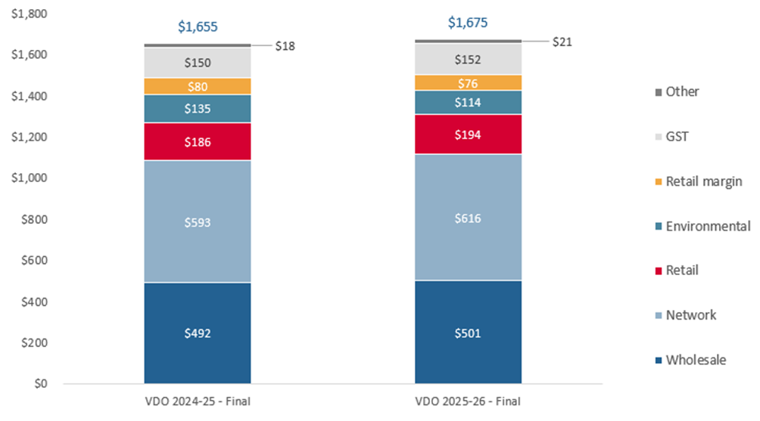

Purpose of this paper
The purpose of this paper is to seek your comments on specific aspects of the wholesale electricity costs, network costs and other costs components of the Victorian Default Offer (see details in Box 1.1). We also welcome your views on our approach to determining all cost components within the Victorian Default Offer.

We propose to apply the same methodologies as in past reviews
Our current methodologies for calculating each cost component are set out in our final decision on the 2025–26 Victorian Default Offer. While we propose to continue to generally apply the same methodologies, we are considering whether to refine certain aspects of our approach as set out in this paper.
More details on how we review cost components, and past decision papers, can be found on our website.

General matters
We are not proposing any changes to aspects of the Victorian Default Offer other than those listed in this paper. We propose to continue using the same methodologies applied in earlier reviews, as described in the 2025–26 Victorian Default Offer final decision. We consider these elements are stable and provide regulatory consistency.
We welcome your views on our approach to estimating all cost components within the Victorian Default Offer. We will consider all submissions and may incorporate suggestions into our approach where they best align with the objectives of the Victorian Default Offer legislative framework.
Question
    - Are there matters that you would like to raise, including methodological approaches to other cost components not mentioned in this paper?

Wholesale electricity costs – calculating and recovering exports
Our final decision on the 2025–26 Victorian Default Offer used a futures market approach to forecast wholesale electricity costs, based on a 5-minute load profile of customer imports only. This replaced the 30-minute load profile based on the balance of customer import-export.
In the 2025–26 final decision, we referred to exports as ‘solar’ for simplicity and because in the context of load profiles, small customer exports primarily come from rooftop solar systems. However, we recognise that not all customer exports are solar and that some come from batteries and other sources and will therefore use the term ‘exports’ in this paper and going forward.
We continue to consider that our approach best reflects the costs retailers face when supplying customers. Customer load profile data shows the amount of electricity retailers expect they need to supply to their customers.

Allowance for the wholesale electricity cost of exports
In our 2025–26 final decision, following our change to the load profile methodology, the removal of the minimum feed-in tariff and the social cost of carbon in Victoria, the Victorian Default Offer included an allowance for the wholesale electricity cost of exports.
This allowance is aiming to reflect the fact that Victorian retailers cannot charge their solar customers for their exports, even when the wholesale price is negative during periods of high solar output.
When the wholesale electricity price is negative, a retailer’s customers’ exports result in a settlement payment from the retailer to the market operator (which may be offset in part or in full by settlement payments for the customers’ imports), yet retailers cannot recover this cost by charging their solar customers to export electricity.
We calculated the allowance for the wholesale electricity cost of exports by:
- multiplying our forecast export volume weighted wholesale price (export wholesale price) for 2025–26 by the total small customer exports (provided in market operator metering data), then
- dividing this cost by forecast total consumption for the same period.
The export wholesale price is the expected average wholesale electricity price at times when households export electricity to the grid, weighted by how much they export at those times. This price reflects the outcome of market wide supply and demand, not the behaviour of small customers who export (most commonly, solar energy) alone. It is therefore appropriate to divide this price by forecast total consumption, not solely small customers’ consumption, because this reflects the whole market contribution to the wholesale price at times of negative prices. We intend to keep this approach for the 2026–27 Victorian Default Offer. We forecasted an overall negative export wholesale price in 2025–26 as this reflected the market-wide supply and demand at the time.

Data sources
To estimate the wholesale electricity cost of exports we can use small customer data from either the market operator or distribution network service providers.
We consider the market operator data provides a full picture of customers’ imports and exports as we use the load data as the source for wholesale electricity costs. This enables us to estimate the wholesale electricity costs to retailers that arise from their customers imports and exports.
Questions
    - We propose to continue the approach adopted in our final 2025–26 Victorian Default Offer decision to account for the wholesale cost of exports within the Victorian Default Offer. This includes a forecast export volume weighted wholesale price, multiplied by small customer export volumes, and divided by total forecast consumption. Do you agree with this approach? If not, why, and what alternative approach should we consider?
    - We propose to continue to use data sourced from the Australian Energy Market Operator and the Australian Energy Regulator to inform our estimate of the wholesale cost of exports. Do you agree with these data sources? If not, why, and what alternative data sources should we consider?

Network Costs – residential time of use tariff with new lower cost solar soak period
Network costs cover the construction, operation, maintenance, and expansion of electricity transmission and distribution infrastructure.

Role of the Australian Energy Regulator (AER) in setting network costs
Distribution Network Service Providers (distribution providers) and Transmission Network Service Providers (transmission providers) submit revenue proposals to the Australian Energy Regulator (AER) every five years. The AER in turn makes a five-year revenue determination, setting the maximum revenue providers can recover. Every year, electricity distribution and transmission businesses are required to submit their respective pricing proposals to the AER that contain the tariffs and metering charges they propose to charge their customers. These pricing proposals follow the revenue path set out in their respective five-year revenue determinations (with adjustments) and together form network tariffs.
The AER approves network tariffs and other metering costs each May for the following financial year. Network tariffs include:
- distribution charges – for the use of the distribution network
- transmission charges – for the use of the transmission network
- jurisdictional charges – for the payments distributors are required to make within each jurisdiction, including jurisdictional scheme amounts.
In turn, retailers must pay approved network tariffs and metering costs to access network services and then pass the costs on to customers.

Our pass-through approach
In line with our established approach to network costs, we propose to continue to apply a cost pass-through approach, with network costs in the Victorian Default Offer reflecting network tariffs and metering charges as approved by the Australian Energy Regulator (AER). This is consistent with the AER’s role in regulating networks focused on efficiency and the long-term interests of consumers.
For our draft decision on the 2026–27 Victorian Default Offer, we propose to use indicative network tariffs based on distribution providers’ revised revenue proposals, to be published by the AER in December. The revised revenue proposals will reflect updates to distribution tariffs and metering charges made in response to the AER’s draft determinations in September 2025. We consider this approach remains appropriate and ensures our draft decision reflects the best information available.

Distribution tariff reforms – ‘solar soak’ period
The AER is reviewing 2026–31 revenue proposals from Victoria’s five distribution providers, with new tariff structures and metering charges to take effect from 1 July 2026.
Key tariff changes include:
- Introduction of a ‘solar soak’ period in the residential time of use (ToU) tariff between (11am–4pm daily) to encourage electricity use during high solar generation.
- Adjustment of the residential time of use (ToU) peak demand period from 3pm–9pm to 4pm–‍9pm to better reflect demand patterns.
Since 2021, the Victorian Default Offer domestic ToU tariff has included two price periods, reflecting the underlying structure of distribution tariffs. Should we reflect the solar soak period in the 2026–‍27 Victorian Default Offer by updating the domestic ToU tariff to include three price periods or are there other alternatives we should consider? Figure 2 illustrates the possible changes to our model assumptions to incorporate this three-period structure.
Figure 2: Historical and possible Victorian Default Offer time of use tariff assumptions
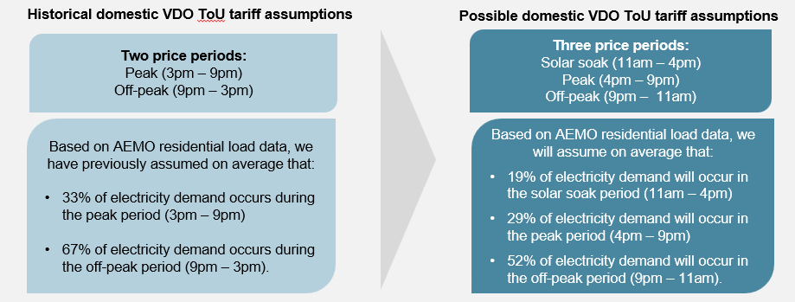
Questions
    - Given the objective of the Victorian Default Offer is to provide a simple, trusted and reasonably priced electricity option that safeguards consumers unable or unwilling to engage in the electricity retail market, do you foresee any difficulties in transitioning from a two-period to three-period time of use (ToU) tariff? And if not, is continuing our pass-through appropriate or are there other approaches we should consider?
    - Are there any other matters proposed by distribution network service providers, or the Australian Energy Regulator that you think we should consider in setting the Victorian Default Offer?

Free power period tariff
The commission received a letter from the Minister for Energy, Environment and Climate Action on 10 November requesting “the ESC seek information from stakeholders as part of this VDO consultation on the suitability of a regulated free power period offer for residential electricity consumers” in Victoria. The Minister identified the government’s commitment to keeping electricity bills low for Victorians.
The time of day that electricity is consumed impacts wholesale and network costs, which are the two biggest components of the Victorian Default Offer. Residential energy consumption tends to peak in the morning and evenings, and is lower in the middle of the day.
We are seeking views on whether to implement a regulated residential tariff under the Victorian Default Offer framework that includes a free power period for residential consumers in the middle of the day. The intention would be to flatten the aggregate demand curve by shifting consumption to the middle of the day and reducing demand at peak times. This could provide supply chain-wide benefits over the long term including better network utilisation and downward pressure on wholesale prices. We note the Commonwealth Government is consulting on a similar product.
Question
    - What are your views on the suitability of a regulated residential tariff with a free power period in Victoria?
    - Are there additional safeguards – such as eligibility requirements – that should be implemented before a customer could opt-in to such a product?

Other costs – Australian Energy Market Operator fee changes

AEMO National Electricity Market Participant Fees
The market operator charges market participants National Electricity Market (NEM) Participant Fees which recover the costs of managing and operating the NEM. The market operator is reviewing the structure of these fees, with changes in their draft determination proposed to take effect from 1 July 2026. We expect the final NEM Participant Fee Structure Report to be released in March 2026.
Figure 3 shows the market operator NEM Participant Fees that will affect the Victorian Default Offer, including the recently introduced ‘Cyber Security & Resilience’ fee.
Figure 3: Existing and proposed NEM Participant Fees
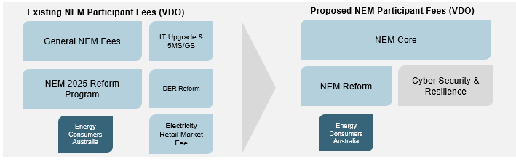
We propose to pass through the proposed NEM Participant Fees, should they be implemented by the market operator in its final NEM Participant Fee Structure Report, and seek your feedback on this proposal.

AEMO ancillary service fees
The market operator provides ancillary services, to help keep the power system safe, stable, and reliable by managing frequency, voltage, and system restarts.
The data in the market operator’s ancillary service fee report has been updated to reflect a recent rule change. Figure 4 illustrates the data changes in the market operator’s ancillary service fee report.
Figure 4: Previous and new ancillary service fee data
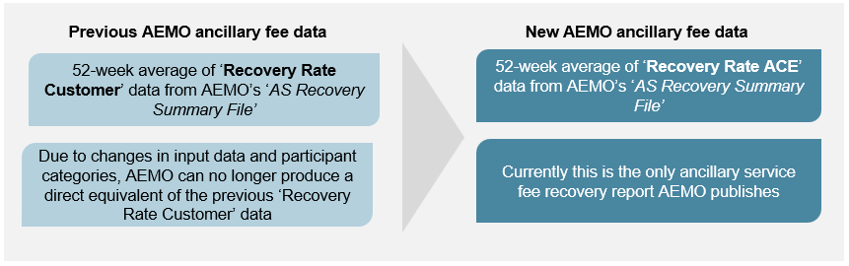
For the 2025–26 Victorian Default Offer, we used both ‘Recovery Rate Customer’ and the new ‘Recovery Rate Adjusted Consumed Energy (ACE)’ data introduced during that regulatory period to calculate a 52-week average of ancillary service fees.
We propose to only use the ‘Recovery Rate ACE’ data to calculate ancillary service fees, going forward because we consider it is now the best publicly available option to reflect ancillary service fees, and seek your feedback on this proposal.
Questions
    - Do you support our proposed approach to pass through the Australian Energy Market Operator’s recently introduced ‘Cyber Security & Resilience’ fee and if implemented, the updated National Electricity Market Participant fee structure? If not, why, and what alternative approach should we consider?
    - Do you have any feedback on our proposed use of the Australian Energy Market Operator’s updated data to inform our ancillary service fee estimate?

The Order in Council was published in the Victorian Government Gazette No. S 208 on Thursday 30 May 2019. Amendments to this Order have been made by Orders in Council published in the Victorian Government Gazette; No. S 216 Tuesday 4 June 2019 and No. G50 14 December 2023. The Order in Council (as amended) is referred to in this paper as the ‘pricing order’.
The first Victorian Default Offer was set by the Victorian Government in 2019 based on advice prepared by the Essential Services Commission. Our first determination of Victorian Default Offer prices came into effect 1 January 2020. We have been responsible for setting Victorian Default Offer prices since then. Essential Services Commission 2019, Victorian Default Offer to apply from 1 January 2020: final decision.
Clause 10(1) of the pricing order.
Figures reflect contract type recorded through National Meter Identifier, as of June 2025. A recent increase in customers on electricity standing offers and subsequently have their price set through the Victorian Default Offer, was because one retailer recently assigned customers with an expired contract on to a standing offer. Essential Services Commission, Energy Market Dashboard, available at: https://www.esc.vic.gov.au/electricity-and-gas/market-performance-and-reporting/victorian-energy-market-report/energy-market-dashboard.
To promote the long-term interests of Victorian consumers having regard to the price, quality and reliability of retail electricity services. See the Essential Services Commission Act 2001, s8; To facilitate the development of full retail competition, and to promote protections for customers including in relation to assisting customers who face payment difficulties. See the Electricity Industry Act 2000, s10; Essential Services Commission Act 2001, s33(2).
To provide a simple trusted and reasonably priced electricity option that safeguards consumers unable or unwilling to engage in the electricity retail market. See clause 12(2) and clause 3 of the pricing order.
Clause 12(3) of the pricing order.
Essential Services Commission, Victorian Default Offer 2025–26: Final Decision Paper, pp. 18–64, 21 May 2025.
Essential Services Commission, Victorian Default Offer 2025–26: Final Decision Paper, pp. 18–64, 21 May 2025.
For the reasons we made this change please see Essential Services Commission, Victorian Default Offer 2025–26: Final Decision Paper, pp. 22–34, 21 May 2025.
Essential Services Commission, Victorian Default Offer 2025–26: Final Decision Paper, pp. 22–34, 21 May 2025.
The reasons for this change are outlined in our decision paper, Essential Services Commission, Victorian Default Offer 2025–26: Final Decision Paper, pp. 24–26, 21 May 2025.
The AER and distribution providers use the term ‘residential’, while the VDO refers to this customer category as ‘domestic’.
Australian Energy Regulator 2025, AusNet Tariff Structure Statement, CitiPower Tariff Structure Statement, Jemena Tariff Structure Statement, Powercor Tariff Structure Statement, United Energy Tariff Structure Statement.
Minister for Energy, Environment and Climate Action, Letter to the Essential Services Commission, November 2025.
Department of Climate Change, Energy the Environment and Water, Have your say on the Solar Sharer Offer (SSO), November 2025.
On 23 June 2025, the market operator introduced a new ‘Cyber Security & Resilience’ fee to fund responsibilities assigned under an Australian Energy Market Commission rule change made on 12 December 2024. This rule strengths its role in preventing and responding to cyber threats. The 2025–26 Victorian Default Offer was released before the fee announcement, so it was not included. We will include this fee in the 2026–27 Victorian Default Offer.
Historically we have used ‘Recovery Rate Customer’ data provided in AEMO’s ‘AS Recovery Summary File’ to estimate the ancillary service fees paid by Victorian retailers. In 2024, AEMO’s updated this dataset to reflect changes under the Australian Energy Market Commission’s Integrating Energy Storage Systems rule determination, which took effect on 3 June 2024.

