



Electricity generation licence application form

Purpose of this form
This form must be completed by persons applying to the Essential Services Commission (the commission) for a licence to authorise electricity generation in Victoria. Electricity generation includes battery energy storage systems.

Basis for this form
Section 18 of the Electricity Industry Act 2000 (the Industry Act) provides that a licence application must be made in a form approved by the commission. This is the form approved by the commission.

Use of this form and the applicant’s responsibilities
A licence application may be made by any legal person including, without limitation, individuals, incorporated associations, unit and other forms of trusts and corporations. Entities that are not a legal person (for example, an unincorporated joint venture or a partnership) cannot apply for a licence.
For the purpose of this application form, reference to the term “Officer” includes the applicant’s directors and secretary, and other persons who make or participate in making decisions that affect a substantial part of the business (for example, Chief Executive Officer, Chief Financial Officer or General Manager).
The applicant should list the information requested in the spaces provided in this form and enclose additional information when required.
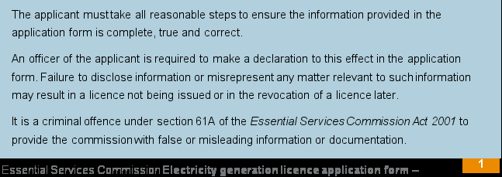

The applicant is responsible for providing the commission with current, accurate and relevant documentation. It is the applicant’s responsibility to make all reasonable inquiries to obtain the information requested by this form.
Providing accurate and relevant information and a complete application (answering all questions and providing all information) will assist in timely processing of an application. All applications are assessed on a case-by-case basis. If insufficient information is provided with an application, we will contact the applicant about the requirement for additional information to be submitted before the application is considered further.

Prior reading
It is expected that the applicant has read our Guideline: Applications for electricity and gas industry licences before completing this form.
It is the applicant’s responsibility to ensure its compliance with legal obligations when applying for a licence.

Licence conditions
Section 20 of the Industry Act authorises the commission to issue licences subject to conditions as decided by the commission. Licences are published on our website. We recommend the applicant familiarise itself with the relevant standard conditions and be confident that it can comply with those conditions prior to applying for a licence.

Further information
The applicant should note that we may ask for further information, or to clarify the information that the applicant has already provided with the application.

Consultation and confidentiality
We will consult with relevant government, industry and consumer groups on the licence application through a public consultation process. Applications and/or supporting information that is not confidential will be made available on our website.
If the applicant believes that any information provided as part of its application is confidential or commercially sensitive, it is the applicant’s responsibility to clearly identify this information on those documents. The applicant should also provide a ‘non-confidential’ version of the application form and documents for publication on our website.

How to lodge an application
The applicant may send the completed application form electronically (preferred) or in hard copy to:
Electronically: licences@esc.vic.gov.au

Hard copy: Market Operations, Energy Division Essential Services Commission Level 8, 570 Bourke Street
Melbourne VIC 3000

Large files

Applicants generally need to send us large files which is often not suitable via email. Please contact us at licences@esc.vic.gov.au to discuss alternative options to provide an application to the commission.

Application fees and annual licence fees
The commission has the authority to set a licence application fee. Currently, there is no application fee.
Holding a licence incurs annual licence fees. Refer to the commission’s Guideline: Applications for electricity and gas industry licences for more information regarding annual licence fees.

General Information – The Applicant
The applicant must answer all questions in this section.

Legal name of applicant
State the full legal name of the applicant. The applicant is the person who will be generating electricity and/or selling (wholesale) electricity that will be the subject of the licence.

Name: Energy Storage Project No 6 Pty Ltd as trustee of the Energy Storage Project No 6 Unit Trust

  - Legal identity of applicant
Provide the applicant’s ABN and ACN (where relevant) and information about the applicant (for example, whether the applicant is a private limited company, trust, or joint venture).

ABN: 94 228 071 218 | ACN: 653 663 444
Type of entity: Trust

Contact details and address of the applicant

The applicant
Business address: Level 19B, 2 Park Street, Sydney
State: NSW | Postcode: 2000
Postal address (if different): As per business address
State: | Postcode:
Full name of contact person:
Position title:
Telephone: | Mobile:
Email:

  - Diagram of corporate and organisational structure

Attach a diagram illustrating the corporate structure, including details of any related companies within the meaning of the Corporations Act 2001 and the organisational chart. Provide a diagram of the:
- corporate structure (including any parent and related companies within the meaning of the
Corporations Act 2001), and

Attachment reference:

- organisational chart (including composition of the board, management, and other key personnel responsible for the key functions).

Attachment reference:

  - The licence

The applicant must answer all questions in this section.

If the applicant is seeking for a licence to be issued by a certain date, identify this date. Note: we do not undertake to issue the licence by this date. The applicant should usually allow a minimum of eight to 10 weeks once we consider the application to be complete. An application is considered complete once we have all the information needed for the commission to make a decision. In other words, when we have no need to request further information from the applicant. This includes a public consultation period of four weeks (generally) as part of our consideration of licence applications.

Provide details on the following:
Date from which licence is sought: 01/12/2025
Type of generation: Battery Energy Storage System
Expected name plate capacity: 250MW
Location of generation facility: 830 Sidebottoms Road, Pine Lodge VIC 3631
Details of how the generator will be connected to the network:
The Pine Lodge BESS is to connect to the AusNet Pine Lodge Terminal Station (Bay A) on the 220kV network.

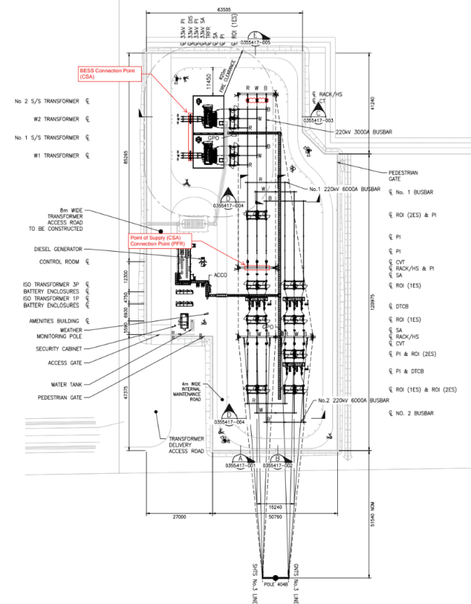

Technical capacity
The applicant must answer all questions in this section.

Experience and knowledge of the industry
Provide information about the human resources available to the applicant. This includes:

    - The experience and qualifications of those employees outlined in the organisational chart (see 1.4b);
    - If the applicant will employ contractors or agents to assist with the licensed activities, the name of those contractors or agents, details about the experience of the contractors or agents in such operations and details of the processes in place to ensure the contractors or agents comply with the licence conditions, including relevant regulatory obligations

Attachment reference:

Where the applicant is relying on a third party to provide staff and/or resources to meet the technical capacity requirements of the generation and wholesale licence, provide:
    - the experience and qualifications of any relevant key employees who will manage those systems and processes;
    - if the applicant will engage third parties to assist with the licensed activities, provide the following information in relation to each third party:
      - the name of that third party
      - the scope of activities undertaken by the third party
      - details and copies of any agreements for the provision of services
      - details about the experience of the third party in relation to the activities that it will be undertaking, including any accreditations
      - details of the processes in place to ensure the third party complies with the licensee’s regulatory obligations.

Attachment reference:

  - Risk management
- Provide confirmation and evidence that the applicant has identified the risks associated with electricity generation and wholesale operations. Additionally, provide evidence that the applicant has established, utilised and relied upon risk management systems and processes which are adequate, accurate and current to address those risks.
- Provide a copy of the applicant’s risk management strategy. A statement should also be provided (or supporting document must make it clear) whether the strategy has been developed in line with any Australian or International Standard (for example, ISO 31000:2018).
- Provide a copy of a risk register that identifies risks, controls and mitigations.

The details of the risk management strategies and processes are included in the attachments for this section.

Attachment reference:

  - Registration with the Australian Energy Market Operator and generator performance standards
Advise if the applicant will apply to register with the Australian Energy Market Operator (AEMO). If so, provide evidence of registration or exemption, or intending registration or exemption (for example, correspondence between the applicant and AEMO). If the applicant is not registering with AEMO, describe why that is the case.
Provide confirmation from AEMO that proposed negotiated generator performance standards will meet requirements for power system security and reliability under the National Electricity Rules.

The applicant is currently in the process of applying to AEMO to register as a generator in the NEM. This process will be finalised prior to site energisation.
The current version of the GPS has been attached with this application.

Attachment reference:

Licences held in other jurisdictions
If the applicant holds, or has previously held, electricity and/or gas licences or authorisations in other jurisdictions provide details. If a licence or authorisation previously held has been suspended or cancelled, provide details.

The applicant does not currently hold any electricity licences in Victoria or any other Australian jurisdictions.

Previous unsuccessful licence applications in other jurisdictions

Confirm whether the applicant has applied for an electricity or gas licence in another jurisdiction and not been issued with a licence or authorisation, provide details.

The applicant has not applied for an electricity or gas license. An associated subsidiary of the applicant’s parent company has applied for and been granted an electricity generation license for Mornington BESS by the ESC in Victoria.
JV Partner BW ESS holds a generation licence in the UK for the Bramley BESS project which is in operation.

Licences held by associates of the applicant

If an associate (within the meaning of the Corporations Act 2001) holds an electricity or gas licence in Victoria or in other Australian jurisdiction, provide details.

The associated entity, Mornington BESS Project Pty Ltd as trustee for the Mornington BESS Project Trust, holds an electricity generation licence for the Mornington BESS asset in Victoria as of January 2026.

Compliance management

- Provide evidence of compliance management which demonstrates how the compliance systems the applicant has (or will have) in place will ensure compliance with all the relevant regulatory obligations required by an electricity generation licence.
- Provide a copy of the applicant’s compliance management strategy. A statement should also be provided (or supporting document must make it clear) whether the strategy has been developed in line with any Australian or International Standard (for example, AS ISO 19600:2015).

The details of the Compliance Management system have been attached. The compliance management is aligned with ISO37301:2021, the international standard for compliance management systems. It is also aligned with the ISO31000:2018, the risk management standard.

Attachment reference:

  - Material agreements
Provide copies of agreements entered into, or intended to be entered into, by the applicant that are material to the undertaking of the electricity generation activity. Agreements that are material to the undertaking of the electricity generation activity may include:
    - Connection agreements, such as a Generator Connection Agreement and Generator Project Agreement with a generation facility.
    - Any contract concerning the construction and delivery of the project (sometimes commonly referred to as a Project Construction and Coordination Deed (PCCD) or Engineering, Procurement and Construction Agreement).
    - Any Network Services Agreements.
    - Any contracts concerning the managerial aspects of the activity (sometimes commonly referred to as a Management Services Agreement or Asset Management Agreement).
    - Any contract concerning the ongoing operations and maintenance of the transmission assets (sometimes commonly referred to as an Operations and Maintenance Agreement).
    - Any contract concerning the sale of electricity from the generator under a Power Purchase Agreement.

Attachment reference:

The following agreement extracts are attached

  - Engagement with Energy Safe Victoria
Provide details about the applicant’s engagement with Energy Safe Victoria and any copies of correspondence regarding the proposed electricity generation facility.

The applicant has engaged with Energy Safe Victoria and has attached the email in relation to the initial meeting and discussion around ESV’s involvement with the project.

Attachment reference:

  - Additional information

Provide any additional information the applicant considers relevant to the commission’s assessment of the applicant’s technical capacity.

The applicant has no further information for the commissions review of this application.

Financial viability

Financial resources

The applicant must provide a statement that will be made available to the public during the consultation period that the applicant has the financial resources to commence and sustainably perform the relevant licensable activities.
Provide a statement to confirm that:

- the applicant is financially viable and has the financial resources to sustainably operate the electricity generation facilities, and
- the applicant will be a registered market participant with the Australian Energy Market Operator for its electricity generation activities, therefore subject to the prudential requirements under the National Electricity Rules.
The commission reserves the right to conduct a financial viability assessment and require the applicant to produce information and documents it considers appropriate to complete such an assessment.

The applicant is a part of Valent Energy (Valent), a joint venture between BW ESS and Gaw Capital Partners, established in 2023.

With the support of their joint venture partners, the applicant has the financial resources to construct and operate the Pine Lodge BESS and to develop and operate its pipeline of projects in a financially viable manner, ensuring compliance with the National Electricity Rules and the Corporations Act 2001 (Cth). In support of this, the applicant has included the 2024 KPGM Audit Report for the project.

The applicant is currently working with AEMO Onboarding and the various other technical and operational teams to register the generator in the NEM.

Fit and proper person

The applicant must answer all questions in this section.

In deciding whether to grant or refuse a licence application, the commission will consider whether the applicant is a fit and proper person to hold a licence in Victoria.
The concept of a ‘fit and proper person’ is established by common law and takes its meaning from its context, from the activities in which the person is or will be engaged, and the ends to be served by those activities.
In considering whether an applicant is a fit and proper person, we will have regard to the applicant’s honesty, integrity and reputation. These are relevant factors as they can inform an assessment of the likelihood of future conduct.
We will also consider the conduct of directors, office holders or any person with significant managerial duties or influence. We will also consider the conduct of related bodies corporate or entities that can exert control over the applicant.
- Have any directors of the applicant, directors of any entity that can exert control over the applicant, or any person with significant managerial responsibility or influence on the applicant:
  - been declared bankrupt,
  - had their affairs placed under administration,
  - been disqualified from managing a company,
  - been subject to debt judgements, or
  - insolvency proceedings (including any administration, liquidation or receivership in connection with the affairs of a company)?
If yes, provide details:

None of the directors of the applicant have been subject to the conditions listed above.

- Has the applicant, any directors of the applicant, directors of any entity that can exert control over the applicant or any person with significant managerial responsibility or influence on the applicant been prosecuted for any offences or had any enforcement action taken under any state, territory, Commonwealth or foreign legislation (including, but not limited to, the Competition and Consumer Act 2010, Corporations Act 2001, or the Australian Securities and Investments Commission Act 2001)?
If yes, provide details:

None of the directors, or those with significant managerial responsibility or influence over the applicant have had enforcement action taken in any jurisdiction.
- Has the applicant, any directors of the applicant, any related body corporate, or any person with significant managerial responsibility or influence on the applicant been involved in any material breaches of obligations regulated by the commission or any other regulator?
If yes, provide details:

None of the directors, or those with significant managerial responsibility or influence over the applicant have been involved in a material regulatory breach.

- Has the applicant, any directors of the applicant, any related body corporate, or any person with significant managerial responsibility been under investigation in relation to its regulatory obligations or is currently bound by an enforceable undertaking?
If yes, provide details:

None of the directors, or those with significant managerial responsibility or influence over the applicant have been under investigation in relation to any regulatory obligation.

- Has the applicant, any related body corporate or any person with significant managerial responsibility or influence on the applicant, been refused a licence or authorisation, or had restricted, suspended or revoked any such licence or authorisation (in any jurisdiction)?
If yes, provide details:

None of the directors, or those with significant managerial responsibility or influence over the applicant have been refused a licence or authorisation, or been restricted, suspended or revoked in relation to any such licence or authorisation.

- Provide any other information the applicant considers relevant to the commission’s fit and proper person assessment.

There is no further evidence the applicant wishes to present in this section.

Additional information

Answer the following questions and, where the answer to any question is “no” (except for question b)), provide further detail.
- Is the applicant a resident of, or does it have permanent establishment in, Australia?

Yes, the applicant is a resident entity in Australia.

- Is the applicant under external administration (as defined in the Corporations Act 2001) or under a similar form of administration under any laws applicable to it in any jurisdiction?

The applicant (and any related Australian entities) is not under external administration or any similar form of administration in any jurisdiction.

- Is the applicant immune from suit in respect of the obligations under the Electricity Industry Act 2000?

The applicant is not immune from suit in respect to any enforcement actions in relation to contravention of the Electricity Industry Act 2000, its subsequent Regulations and the Generation Licence conditions once granted.

- Is the applicant capable of being sued in its own name in a court of Australia?

Yes, the applicant is capable of being sued in Australia.

Commission objectives

The applicant must answer all questions in this section.

In deciding whether to grant or refuse an electricity generation licence application, the commission must consider its objectives under the Electricity Industry Act 2000 and the Essential Services Commission Act 2001 (ESC Act).
Our primary objective under the ESC Act, when performing our functions and exercising our powers, is to promote the long-term interests of Victorian consumers. In seeking to achieve this objective, we must have regard to the price, quality, and reliability of essential services and the matters set out in section 8A to the extent they are relevant.
In seeking to achieve the objectives specified in section 8, the commission must have regard to the matters to the extent that they are relevant in any particular case.
Provide any information the applicant considers relevant to the commission’s consideration of its objectives outlined in:
- Section 8 of the ESC Act (also see section 8A of the ESC Act); and
- Section 10 of the Electricity Industry Act 2000.

The Commission's objectives include the promotion of the long-term interests of Victorian
consumers, having regard to the price, quality and reliability of essential services.

The applicant believes that the granting of this licence is consistent with the ESC’s objectives, specifically relating to section 8 and 8A of the ESC Act, along with section 10 of the EI Act. Pine Lodge BESS will be a financially viable facility, being owned and operated by an experienced team under the guidance and support of the BW ESS team, which has a strong track record of project development, operations and innovation.

The BESS will ensure that Victorians consumers continue to have access to energy whilst maximising stability in the network. Though its PPA the project is also giving Victorian consumers more potential to procure green energy via the retail market.

The operation of the BESS also contributes to the wider ambitions of the Victorian government in meeting its emissions reduction targets – achieving net zero emissions by 2045. With 21 years remaining to achieve this target, the Pine Lodge BESS will be operating right through this period.

Statutory declaration
All the information provided in this application and attached documents for an electricity generation licence must be true and correct and must be verified by a statutory declaration. This statutory declaration must be made by the applicant (where the applicant is an individual) or a director of the applicant (where the applicant is a corporation) and must be made in accordance with the requirements of the Oaths and Affirmations Act 2018.
An example statutory declaration form can be found here. Information for authorised witnesses can be found here.
The statutory declaration must address the following:

- identification of the declarant’s position and/or role with the applicant
- that the declarant believes the information provided in the application to be true and correct
- that the declarant believes the applicant has the financial resources to commence and operate the activities the subject of the licence.
I Michael Hankin Li

of Energy Storage Project No.6 Pty Ltd as trustee of the Energy Storage Project No.6 Unit Trust

make the following statutory declaration under the Oaths and Affirmations Act 2018 (Victoria):

- That I am the director of Energy Storage Project No.6 Pty Ltd as trustee of the Energy Storage Project No.6 Unit Trust (ACN 653 663 444)
- The information provided in this application (including any attachments) to the Essential Services Commission for an electricity generation licence is true and correct
and I make this declaration conscientiously believing these matters to be true and knowing that making a statutory declaration that I know to be untrue is an offence.
I make it knowing that making a statutory declaration that I know to be untrue is an offence.

Date: …………………………….

Signature: ….......................................................

(signature of person making this statutory declaration in the presence of the authorised statutory declaration witness)

Declared at: Level 19, Unit B, 2 Park Street, Sydney, NSW 2000, Australia

Witness

I am an authorised statutory declaration witness and I sign this document in the presence of the person making the declaration:

…………………………………………………………
[signature of authorised statutory declaration witness]

on ………………………………………………………..

[Witness details]

A person authorised under section 30(2) of the Oaths and Affirmations Act 2018 to witness the signing of a statutory declaration.

