Third party access to the new Registry API
For third party vendors or accredited persons who would like to access the new Registry API, please follow the following instructions from Tuesday 3rd of June 2025.

IMPORTANT INFORMATION

Requesting access to the Production instance of the API
Follow instructions below to request access.

- All requests will be actioned on 3rd of June upon system Go-live. Once your access request has been approved, you will receive an email notification with relevant details.
- Please note the URL for the Production API is https://api.esc.vic.gov.au/veu-registry/v1/activities (this is also documented in the API portal)

Access to the UAT instance of the API
Follow instructions below but choose ‘UAT’ instead of ‘PROD’
- All requests will be actioned on 3rd of June upon system Go-live. Once your access request has been approved, you will receive an email notification with relevant details.
- If you have already participated in UAT no further action is required. Once UAT access is reinstated you will be sent a notification automatically with details in the case you wish to continue testing.

Instructions
STEP | DESCRIPTION
1 | Log into the API portal. Click on VEU Registry Experience API. Click Request access.  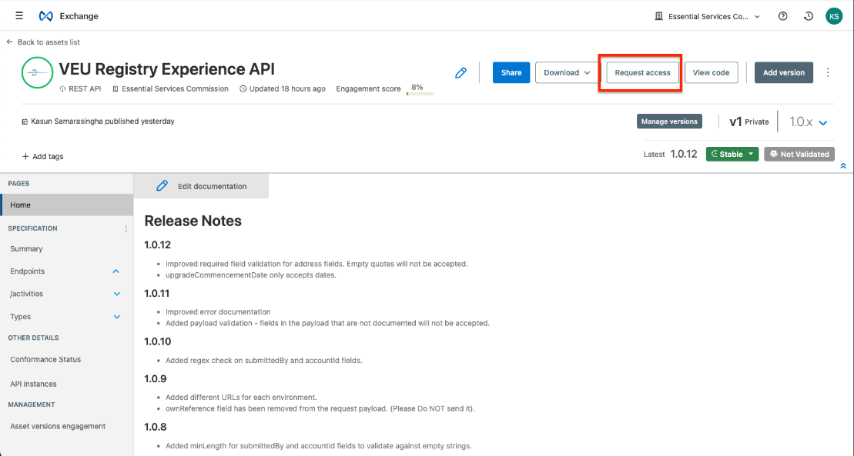
2 | Select the PROD instance from the drop down (or UAT if you have not registered previously).  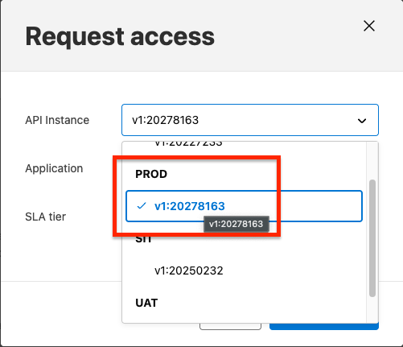  It is recommended that a separate application is created for PROD to keep credentials separate. Select Base SLA tier and click request access.

