Getting to Fair: Advancing Equity
Just and equitable outcomes for all Victorians,
today and tomorrow
Consultation Paper
December 2025


We welcome your feedback on this draft strategy. Please see page 13 for details.

An appropriate citation for this paper is:
Essential Services Commission 2025,
Getting to Fair: Advancing Equity Consultation Paper, December 2025

Copyright notice
© Essential Services Commission, 2025

This work, Getting to Fair: Advancing Equity, December 2025, is licensed under a Creative Commons Attribution.
4.0 licence [creativecommons.org/licenses/ by/4.0]. You are free to re-use the work under that licence, on the condition that you credit the
Essential Services Commission as author, indicate if changes were made and comply with the other licence terms.
The licence does not apply to any brand logo, images or photographs within the publication.



Dill-ba-din Balluk Biik
- Protect Community and Country. Artist: Simone Thomson

Acknowledgement
We acknowledge the Traditional Owners of the lands and waterways on which we work and live. We acknowledge all Aboriginal and Torres Strait Islander communities, and pay our respects to Elders past and present.
As the First Peoples of this land, belonging to the world’s oldest living cultures, we recognise and value their knowledge, and ongoing role in shaping and enriching the story of Victoria.

Getting to Fair: Advancing Equity
  - Just and equitable outcomes for all Victorians, today and tomorrow
Getting to Fair: Advancing Equity is our plan to address individual and systems-level inequity to improve consumer outcomes, with a continued focus on consumers experiencing vulnerability.

Our evolving response to break down barriers to essential services
As Victoria’s economic regulator of essential services, our work touches the lives of every Victorian every day. Our overarching legislative objective is to promote the long-term interests of Victorian consumers, including having regard to the price, quality and reliability of essential services. Our regulatory roles include setting prices, enforcing consumer protections and monitoring industry performance.

Aligning efficiency, equity and consumer outcomes
Economic regulation plays a central role in shaping how essential services perform for all Victorians. We consider efficiency to be an important driver of performance, but it is most meaningful when it contributes to good outcomes for all consumers.
We consider concepts of social and environmental equity and justice are relevant to considerations of efficiency because these factors shape the real costs and benefits that consumers bear over time. For example:
- The affordability and accessibility of essential services influences demand and payment behaviour, impacting the sustainability of service provision.
- Informed product and service design and engagement can improve uptake and trust, reducing dispute, enforcement and transaction costs.
- Social, environmental and cultural considerations may create hidden liabilities that consumers eventually pay for through higher prices or degraded service quality, for example, climate-related disruptions.
Ensuring that essential services work well for diverse consumer and user cohorts is fundamental to promoting the long-term interests of Victorians. Embedding fairness and equity into regulatory decisions helps ensure that the distribution of costs, benefits and risks reflects the real impacts consumers bear over time. This, in turn, supports services to be more resilient and capable of sustaining long-term growth, reinforcing the dependability of essential services across generations – aligning economic efficiency with the long-term interests of Victorian consumers.

We must be flexible and respond to emerging needs to achieve our goal
Essential services are undergoing significant transitions: decarbonisation, digitalisation, technological innovations and new service delivery models. Combined with ongoing cost-of-living pressures, the potential for inequitable impacts across different consumer groups is significant.
Getting to Fair: Advancing Equity is our strategy to ensure that the costs, benefits and risks of the essential services we regulate are distributed fairly across diverse consumer and user segments, including current and future generations.
Ensuring equitable access and just outcomes in the face of rapid change requires a dynamic approach. Our strategy is flexible by design. Instead of setting out a four-year action plan, each year we will include actions in our annual work program that align with the goal of our strategy. This will ensure we can address known issues and respond to new and emerging needs, risks and harms.

We are building on strong foundations
Advancing Equity is an evolution of work that began with our Getting to Fair strategy 2021–2024. It also aligns with our Strategic Plan 2025–29 vision for fair and dependable essential services, today and tomorrow.
The actions in Getting to Fair 2021–2024 largely focused on removing barriers to individual consumers accessing essential services. Advancing Equity broadens our focus to also target systemic factors, and how we can improve equity and outcomes through system-level regulatory responses.

We will continue to break down barriers to accessing essential services
Getting to Fair 2021–2024 delivered a shift in regulatory culture – breaking down barriers to essential services by embedding fairness, inclusion, and accessibility in the way the commission and our regulated sectors work. The strategy included our definition of consumer vulnerability which continues to guide our work. Our definition highlights the role of regulators and businesses in supporting vulnerable consumers. It identifies barriers as the biggest contributing factor in minimising access and engagement with essential services rather than the characteristics of the individual.
Getting to Fair consumer vulnerability definition
A person experiencing, or at risk of experiencing, vulnerability is someone who experiences barriers to accessing or engaging in the essential services we regulate or administer. As a result of those barriers, that person experiences economic and/or social exclusion or harm. Barriers can include event-based circumstances, systemic factors, and market-based factors.

Supporting our vision for fair and dependable essential services, today and tomorrow
Our Strategic Plan 2025–29 seeks to achieve long-term impact across four domains: Efficient Pricing, Resilience and Sustainability, Equitable Services, and Integrity and Trust. This strategy will drive impact in the Equitable Services domain, which seeks to ensure essential services are accessible, inclusive and responsive to all consumers, regardless of circumstances. It will also guide impact across:
- Efficient Pricing: by embedding considerations of fairness in ‘best value’ pricing decisions.
- Resilience and Sustainability: by advancing just outcomes across diverse consumer and user segments as essential services adapt to long-term changes.
- Integrity and Trust: by strengthening market and regulatory transparency, accountability and confidence, particularly for consumers experiencing vulnerability and impacted users.

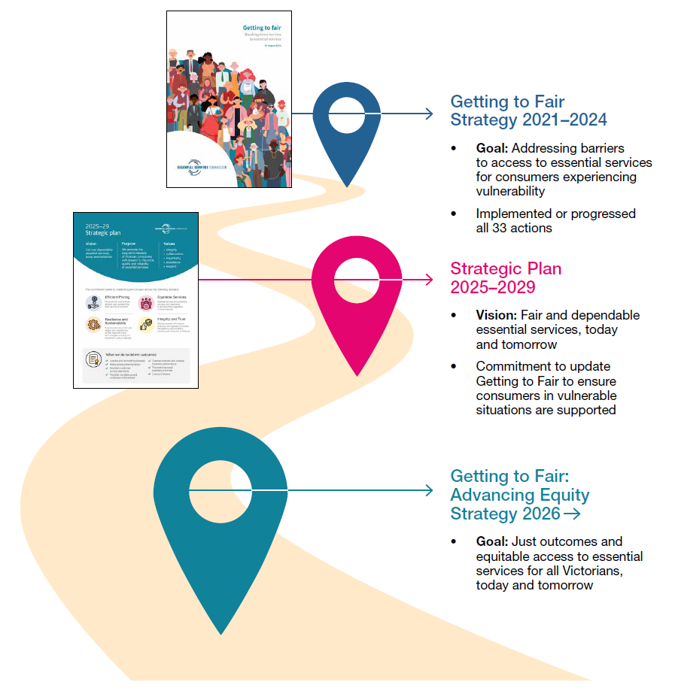
Figure 1: Our fairness and equity journey

Getting to Fair: Advancing Equity strategy
The goal of our strategy is to promote just outcomes and equitable access to essential services for all Victorians, today and tomorrow.
Our flagship frameworks and priority actions will help us achieve our goal.
Four pillars underpin our strategy. They will support the delivery of our flagship frameworks and priority actions and guide us as we embed considerations of justice and equity into all our work.
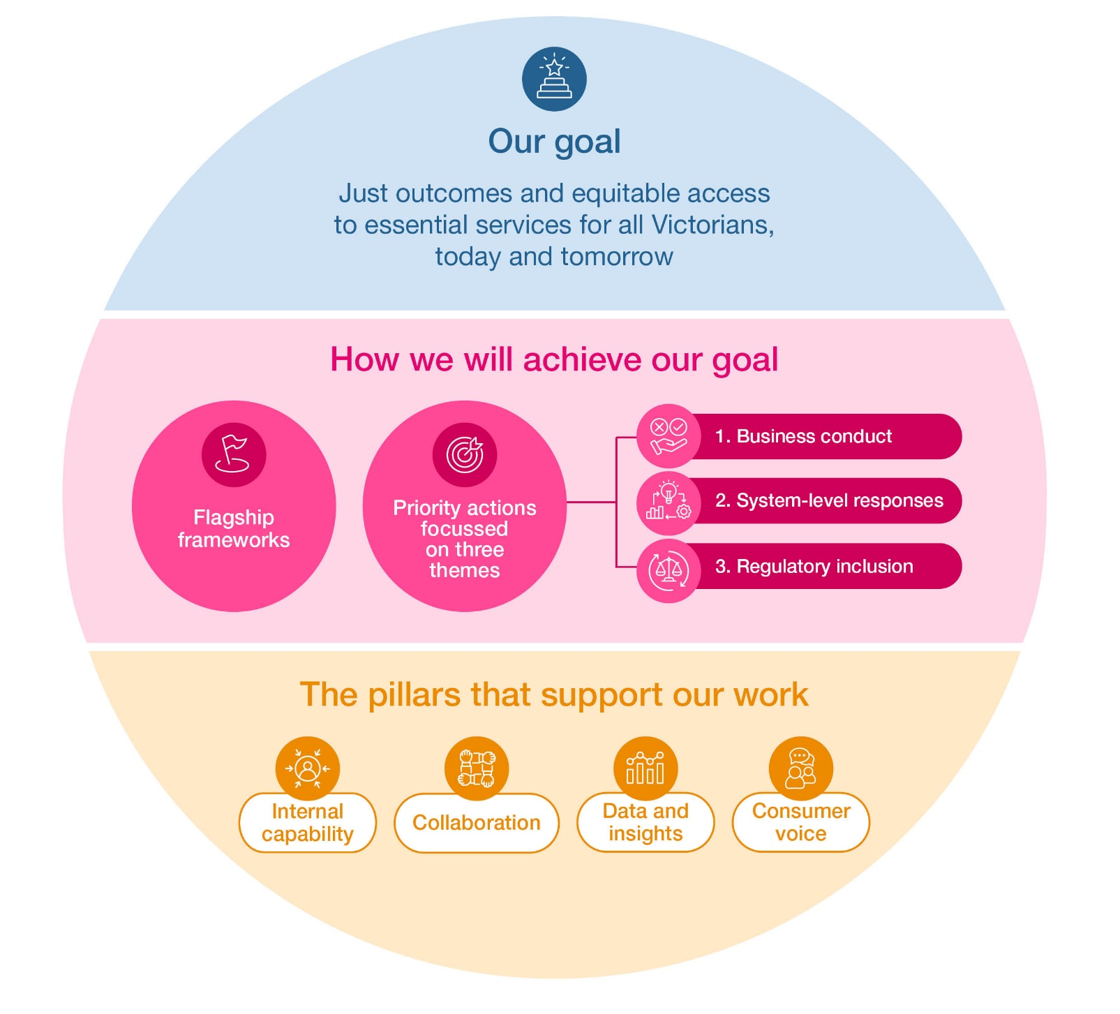
Figure 2: Getting to Fair: Advancing Equity strategy
Our goal is to promote just outcomes and equitable access to essential services for all Victorians, today and tomorrow.
Our goal
Achieving just outcomes will ensure the cost, benefit and risks of the essential services we regulate and administer are justly and equitably distributed among all Victorian consumers and users, including different consumer and user segments and future generations.
Achieving equitable access will ensure all consumers, regardless of circumstances, have equitable access to the essential services we regulate and administer.
Our goal is consistent with our Strategic Plan. In addition to guiding this strategy, it will inform our annual work program. For example, our compliance and enforcement priorities and our annual operational planning.
How we will achieve our goal

We will achieve our goal by developing and implementing two flagship frameworks and a program of priority actions.
Our flagship frameworks are areas of strategic focus identified to progress just regulatory outcomes and equitable access.

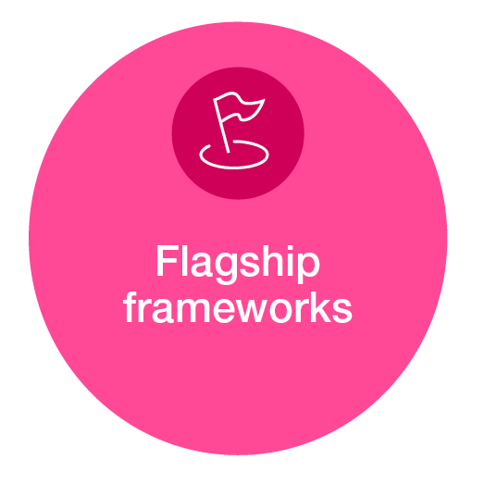
First Nations Self-Determination Framework
We will develop a First Nations Self-Determination Framework to be our common regulatory approach to enable self-determination, address barriers, and drive equitable regulatory participation and outcomes for and with First Nations peoples.

Energy Justice Framework
We will develop an Energy Justice Framework to provide a common regulatory approach that supports just regulatory outcomes for consumers as the energy sector adapts to long term change.
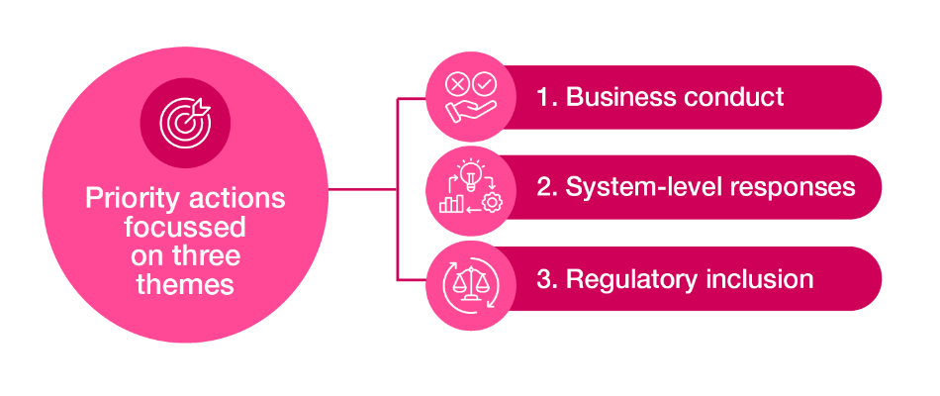
Our work program will include priority actions to align with our priority themes. These actions will include both existing and new activities. Some actions may address more than one priority theme. We have selected these themes to ensure we address both known and emerging needs, risks and harms. Priority actions will be published each year in our Regulatory Priorities paper.
Note: The examples shared below show the types of actions that align with the themes, but these are not yet actions we have committed to deliver.


Priority theme 1: Business conduct
To ensure the success of our strategy, the conduct of regulated businesses must align with our goal. We will influence and monitor business conduct through ongoing compliance projects, regulatory stewardship and reform. We will encourage businesses to use principles of justice, fairness and equity in their business activities, including as they apply rules, particularly rules that are principle-based. We will carefully consider implementation, recognising the costs and benefits of additional obligations and having regard to the long-term interest of consumers.
Actions under this theme may seek to address systemic barriers that cause inequitable outcomes for different consumer or user cohorts, barriers to individual consumers accessing existing rights and entitlements, or development of protections for future products and services. For example:
- Consumer protections for innovative products and services.
- Industry standards or guidance for engagement with First Nations consumers.
- Using data and insights to understand the effectiveness of consumer outcomes in the Victorian Energy Upgrades program.


Priority theme 2: System-level responses
As essential services transition and respond to long-term change, we must ensure that existing inequities are addressed and not exacerbated, and that new inequities are not created. Actions addressing this theme will target systemic barriers and risks of inequitable outcomes through system-level regulatory responses. For example:
- Exploring principles-based, outcomes-focused regulation to drive better consumer outcomes and reduce reliance on unnecessary prescription (for example, a consumer duty of care).
- Explore options to reduce higher energy costs faced by some consumers experiencing vulnerability.
- Incentivising regulated businesses to better engage with Traditional Owners and address the risks and impacts of proposed activities on Traditional Owner rights and interests.


Priority theme 3: Regulatory inclusion
To achieve our goal, we must consider the impact of our actions and decisions on diverse consumer and user segments. Actions addressing this theme will focus on ensuring our actions, policies and practices are inclusive and guided by the principles of justice, fairness and equity. For example:
- Improving our relationships and engagement approaches to maximise access and participation for diverse consumer and user cohorts.
- Assessing individual and system-level impacts on diverse consumer and user rights and interests as part of our regulatory decision-making.
- Ensuring our regulatory activities and decisions are supported by data and evidence relating to diverse consumer and user cohorts.
The pillars that support our work
The pillars are foundational elements that will support our strategy and embed consideration of justice and equity into all our work.


Internal capability
Delivering our strategy requires us to integrate equity and justice principles and approaches into all our regulatory activities and decision-making. We will do this through staff training and education and updating our internal processes and systems. This will ensure we can deliver the flagship frameworks and priority actions, identify opportunities for future actions, and embed this way of thinking in all our work.


Data and insights
Data is essential to informed decision-making and can drive insights that help us understand whether our actions are improving outcomes. We will use data to generate insights to inform our priority actions and identify gaps to guide future actions. This will include existing data we have access to and considering whether we need to collect more or different data to make better informed decisions.


Consumer voice
It is essential that we understand the varied experiences of consumers, both to inform our current work as well as to understand what more needs to be done. We will actively seek consumer input into our flagship frameworks and priority actions. This will include consumer feedback, lived experience (for example of consumers experiencing family violence), and playing our role to enable self-determination for First Nations people.


Collaboration
Collaboration across regulators, governments, industry and the community sector is key to understanding and addressing system-based issues. We will continue to play an active role in building relationships and bringing stakeholders and decision-makers together, including to address systems-based issues. This will include our regular community and industry roundtables and partnering with experts to explore innovative approaches to challenges.

We will use our regulatory tools and work collaboratively to achieve our goal
Advancing Equity sets out how we will use our existing regulatory roles and tools to maximise just outcomes and equitable access to essential services, consistent with broader Victorian and Commonwealth policy and legislative commitments. But we can’t achieve our goal alone. We will continue to work collaboratively with government, industry and the community sector and contribute to policy discussions to influence how just outcomes and equitable access can be promoted in the sectors we regulate.


Reporting and measuring our progress
We will announce our priority actions annually in our Regulatory Priorities paper published on our website.

We will report on our strategy annually through the commission’s annual report. This will include updates on flagship frameworks and priority actions.


We will measure our progress against the outcomes in our Strategic Plan, including:
- More customers receive their rights and entitlements.
- Data on service quality, prices and reliability drive action in addressing gaps.
- Businesses and markets actively adjust to major forces, trends and transitions, maintaining reliability.
- Earlier identification and response to consumer harm and integrity failures.

About the Essential Services Commission
The Essential Services Commission is Victoria’s economic regulator. We promote the long-term interests of Victorian consumers with respect to the price, quality and reliability of essential services. We promote consumer interests by:
- regulating Victoria’s energy, water and transport sectors
- overseeing the Fair Go Rates system
- regulating the Victorian Energy Upgrades program.

We want your feedback on our draft strategy
Getting to Fair: Advancing Equity continues our work to break down the barriers for consumers experiencing vulnerability and broadens our focus to target systemic factors, encompassing both individual and system-level equity.

We invite you to provide feedback by responding to our consultation questions
- Are there matters we should consider in evolving our Getting to Fair strategy to encompass both individual and system-level equity?
- Do you think the priority themes are the right themes to help achieve our goal?
  - If yes, is there a way we could strengthen or improve the themes?
  - If no, are there other themes we should consider?
- What can be done to support our regulated sectors embed considerations of justice and equity at both the individual and system level?
- Is there anything else we should be doing to ensure the success of this strategy?
- What challenges or barriers might make it harder to deliver this strategy?
Please share any other feedback you would like us to consider.

How to provide feedback
Please provide feedback by 5pm Wednesday 18 February 2026.

Written comments or submissions
You can lodge a submission on Engage Victoria or complete our online survey.
Alternatively, you may send comments and submissions by mail to:
Getting to Fair: Advancing Equity strategy consultation
Essential Services Commission
Level 8, 570 Bourke Street
Melbourne VIC 3000.
Written comments and submissions will be published on our website, as part of our commitment to transparency. If you want part of or all your submission to be private, please call us on
(03) 9032 1300 or email us at engage@esc.vic.gov.au.

Verbal feedback
You can provide verbal feedback by arranging a conversation with our team. Please email us at engage@esc.vic.gov.au to arrange a time.

