Price Submission
A submission for water and sewerage pricing for the 2023–28 regulatory period
30 September 2022
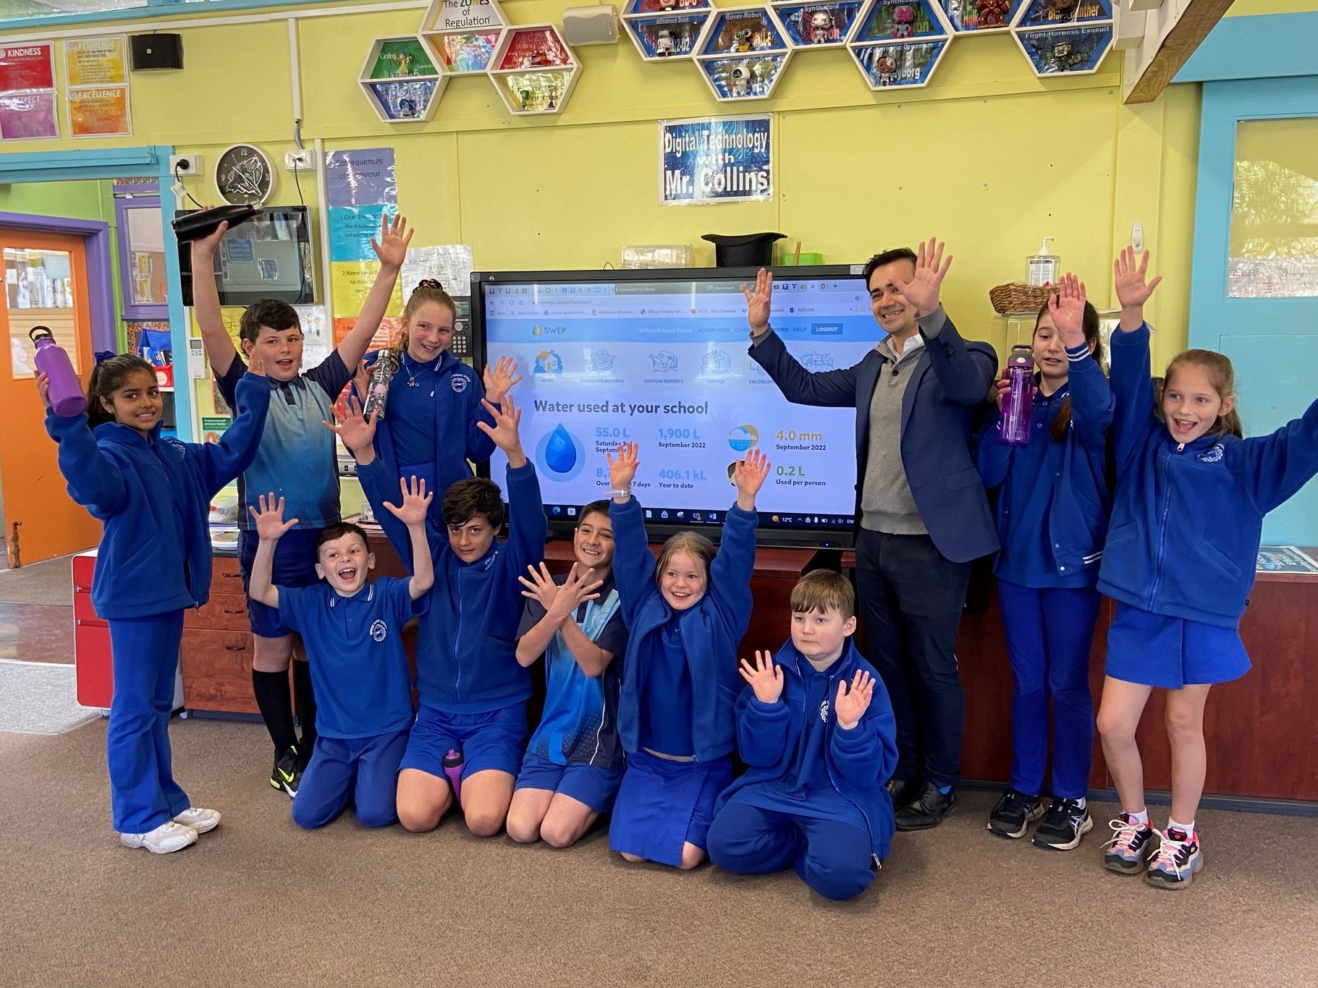

Table of contents
Price submission: At-a-glance 4
Board attestation 5
Message from the Customer and Community Advisory Council 6
Executive summary 8
Part 1: Our commitment to delivering outcomes for customers 17
Performance 18
Engagement 24
Outcomes 36
Part 2: How we will deliver these outcomes 48
Management 49

Risk 60

Forecast capital expenditure 68
Forecast operating expenditure 94
Part 3: Prices to support delivery of outcomes 108
Overall revenue requirement 109
Demand forecasts 114
Prices and tariff structures 129
Regulatory settings 143
Appendices 154
Cover: Students from Officer Primary School (Bunurong Country) participating in the Schools Water Efficiency (SWEP) Program aimed at improving water literacy and efficiency.

Aboriginal acknowledgment
South East Water proudly acknowledges the Bunurong and Wurundjeri Woi Wurrung as the Traditional Owners of the land on which we operate, and pay respect to their Elders past, present and emerging.
We acknowledge their songlines, cultural lore and continuing connection to the land and water.
We recognise and value their rich cultural heritage and continued contributions of Aboriginal people
and communities to our society in Victoria.

Price submission: At-a-glance

Delivering on what our customers told us
Once key assumptions and price submission activities are finalised, our projected self-assessment is an ‘Advanced’ PREMO rating.
 | Our performance against 2018–23 outcomes |  | Outcomes we will  deliver in 2023–28
- We are delivering our 5 customer outcomes to a high standard. Over the 4 years of the regulatory period to date we have met our targets or been within the tolerance band 93% of the time, only missing a target on 5 occasions.  - The few instances where the target or tolerance band was not met did not represent major departures and were generally due to external events.  - In 2021–22 South East Water has the highest overall customer satisfaction rating among the Victorian businesses  (as reported by the Essential Services Commission (ESC)) and receives high satisfaction ratings in our own customer sentiment surveys.​ |  | - We undertook extensive engagement with over 8,500 customers and stakeholders to test what they value and their willingness to pay. ​  - We held special discussion groups with Traditional Owners, vulnerable and culturally and linguistically diverse (CALD) customers (amongst other groups) to understand their needs. ​  - Customers told us our existing outcomes should remain and endorsed our associated measures, targets and their preferred proposals.  This includes our rollout of digital meters, increased investment in water security and improving bill clarity. ​
 | How we will deliver  on these outcomes |  | What this means for  prices and bill impacts
- Invest $1.92 billion in our 2023–28 capital program. Capital investments are based on  a bottom-up risk assessment to ensure we meet service needs but minimise costs.  The investment represents an annual increase of 5% on our regulatory asset base (RAB).  - Achieve controllable operating expenditure of an average $160 million p/a. We continue  to focus on operational cost control, as demonstrated by results of industry benchmarking. The operating expenditure represents identified step changes needed to meet regulatory and customer requirements. This represents a 10% increase but includes efficiency savings of 2% each year in controllable costs.  - By delivering significant operating  efficiency savings and investing in digital transformation/innovation we will support improved, cost-effective services into the future. |  | - Prices are forecast to decrease by around 6%  (on average) in real terms. ​  - As agreed with customers, we propose removing the residential sewage disposal charge.  - We will allocate the shortfall in revenue to  variable water tariffs, allowing residential  customers to have more control over their bills  (supported by the rollout of digital meters).  - We are also making the bill easier to read and understand. ​

Board attestation
The directors of South East Water having made such reasonable enquiries of management as we considered necessary (or having satisfied ourselves that we have no query), attest that, to the best of our knowledge, for the purpose of proposing prices for the Essential Services Commission’s Water Price Review 2023:
- information and documentation provided in the price submission and relied upon to support South East Water’s Price Submission is reasonably based, complete and accurate in all material respects
- financial and demand forecasts are the organisation’s best estimates, and supporting information is available to justify the assumptions and methodologies used
- the price submission satisfies the requirements of the Water Price Review 2023 guidance paper issued by the Essential Services Commission in all material respects.

Lucia Cade
Chair, South East Water

Message from the Customer
and Community Advisory Council

Friday 10 June 2022

Mr Marcus Crudden
Executive Director, Price Monitoring and Regulation
Essential Services Commission
Level 8, 570 Bourke Street
Melbourne VIC 3000

Dear Mr Crudden,
I am writing to you in my role of Chair of South East Water’s Customer and Community Advisory Council (CCAC) regarding South East Water’s price submission proposal for 2023–28.
South East Water re-established the CCAC in 2018, after its previous Customer Engagement Committee, and in doing so expanded the membership to 13, including the South East Water Managing Director and a board member.
South East Water regards the CCAC as a ‘critical friend’ to provide the organisation with feedback and challenge that it is meeting customer expectations.
The CCAC meets 4 times a year and has industry and community members representing its customer base and community. Industries and fields include agriculture, behaviour change, customer advocacy, environment, local government, multicultural affairs, plumbing, development and youth.
In March 2021, South East Water, in partnership with the CCAC, established a sub-committee of CCAC members to oversee and provide feedback on the customer and community engagement program for the 2023–28 Price Submission.
South East Water met with the sub-committee regularly, providing members with oversight of the engagement program and the opportunity to provide feedback throughout the process. Full CCAC meetings were also held each quarter to provide all members the opportunity to provide feedback and remain updated across the customer engagement program.
South East Water was open to observations and feedback, which informed further engagement and supported greater reliability of the customer engagement findings.
We found the methodology, objectivity, and inclusivity of the customer engagement program aligned with the engagement principles outlined in the ESC’s Water Price Review 2023 guidance paper including opportunities to participate, understanding what customers wanted to engage on, and providing information back to its customers.

It is our view that South East Water has adopted a sound and robust customer engagement program, particularly:
- using a range of methods including online surveys, deliberative online discussions,
an online bill simulator, focus groups, and workshops
- engagement with a cross-section of customers including customers experiencing vulnerability
- covering key matters including willingness to pay for certain services, projects, tariffs,
and GSLs
- empowering customers to determine how much participation they wanted and the engagement agenda
- validating customer panel recommendations during the ‘closing the loop’ workstream to understand any movements in customer priorities given recent events such as inflationary pressures.
While South East Water’s 2023–28 Price Submission is being drafted and inputs were still to be approved by the South East Water Board, the CCAC was presented with high-level plans for the price submission proposal for 2023–28 and we are pleased with how South East Water has incorporated customer feedback into these.
On behalf of the Customer and Community Advisory Council, I’m pleased to offer this letter of support of South East Water and its customer engagement program as part of its 2023–28 Price Submission.
Kind regards

David Heeps
Chair
South East Water Customer and Community Advisory Council

Executive summary

This submission for the 2023–28 regulatory period is based on an extensive process of engagement and collaboration with our customers and communities. In this period of uncertainty and change (including due to the coronavirus (COVID-19) pandemic), it has been more important than ever to ‘check in’.
We have responded to the increasing vulnerability of some sections of our customer base and will continue
to do so. Looking to the future, our customers are seeking stable delivery of our 5 agreed customer outcomes.
To be more efficient and responsive to our customers we aim to maintain reliable services, cater for the expected growth in our network, scale up digital metering and modernise our business systems. We will make it easier for our customers to pay their bills or move house, and we will give them access to information when they need it (for example, when there is a service interruption).
Our customers want us to be more responsive to the increasing impacts of climate change. We are embedding climate resilience into the way we design and operate our assets, implementing our Climate Adaptation Action Plan, and reducing our greenhouse gas emissions.

We have listened to customers and collaborated to reflect their views in our submission
The comprehensive engagement
process undertaken to develop the price submission covered 5 phases over an
18-month period.
In Phase 1, a strategic engagement
plan was developed to understand the information we already had and how
we needed to build on this.
Phases 2 and 3 involved new primary research and engagement involving over 8,500 residential, business, vulnerable and First Nations customers. Key messages from customers were continued support for our 5 existing customer outcomes (especially for reliable services and improvements to their experience, such as access to online self-serve systems). There was also support for key modernisation programs, including digital metering and environmental programs,
as well as the desire to address affordability concerns, particularly for vulnerable customers.
In Phase 4, South East Water and a community panel collaborated on how best to reflect these customer views in
this submission.
In Phase 5, we ‘closed the loop’ with the community panel by testing proposed key elements of the price submission that had been aligned to their recommendations. We also circled back with stakeholders who had provided input to let them know how their input had helped shape our submission.
The engagement was comprehensive
and inclusive, encompassing all elements of our customer base, our broader community and key stakeholders.
It specifically engaged customers and communities experiencing vulnerability and First Nations people, engaging these groups on their terms. The work with the community panel positions the engagement process at the ‘Collaborate’ and ‘Empower’ end of the IAP2 engagement spectrum.

We have delivered outcomes
to a high standard
We have delivered customer outcomes to a high standard in the current regulatory period. Of the 18 targets delivered in each of the 4 years of the regulatory period to date, we have met the target or been within the tolerance band 93% of the time, only missing a target on 5 occasions.
The few instances where the target or tolerance band was not met did not represent major departures and were generally due to either setting a stretched target or external events including the impact of coronavirus (COVID-19).
This performance is reflected in high levels of customer satisfaction. In 2021–22 South East Water had the highest overall customer satisfaction rating among the Victorian businesses (as reported by the ESC) and received high satisfaction ratings in our own customer sentiment surveys.

We have agreed to keep delivering our 5 core outcomes but have refreshed our output measures and targets
The 2023–28 Price Submission is designed to deliver on our 5 customer outcomes that have been reaffirmed by customers as the outcomes they most value. The associated outputs and targets have been updated to align them to service levels and priorities (and supporting investments) agreed for the 2023–28 period, particularly those arising from the community panel deliberation process. For example, our proposed digital utility investments (including digital metering) will improve our visibility of the network and identification of defects at
an earlier stage.
In addition to delivering on the agreed outcomes, South East Water is committed to managing price impacts for our customers and maintaining affordable services. As a result, we are adopting a return on equity level (of 4.1%) that can support this. This will ensure that we can deliver the outcomes that customers value and undertake the necessary investments for this to occur, while addressing the cost pressures that our customers are facing on many fronts.

Table 1: Our refreshed output measures and targets
Output measures | 2021–22  result | 5-year average | 2027–28  target
1. Get the basics right, always
Percentage compliance with drinking and recycled water standards | 100% | 100% | 100%
Customers experiencing more than 5 unplanned disruptions in a 12-month period (water, sewer and water quality) ^{(a)} | Redefined | N/A | 450
Total volume of water saved through digital detection of network leaks (ML) | New | N/A | 1,271
2. Warn me, inform me
Customer savings realised through repair of digital meter-detected property leaks ^{(b)} | $585,700 | N/A | $7,793,723
Customers notified per unplanned disruption as a percentage of total customers affected | 71% | 63% | 75%
Water literacy of South East Water customers | New | N/A | 31%
3. Fair and affordable for all
Percentage of existing properties upgraded to a digital meter | 9% | N/A | 85%
Total customers supported (provided assistance) | 10,612  (COVID-19 impacted) | 7,134 | 10,000
Percentage of customers with arrears greater than 90 days who have used South East Water support offerings | 41% | 37% | 55%
4. Make my experience better
Total number of inbound contacts (per 100 customers) | 62.6 | 67.9 | 59.5
Overall customer satisfaction with South East Water ^{(c)} | Redefined | N/A | 70%
Number of enquiries relating to the explanation of charges (per 100 customers) | 7 | 5.4 | 5.4
5. Support my community, protect my environment
Overall community trust in South East Water | 68% | 63% | 70%
Total greenhouse gas emissions (tCO₂e) | 28,577 | N/A | 12,033
Alternative water as a percentage of total water supplied to customers | 4.0% | 3.8% | 7.0%
Number of EPA reportable dry weather sewer spills (d) | 11 | 14 | 15
(N/A) Data not available due to new or redefined measure
(a) Water quality disruptions relate to the issue of a ‘Do not drink’ or ‘Boil water’ advisory
(b) Total water saved from date leak fixed to next bill date by the 2023–24 tier 2 water price ($4.0896 per kL)
(c) Re-baselined due to expansion of channels including credit management and hardship. Responses of 7 and above out of 10 are considered positive
(d) Target is based on longer-term modelling given weather dependency

Prices are forecast to fall in real terms
Prices are forecast to fall by around 6% (on average) in real terms in 2023–24.
As agreed with customers, we propose to change tariff structures by removing the residential sewage disposal charge. We will allocate the shortfall in revenue to variable water tariffs, allowing residential customers to have more control over their bills
(supported by the rollout of digital meters).
Tables 2 and 3 show a sample of customer bill impacts resulting from the proposed 2023–24 price change.

Table 2: Residential customer impacts from proposed 2023–24 changes
Residential customer | Usage per year (kL) | 2022–23 annual bill | 2023–24 annual bill | $ change | % change
Owner occupier  - Small user | 76 | $711.76 | $669.00 | -$42.77 | -6.01%
Owner occupier  - Average user | 150 | $966.95 | $908.28 | -$58.66 | -6.07%
Owner occupier  - Large user | 300 | $1,583.85 | $1,510.92 | -$72.93 | -4.60%
Tenant - Small user | 76 | $260.28 | $243.64 | -$16.64 | -6.39%
Tenant - Average user | 150 | $515.47 | $482.93 | -$32.54 | -6.31%
Tenant - Large user | 300 | $1,132.37 | $1,085.57 | -$46.80 | -4.13%
Owner occupier  - Water-only customer | 150 | $492.94 | $464.42 | -$28.52 | -5.79%
Landlord | N/A | $451.48 | $425.36 | -$26.12 | -5.79%

Table 3: Non-residential customer impacts from proposed 2023–24 changes
Non-residential customer | Usage per  year (kL) | 2022–23 annual bill | 2023–24 annual bill | $ change | % change
Non-residential customer - Small | 150 | $1,281.45 | $1,207.30 | -$74.15 | -5.79%
Non-residential customer - Medium | 1,000 | $5,593.84 | $5,270.16 | -$323.68 | -5.79%
Non-residential customer - Large | 10,000 | $51,254.44 | $48,288.68 | -$2,965.76 | -5.79%

Our expenditure proposals are higher, but reflect prudent and efficient forecasts that build in efficiency savings
An average operating expenditure of $160 million per annum is proposed, representing around a 10% increase compared to the 2018–23 regulatory period. Our forecast capital investment is $1.92 billion, which represents an average annual increase in our regulated asset base of 5% or a total 54% increase in capital expenditure.
While significant, this capital program will allow us to deliver on the standards of service that we have agreed upon with customers and to build a platform for improved services at lower costs in the future. Key projects and programs that contribute to these outcomes include the Digital Utility program, major sewerage treatment, water recycling and pipeline assets, and renewals and upgrade programs.
To limit costs, our forecasts build in a range of efficiency savings. Significant operating cost savings will be delivered to customers in the following ways:
- Efficiency improvement rate that is higher than the ESC’s hurdle rate: South East Water is committed to a 2% efficiency improvement rate, which is ahead of the ESC’s efficiency hurdle rate. This efficiency rate delivers a reduction in controllable expenditure of $22.5 million over the 2023–28 regulatory period.
- Expenditure growth rate below expected customer growth: South East Water has applied an expenditure growth rate which is below our expected customer growth rate. An annual average ‘uncertainty discount’ of 0.22% has been applied.
- Revised maintenance model: Providing further confidence in our ability to achieve the 2% efficiency rate, a revised maintenance model will apply in the 2023–28 regulatory period that incorporates performance measurement penalties and rewards, and is expected to reduce operating costs overall.
Capital expenditure efficiency savings will be delivered by:
- Implementing a new capital delivery model with our contractors: The capital delivery model being introduced at the start of the regulatory period better integrates planning and delivery and is forecast to deliver a 5% efficiency saving on program costs. Around 40% of the 2023–28 capital expenditure program will be delivered under this model.
- Maintaining our programmatic risk bank approach: South East Water uses a programmatic risk bank approach that enables savings from one project to fund increased costs in other projects. In the current pricing submission period, this has enabled us to remain 1% lower than our capital allowance whilst supporting unexpected increased costs in individual projects such as the Boneo Treatment plant. This same approach will be used in this pricing period.
- Ensuring our capital works are delivered efficiently: For the 60% of our capital spend not covered under the capital delivery model, we have also put in place actions to drive cost effectiveness. This includes the recent market tender of the maintenance works (12% of capital budget), absorption of any cost overruns in the Digital rollout (9% of capital budget) and market testing of other key projects as they arise.
- Realising continued efficiencies through strategic procurement and collaboration with other water corporations: South East Water works with other water corporations in strategic procurement and joint programs to minimise the cost for the community and increase the benefits. Examples in this pricing submission period include the Hobson Bay Sewer (our project added to Melbourne Water’s procurement) and the Poowong Loch Nyora Pressure Sewer Scheme (South East Water procurement, delivery for South Gippsland Water). With Yarra Valley Water and Greater Western Water, we formed the Digital Meter Joint Committee to work on shared digital meter projects to streamline knowledge and costs. This approach will continue throughout this pricing period.
- Investing in the Digital Utility/Digital Meter program: Over the long term, this is expected to defer major network augmentations by reducing water demand and providing better information on network expansion needs. In addition, it will allow us
to reduce maintenance and renewal costs by identifying problems earlier.

Our overall PREMO self-assessment is ‘Advanced’
The self-assessment for this pricing submission is an ‘Advanced’ PREMO rating based on the following elements.

Table 4: PREMO rating overview
PREMO element | Rating | Comment
Performance | Advanced | South East Water has shown very strong performance delivering on the agreed outcomes. Operating and capital expenditure outcomes are expected to be just under the benchmark allowances. Necessary deferrals and delays to the delivery of major capital projects are largely due to external events that are explained in this submission.  Further, we had excluded 2 of the major projects from our capital allowance to mitigate any uncertainties associated with the delivery or timing of these projects to ensure risks remained with South East Water rather than with our customers.
Outcomes | Advanced | South East Water’s proposed outcomes and associated outputs and targets reflect what matters most to our customers, and our 2023–28 expenditure proposals strongly align to delivering on these outcomes.
Management | Standard | It is acknowledged that expenditure increases are proposed for the 2023–28 period in order to deliver agreed outcomes to customers  and to make the investments now that will contribute to improved service outcomes and more efficient cost levels in the future.  We have used sound methodologies and assumptions to develop these prudent and efficient forecasts. This submission and the comprehensive supporting documentation provide an ‘open book’.  We have built in substantial efficiency and productivity improvements that will deliver cost savings to customers including the 2% operating expenditure efficiency improvement rate, a discounted operating expenditure growth rate, and new operating and capital delivery programs that will drive efficiencies.  Finally, the executive and board have had extensive involvement in the development of this price submission including involvement in setting the strategic parameters, collaboration with the community panel to determine the priorities for the price submission, and full participation in the submission assurance process.  As a result, the board attest that:  - the information and documentation provided in the price submission and relied upon to support South East Water’s price submission is reasonably based, complete and accurate in all material respects  - financial and demand forecasts are the organisation’s best estimates  - supporting information is available to justify the assumptions and methodologies used in the price submission satisfies the requirements of the Water Price Review 2023 guidance paper issued by the Essential Services Commission (ESC) in all material respects.
Engagement | Advanced | South East Water delivered an extensive 5-stage engagement process that included all key customers and stakeholders, and has significantly shaped our plans and this price submission.  A deliberative process with customers was used to decide how to reflect customers’ views in this price submission. This positions the engagement process at the ‘Collaborate’ and ‘Empower’ end of the IAP2 engagement spectrum.
Risk | Advanced | South East Water has in place sound risk management practices. Our enterprise risk management framework is embedded across all our processes and is aligned to AS/NZS 31000 and the requirements of the VGRMF. South East Water has committed to protecting customers from the risk of cost overruns, particularly associated with the delivery of our capital program. For example, South East Water would absorb any cost overruns associated with the digital metering program and will not pass on GSL costs. In addition, the approach to setting demand and tariff proposals accompanied with a price cap regime allocates greater revenue risk to South East Water.
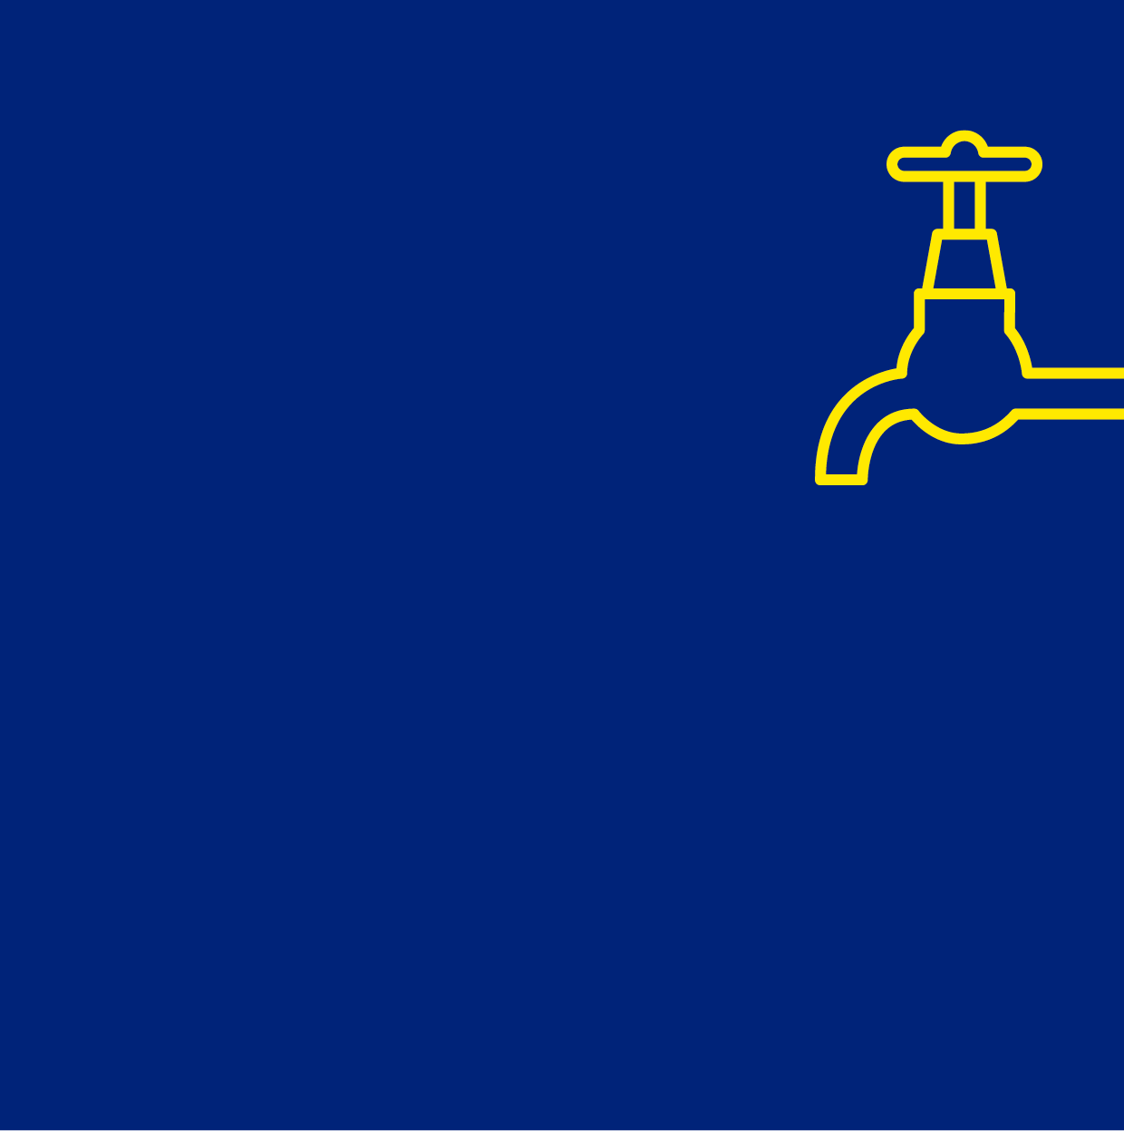
Part 1:
Our commitment to delivering outcomes
for customers

01

Part 1: Our commitment to delivering outcomes for customers
Part 1 of the 2023–28 Price Submission explains the outcomes agreed with customers that South East Water is focused on delivering.
Part 1 explains:
- Our performance in the current 2018–23 regulatory period against the outcomes agreed with customers (Performance)
- How we have engaged with our customers and other stakeholders to establish the outcomes we will deliver in the 2023–28 period, and associated investment levels (Engagement)
- The outcomes, as determined by customers, that we will deliver over the 2023–28 period and the specific outputs and deliverables we will measure (Outcomes)

- Performance

Key points
- South East Water has delivered agreed outcomes for the 2018–23 period to a high standard.
- This is reflected in high levels of customer satisfaction expressed in the surveys conducted by the ESC and South East Water.
- There has been some variation from benchmark expenditure allowances in the current regulatory period, which are largely associated with factors outside of our control.
- Our PREMO self-assessed rating for Performance is Confident overall performance is ‘Advanced’.

This Performance element of the price submission reports on our performance delivering key services and outcomes during the current 2018–23 regulatory period.
South East Water has developed a comprehensive performance assessment framework that converts performance into a scoring system consistent with the ESC’s scoring methodology. The assessment framework has informed our self-assessment of the performance or ‘P’ element of PREMO.
We undertook the design of the performance assessment framework with our Customer and Community Advisory Council (CCAC), Executive team and board.
In line with the ESC’s guidance, our assessment framework measures performance in the current regulatory period in terms of:
- delivering the 5 customer service outcomes agreed with customers
- delivering prudent and efficient expenditure outcomes and explaining departures from the benchmark expenditure allowances set for the period (for controllable operating expenditure, capital expenditure and delivery of major capital projects)
- customer satisfaction outcomes achieved.
Detail on the performance assessment framework and performance outcomes
is provided in our Performance Self-Assessment Framework (Appendix 3).

1.1 Performance delivering outcomes
For the current 2018–23 regulatory period, South East Water agreed with customers that we would deliver on 5 outcomes:
- Get the basics right, always: delivering service quality outcomes
to customers.
- Warn me, inform me: delivering outcomes that keep customers well informed during service interruptions.
- Fair and affordable for all: delivering efficient operating cost outcomes and support for vulnerable customers.
- Make my experience better: delivering outcomes to support customer satisfaction.
- Support my community, protect
our environment: delivering agreed environmental outcomes.
We regularly report our performance on delivering these outcomes, including performance against each of the 18 output targets. We have reported quarterly to our customers and annually to the ESC.
Over the current regulatory period to date (that is, the 4-year period from 2018–19 to 2021–22), we have performed to a high standard. Key features of our performance against output targets are as follows:
- Of the 18 targets delivered in each of the 4 years, we have met the target or have been within the tolerance band 93% of the time, only missing a target on 5 occasions.
- We have met all targets over the 4 years for Outcome 1: Get the basics right, always and for Outcome 3: Fair and affordable for all. This means that we have consistently been compliant with the Safe Drinking Water Act 2003 and have addressed network issues such as water main leaks and sewer blockages, ensuring minimal impacts for customers.
- We have met targets over the
4 years on:
    - all but one occasion for Outcome 2: Warn me, inform me
    - all but 2 occasions for Outcome 4: Make my experience better and Outcome 5: Support my community, protect our environment.
- The few instances where the target or tolerance band were not met did not represent major variations from the target. Any variations were generally due to setting a higher stretch target or due to external events. For example, we have changed the definition of customer complaints in order to capture better information on customer pain points that can be acted on. The coronavirus (COVID-19) impacted on the delivery of recycled water targets.
Applying South East Water’s performance assessment framework, our score for 2021–22 is 3.5 out of 4. This equates to
a PREMO performance rating of Very confident the element is ‘Advanced’.

1.2 Expenditure performance
Expenditure performance is assessed in terms of expenditure outcomes in the 2018–23 regulatory period relative to the benchmark expenditure allowance for controllable operating expenditure, capital expenditure and major capital project delivery. In summary:
- controllable operating expenditure is forecast to be in line with the 2018–23 benchmark allowance (see Section 7)
- capital expenditure is expected to be 0.1% above the 2018–23 benchmark allowance (see Section 6)
- the top 10 major projects have been implemented diligently and the unavoidable variances from our original plans are able to be explained.
Based on our performance assessment framework, performance is consistent with ‘Leading’ and ‘Advanced’ PREMO ratings (see Table 5).

Table 5: Performance rating overview
Expenditure performance | Score | Comment
Controllable operating expenditure outcome relative to allowance | 4 out of 4 | Equates to PREMO performance rating of  Very confident the element is ‘Leading’
Capital expenditure outcome relative to allowance | 4 out of 4 | Equates to PREMO performance rating of  Very confident the element is ‘Leading’
Top 10 major project delivery against expectations | 3 out of 4 | Equates to PREMO performance rating of Satisfied the element is ‘Advanced’

Further detail on the calculation of these scores is provided in the Performance Self-Assessment Framework (Appendix 3) and Major Projects (2018–23) Summary Report (Appendix 2).

1.3 Benchmarking against industry performance

Customer satisfaction
Customer satisfaction with South East Water is regularly tested in surveys conducted by the ESC and by our organisation. Both sources indicate a high level of customer satisfaction since the commencement of the 2018–23 regulatory period.
The ESC’s quarterly Water Customer Satisfaction Survey (which asks customers about their view on value for money, reputation in the community, level of trust and overall satisfaction) shows that we consistently have had one of the higher customer satisfaction ratings among the Victorian water businesses in the current regulatory period.
Figure 1 provides the most recent survey results (for 2021–22) and shows that South East Water has the highest customer satisfaction rating among the Victorian water businesses.

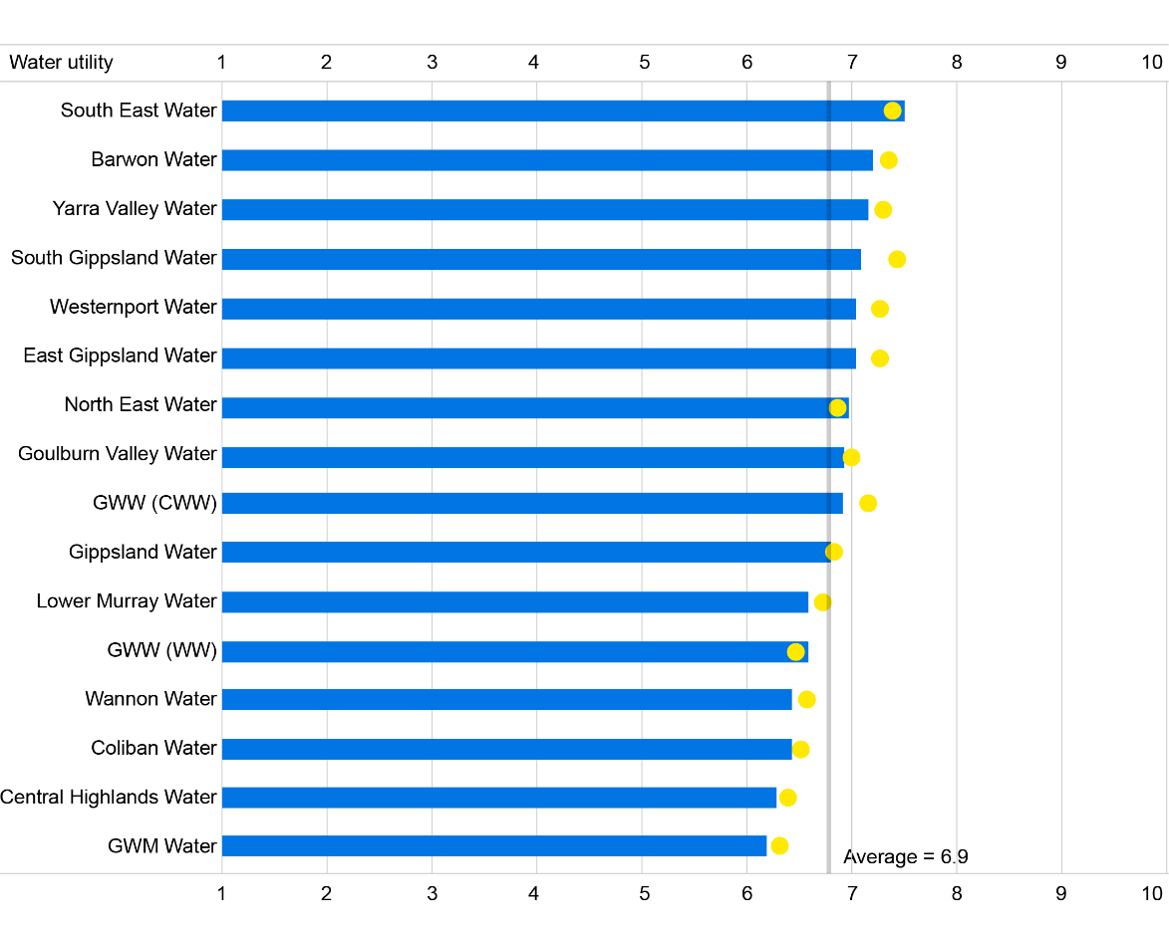
Figure 1: Overall customer satisfaction rating (score out of 10)

Note: The yellow dots show April 2021 to January 2022 results. The bars show July 2021 to June 2022 results.
Source: Essential Services Commission 2022.

There is also consistency in customer satisfaction outcomes between the ESC and our own customer surveys. We test customer satisfaction on an ongoing basis via:
- post-interaction surveys: sent out following an inbound call to the accounts and faults lines, completing a transaction or lodging an enquiry online
- after an unplanned interruption: emailed and letterbox drop surveys (containing the same questions) that go to any household affected by an unplanned water supply interruption
- a Brand tracker survey: a monthly survey conducted by a panel provider, targeting consumers in our service area who may not be account holders.
Over the period 1 July 2018 to 31 March 2022, 102,652 participants responded to these surveys providing the following satisfaction scores (with 100% representing the highest possible score):
- overall customer satisfaction: 84%
- reputation: 83%
- trust: 85%
- value for money: 73%

Industry benchmark score
South East Water’s performance assessment framework scores our performance relative to the average for the Victorian water industry, as reported in the ESC’s Water Performance Report. This report benchmarks a number of aspects of industry performance including a range of customer perception measures and service quality outcomes. The assessment framework accounts for performance over the 5-year period from 2017–18 to 2021–22 and across the 20 reported industry performance metrics.
Our total score of 3.5 out of 4 equates to a PREMO performance rating of Very confident the element is ‘Advanced’.

1.4 PREMO summary – Performance
The performance scores are summarised in Table 6, showing that South East Water’s overall score is 18, which equates to a rating of Confident overall performance is ‘Advanced’.

Table 6: Performance summary
Performance element | Score | Rating
Delivery of customer outcomes | 3.5 out of 4 | Very confident the element is ‘Advanced’
Controllable operating expenditure | 4 out of 4 | Very confident the element is ‘Leading’
Capital expenditure | 4 out of 4 | Very confident the element is ‘Leading’
Major projects delivery | 3 out of 4 | Satisfied the element is ‘Advanced’
Industry benchmark | 3.5 out of 4 | Very confident the element is ‘Advanced’
Total combined scores | 18 out of 20 | Confident overall performance is ‘Advanced’

Table 7 provides our responses to the ESC’s guiding questions for PREMO assessment
in relation to the Performance element.

Table 7: Response to performance guiding questions
Guiding question | Response
To what extent has the organisation demonstrated delivery of its customer outcomes commitment over the current regulatory period? Did its customers get what they paid for? | We have delivered customer outcomes to a high standard to date, ensuring that customers received the outcomes they paid for. Of the 18 targets delivered in each of the 4 years (that is, 18x4 or 72 targets), we have met the target or been within the tolerance band 93% of the time, only missing the target on 5 occasions.  The few instances where the target or tolerance band was not met did not represent major departures and were generally due to setting a higher stretch target or external events.
How does actual operating expenditure across the current period compare with the established benchmark allowance, and to what extent has the organisation rationalised any discrepancies? | The total operating expenditure, including a forecast for year 5, is slightly lower than the benchmark operating expenditure allowance for the 2018–23 regulatory period.  Further detail is provided in Section 7.
How does actual capital expenditure across the current period compare with the established benchmark allowance, and to what extent has the organisation rationalised any discrepancies? | Capital expenditure is expected to be 0.1% above the 2018–23 benchmark capital expenditure allowance.  Further detail is provided in Section 6.
To what extent does customer sentiment demonstrate satisfaction in the organisation’s performance over the current regulatory period? Are customers happy with the value they receive from their water organisation? | We have performed strongly in both our own customer sentiment surveys and those conducted by the ESC as part of the annual benchmarking program. Over the 2021–22 financial year, the ESC reported that South East Water achieved the highest overall customer satisfaction score among the Victorian water businesses.  Total complaints per 100 customers are currently higher than our target. However, we are purposefully capturing feedback across a broader range of channels and are defining more feedback as complaints. Figure 18 This is being done to provide greater business focus on customer  pain points.

Supporting documents
- Performance Self-Assessment Framework – Appendix 3
- Major Projects (2018–23) Summary Report – Appendix 2

Supporting documents
- Performance Self-Assessment Framework – Appendix 3
- Major Projects (2018–23) Summary Report – Appendix 2

2. Engagement

Key points

In addition to the feedback we receive through ongoing customer engagement, South East Water has extensively re-engaged with customers and stakeholders to prepare our 2023-28 Price Submission.

The engagement was comprehensive, encompassing all elements of our customer base, our broader community and key stakeholders. It specifically engaged customers and communities experiencing vulnerability and First Nations people, engaging these groups on their terms.

The 5 customer outcomes we will deliver to customers have been reaffirmed and we have engaged on the issues that are important in driving customer value.

Using the engagement information, a deliberative process with customers was used to decide how to reflect customers' views in our price submission. This positions the engagement process at the 'Collaborate' to 'Empower' end of the IAP2 engagement spectrum.

Our PREMO self-assessed rating for Engagement is ‘Advanced’, given the extent and depth of the engagement process and that it has significantly shaped and influenced our plans and price submission.

This Engagement element of the price submission describes how South East Water has engaged with customers and other key members of our community to develop our plans for the 2023–28 regulatory period. It also explains how the engagement feedback has been reflected in this price submission.

2.1 Our approach to engagement
South East Water, with the support of professional engagement firms, has designed and delivered a comprehensive and customer-centric engagement program to assist with the development of our 2023–28 Price Submission. The engagement program has followed a logical sequence to obtain agreed positions with customers on outcomes and investments for the 2023–28 regulatory period reflecting what customers told us is important to them.

The engagement program consisted of 5 key phases as shown in Figure 2.
Figure 2: Engagement journey
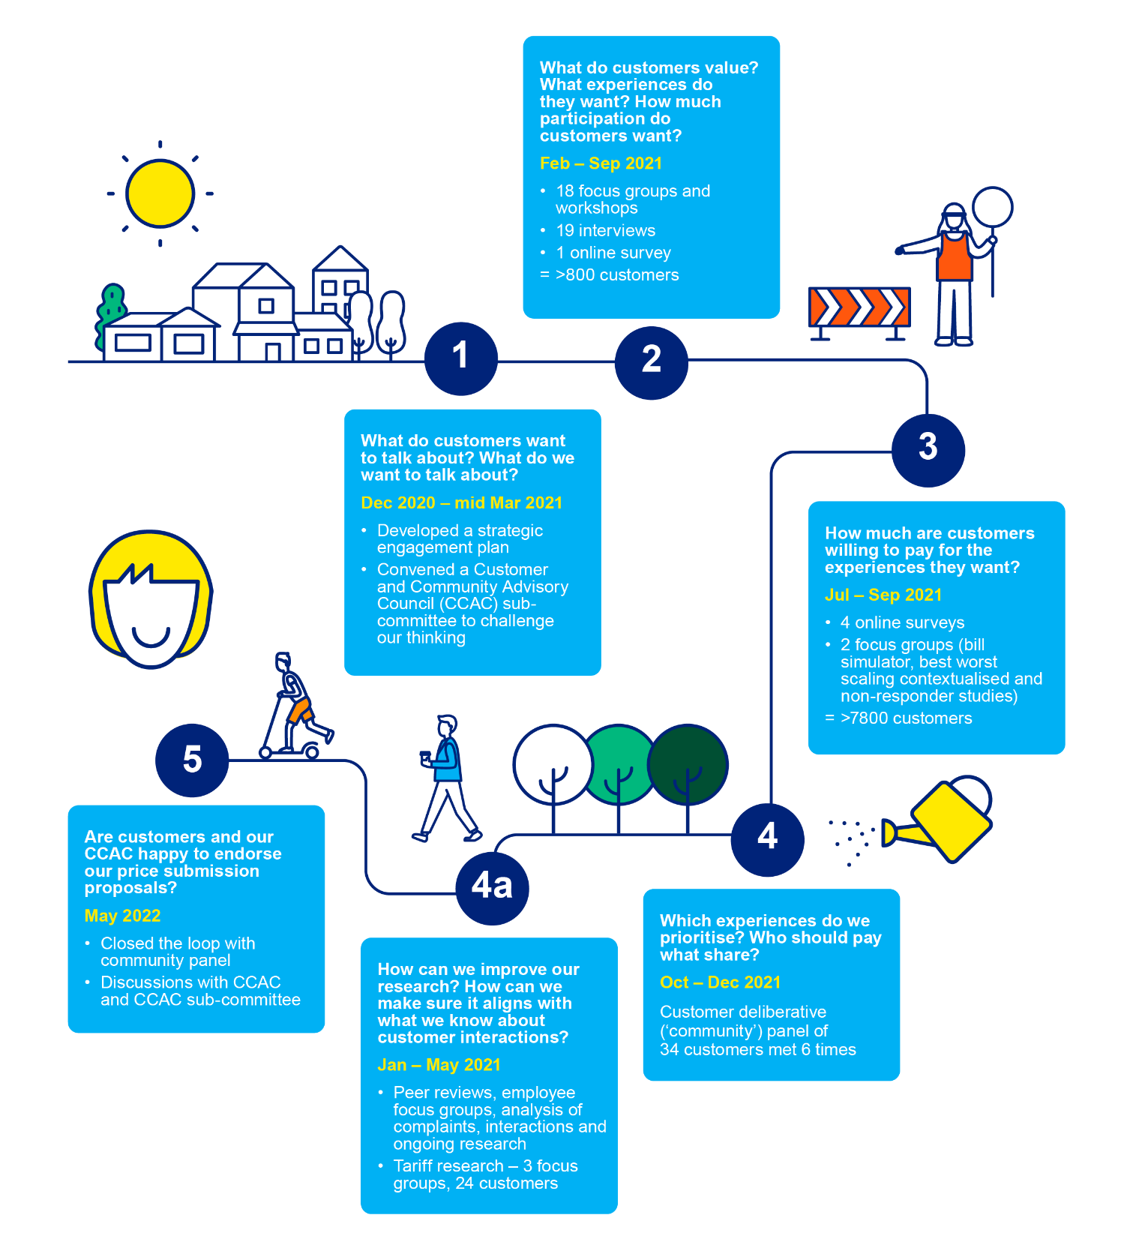

In Phase 1, a strategic engagement plan was developed with the Executive team to understand the information we already had and how we needed to build on this to prepare the 2023–28 Price Submission.

In Phases 2 and 3, extensive primary research and engagement were undertaken involving over 8,600 customers (see Table 8 for detail on each element). The broad engagement in Phase 2 explored the issues that are important to customers and the nature and level of service outcomes that they value. The level of engagement that customers and stakeholders were seeking as part of developing the price submission was also tested.
Phase 3 investigated willingness to pay (WTP) for different service level outcomes and tested the relative importance of different service outcomes to overall customer value (by exploring preferences and ranking).
The comprehensive WTP analysis also investigated:
- the WTP values of different customer groups including financially vulnerable customers and pensioners
- WTP for core service standards (such as reduction in service interruptions) and broader outcomes (such as sustainability and emission reduction outcomes).
We also investigated the customer and community views gained via the engagement processes embedded in the operation of our organisation. This included:
- regular discussion with our CCAC
- information from our frontline employees (summarised in a report prepared by JWS Research)
- ongoing customer surveys we conduct (including post-interaction surveys, post-supply interruption surveys, and a monthly Brand tracker survey).
Table 8: Stages of customer research and engagement (phases 2 and 3)
Timing | Engagement activity | Objective/purpose
What do customers value?
March 2021 | 5 public workshops (n=86 including customers experiencing hardship) | To understand the interests, concerns and priorities of our customers
April 2021 | 10 focus groups (n=98 including customers experiencing hardship) | To understand the interests, concerns and priorities of our customers
May 2021 | 6 community focus groups (n=63) | Expectations about customer involvement in decision making for price submission
May–June 2021 | 19 stakeholder interviews (n=25) | To understand the interests, concerns and priorities of particular stakeholders including small and large businesses, environmental groups, not-for-profit groups, property developers and councils
May–June 2021 | Online survey (n=549) | What Matters to You?  All customers given an opportunity to take the survey.
Sept 2021 | First Nations focus group (n=5) | To understand the interests, concerns and priorities of our First Nations customers.
How much are customers willing to pay?
July–Sept 2021 | WTP survey using bill simulator (self-selecting)  (n=2,687) | Have your say on what you’ll pay  Testing of WTP for different levels of service/outcomes associated with 7 topics:  - Service disruptions and sewer spills  - Integrated water management  - Education and awareness  - Affordability  - Digital meters  - Sustainability  - Climate change
Aug 2021 | WTP survey using bill simulator  (paid panel)  (n=401) | Have your say on what you’ll pay: Non-responder (Dynata survey)  Topics as above
Aug–Sept 2021 | WTP survey using bill simulator (customer had experienced disruption or leak) (Disruption n=630, Leak n=486, including 198 both disruption and leak) | Have your say on what you’ll pay: Contextualised study  Topics as above
July–Sept 2021 | Preferences survey using 7-point scale from strongly disagree to strongly agree (n=2,256) | Willingness to Pay: What Matters to You?  Preference testing on 6 topics: innovation, environment, water security, education, community support and digital meters
July–Sept 2021 | Ranking survey using best worst scaling (n=1,532) | It’s your choice  To explore how customers want services delivered relating to: Service disruptions and sewer spills; supporting the community; digital metering; education; greenhouse gas emissions reduction; alternative water.
Sept 2021 | 6 WTP focus groups (n=42) | Test WTP values of pensioners, tenants, homeowners, long-term financially vulnerable customers, newly financially vulnerable customers and small business owners
8,662 people engaged

In Phase 4, a deliberative engagement process between South East Water and a community panel agreed on how best to reflect customer views and values in the price submission.
A separate, comprehensive engagement process has also been undertaken to explore potential tariff reforms. This is discussed in the tariff section of the price submission.

2.2 Key issues covered in engagement
The issues covered in South East Water’s engagement were informed by:
- early, open engagement with our customers and community that allowed issues of concern and interest to be raised by them (rather than directed by us)
- testing whether the outcomes we agreed with customers for the 2018–23 regulatory period need to change for the forthcoming period
- new aspects of our business strategy and planned investments that are designed to ensure that we deliver agreed outcomes in the best way for customers.

The key issues tested in the engagement program encompass:
- delivery of core service outcomes (service disruptions and sewer spills, digital meters)
- services with broader environmental and community benefits including integrated water management, education and awareness and sustainability and climate change
- testing how best to deliver affordable services
- whether our customer outcomes still resonated.

2.3 How engagement has informed this submission

What was learnt from our initial phases 2 and 3 engagement
The following summarises the key outcomes from the initial phases of customer research and engagement. This was an important input to the subsequent deliberation with the community panel and CCAC on how best to reflect customer views in the price submission.

Customer outcomes
The 5 outcomes agreed for the current 2018–23 regulatory period still resonate with customers and qualitative surveys and focus groups showed the strongest support for the ‘Make my experience better’ outcome.

Disruptions and sewer spills
High-quality drinking water and reliable supply (water and wastewater) were most highly valued in qualitative surveys and focus groups. WTP analysis showed support for an increase in expenditure to reduce water supply outages. Best worst scaling analysis showed the strongest support for increased expenditure to reduce the number of sewer spills.

Other customer experience issues
Customers are seeking easier access to information on South East Water’s website, including information addressing common questions such as bills and charges and information needed when moving. Customers are also seeking improved functionality to allow them to self-serve by completing key tasks themselves online. This includes self-reporting of faults, completing a variety of application forms and paying bills and charges.

Affordability
Qualitative surveys and focus groups considered that affordability should be considered and suggested supporting the charities that directly assist vulnerable customers as a means of aiding customers most in need. First Nations customers sought support and compassion for vulnerable customers, including to help them understand payment
options and how to communicate with South East Water on their affordability issues.
WTP analysis supported an increase in expenditure to assist customers in genuine financial need.

Digital meters
WTP analysis survey participants supported an increase in expenditure to roll out digital meters.

Innovation
Qualitative surveys and focus groups showed support for South East Water taking a lead on innovation.

Education and awareness
Qualitative surveys and focus groups supported education and communication on water conservation. This is also an issue that is important to First Nations customers. WTP analysis showed support for an increase in expenditure to fund water-related education.

Integrated water management
Qualitative surveys and focus groups expressed ongoing community concern about securing future water supply and improving waterway health via Integrated Water Management investment. Best worst scaling analysis showed the strongest support for recycled/stormwater projects for agricultural and business users to create further jobs
and employment. WTP analysis showed support for an increase in alternative water investment.

Sustainability and climate change
Qualitative surveys and focus groups indicated that customers prioritise local environmental benefits. This includes providing healthy waterways and places to walk/ride/relax in nature. First Nations customers also supported riverbank and environment rehabilitation. WTP analysis showed support for an increase in expenditure to fund emissions reduction.

Deliberative process with community panel
A community panel was convened to work with South East Water in a deliberative process that would consider how to best reflect customer and stakeholder views within the 2023–28 Price Submission. The community panel was specifically tasked with considering how we balance differing community needs and cost our services effectively for current and future communities.
Six full days of facilitated education and deliberation sessions were undertaken over the period from October to December 2021. With the challenge of coronavirus (COVID-19) impacts on the process, the community panel fluctuated between 29 and 35 participants, with 33 participating on the final day.
As described in Table 9, the community panel made 8 final recommendations, which were subsequently presented to the South East Water Board.

Table 9: Community panel recommendations
Recommendation | Degree of panel support | What this means for  South East Water
Water security (quality and quantity) achieved sustainably for now and  the future | Super majority agreement ¹ | Increase South East Water’s commitment to providing alternative water sources for current and future generations in a sustainable and cost-effective manner.
Reliable service across the whole network | Unanimous agreement | Increase spending on proactive planned maintenance and upgrades  to systems and processes to reduce unplanned disruptions. Stricter targets on disruptions (fewer disruptions). Deliver in a cost-effective manner.
Water security awareness | Super majority agreement | Support for educating all demographics. Survey customers  on level of awareness and report  this outcome.
Bills to be clear, simple  (easy to navigate) and transparent | Super majority agreement | Provide facts and tips in bills that meet accessibility standards and encourage customers to move to electronic bills.
Digital meter rollout | Super majority agreement | Replace all meters with digital meters over 6 years, offer flexible payment terms and provide timely communications and data to customers from the meter data.
Effective and efficient communication | Unanimous agreement | Ongoing communication with customers via bills and proactive communication for disruptions/ works (including via email and text). Offer discount to customers that did not receive communication of a significant disruption.
Delivery of innovative and best service methodology by SEW | Super majority agreement | Focus innovation on security and sustainability outcomes including through potential innovation relating to recycling, innovative communications and benchmarking/ best practice.
Affordable and accessible service | Unanimous agreement | Continue providing bill relief to customers on a needs basis. Review tiered pricing for commercial and high water usage customers only. Create  a fund to help support vulnerable customers when in need (optional participation).
Source: MosaicLab and Insync, Community Panel, Process Report, December 2021 and Community Panel, South East Water Price Submission Panel Report, 4 December 2021
1. Super majority agreement reflects 80% or more agreement.

2.4 ‘Closing the loop’ to reflect customer views in the price submission
South East Water has prepared detailed expenditure proposals based on what we heard in the engagement process and the deliberation with the community panel.
This was done in 2 key steps.

Step 1: Reflecting customer outcomes in price submission proposals
First, we went through a comprehensive process of incorporating the engagement outcomes within our plans and expenditure proposals for the 2023–28 period.
This was done by incorporating key customer engagement recommendations, including those from the community panel, into the South East Water strategic prioritisation framework. This is a tool we use to refine our proposed future capital expenditure program. The main desired customer outcomes were mapped to supporting investments and initiatives.
The prioritisation framework was used by the Senior Leadership team to draft a future capital expenditure program, reflecting customer priorities, which was further refined by the executive team and board.
In summary, key customer views are reflected in this price submission in the following ways:
- Affordability: Drawing on a range of customer feedback sources and recognising broader cost-of-living pressures, South East Water proposed to hold prices stable
in real terms (that is, prices will only rise in line with CPI).
- Customer outcomes: The 5 customer outcomes were validated in the engagement process, including with the community panel.
- Major projects and investments: Proposed major projects and investments are
mapped against each of the community panel’s 8 recommendations.
- GSL: GSL modifications were proposed in response to feedback including the
addition of a GSL relating to notification of planned water supply interruptions.
More detail is provided in the supporting document Closing the loop.

Step 2: ‘Closing the loop’ with the community panel
The second step of incorporating customer views within this price submission was then
to ‘close the loop’ by testing proposals with the community panel. The community panel was reconvened in May 2022. Fifteen members of the community panel attended the recall day.
The panel deliberated and overwhelmingly endorsed the expenditure program as reflective of their recommendations. ‘Comfort’ levels expressed by the community panel provided an average of 93% score for ‘Like it’ and ‘Love it’ across all 8 recommendations.
The strongest levels of comfort related to:
- Recommendation 5: Digital meter rollout
- Recommendation 6: Effective and efficient communication
- Recommendation 8: Affordable and accessible services.
The lowest level of comfort was with Recommendation 3: Water security awareness where panel members expressed a preference for lower investment.

2.5 Ongoing culture of embedded engagement
South East Water does not limit its engagement with customers and stakeholders to the process of preparing our price submission. Involving and engaging with our customers and community is an important part of our day-to-day business culture and operation.
We have an ongoing customer insights program to help provide an understanding of what is important to our customers and how they feel with respect to value-for-money, trust, reputation and overall satisfaction. The outcome of the program helps inform the organisation on investment priorities and customer improvement initiatives.
The program adopts a multi-pronged approach to ensure that we consider various sources of information from a moment in time as well as from a longitudinal perspective.
Key elements of the customer insights program include:

1. Daily post-transaction customer feedback (surveys)
On average, we conduct and analyse (290,000 – issued/23,000 – received) post-transaction surveys each year that provide insights on a weekly, monthly, quarterly, and annual basis. These allow us to understand customer sentiment at a granular level with respect to a broad range of matters including customer service quality, customer billing experiences and water service delivery. At present, we gain customer feedback through
5 transactional channels (customer contact centre, payments and affordability, customer portal, faults and emergencies, and unplanned water interruption events).

2. Monthly field surveys
Each month, we conduct over 200 field surveys (Brand tracker) to understand the most important factors that influence our customers’ perception and how that translates to operational priorities and improvements.

3. Weekly network services surveys
Each week we send digital feedback surveys to customers who had contacted us to report a water or sewer issue or recently had work completed at their property. This gives them the opportunity to provide feedback and score us from 1 (poor) to 10 (excellent) on service, attitude, time to repair and overall thoughts on their experience and the organisation. These surveys and scores are used to inform our customer satisfaction scores (CSAT), contractor performance reports and KPIs, and identify opportunities for improvement and allow us to follow up directly with customers to resolve issues.

4. Customer engagement data analysis
To complement the insights gained from the customer feedback and field surveys, we conduct analysis on transaction data including customer verbatims and engagement trends to enrich our learnings and inform further customer research focus areas.

5. Focused customer research
To support key outputs from customer research that relate to water literacy and lowering bills through behaviour change, we have developed more focused research programs to enhance our understanding in terms of customer behaviour and what measures we can use to encourage customer behaviour change.

6. Expanding the customer insights program
We have recruited customer research experts, who give us the capacity to further embed customer insights in our core business and to incorporate ongoing customer focus groups, with the aim of tailoring services to meet specific customer segments.

7. ‘Closing the loop’ with continuous learning
When our customers rate us below 6 for satisfaction, we conduct an internal review of the transaction to understand where we can improve. This can include coaching and development for our teams, system improvements and conversations with our customers.
In addition to the above insights program, we will enhance our capabilities through digital metering and customer management systems that will improve our understanding of customers and allow us to respond to their needs more effectively.
Finally, our CCAC will continue to play a vital role in helping us to connect with and understand our communities.

2.6 PREMO summary – Engagement
Table 10 provides our responses to the ESC’s guiding questions for PREMO assessment in relation to the Engagement element.
Table 10: Responses to engagement guiding questions
Guiding question | Response
To what extent has the organisation justified how  the form of engagement suits the content of consultation, the circumstances facing the water organisation and its customers? | South East Water has undertaken different forms of engagement to suit the different engagement needs of our customers and our organisation.  For example:  - More open conversations and engagement at the start of the process allowed customers and the community to tell us about their concerns and how involved they would like to be in the submission development process.  - Conversations with customers experiencing vulnerability and First Nations people were designed with sensitivity and to be on their terms.  - More targeted and professionally designed surveys were undertaken to test WTP.  - Facilitated and deliberative processes designed for collaborative decision making were used to directly involve the community panel  in the development of this price submission.
To what extent has the organisation demonstrated that it provided appropriate instruction and information to customers about the purpose, form and content of the customer engagement? | Our customer engagement processes were conducted by professional engagement delivery partners, including Insync and MosaicLab. For each engagement process, together with our engagement delivery partners, we designed easy-to-understand information and guidance material.  This underpinned the validity of the more formal surveys and ensured that customers were sufficiently informed to engage in a meaningful way.  The community panel, who we worked with to determine key elements  of expenditure and price submission priorities, were given extensive information and training in advance of the deliberative sessions that resulted in their recommendations to us.
To what extent has the organisation demonstrated that the matters it has engaged on are those that have the most influence on the services provided to customers and prices charged? | The breadth of the engagement undertaken means that it has encompassed the matters that will have the most influence on services  and prices. This has included engagement on:  - the outcomes that customers are seeking  - the major elements of our expenditure program including service quality and digital transformation including digital metering  - how best to address broader priorities including environmental (emission reduction and integrated water management) and social priorities (assistance to customers experiencing vulnerability)  - the price impacts of different expenditure and service options  - how costs are translated in tariff forms.
To what extent has the organisation explained how it decided when to carry out its engagement? | As explained above, South East Water has well-established processes for ongoing engagement with customers that provide continual feedback to the organisation on customer concerns, friction points and degree of satisfaction. This means that additional engagement that is conducted specifically to assist with developing the detail of this price submission is building on a rich information base.  We have widely communicated our engagement timeline and processes during the development of the price submission. This has included providing information on our website:  https://southeastwater.com.au/about-us/our-role/plan-for-the-future/  We have explained each step of our planned engagement program and reported on outcomes as they were completed.
To what extent has the organisation demonstrated how its engagement with customers has influenced its submission? | South East Water has outlined a clear process by which it has taken the outcomes of the customer engagement and used a deliberative process with customers to agree on how this should be reflected in the 2023–28 Price Submission. The deliberative panel were also given the opportunity to provide feedback on the draft submission in the ‘closing the loop’ stage, specifically how their recommendations had been interpreted and represented in this submission.
To what extent has the organisation demonstrated that its engagement was inclusive of consumers experiencing vulnerability? | South East Water engaged with customers experiencing vulnerability  as part of the price submission specific engagement (Phases 2 and 3). We also have a range of business-as-usual engagement activities with customers experiencing vulnerability through the delivery of customer support programs.
To what extent has the organisation demonstrated that its engagement was inclusive of First Nations people? | South East Water engaged with First Nations people as part of the price submission-specific engagement (Phase 2). We also regularly engage with Traditional Owners in our service area, including Bunurong Land Council Aboriginal Corporation and Wurundjeri Woi Wurrung Cultural  Heritage Aboriginal Corporation as part of our Reconciliation Action Plan.

South East Water has delivered comprehensive customer and community engagement, and customer preferences have strongly influenced our 2023–28 expenditure priorities and price submission proposals.

As a result, our PREMO self-assessed rating for engagement is ‘Advanced’.

Supporting documents
- South East Water Strategic Engagement Plan, South East Water Price Submission 2023
- Insync and MosaicLab, Stage Two Engagement Findings Report, July 2021
- South East Water Customer Engagement Report, October 2021
- MosaicLab and Insync, Community Panel, Process Report, December 2021
- Community Panel, South East Water Price Submission Panel Report, 4 December 2021
- Insync, Willingness To Pay Study Summary
- JWS Research, Pricing Submission Employee Research, February 2022
- Painted Dog Research, SEW Customer Research and Data Audit: Exploring our Internal Customer Data, April 2022
- South East Water, ‘Closing the Loop’, Customer Deliberative Panel, 14 May 2022
- MosaicLab and Insync, Community Panel Recall Day, ‘What Was Said’ Report, May 2022

3.Outcomes

Key points
- As reaffirmed with customers, South East Water will retain its 5 outcomes for the
2023–28 regulatory period.
- The output measures and targets have been refined to reflect the evolving outcome expectations of our customers and the service capabilities expected from our digital strategy investments.
- Our PREMO self-assessed rating for outcomes is ‘Advanced’.

This Outcomes element of the price submission provides South East Water’s proposed outcomes for the 2023–28 regulatory period, and the associated output measures and targets. It also provides our proposed Guaranteed Service Levels (GSLs).

3.1 Proposed outcomes and outputs
The proposed output measures and targets associated with each of the 5 outcomes are summarised below, along with information on key actions and programs that would support their achievement.
The comprehensive engagement processes outlined in the customer engagement section allowed us to test whether our customers and community are seeking changes to the 5 customer outcomes delivered in the 2018–23 regulatory period, namely:
- Outcome 1: Get the basics right, always
- Outcome 2: Warn me, inform me
- Outcome 3: Fair and affordable for all
- Outcome 4: Make my experience better
- Outcome 5: Support my community, protect our environment.
The engagement process found that while the overall sentiment and expectations of our customers have been evolving, they had not shifted at a thematic level and that our existing 5 customer outcomes remain valid and fit-for-purpose.
However, the prioritisation process that South East Water used to incorporate customer views in the 2023–28 expenditure priorities and plans was also used to update the output measures and targets for each of the 5 outcomes. This process has aligned the outputs and targets to updated service levels and priorities flowing from agreed investments and initiatives for the 2023–28 regulatory period.
For example, our proposed digital utility investments (including digital metering) will improve our visibility of the network and identification of defects at an earlier stage, supporting a reduction in unplanned, emergency interruptions to customer services.
This has allowed us to tighten our output measures and targets relating to unplanned service disruptions, and to expand the targets to encompass water, sewerage and water quality disruptions.
The proposed outcomes and output measures will be continuously monitored through our ongoing customer engagement program (outlined in Section 2.5) to ensure our levels of service align to any changes in customer preferences.

Outcome 1: Get the basics right, always
Customers have told us that it is critical that the services we provide are safe and reliable.
For them, it is important we maintain and improve upon current high levels of service and that, as experts in our field, they trust and expect us to continuously innovate and improve.
For us, that means full compliance with drinking water standards and fewer unplanned disruptions for customers across all our services. It means continually refreshing our knowledge, using ideas from across the sector, and drawing on predictive digital technologies to proactively find better, less disruptive ways to deliver the basics for
our customers.

Table 11: Outcome 1 output measures and targets
Output measure | Existing, improved or new | 2021—22  result | 5-year average | 2027–28  target
Percentage compliance with drinking water standards | Existing | 100% | 100% | 100%
Customers experiencing more than 5 unplanned disruptions in a 12-month period (water, sewer and water quality)¹ | Improved | Redefined | N/A | 450
Total volume of water saved through digital detection of network leaks (ML) | New | 0 | N/A | 1,271
Key supporting actions, activities and programs
Digital utility
Digital metering
Potable water quality
Potable water reliability renewals and compliance
Water quality disruptions relate to the issue of a ‘Do not drink’ or ‘Boil water’ advisory

Output measures for the 2018–23 period (Get the basics right, always) included 3 separate service standard outputs relating to different aspects of service:
- number of water quality complaints per 100 customers
- number of customers receiving greater than 5 unplanned water supply interruptions
- number of customers receiving 3 or more sewerage blockages.

These have been combined into an ‘all-of-service’ output measure for unplanned interruptions based on customer sentiment that any disruption is an inconvenience, regardless of the specific service.
An additional output measure has been added under Outcome 1, relating to:
- volume of water saved through digital detection of leaks.

Outcome 2: Warn me, inform me
Our customers told us they’d like to be better informed of disruptions, including better visibility of leaks on their premises and timely warnings when there are wider network disruptions.
Advanced network monitoring and digital meters installed across our whole service region will provide more customers access to near real-time water usage information and notifications of any irregularities. This allows faults to be detected and fixed more quickly and provides customers more control over their water use and bills.

Table 12: Outcome 2 output measures and targets
Output measure | Existing, improved  or new | 2021—22  result | 5-year average | 2027–28  target
Customer savings realised through repair of digital meter detected property leaks | New | $585,700 | N/A | $7,793,723
Customers notified per unplanned disruption as a percentage of total customers affected | Existing | 71% | 63% | 75%
Water literacy of South East Water customers | New | N/A | N/A | 31%
Key supporting actions, activities and programs
Digital utility
Digital metering
Customer information systems
Customer education programs and monitoring of knowledge levels

The Warn me, inform me output measures have been modified to ensure that customers receive the intended outcomes from the investment in digital utility capability, and in response to customer feedback that valued improved water literacy.
Discontinued outcome measures from the current period are:
- average duration of unplanned water supply interruptions (noting that Outcome 1 retains an output measure related to unplanned interruption frequency)
- percentage of customers impacted by an unplanned water supply interruption in peak times
- percentage of planned water interruptions restored within notification period.
Each of these discontinued measures remains as operational performance measures that underpin our service standards; however, they were found to not directly measure our customer panel recommendations and areas of greatest interest.
Two additional output measures have been added under Outcome 2, relating to:
- the customer savings (benefits) realised through digital meter detected property leaks
- level of water literacy across our service area.

The new output measures have been developed to directly report back to customers on key areas discussed and endorsed during our engagement program and align with the community panel recommendations.

Outcome 3: Fair and affordable for all
Providing essential services to our community, our customers expect our services and charges to be fair and affordable for all. They’ve told us they expect us to continue to provide support to those who need it, and to keep learning, so we can tailor our support for changing times.
Fairness means providing an equal approach to how customers find out about and access our support options, when they have the intention, but not the financial capacity, to make the required payments.
Affordability means providing good value, prudent and efficient services by drawing on the benefits of digitisation, freeing up fixed charges where we can and identifying efficiencies in how we deliver all customer outcomes.

Table 13: Outcome 3 output measures and targets
Output measure | Existing, improved or new | 2021—22  result | 5-year average | 2027–28  target
Percentage of existing properties upgraded to a digital meter | New | 9% | N/A | 85%
Number of customers supported (provided assistance) | Existing | 10,612  (COVID-19 impacted) | 7,134 | 10,000
Percentage of customers with arrears older than 90 days who have used South East Water support offerings | New | 41% | 37% | 55%
Key supporting actions, activities and programs
Customer support programs
Digital utility
Digital metering
Efficiency rate of 2.0%

The Fair and affordable for all output measures have also been modified to align outcomes to the implementation of our digital utility capability, and in response to customer feedback on ensuring affordable and accessible services.
The operating cost per property measure has been removed. Operating cost efficiency will still be tracked and scrutinised under the PREMO framework.
The outputs are defined to better capture support outcomes for customers, including those most in need. They will also report against the progress of the digital meter exchange program, that is expected to have a significant impact on customers’ ability to understand and adjust their usage and provide greater control over their bills.

Outcome 4: Make my experience better
Customers have told us they want an easier experience with us and, whether by digital or traditional means, one which gives them more control over how and when it happens.
This means listening to more of our customers across a wider range of the interactions we have with each of them, to remove pain points and empower frontline employees, leading to a more streamlined customer experience.
It means empowering our customers through more self-service options, including visibility of their near real-time water usage through our digital meter portal.

Table 14: Outcome 4 output measures and targets
Output measure | Existing, improved or new | 2021—22  result | 5-year average | 2027–28  target
Total number of inbound contacts (per 100 customers) | New | 62.6 | 67.9 | 59.5
Overall customer satisfaction with South East Water | Improved | Redefined | N/A | 70%
Number of enquiries relating to the explanation of charges (per 100 customers) | New | 7 | 5.4 | 5.4
Key supporting actions, activities and programs
Digital utility
Customer information and education programs
Clearer bills

The Make my experience better output measures retain the customer satisfaction output measure, noting that this is re-based due to the planned extension of customer touchpoints being surveyed, including complaints, debt collection and vulnerable support customer interactions.
The new output measures are designed to demonstrate improving customer experience, due to investment in the digital strategy and digital metering. As a result of these systems, customers should have better and more real-time information and an improved ability to self-serve using South East Water’s digital systems.
Discontinued outcome measures from the current period are those relating to value for money and total complaints per 100 customers.

Outcome 5: Support my community, protect our environment
Customers place importance on us ensuring long-term water security, minimising our impact on the environment, and supporting our community. This means preserving our connection to the land and water and continuing to learn from Traditional Owners in our service region.
It means easing demand on potable water supplies, by continuing our push to deliver more alternative water and encouraging and enabling customers to be wise with their water use.
It also means reducing sewer leaks and blockages through more advanced network monitoring devices and digital sensors, and driving our commitment to net zero emissions by 2030.

Table 15: Outcome 5 output measures and targets
Output measure | Existing, improved or new | 2021—22  result | 5-year average | 2027–28  target
Overall community trust in South East Water | New | 68% | 63% | 70%
Total greenhouse gas emissions (tCO₂e) | Existing | 28,577 | N/A | 12,033
Number of EPA reportable sewer spills | Existing | 11 | 14 | 15
Alternative water as a percentage of total water supplied to customers | Improved | 4.0% | 3.8% | 7.0%
Key supporting actions, activities and programs
Community programs and communication
Emission reduction investments
Sewer improvements/compliance
Distributed treatment
Treatment improvements/compliance
Alternative water projects, including Dingley and Fishermans Bend

The Support my community, protect our environment output measures retain the measure and target relating to greenhouse gas emissions.
A new community trust output measure is introduced to separately identify trust of those within our community, not just bill payers captured via the existing customer satisfaction measures. Trust is important to our customers.
The improved alternative water measure better captures the overall proportion of water being supplied from alternative water sources and replaces the 2 previous measures which were limited to designated greenfield areas.

Accountability for outcomes
South East Water will continue its current, comprehensive reporting on how it has performed in delivering customer outcomes during the 2023–28 regulatory period.
Our performance reporting will include:
- reporting in an easy-to-understand format on our website every 6 months: https://southeastwater.com.au/about-us/our-role/our-performance/
- providing an annual outcomes performance report to the ESC in the required template. This compares outcomes performance against our target commitments, using a traffic light rating system and provides additional commentary and information where required
- annual reporting to the ESC on delivery of our proposed major capital projects
- a 6-monthly update to South East Water’s CCAC.
In addition to our performance reporting, our proposed GSL scheme addresses underperformance by compensating customers where service levels have not been met. To further strengthen accountability, the costs of this compensation will be absorbed by South East Water and not passed on to customers through pricing.

3.2 Proposed GSLs
Customers have been involved in the development of the GSL scheme throughout the engagement program, particularly in discussions held by the community panel. At the ‘closing the loop’ stage, the GSL scheme (including payment amounts) was shared and discussed, with 67% of the community panel saying they ‘Loved it’ and the remainder saying they ‘Liked it’ or could ‘Live with it’ (Community panel recall day – Report). The proposed GSL scheme was also presented to CCAC for their consideration.

Water quality
Following 2 water quality incidents in the current regulatory period, we learnt from our customers that, in cases where the water is deemed not drinkable, this is seen as an interruption and service below the guaranteed level. As we play our role in protecting public health within a large, joined-up Melbourne water supply system we consider it imperative that any rebate we introduce for water quality events should be consistent with the other metropolitan water corporations. We commit to working together with YVW, GWW and MW to achieve a consistent Melbourne-wide approach to a defined guaranteed service level rebate for water quality events by the end of November 2022.

New GSLs
The proposed GSLs for the 2023–28 period include 2 new GSLs:
- Water spills
The proposed GSL related to a water spill entering a home is a result of engagement with customers who have been directly impacted by this type of event. We learnt that a water spill that enters a customer’s home can cause significant damage and inconvenience. A GSL to acknowledge that we have not met our commitment to service is warranted. The payment amount ($1,500) has been selected as appropriate to acknowledge the inconvenience caused, and in most cases, covers a private insurance excess payment.
- Advanced notice
The proposed GSL related to advanced notice of planned works provides further support to our customer outcome, ‘Warn me, inform me’, which customers have reaffirmed is important to them. This also came through in the engagement program, highlighted by the community panel in recommendation number 6, which specifies that advanced notice of works is important to customers. The payment amount ($60) aligns to existing GSLs of a similar nature. The amount is sufficient to incentivise the organisation, looking at historical annual amounts paid out, to drive better outcomes in this area of service.

Enhanced GSLs
Two existing GSLs have been amended to make them more customer-centric:
- Combining interruptions
The proposed unplanned interruptions GSL combines interruptions across water and sewer assets in the count toward the number of interruptions. It accounts for all interruptions to the customer, including water quality (the issue of a ‘Do not drink’ or ‘Boil water’ advisory). This is based on customer feedback that any interruption is inconvenient, no matter what the cause. We have also maintained the existing GSL related to sewerage service interruptions to ensure no customers are worse off after combining the measures. The payment amount is aligned with other GSL payments of the same nature.
- Sewer spill within the home payment increase
The GSL for a sewer spill within the home has also been enhanced by doubling the payment value. This responds to feedback from customers who have experienced this event. The previous time threshold of 1 hour for clean-up has been removed. This acknowledges that once a sewer spill has happened, it is already inconvenient no matter how long it takes to clean up. We will retain a 1-hour clean-up time as our operational KPI to ensure this remains a priority for contractors.

Removed GSLs
It is proposed that one GSL be removed:
Beach closure
The GSL for beach closures has evolved into a broader-reaching and highly regarded community grants program. This GSL has been part of the scheme over the current regulatory period. We learnt from our customers over this period that a ‘beach closure’ was not broad enough to cover our full service area that may be impacted by sewer spills. The community grants program will continue to be offered by South East Water, supporting a variety of community organisations across our service area, but will not be paid as a GSL payment.
Table 16: Proposed 2023–28 GSLs
Outcome | Proposed GSL | Proposed payment | Status
Outcome 1: Get the basics right, always | Water spill within the house caused by South East Water | $1,500 | New
Outcome 2: Warn me, inform me | Failure to provide a minimum of 48 hours’ notice to a customer of any planned water supply interruption impacting their property | $60 | New
Outcome 1: Get the basics right, always Outcome 4: Make my experience better | More than 5 unplanned disruptions to services (water, sewer and water quality¹) in any 12-month period | $60 per disruption >5 | Enhanced
Outcome 1: Get the basics right, always Outcome 5: Support my community and protect our environment | Sewer spill within the house | $3,000 | Enhanced
Outcome 1: Get the basics right, always Outcome 5: Support my community and protect our environment | More than 2 unplanned sewerage service interruptions in any 12-month period | $60 per disruption >2 | No change
Outcome 1: Get the basics right, always | Unplanned water supply interruption longer than 5 hours | $60 | No change
Outcome 1: Get the basics right, always Outcome 5: Support my community and protect our environment | Unplanned sewerage service interruption not restored within 4 hours | $60 | No change
Outcome 1: Get the basics right, always Outcome 5: Support my community and protect our environment | Sewage spill not contained within 5 hours of notification | $1,000 | No change
Outcome 3: Fair and affordable for all | Restricting the water supply of, or taking legal action against, a residential customer prior to taking reasonable endeavours (as defined by the ESC) to contact the customer and provide information about help that is available if the customer is experiencing difficulties paying | $500 | No change

Funding of GSLs
To drive better incentives for the organisation, we have chosen not to include costs associated with the proposed GSL scheme in the revenue requirement allowance. Where South East Water has not met the agreed level of service, resulting in a GSL payment, we will absorb that cost. This will lead to better outcomes for customers, as the organisation is driven to meet the service levels we have committed to customers.

3.3 PREMO summary – Outcomes
Table 17 provides our responses to the ESC’s guiding questions for the PREMO assessment in relation to the Outcomes element.
Table 17: Responses to Outcomes guiding questions
Guiding question | Response
Has the organisation provided evidence that the outcomes proposed have taken into account the views, concerns and priorities of customers? | The customer engagement program reviewed and validated the existing 5 customer outcomes to ensure they continue to align to customer values.  The development of key elements of the price submission with the community panel ensured that these were designed to deliver on agreed customer outcomes.
Has the organisation provided sufficient explanation of how the outcomes it has proposed align to the forecast expenditure requested? | Each program of work or project within the forecast expenditure has been developed to address customer priorities and to improve the reliability of the network.  Each of the top 10 capital expenditure projects has also been designed to support the delivery of the 5 customer outcomes.
Has the organisation proposed outputs to support each of its outcomes, which are measurable, robust and deliverable? | All output measures have been developed and tested with our community panel and CCAC to ensure they address relevant performance for each outcome.  They have also been developed to provide stretch performance targets and ensure the customer benefits of key programs, like the digital metering rollout, are realised and continue to drive improvements across the organisation.
Has the organisation provided evidence that the outputs it has proposed are reasonable measures of performance against stated outcomes? | Each output measure, new or existing, has been reviewed using historical performance data to observe any emerging trends as well as incorporating forecast efficiencies or improvements from the proposed capital and operating expenditure programs.
Has the organisation demonstrated a process to measure performance against each outcome and to inform customers? | South East Water will continue with the traffic light scoring methodology developed as part of the 2018–23 regulatory period. This uses tolerance bands to highlight sound performance that may be just outside target. Given the variability and impact of weather on many of our services, we believe that this approach is fair, and has been well received by our customers.

South East Water’s proposed outcomes and associated output measures and targets reflect what matters most to our customers, and our 2023–28 expenditure proposals strongly align to delivering on these outcomes.
As a result, our PREMO self-assessed rating for Outcomes is ‘Advanced’.

Supporting documents
- 2023-28 Output measures and Guaranteed service levels (GSLs)

02
Part 2:
How we will deliver these outcomes

02

Part 2: How we will deliver these outcomes
This part outlines how South East Water proposes to deliver the outcomes we have committed to. It covers:
- our approach to management to deliver agreed customer outcomes in an efficient manner (Management)
- how we propose to manage and allocate risks, including how we have accepted risks on behalf of customers (Risk)
- details of our proposed capital expenditure program that is designed to ensure that customer outcomes are delivered, while managing uncertainty and ensuring that customers are only paying for the services they receive (Capital expenditure)
- details of our proposed operating expenditure that includes an ongoing commitment
to deliver substantial efficiency savings to customers (Operating expenditure).

4. Management

Key points

To inform our expenditure and output proposals, we developed a strategic prioritisation framework.

Our board was actively engaged with our community panel.

We embedded a board attestation and engagement program that allowed directors to provide guidance and support the price submission work program.

Our PREMO self-assessed rating for Management is ‘Standard’.

This section provides information supporting our Management self-assessment. We are confident in demonstrating the efficiency and prudency of our expenditure proposals for the 2023–28 regulatory period, and how these have been developed based on sound information and methodologies.
We also outline how South East Water’s senior management and board have been integrally involved in the development of the proposed plans and required expenditure proposals, based on an understanding of customers’ priorities and a considered approach to managing risk and the long-term challenges faced by the water industry.

4.1 Prudent and efficient expenditure
South East Water acknowledges that we are proposing increases in operating and capital costs for the 2023–28 regulatory period. This submission provides the detailed analysis and justification for the forecasts. We have included the documentation forming the basis of our analysis in our submission, making it an ‘open book’.
The analysis, capital planning and governance processes used to develop the operating and capital costs for this submission can be considered ‘Advanced’. Acknowledging the increase in cost, South East Water is committed to managing price impacts for our customers and maintaining affordable services. As a result, we are adopting a ‘Standard’ return on equity that can support this. This will ensure that we can deliver the outcomes that customers value and undertake the necessary investments for this to occur, while addressing the cost pressures that our customers are facing on many fronts.
Key investment programs for the 2023–28 period that will allow us to deliver on the standards of service agreed with customers and to build a platform for improved services at lower costs into the future include the digital metering programs, major sewerage treatment upgrades, new water recycling and pipeline assets, and renewals and upgrade programs.
However, to limit these costs, our forecasts also build in a range of efficiencies that we undertake to pass on to customers in full.

Delivering strong operating expenditure efficiency
Significant operating cost savings will be delivered to customers in the following ways:
- Efficiency improvement rate that is higher than the ESC’s hurdle rate: South East Water commits to a 2% efficiency improvement rate which is ahead of the ESC’s efficiency hurdle rate. This efficiency rate delivers a reduction in controllable expenditure of $22.5 million over the 2023–28 regulatory period.
- Expenditure growth rate below expected customer growth: South East Water has applied an expenditure growth rate that is below our expected customer growth rate. An annual average ‘uncertainty discount’ of 0.22% has been applied.
- Revised Maintenance model: Providing further confidence in our ability to achieve the 2% efficiency rate, a revised maintenance model will apply in the 2023–28 regulatory period that incorporates performance measurement penalties and rewards.

Delivering a prudent and efficient capital program
The capital expenditure forecasts contain commitments that will deliver efficiency savings to customers. Efficiency savings will be delivered by:
- Implementing a new capital delivery model with our contractors: The capital delivery model will be introduced at the commencement of the regulatory period (July 2023). This integrated planning and delivery model is forecast to deliver a 5% efficiency saving on capital expenditure program costs. Around 40% of the 2023–28 capital expenditure program will be delivered under this model.
- Maintaining our programmatic risk bank approach: South East Water uses a programmatic risk bank approach that enables savings from one project to fund increased costs in other projects. In the current pricing submission period, this has enabled us to remain 1% lower than our capital allowance whilst supporting unexpected increased costs in individual projects such as the Boneo Treatment plant. This same approach will be used in this pricing period.
- Ensuring our capital works are delivered efficiently: For the 60% of our capital spend not covered under the capital delivery model, we have also put in place actions to drive cost effectiveness. This includes the recent market tender of the maintenance works (12% of capital budget), absorption of any cost overruns in the Digital rollout (11% of capital budget) and market testing of other key projects as they arise.
- Realising continued efficiencies through strategic procurement and collaboration with other water corporations: South East Water works with other water corporations in strategic procurement and joint programs to minimise the cost for the community and increase the benefits. Examples in this pricing submission period include the Hobson Bay Sewer (our project added to Melbourne Water’s procurement) and the Poowong Loch Nyora Pressure Sewer Scheme (South East Water procurement, delivery for South Gippsland Water). With Yarra Valley Water and Greater Western Water, we formed the Digital Meter Joint Committee to work on shared digital meter projects to streamline knowledge and costs. This approach will continue throughout this pricing period.
- Investing in the Digital Utility/Digital Meter program: Over the long term this is expected to defer major network augmentations by reducing water demand and providing better information on network expansion needs. In addition, it will allow us to reduce maintenance and renewal costs by identifying problems earlier.
Our forecasts are also based on an investment planning approach that optimises the capital program using a risk-based investment framework and which plans efficiently
for the future. This is explained further below.

Short-term capital expenditure planning
To ensure the expenditure proposals outlined in this submission are prudent and efficient, South East Water applied a two staged approach to investment planning.
The first stage involved determining the size of the capital program required to manage risk and achieve our asset management objectives without any financial or deliverability constraints. Capital projects and programs identified were categorised into a set of investment portfolios based on the service they provide and the main cost driver (as shown in Table 18).
Under these portfolios, a range of investment scenarios was developed based on varying levels of risk and growth assumptions to understand the cost implications for each investment portfolio. The 3 scenarios are described as:
- low-risk/high-cost (defined as High in Table 18)
- balanced-risk/medium-cost (defined as Medium in Table 18)
- high-risk/low-cost (defined as Low in Table 18)
In the second stage of the investment planning, the final preferred investment option was selected based on South East Water’s risk appetite and risk mitigation processes. For some portfolios, the recommended level of investment ended up between 2 ranges due to the diversity of capital projects assigned to the portfolio, making it difficult to define a specific level of risk.
The final scenarios profiled and presented to the executive and board as part of the strategic prioritisation framework are shown in Table 18:
Table 18: Optimising the investment portfolio ($million 2022–23)
Investment portfolio | High-risk/low-cost | Balanced risk/medium cost | Low-risk/high-cost | Selected cost scenario | Portfolio  risk profile
Sewer growth | 260.30 | 272.66 | 304.05 | 260.30 | Low
Sewer compliance, reliability and renewals | 131.36 | 219.29 | 260.50 | 219.29 | Medium
Treatment growth | 207.67 | 263.87 | 306.36 | 218.69 | Low–Medium
Potable water compliance, reliability and renewals | 180.45 | 209.12 | 220.37 | 209.12 | Medium
Digital Metering | 152.51 | 206.00 | 245.11 | 206.00 | Medium
Treatment compliance | 128.99 | 153.24 | 162.60 | 159.21 | Medium
Information Technology | 106.97 | 120.52 | 142.52 | 142.52 | High
Treatment reliability | 61.09 | 76.28 | 90.07 | 79.13 | Medium
Potable water growth | 76.18 | 112.72 | 129.67 | 76.18 | Low
Integrated Water Management (IWM) Schemes | 74.04 | 105.24 | 174.45 | 74.04 | Low
Potable water quality | 40.54 | 63.14 | 93.16 | 63.14 | Medium
Recycled water growth | 58.16 | 84.02 | 99.59 | 58.16 | Low
Sewer backlog | 43.09 | 54.02 | 64.10 | 54.02 | Medium
Distributed treatment | 32.37 | 61.53 | 153.22 | 51.02 | Low–Medium
Motor vehicle fleet | 18.92 | 21.02 | 23.12 | 21.02 | Medium
SCADA and real-time systems | 17.62 | 19.57 | 21.53 | 19.57 | Medium
New technology | 3.66 | 8.49 | 19.82 | 6.76 | Low–Medium
Facilities | 2.59 | 2.92 | 3.16 | 2.92 | Medium
Totals | 1,596.50 | 2,053.65 | 2,513.40 | 1,921.07

A lower cost scenario forecast, which allocates higher financial risk to South East Water, has been adopted for substantial capital expenditure portfolios that account for 24% of the recommended investment shown in Table 18.
Sewer Growth, Potable Water Growth, Recycled Water Growth: The growth portfolios assume a slower development rate and deferral of projects where there is timing uncertainty. This includes deferral of $34 million of the $64 million Ballarto Road Transfer System Upgrade to the next regulatory period. This risk will continue to be monitored and will be absorbed as a financial risk should works be required sooner.

IWM schemes: The budget for IWM schemes is focused on projects with business cases that demonstrate economic value to customers and/or has secured external funding support and excludes projects that are considered uncertain in terms of scope and funding.

A higher-cost scenario forecasts, which allocates more risk to customers, has only been adopted for one portfolio, Information Technology, which accounts for 7% of the recommended investment.
Information Technology: This includes all essential and beneficial investments to support our path to become a digital utility including IT systems that support the digital meter rollout and improvements in information and asset management.
For the remaining 68% of the recommended investment, a balanced sharing of financial risk between South East Water and customers is proposed.
The risk-related investment planning is not a static process. It will be re-examined at regular intervals during the forecast period as new and more granular information becomes available, including via the digital utility investments. This will allow South East Water to continuously seek opportunities to optimise the expenditure program and to reduce risks for customers.

Long-term capital expenditure planning
We continually review our operating environment to understand future challenges and opportunities that we account for in our long-term planning through state or joint strategies such as the Central and Gippsland Region Sustainable Water Strategy, Water for Life and the Melbourne Sewerage Strategy among others. We have drawn on this strategic planning to inform the expenditure proposals in this and subsequent price submissions. The ongoing trends, summarised below and detailed through our Corporate Asset Management Plan, will continue to influence our planning for the future.
A growing and expanding region
The policy and community response to the coronavirus (COVID-19) pandemic means there has been a reduction in immigration and people migrating from Melbourne to the regions, interstate and overseas. However, significant greenfield development has continued in the outer regions of Melbourne and peri-urban areas. Immigration is expected to recommence over the regulatory period and Melbourne is expected to continue to grow.
The ongoing growth and associated increase in water demand will drive the need for augmentation to our bulk water supply. The regional growth patterns mean that our local treatment plants are observing increasing flows and loads and require capital investment as they are nearing full capacity.
A changed and changing climate
The impacts of climate change for South East Water are increasing. The most direct recent impact has been a reduction in the allocation against our surface water entitlements relative to historical trends. As climate change impacts continue to materialise, this may not only exacerbate the existing trend of reducing surface water availability but could start to materially impact our physical assets through rising sea levels and increasing frequency and intensity of extreme weather events.
Increasing community and stakeholder expectations
There is an increased community and stakeholder expectation that requires us to minimise any adverse impact of our operations on customers, community and the environment, and that we will continue to maintain efficient and safe services. South East Water is also committed to ensuring our services do not negatively impact our customers, the community or the environment.
These expectations are reflected in changing water policy, environmental regulations and business commitments which are informed through our long-term strategies.
Managing increasing asset risk
South East Water owns and operates a wide variety of assets including, but not limited to, pipes, pumping stations, water storage tanks and sewerage treatment plants.
Current levels of investment in new assets and renewals mean that those assets which are reaching the end of their nominal functional life will continue to increase over time.
As these assets wear and age, and as the population grows and climate changes, the risk of asset failure occurring will increase, which could compromise service levels.
Our response through long-term planning
Each of the above trends has informed our investment planning to ensure we are able
to deliver the outcomes our customers are seeking from our services, now and over the longer term.
Investment proposed in this price submission will allow South East Water to manage
(and avoid) future costs, in particular:
- The Digital Utility program responds to a number of challenges that South East Water faces. We can provide customers with real time awareness of water use (and leaks) which will help manage customer demand and allow ongoing monitoring on an increased range of assets. Digital metering will enable South East Water to actively monitor the water supply and demand balance for Melbourne and defer major augmentations.
- Our Integrated Water Management (IWM) program seeks to increase uptake of alternative water to offset drinking demand, seeking to avoid and defer future costs, in addition to the broader benefits of integrated water such as liveability and supporting environmental and community values.
- Our treatment growth and compliance programs seek to manage our current and future growth challenges while delivering reliable services and mitigating impacts to the environment which includes future emission constraints.
- Proactive investment in ongoing adaption for climate change for our current and future assets to ensure we maintain critical asset service standards that support customer and stakeholder expectations.

Case study: Digital Utility program
South East Water’s Digital Utility program is an example of transformational investment we are making now, that will deliver deep and lasting cost efficiencies, while improving control and service standards for customers. It will improve our ability to efficiently operate our network and to optimise the size and timing of future network expansions.
It is fundamental to our ability to respond to external risks and challenges, including climate change and changing customer expectations, and to evolve our business model to deliver on our core strategies of: Empower our people; Deliver for our customers; Protect our environment; Optimise our operations and Drive for innovation at scale.

Long-term benefits for customers
South East Water’s Digital Utility program aligns with our strategic focus to move towards a more digitally oriented organisation. The program has evolved from a metering strategy into a business model for improved operation and customer service provision, for now and into the future. It will leverage granular network, consumption and operational data to support better services and value
to our customers and stakeholders.
The focus of this transformational program is delivering sustainable value to customers, through improved services and lower costs over the long term, which includes the deferral of future augmentations over a planning horizon expanding beyond 30 years. This strongly aligns to the objective of our organisation (and the ESC) to promote the long-term interests of Victorian consumers.
Our detailed business case provides the strong evidence that the program is net beneficial for customers.

These benefits align with the key Victorian Government strategies
Improved real-time data and information for customers, and greater visibility of the South East Water network, are closely related to the Victorian Government’s shifts to more digital public services.
Making better use of drinking water, through reductions in non-revenue water and customer demand, deliver on the Victorian Government’s water conservation objective. Ultimately, this means more water security within storages and water for the environment, Traditional Owners and other beneficial uses.
In addition, the benefits of water demand reduction may provide carbon reduction benefits (including reduced energy consumption for pumping and treatment, customers using less hot water, etc.). This aligns with a number of Victorian Government strategies, including Victoria’s Climate Change Strategy.

Demonstrated customer support
Our customer engagement program and deliberation with our community panel have demonstrated that there is strong support for the program and agreement has been reached on the implementation timetable reflected in our plans.

4.2 Executive and board attestation program
To ensure sound governance and accountability, we implemented an executive and
board attestation program to support the development of the 2023–28 Price Submission. The attestation program consists of the following elements:
- a price submission assurance process with 3 lines of defence including independent, external advice
- a board monitoring and reporting program.
The assurance framework provides a governance structure, internal review program
and certification process.

Price submission assurance process delivers a rigorous and accurate price submission
The price submission assurance framework entailed ‘3 lines of defence’ that aligns to
the price submission governance arrangements.
First Control
Assurance is provided across the 12 key work streams that support the development
of the price submission. These work streams represent the ‘front-line’ or operational functions of the organisation that have established processes, skills, and information
that support the price submission process. For example, the development of the asset management plans that underpin the capital expenditure forecasts and demonstrate prudency and efficiency were delivered under the asset management and capital expenditure workstream.
Second Control
Assurance is provided by a price submission project team whose membership included each of the 12 work stream leaders. The functions of the price submission project team were to:
- assure that the group leads understand (and support) the interdependencies across the 12 key work streams
- understand the key timelines, milestones and required outputs from each work stream to support the development of the price submission
- assure that South East Water is meeting the requirements as outlined in the ESC’s guidance paper
- assist with formulating the price submission proposals which includes demonstrating how the various elements of PREMO have been addressed both individually and collectively
- monitor the progress of the price submission and identify any resourcing issues that may require additional support.

Third Control
Assurance is provided by an independent consultant who has reviewed South East Water’s price submission, supporting models and information to give the board and executive comfort that South East Water is meeting the ESC’s requirements and that the proposed PREMO rating is a reasonable self-assessment.

Monitoring and reporting program
This ensured the directors had consistent and detailed engagement with the price submission project team. The program encompassed monthly board updates and a series of comprehensive, full-day collaborative board workshops held over an 18-month period.
The board engagement program:
- provided sufficient and timely information on key price submission topics
- focused on key strategic matters to South East Water
- demonstrated how the price submission proposals were informed by the customer engagement program
- demonstrated how the various elements of PREMO had been addressed both individually and collectively
- provided the board confidence that the price submission capital and operating expenditure forecasts are prudent and efficient
- allowed the board to consider strategic risks including the efficient allocation of risks between South East Water and customers.
The board was also actively engaged in the deliberative process with the community panel to ensure customer views were reflected in the price submission. The board interacted with customers at the community panel workshops and observed key elements of the process.
The board then invited members of the community panel to present their recommendations at a December 2021 board workshop, which provided directors with the opportunity to consider and discuss the panel’s recommendations.

Strategic prioritisation framework
To complement the board attestation program, we implemented a strategic prioritisation framework that assessed step change investment portfolios, and future prioritisation efforts to inform trade-off investment decisions.
This was used to critically analyse and prioritise our initiatives and business programs to inform investment trade-off decisions.
A key feature of the framework was a prioritisation tool. We used this tool to assess the prudency and efficiency of different investment portfolios and business initiatives and to align them to agreed customer outcomes. The tool considered several prioritisation questions for each initiative including:
- Are we required to do it by legislation?
- What value does it create for our customers, employees and communities?
- Does it support one of the 8 community panel recommendations?
- Is it a government or regulatory requirement?
- What is the impact on customer bills?
- What is the main risk that this initiative is impacting?
- Which strategic focus areas does the initiative impact most?
From this assessment, the board proposed several settings for this price submission, including:
- that price increases should not exceed 0% in real terms
- an operating expenditure efficiency target of 2% per annum
- directors agreed to a number of non-negotiable initiatives including investments that support South East Water becoming a digital utility, IWM projects and Climate Adapt Action plans that align to the requirements outlined in our Statement of Obligations.

Attestation
Implementing the assurance and engagement framework has provided the board a reasonable level of confidence that:
- the information and documentation relied upon to support the price submission is reasonably based, complete and accurate in all material respects
- financial and demand forecasts are our best estimates, and supporting information is available to justify the assumptions and methodologies used
- this price submission satisfies the requirements of the ESC’s Water Price Review 2023 guidance.

4.3 PREMO summary – Management
Table 19 provides our responses to the ESC’s guiding questions for PREMO assessment in relation to the Management element.
Table 19: Responses to the Management guiding questions
Guiding question | Response
To what extent has the organisation demonstrated how its proposed prices reflect only prudent and efficient expenditure? | It is acknowledged that expenditure increases are proposed for the 2023–28 period in order to deliver agreed outcomes to customers and to make the investments now that will contribute to improved service outcomes and more efficient costs levels into the future. This includes investment in our Digital Utility program.  The expenditure forecasts for the 2023–28 period are demonstrated to be prudent and efficient as they:  - align investment to achieving the outcomes that  we have agreed with customers  - have been developed using sound assumptions  and methodologies to produce efficient expenditure forecasts across operating and capital expenditure projects and programs. These are extensively documented in this submission and our supporting documents.
To what extent has the organisation justified its commitment to cost efficiency or productivity improvements? | South East Water has committed to deliver significant cost efficiency and productivity improvements in the following ways:  - Efficiency improvement rate that is higher than the ESC’s hurdle rate: South East Water commits to a 2% efficiency improvement rate which is ahead of the ESC’s efficiency hurdle rate.  - Expenditure growth rate below expected customer growth: South East Water has applied an expenditure growth rate that is below our expected customer growth rate. An annual average ‘uncertainty discount’ of 0.22% has been applied.  - Revised maintenance model: Providing further confidence in our ability to achieve the 2% efficiency rate, a revised maintenance model will apply in the 2023–28 regulatory period that incorporates performance measurement penalties and rewards, and is expected to reduce operating costs overall.  - Implementing a new capital delivery model with our contractors: The capital delivery model being introduced at the start of the regulatory period better integrates planning and delivery and is forecast to deliver efficiency saving on capital expenditure program costs.  - Investing in the Digital Utility/Digital Metering program: Over the long term this is expected to defer major network augmentations by reducing water demand and providing better information on network expansion needs. In addition, it will allow  us to reduce maintenance and renewal costs by identifying problems earlier.
To what extent has the organisation justified or provided assurance about the quality of  the submission, including the quality of supporting information on forecast costs or projects? | As described in the submission, South East Water has implemented a comprehensive price submission assurance process to ensure that:  - the information and documentation relied upon to support the price submission is reasonably based, complete and accurate in all material respects  - financial and demand forecasts are our best estimates, and supporting information is available to justify the assumptions and methodologies used  - this price submission satisfies the requirements of the ESC’s Water Price Review 2023 guidance  This included a process involving 3 lines of defence, encompassing appropriately skilled front-line work streams, a price submission project team consisting of the work stream leads oversighting the price submission, and independent and expert consultant review.
To what extent has the organisation provided evidence that there is senior level, including board level, ownership and commitment to its submission and its outcomes? | As described in the submission, the executive and board have had extensive involvement and ownership over the development of the price submission over an 18-month period. This has included:  - monthly board updates and a series of comprehensive, full-day collaborative board workshops held over an 18-month period  - direct involvement in the engagement program including collaboration with the community panel  - direct involvement in the strategic prioritisation of expenditure programs to support the delivery of agreed customer outcomes
To what extent has the organisation demonstrated its price submission is an ‘open book’? | This submission and the comprehensive supporting documents provide an ‘open book’ for the ESC and their advisors to understand in detail the basis of our expenditure and pricing forecasts.

Based on this assessment, our PREMO self-assessed rating for Management is ‘Standard’.

Supporting documents
Board assurance and engagement program (Appendix 5)
South East Water's strategic prioritisation framework
Deloitte self-assessment reports

5. Risk

Key points

South East Water implements a robust risk management framework aligned to AS/NZS ISO31000: 2018 and the Victorian Government Risk Management Framework (VGRMF).

South East Water will manage operational, cost and business risks to protect customers from potential bill increases. This will be achieved by absorbing potential cost overruns on key projects (which is significant at a time of inflation and construction cost pressure and uncertainty), by absorbing GSL costs and by basing our expenditure proposal on conservative demand forecasts.

South East Water's PREMO self-assessed rating for Risk is ‘Advanced’.

This Risk element of the price submission identifies key risks, how we propose to manage and allocate risks, and how we have accepted risks on behalf of customers.
The submission has a number of features that will protect customers from the risk of rising costs in the 2023–28 period. This includes a commitment to continuing efficiency improvements, a commitment to protect customers from potential cost overruns on key projects (which is significant at a time of inflation and construction cost pressure and uncertainty), a commitment to absorb any GSL costs and a proposal based on conservative growth forecasts. Our proposed tariff and digital metering investment will also support customers to have more control over their bills.

5.1 Approach to risk management
Our enterprise risk management framework is consistent with the Australian/New Zealand Risk Management Standard (AS/NZS 31000) and the requirements of the Victorian Government Risk Management Framework (VGRMF). It provides a consistent, forward-looking approach to identify and assess risks that could impact on our ability to provide core water and sewerage services and the outcomes agreed with customers. Risk management is embedded across all of South East Water’s management systems and processes.
A risk identification and allocation framework for the price submission was also developed that builds on the enterprise risk management framework. This provides the principles
and approach to:
- ensure risks associated with the price submission are identified and quantified
- identify the mechanisms to manage those risks
- guide consideration of risk allocation between customers and South East Water.
The framework is also guided by our risk appetite, as set by management and the board, to align with South East Water’s strategic vision. Risk appetite is embedded in the risk framework to assist in promoting informed business decision making within agreed boundaries and ensure effective governance.

Material risks are identified
South East Water undertook a robust process to identify and assess material risks that relate to the provision of our services and agreed customer outcomes, and how we charge for those services. This included the review of management and mitigation options and consideration of how to allocate residual risk.
The risk management process informed the identification of material risks that may affect the achievement of the service and performance outcomes we have described in the Outcomes section of this price submission. This led to the development of a risk allocation matrix that demonstrates how we:
- identified significant risks that impact on customer prices or services
- identified the cost and management allocation of those significant risks
- demonstrated how the proposals support efficiency
- provided evidence of strategic consideration to the allocation and management of risk in developing the price submission.
The South East Water risk management process (refer to the diagram in Appendix 4) reflects the integration of primary risk information sources that have been considered in the preparation of this price submission.

Sound principles for risk allocation are applied
In terms of risk allocation, we were guided by the following principles to determine when customers should pay for risks versus South East Water bearing residual risk post any management mitigation. These principles are:
- We take a balanced approach to ensure there is a fair sharing of risk between us and our customers
- Responsibility for a risk should sit with the party best placed to manage it
- Be equitable (we will retain risk associated with high uncertainty)
- Risk management should not jeopardise public health or the environment, with specific emphasis on ageing infrastructure investment
- Aim to promote customer and community value
- Be long-term focused and not to the detriment of future generations.
These principles demonstrate South East Water’s preparedness to manage and absorb risk on behalf of customers.

5.2 Identification and allocation of key risks
Table 20 summarises key risks identified for the 2023–28 period, proposed mitigation actions and the allocation of risk between South East Water and customers.
This is done for key elements of the price submission including:
- operating expenditure, which incorporates a net efficiency target
- capital expenditure, which accounts for industry challenges associated with climate change, environmental protection, digital metering and growth
- GSLs, which are informed through customers insights
- tariffs and cost pass-through mechanisms
- demand forecasts, which consider the implications associated to coronavirus
(COVID-19), security of supply and climate variability.

Table 20: Risk summary | Risks | Mitigation | Allocation of risk
Operating expenditure | Operational risks:  Key operational risks relate to asset maintenance, drinking water quality, supply chain disruption and operational performance.  Financial risks:  All businesses are likely to face continuing financial risk associated with significant inflationary pressures on key input costs which have arisen in a short period, and were not anticipated. This has included the inflationary impacts of supply side shocks (including supply chain disruptions and rising fuel costs) combined with strong demand.  Wage growth is forecast to be stable. However, South East Water will absorb the 2.5% increase in labour costs.  Business risks:  Direct COVID-19-related expenses were largely incurred in 2020–21. Material COVID-19-related costs are not expected in the 2023–28 period.  There is an increasing need for climate change impact mitigation and adaptation activities.  Regulatory risks:  Evolving regulatory requirements are adding to compliance and operating challenges (e.g. in relation to water quality). | Mitigation of operational, financial and regulatory risks:  Operational assets will continue to be maintained to provide services to customers.  Drinking water improvements and the revised maintenance model will provide greater value, reliability and safety for our customers.  Supply chain risk will be mitigated through established contractual relationships and South East Water’s participation in the water sector national mutual aid program to mitigate risks associated with resourcing, equipment and chemical supplies.  South East Water has renewed its maintenance model that creates (and maintains) competition by comparison between competing contractors, to promote value-for-money outcomes with more emphasis on performance.  Mitigation of risk of inefficient cost increases:  Prudent and efficient expenditure programs are built into the operating and capital expenditure forecasts.  South East Water’s digital investments and contracting arrangements will drive productivity and efficiency to manage financial risks.  Mitigation of business risks:  South East Water is proposing a modest step change of $1.8 million to enhance our climate adaption management. | Risk is shared between South East Water and customers.  South East Water proposes to bear key risks to ensure that our operating expenditure proposal is efficient and to ensure that we have strong incentives to reduce the risks of poor performance.  To achieve this, South East Water will:  - offset step changes in operating expenditure by adopting a 2% efficiency target, which equates to a net $22.5m in operating expenditure savings  - delivering the efficiency savings will be underpinned by the new maintenance model which incorporates performance measurement penalties and rewards and profit-sharing arrangements associated to cost over or under runs attached to poor performance  - absorb any GSL costs.
Capital expenditure | Financial and construction risks:  South East Water is proposing to  deliver a significant capital program.  The investment program is exposed  to financial and construction risk.  Cost pressures and resource constraints  are driven by supply chain disruptions, competition with other infrastructure projects and input cost escalation rates beyond CPI.  Operational risks:  The average age of our assets is increasing. Current levels of investment in new assets and renewals mean that those assets which are reaching the end of their nominal functional life will continue to increase over time.  This aging asset profile combined  with expected population growth and increasing climate change impacts,  is increasing the risk of asset failure  and resulting service disruptions. | Mitigation of financial and cost escalation risks:  P50 cost estimates were used when preparing  the capital expenditure program, which strikes the efficient balance in making provision for the risk  of cost over runs. To mitigate the financial risks of rising construction and capital expenditure delivery costs (including from supply chain risks and competition with other major infrastructure projects), we have implemented a new capital delivery model to better manage and control costs (including by delivering a 5% capital expenditure efficiency saving).The investment profile is more weighted to the end of the regulatory period when the current inflationary pressures are anticipated  to ease.  Mitigation of construction risks:  The capital delivery model, which includes better integrated project planning, will also improve project management and delivery and hence manage construction risks. It will also provide the capacity and capability to deliver the scope and scale of projects and programs planned for the 2023–28 regulatory period.  Mitigation of operational risk:  To ensure service standards are maintained and customer outcomes are met, the capital program has been prioritised based on customer requirements, asset condition and performance data. This is implemented using South East Water’s Asset Criticality Framework (described in the capital expenditure section of this submission).  The capital program targets investments that support compliance with regulatory obligations, maintaining service standards, environmental protection and safety.  However, to ensure the capital expenditure program is based on an efficient balancing of operational risk and cost, we derived 3 investment scenarios based on:  - lower cost and higher risk  - balanced cost and balanced risk  - higher cost and lower risk.  The proposed capital expenditure program is optimised to provide this balance.  We will continue to monitor operational risk throughout the regulatory period to ensure investment priorities are prudent and efficient.  This involves continued challenging of project scopes and specifications without compromising on agreed service outcomes.  South East Water has optimised the management of assets utilising ISO 55000 and is seeking accreditation prior to the end of the current regulatory period. | A balanced cost-risk approach has been adopted between South East Water and customers. This approach has meant  that the cost of the optimised investment program is approximately $590m less  than if a more risk-averse approach had been applied.  Through the portfolio assessment, the risk-based prioritisation approach has delayed uncertain projects to the following regulatory period. We will reprioritise or absorb the higher costs if delayed projects are required sooner, to mitigate risk or maintain value to our customers.  South East Water will also manage the risk of potential cost increases in the following ways:  - We will absorb any expenditure overruns associated with our digital metering program.  - The capital delivery model will deliver a 5% delivery efficiency saving.  - If the escalation rate assumptions in the capital program are exceeded, we will absorb this cost increase without passing it through to prices.
GSLs | Revenue risk:  Under the GSL scheme, South East Water will place revenue at risk where we fail to deliver the levels of service defined under the scheme.  The GSLs underpin our commitment to improve customer trust and to deliver agreed levels of service.  The proposed GSLs are aligned to insights regarding customer service quality expectations gained from our extensive customer engagement program and from customers that have previously experienced service interruptions. | Mitigation of GSL-related revenue risk:  Providing agreed levels of service, and avoiding GSL payments, is supported by our capital program. | GSL costs will not be recovered from customers.  We retain this risk. Our amended GSL program holds South East Water accountable to address issues that may result in poor performance.
Demand | Demand risk:  Lower growth demand forecast assumptions have been assumed for planning purposes.  Uncertainty associated to climate and COVID-19 and the implications for volumetric forecast. | Mitigation of demand risk:  Demand based on robust and sound assumptions and methodologies.  We have applied models and economic research that best represents our customers.  Digital metering investments will enable a better understanding of real-time water use into the future and will enhance future demand capability. | South East Water has adopted a lower growth assumption which has been applied to growth expenditure. South East Water bears the risk if growth accelerates beyond forecast assumptions.  Any additional water savings promoted by water efficiency programs (including digital metering) that are not included in the demand forecast will be borne by South East Water.  Any uncertainty on demand caused by external impacts i.e., inflationary pressure, endemic pandemic, etc., will be worn by South East Water via the proposed price cap regime.
Tariffs | Revenue risk:  Customers requested control over their bills and more stability.  We have removed the residential sewage disposal charge and allocated the revenue shortfall to the water usage charge.  This provides a more direct price signal to customers, which will be complemented by notifications supported through digital metering, which increases the ability for customers to make decisions on how much water they choose to consume and promote water conservation. | Mitigation of revenue risk:  Continuation of the Tariff basket as a form of price control accompanied with a price cap regime.  Digital meter implementation will better inform customers and circumvent bill shock.  Continuation of desalination order cost recovery mechanism. | South East Water to absorb revenue implications if customer consumption behaviour changes supported through digital metering are greater than forecast.

5.3 PREMO summary – Risk
Table 21 provides our responses to the ESC’s guiding questions for PREMO assessment in relation to the Risk element.

Table 21: Responses to Risk guiding questions
Guiding question | Response
To what extent has the organisation demonstrated a robust process for identifying risk, and how it has decided who should bear these risks? That is, such that customers are not paying more than they need to. | Our enterprise risk management framework is embedded across all our processes and is aligned to AS/NZS 31000 and the requirements of the VGRMF.  We also developed a specific risk framework for this price submission that builds on our risk management framework and is guided by our risk appetite. This provides the principles and approach underpinning the Risk component of PREMO.
To what extent does the proposed Guaranteed Service Levels (GSL) scheme provide incentives for the organisation to be accountable for the quality of services delivered, and provide incentives to deliver valued services efficiently? | Our proposed GSL scheme places financial accountability onto South East Water.  South East Water will not recover GSL costs from customers.

Based on this assessment, our PREMO self-assessed rating for Risk is ‘Advanced’.

Supporting documents
Risk management process (Appendix 4)
BS1026 Risk Management Framework
BS2808 Risk Appetite Framework
Price submission risk framework

6. Forecast capital expenditure

Key points

South East Water has delivered a capital program that was very close to the benchmark allowance for the 2018–23 regulatory period ($1.5 million more than the $1.25 billion allowance).

Capital expenditure investment of $1.92 billion is proposed for the 2023–28 regulatory period, which represents an average of 5% per annum increase in our regulatory asset base and a 54% increase on the 2018–23 allowance.

This will deliver significant benefits for customers in terms of providing safe and reliable services, being better informed through digital metering and ensuring long-term water security.

Our forecasts, which include efficiency savings and deliverability, are supported by a new integrated capital planning and delivery model and our programmatic risk bank approach.

6.1 Current period outcomes
Throughout the 2018–23 regulatory period, our capital expenditure has focused on delivering water, sewerage and recycled water systems that support growth in new areas, contribute to asset reliability, deliver a more sustainable and resilient water service to our customers, and allow us to improve on and maintain environmental compliance.
Figure 3 shows that capital expenditure delivered in the 2018–23 period is expected to closely match our benchmark allowance, with expected capital expenditure approximately $1.5 million more than the $1.25 billion benchmark allowance.

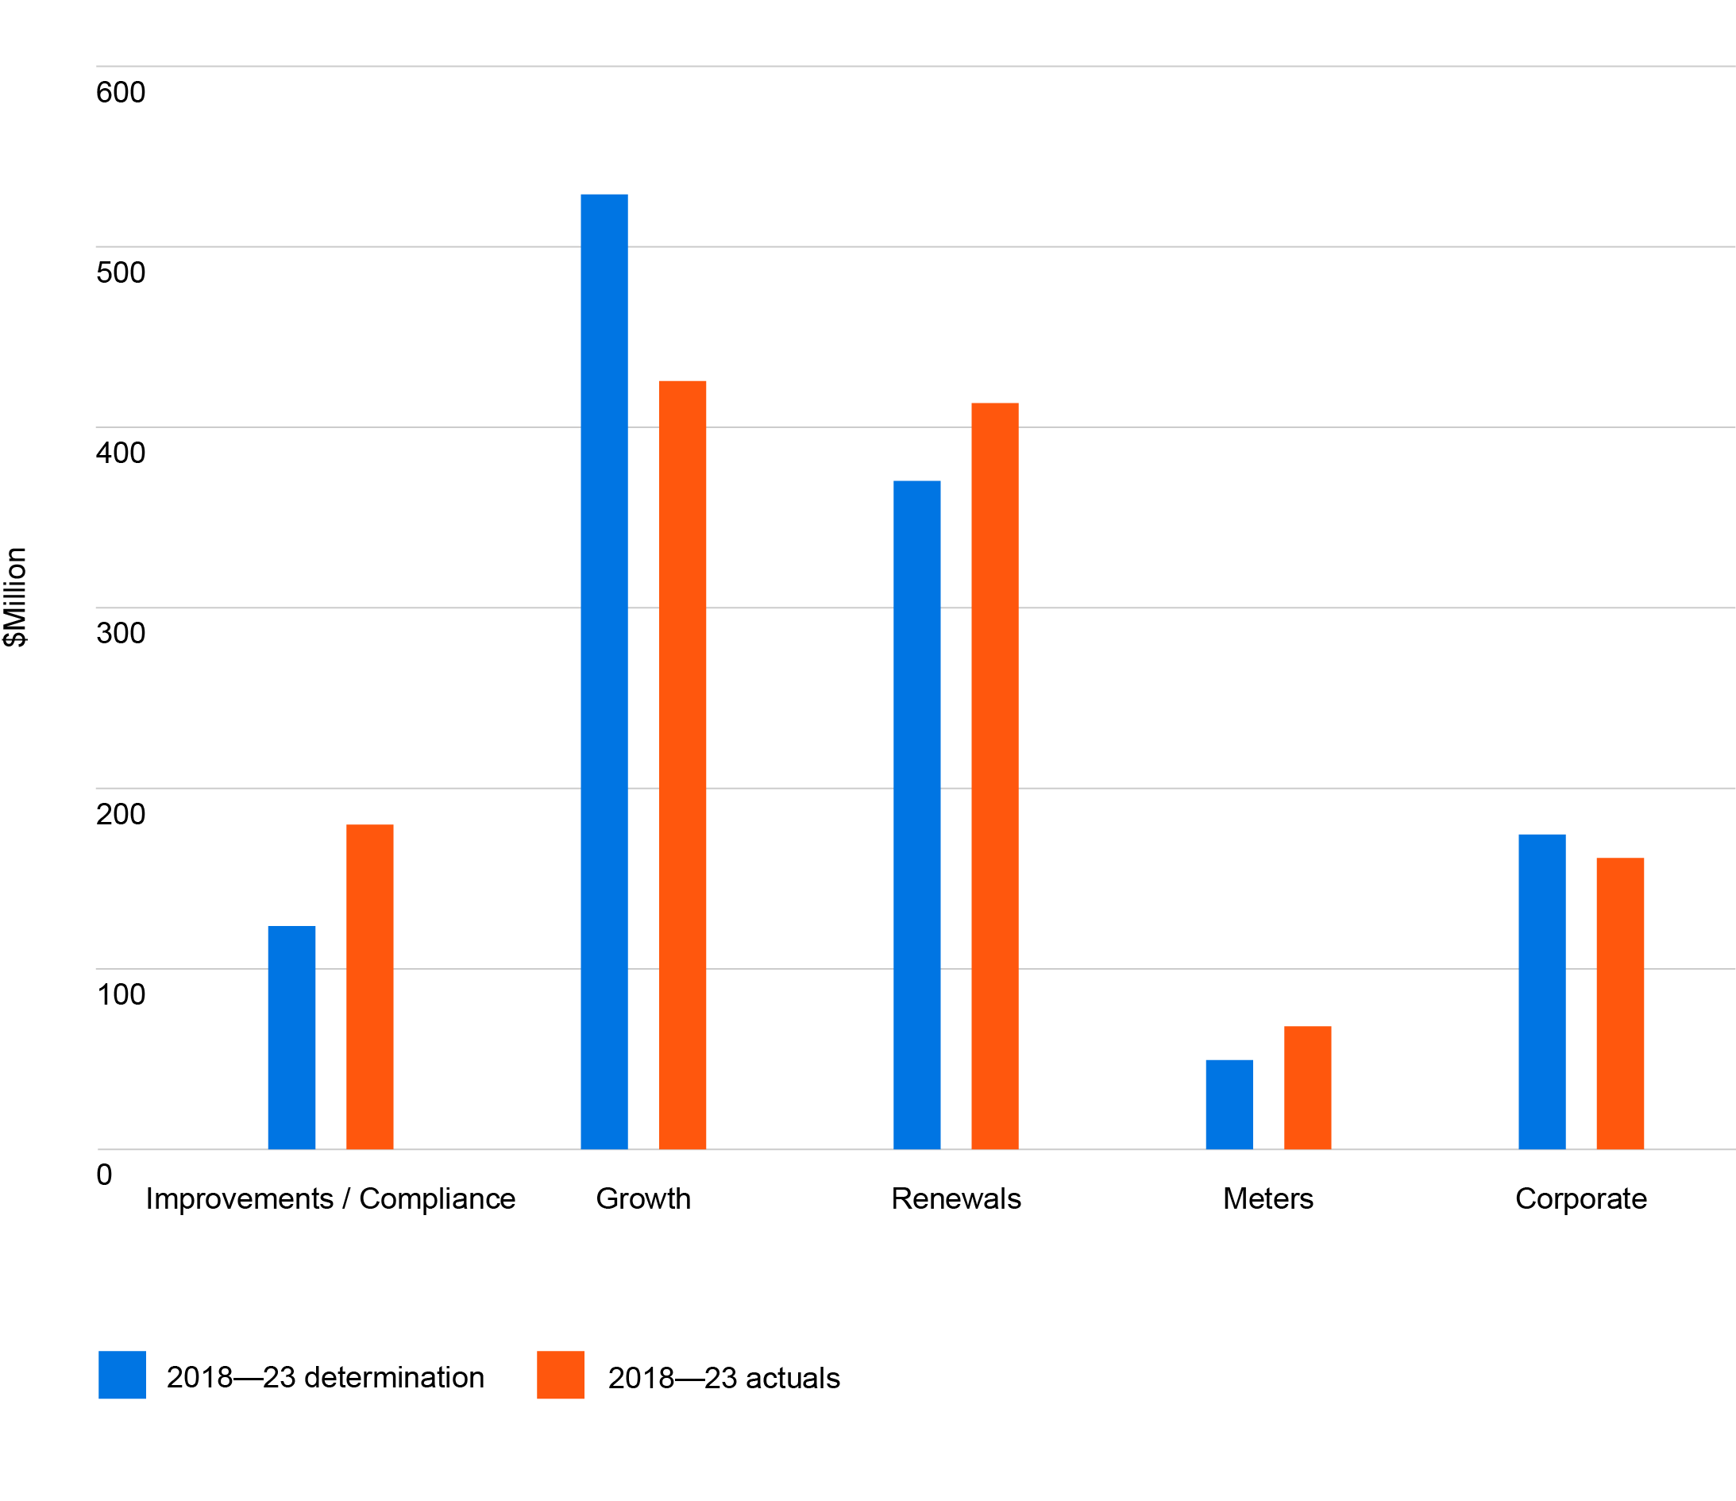
Figure 3: 2018–23 capital expenditure compared to the benchmark allowance
($million 2022–23)

Capital expenditure variations in the 2018–23 period reflect:
- coronavirus (COVID-19)-related impacts, including slower than anticipated growth
- increased investment in sewer compliance to reactively manage sewer spills caused by asset failures to protect the environment and ensure compliance
- reduced investment in water renewals as burst and leaks were lower than forecast
- increased investment in sewer renewals to reactively manage climate variations causing high than expected sewer asset failures
- reduced corporate investment due to the deferral of planned information system replacements to reprioritise security-related projects, and remote working capabilities during the coronavirus (COVID-19) pandemic.
To minimise the risk to customers in the 2018-2023 regulatory period, we kept Elster Creek Catchment and Clayton East and West Catchment Capacity Improvement projects in our Top 10 project list but removed them from our capital allowance. This enabled South East Water, rather than our customers, to take the risk of the unknown timing of these projects. The subsequent deferral of these projects has resulted in the development of lower-cost solutions, the safe deferral of significant upgrade works, and an overall reduction in spend.
We also used our programmatic risk bank approach (see page 92) to internally fund the increased costs associated with the Boneo Water Recycling Plant and Pakenham East Sewer so that these could be funded at no additional costs to customers.
Of the 8 top 10 projects that were in our capital allowance, 4 projects were delivered either on time or later than planned (but within the 2018–23 regulatory period). The remaining projects have either been delayed or deferred.
Table 22 provides a list of our top 10 major capital projects for 2018–23, their current status and performance score (against their 2018–23 commitment).
Table 22: 2018 top 10 capital projects
Project | Status | Performance score
Boneo Water Recycling Plant Upgrade (stage 4) | Completed Late | 2
Elster Creek Catchment Capacity Improvement (stage 1) | Excluded from capital allowance | 2
Land Purchase 1 (Fishermans Bend) | Delayed | 2
Clayton East and West Catchment Capacity Improvement Works | Excluded from capital allowance | 3
Pakenham East Branch Sewer | Delayed | 2
Land Purchase 2 (Pakenham) | Delayed | 1
Ballarto Road East Sewer Pump Station | Completed Late | 3
Hanna Street Capacity Improvements | Delayed | 2
Water Recycling Plan Sludge Drying Pans and Stockpile Areas Upgrades | Completed On Time | 3
Digital Utility program | Completed On Time | 3
Note: The performance scores are:
3 – Largely consistent with or exceeded the 2018–23 commitment
2 – Generally consistent with the 2018–23 commitment
1 – Not consistent with the 2018–23 commitment

Delays to the land purchase projects (Fishermans Bend and Pakenham) are due to an inability to conclude negotiations with owners of suitable land. An alternative site in Fishermans Bend that enables us to complete Phase 1 of the water recycling plant is in the settlement period at the time of writing this submission. Negotiations with a site owner in Pakenham have stalled, with land acquisition now expected to occur in the 2023–28 regulatory period.
Coronavirus (COVID-19) impacts, unfavourable site conditions, and delays in obtaining approvals have also contributed to delays in delivering projects.

6.2 Summary of capital expenditure program
When developing our capital expenditure program for 2023–28, we considered our customer feedback and strategic focus areas. As well as reaffirming the 5 outcomes agreed for the current 2018–23 regulatory period, our customers told us they want us to:
- reduce the number of service disruptions and sewer spills and provide a reliable service across our network
- keep water affordable and accessible to all
- roll out digital customer meters to obtain the benefits they offer
- secure future water supplies, improve the health of our waterways and protect our environment
- innovate and deliver new energy-efficient technologies that help to reduce costs.
Other factors we considered included:
- compliance requirements, and ensuring we continue to meet the intent of existing and proposed new government and regulatory obligations
- trends in customer behaviours, needs and expectations, with a focus on continuing to deliver liveability benefits to our customers
- insights from digitised network capacity modelling and critical asset reviews, which give us a deep understanding of where there are existing and potential capacity and performance issues in our networks and assets
- projections for future growth, and the impact it will have on demand for water and sewerage services in growth areas
- climate change, and ensuring our assets deliver climate resilient water supplies, minimise flooding and reduce urban heat impacts
- our capability and capacity to deliver based on past performance, and in the future, through our capital delivery models.
Capital expenditure investment of $1.92 billion is proposed for the 2023–28 period (excluding third-party funded works). This represents a 5% per annum increase in our regulatory asset base and a 54% increase on the projected capital expenditure of $1.25 billion during 2018–23.
Figure 4 shows the 2018 Determination forecast and projected capital expenditure for the 10-year period from 2018–19 to 2027–28 by service.
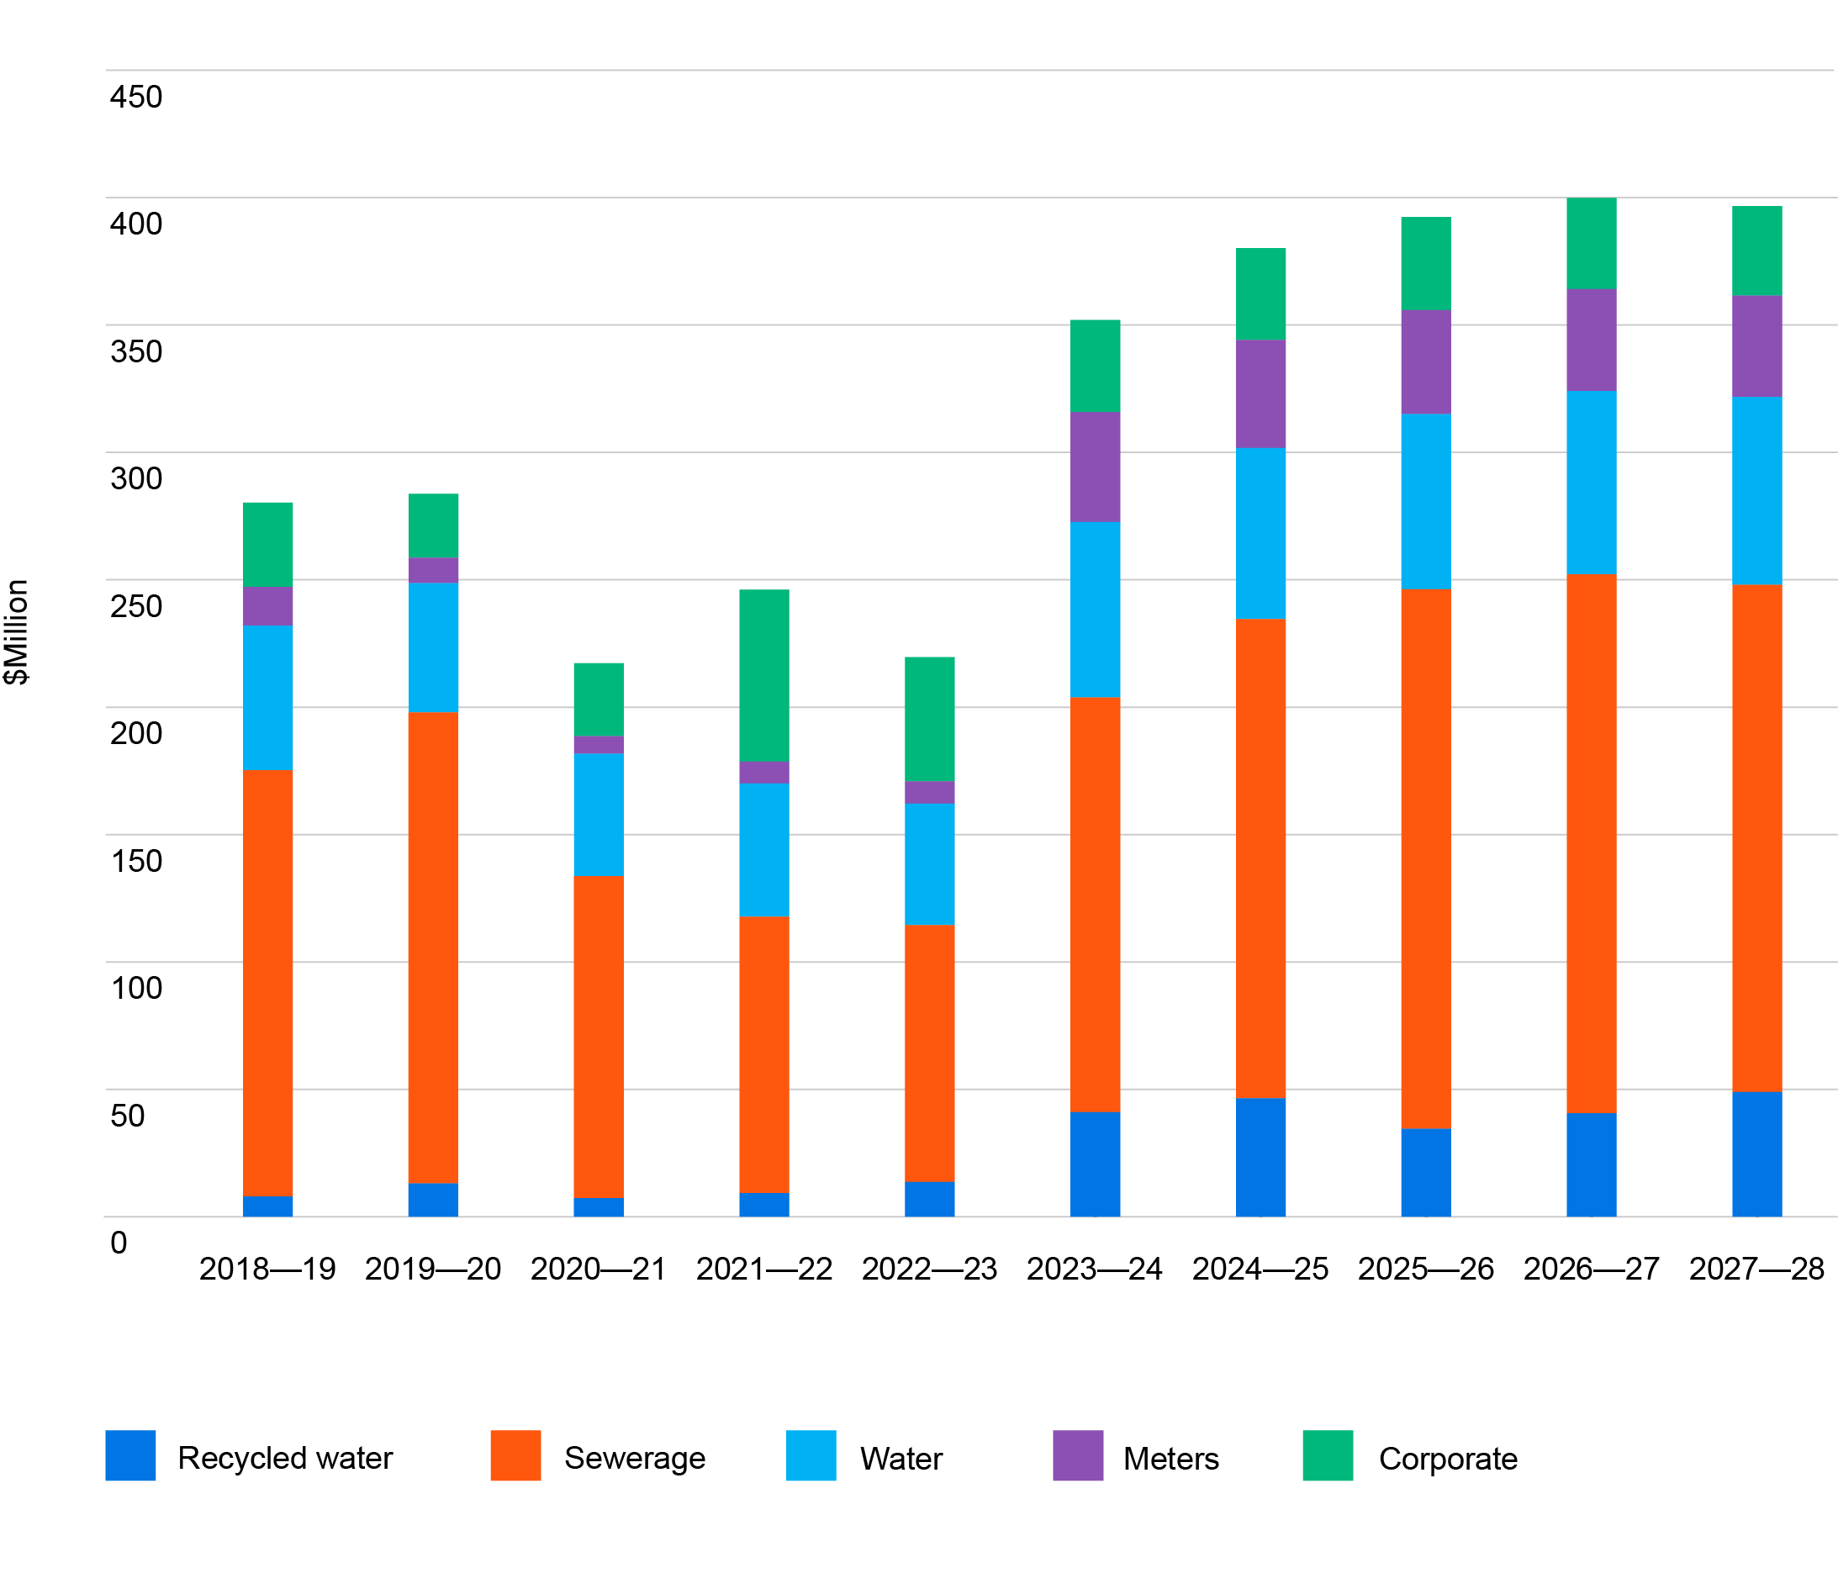
Figure 4: Ten-year capital investment program – 2018–23 determination forecast and 2023–28 forecast by service ($million 2022–23)

Analysis of population data provided by Victoria in Futures and 2 expert demographers, has allowed us to form an opinion on the potential growth in the next regulatory period. Our assumptions allow for steady growth on the back of the coronavirus (COVID-19) pandemic, however at a lesser rate than that assumed by economic forecasts. Based on our assumptions, we have adjusted our capital expenditure on larger projects to push costs out, thereby reducing the total revenue requirement and shifting the risk internally. Refer to the Demand Manual – Dwelling and population forecast document in ‘Supporting documents’ for further information on our growth assumptions.
The increase in our projected capital expenditure for 2023–28 has partly been driven by general economic pressures. Construction prices have risen dramatically since mid-2021, due to supply chain constraints, labour shortages and fuel prices. These have been further exacerbated by the impacts of the coronavirus (COVID-19) pandemic. Refer to the 2023–28 Capital Delivery Report in supporting documents for further information.

Other contributing factors to the increase in our capital expenditure program are:
- increased compliance-related investment driven by:
  - new environmental protection regulations associated with the Environmental Protection Act 2017 that came into effect 1 July 2021. These regulations are founded on the General Environmental Duty (GED), which is modelled on the general duty that underpins Victoria’s occupational health and safety legislation. The GED requires a bespoke approach to managing environmental risks as far as reasonably practicable (SFARP) at a site and activity level. Increased investment to maintain compliance with regulations is necessary, as breaches can have both civil and criminal penalty implications
  - industry-wide improvements in water quality management to ensure the provision of safe drinking water (triggered by the Silvan Dam water quality incident in 2020)
  - safety improvements to maintain compliance to safety regulations for critical assets that are identified to be at risk based on their failure history, asset condition and location, and which can have high to catastrophic consequences if they fail
- investment in treatment and resource recovery assets, driven by increasing demands from customers in high-growth service areas. Three of our water recycling plants are nearing capacity (as outlined in Table 23 below) and require augmentation to accommodate future demands.
Table 23: Longwarry, Lang Lang and Mount Martha water recycling plant capacity
Water recycling plant | Existing capacity  ML/ day | Current  flows  ML/ day | Proposed capacity  ML/ day
Longwarry | 1.1 | 1.0 | 2.0
Lang Lang | 1.1 | 0.8 | 2.0
Mount Martha | 13.5 | 14.0 | 15–18

In addition, we plan to build a biofactory to address capacity flow limitations and service growth in the south-east region which will reduce reliance on the Eastern Treatment Plant. Planning and early works to build a south-east regional biofactory will occur in 2023–28, to lay the path for delivery and commissioning in the 2028–32 regulatory period.
- the continued rollout of digital meters, which is a top 10 project comprising 35% of
our total top 10 project forecast and 11% of our total capital investment program.
We are planning to maintain current capital expenditure levels for water and sewer network reliability and renewals despite an increasing need to address ageing assets and climate change, by leveraging continuous innovation in technology and digital engineering to drive cost efficiency.

Figure 5 shows the increase in our 2023–28 capital investment program by cost driver when compared to the 2018–23 regulatory period.
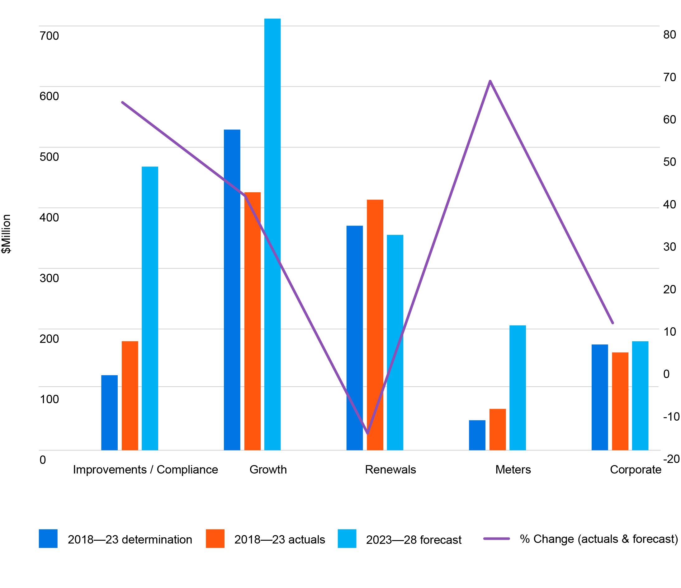
Figure 5: 2023–28 capital investment program comparison to 2018–23 determination forecast and actuals by cost driver ($million 2022–23)

6.3 Method for developing the capital expenditure program
Our capital investment plan was developed through a robust process that identified the investment required to meet our 5 customer outcomes and the associated output measures. The process included the development of reference strategies and master plans that inform the lifecycle management of assets, servicing of growth, maintaining service levels, and meeting regulatory compliance requirements.
A common risk management and asset management framework has been applied for each service (for example, water, sewer, alternative water, business technology and services) and cost driver (for example, maintain service levels, growth, improvements/ compliance) in the process outlined below. Refer to the Corporate Asset Management Plan for further detail.

Risk-based capital investment planning
A key objective when developing our capital investment plan was to deliver on customer outcomes, while managing risk and uncertainty, to ensure that our customers receive an affordable service. To achieve this, our projects and programs of work were developed based on a risk-based capital investment planning process that is underpinned by value, risk appetite and our customer outcomes.

Risk assessment and modelling
We conducted risk assessments on existing and proposed future assets, applying a common risk management framework at both a catchment level, and an individual asset level. We also used comprehensive data sources and various techniques, such as hydraulic modelling, risk profiling, geospatial analysis and data science methods, to support our analysis. Through our analysis, we were able to inform our capital investment priorities for the 2023–28 regulatory period and beyond.

Critical asset reviews
Following a number of critical asset failure incidents in 2017–2018, we conducted a critical asset review using the criticality matrix outlined in our corporate risk framework, to identify and locate our critical assets. These assets are regarded as critical assets because if (and when) they fail, the adverse consequence to customers, community, and environment would be regarded as ‘high’ to ‘catastrophic’.
By joining the critical asset data obtained from the review with asset condition and failure history data, we can form a full understanding of an asset’s risk profile, which in turn enables us to prioritise our investments on critical assets that have a high likelihood (or are at imminent risk) of failure.
As critical asset risk profiling evolves over the regulatory period, and as asset conditions change and become known from ongoing asset condition assessments, we will continually update asset risk profiles and reprioritise investment in individual projects, when considered prudent to do so. This approach to critical asset management, ensures we continue to comply with regulatory requirements and deliver reliable services to customers.

Non-critical assets
In terms of our non-critical assets, we will continue to operate and maintain assets to deliver customer outcomes and keep failure rates and impacts within agreed customer service levels. This will be monitored and measured by the customer disruption performance target: ‘Customers experiencing more than 5 unplanned disruptions in a
12-month period (water, sewer and water quality)’ as outlined in the Outcomes section.
With an ageing asset base, climate change, and improved technology in detecting and discovering asset failures that historically would be undetected, we are forecasting there will be an increasing need to invest so we can maintain customer service levels. Through our investments, we are proposing to leverage advancements in technology, information and digital engineering to manage these risks through early detection and rectification, to minimise customer impacts. This proactive approach to asset management will keep our investments in non-critical asset management at relatively stable levels.

Investment portfolio development and prioritisation
Our investment portfolios were developed based on a set of common objectives and cost drivers within each service area. Each investment portfolio is made up of a set of projects and programs of work that were identified and prioritised using an iterative process of review and challenge to ensure capital expenditure was prudent and efficient.

Investment scenarios
Once our investment needs were identified through our risk-based capital investment planning process, we grouped our 2023–28 capital investment program into investment portfolios by service type and cost drivers. We also established ownership and accountability for each portfolio for planning and delivery purposes.
We then developed a range of investment scenarios (as outlined in the Management section) based on different financial and resourcing constraints. This allowed us to better understand the risk impact associated with a reduction in investment in the 2023–28 regulatory period, broadly broken into 3 scenarios:
1. low-risk/high-cost
2. balanced-risk/medium-cost
3. high-risk/low-cost.
Each scenario outlined the extent of risk mitigation and asset performance given the level of investment, as well as the trade-offs and consequences of selecting the investment scenario.
All our investment portfolios and their associated investment scenarios were then reviewed by our Strategic Asset Management Committee and executive, to provide a balanced and optimised view across competing needs and drivers.
The final capital investment scenario for each investment portfolio was selected based on our risk mitigation processes, risk appetite, regulatory obligations and strategic objectives. For example, we have no (or very little) risk appetite for safety or regulatory compliance and obligations. Benefits and customer outcomes to be delivered through each investment portfolio were also carefully considered when informing the decision-making process.
Once the final capital investment scenario was selected for each investment portfolio, project and program schedules were finalised, and the associated risks to meeting performance targets were captured for ongoing monitoring and management.

Business cases
Concept briefs and business cases were prepared for the top 10 capital expenditure projects identified within our investment reference strategies and master plans.
Briefs included:
- an outline of the problem to be addressed
- the expected benefits and how these align with our customer outcomes
- the options that were considered and justification for the selected option
- details of the risk assessment conducted.

Cost-estimating methods
When estimating our projects and programs, we applied cost-estimating methods suitable for project forecasting for concept design and this price submission, to ensure forecasts were robust and capital expenditure was prudent and efficient.

A minimum of P50 estimates were prepared for our capital projects and programs using:
- unit rate tables
- past projects, first principles and supplier prices
- engineering consultants and contractors.
Unit rate tables used for cost estimating were recently reviewed to ensure they were appropriate for forecasting purposes at concept stage. This involved benchmarking the unit rates against historic projects of a similar cost and nature.

6.4 Investment portfolios
Our capital expenditure program for 2023–28 is grouped into investment portfolios that consist of the top 10 projects, capital work programs and other projects. Table 24 provides a summary of our investment portfolios and proposed capital expenditure for the 2023–28 regulatory period.
Table 24: Proposed 2023–28 investment portfolios ($million 2022–23)
Investment portfolios | Top 10 projects  ($m) | Capital programs/other ($m) | Total  ($m)
Sewer growth | 101.81 | 158.49 | 260.30
Treatment growth | 159.34 | 59.35 | 218.69
Customer metering | 206.00 | - | 206.00
Treatment improvements/compliance | 52.46 | 106.75 | 159.21
Information technology | - | 142.52 | 142.52
Sewer improvements/compliance | - | 98.93 | 98.93
Sewer reliability | - | 91.67 | 91.67
Potable water renewals | - | 84.07 | 84.07
Treatment reliability | - | 79.13 | 79.13
Potable water growth | - | 76.18 | 76.18
IWM schemes | 68.10 | 5.94 | 74.04
Potable water improvements/compliance | - | 67.47 | 67.47
Potable water quality | - | 63.14 | 63.14
Recycled water growth | - | 58.16 | 58.16
Potable water reliability | - | 57.57 | 57.57
Sewer backlog | - | 54.02 | 54.02
Distributed treatment | - | 51.02 | 51.02
Sewer renewals | - | 28.68 | 28.68
Motor vehicle fleet | - | 21.02 | 21.02
SCADA and real-time systems | - | 19.57 | 19.57
New technology | - | 6.76 | 6.76
Facilities | - | 2.92 | 2.92
 | 587.71 | 1,333.36 | 1,921.07

6.5 Major capital projects
The following is an overview of our top 10 capital expenditure projects in order of their estimated cost for the 2023–28 regulatory period, as well as their timing, cost drivers, alignment to customer outcomes, risk profiles and background. The total expenditure for the top 10 projects is approximately 31% of the planned capital expenditure over the 2023–28 regulatory period.
Table 25: 2023-28 Overview of top capital projects
PROJECT 1: Digital Metering – new connections and exchanges
Investment portfolio: Customer metering
Total cost: $261.9m
2023–28 cost and timing: $206m (2023–28)
Service category: Water
Cost driver category: Renewals
Asset category: Pipelines/network
Description: Rollout of new digital meters to all South East Water customers
Customer outcome: Get the basics right, always; Make my experience better; Warn me, inform me; Fair and affordable for all; Support my community, protect our environment.
Current risk rating: Medium
Risk rating post-investment: Low
Background: Water scarcity and climate change impacts are increasing the need to efficiently manage and use water. In addition, customers and communities are expecting to be kept informed of their real-time water usage. As a significant portion of our current traditional mechanical meter fleet is approaching end of life, digital metering provides an opportunity to help address these challenges. This project, which commenced in the 2018–23 regulatory period and delivered digital meters to 50,000 customers, as well as the necessary technology infrastructure, will deliver water savings, customer satisfaction and improved planning capability for South East Water through the delivery of digital meters to all our existing customers. The rollout includes the transformational elements required to ensure that data from digital meters provides both actionable information for customers and information to assist us in taking a proactive approach to network maintenance and infrastructure planning.
PROJECT 2: Hanna Street Capacity Upgrade – Stage 2
Investment portfolio: Sewer growth
Total Cost: $70.28m
2023–28 cost and timing: $70.28m (2023–27)
Service category: Sewerage
Cost driver category: Growth
Asset category: Pipelines/network
Description: Stage 2 capacity upgrades to the Hanna Street branch sewer to provide wet weather containment within the network
Customer outcome: Get the basics right, always; Support my community, protect my environment
Current risk rating: High
Risk rating post-investment: Moderate
Background: The Hanna Street and Wells Street sewer catchments currently serve 24,300 customer connections within Southbank and South Melbourne. The sewers were constructed in the late 1890s, as part of Melbourne’s original sewerage scheme. The catchments’ population have grown substantially over the past 125 years and is expected to grow to approximately 40,000 customer connections by 2056. This project will deliver an upgrade in capacity for the Hanna Street branch sewer, through a new gravity network, via connection at the top end of the existing network and pumping station.

PROJECT 3: South East Regional Biofactory – Stage 1
Investment portfolio: Treatment growth
Total cost: $289.3m
2023–28 cost and timing: $30.16m (2023–28)
Service category: Sewerage
Cost driver category: Growth
Asset category: Treatment
Description: Design and construction of a biofactory in the south-east region to service the growth and reduce reliance on the Eastern Treatment Plant.
Customer outcome: Get the basics right, always; Support my community, protect our environment
Current risk rating: High
Risk rating post-investment: Low
Background: This project is part of a broader plan by South East Water to upgrade its wastewater treatment and resource recovery capabilities in the south-east region by constructing a biofactory that supports emissions reduction and delivery of circular economy initiatives. The South East Regional Biofactory project will deliver the process and detailed design of the new energy-efficient water treatment and recycling plant, completion of early works, and start of construction for the new inlet works and associated odour control facility. These works support the major project to build and commission the new biofactory in 2032.
PROJECT 4: Mount Martha Water Recycling Plant Augmentation
Investment portfolio: Treatment growth
Total cost: $54.78m
2023–28 cost and timing: $54.78m (2023–28)
Service category: Sewerage
Cost driver category: Growth
Asset category: Treatment
Description: Augmentation of the solids handling streams to increase capacity and works to replace ageing infrastructure at the site
Customer outcome: Get the basics right, always; Support my community, protect our environment
Current risk rating: Medium
Risk rating post-investment: Low
Background: The Mount Martha Water Recycling Plant consists of primary, secondary and tertiary treatment processes and produces Class A recycled water. The site contains a number of ageing structures that require replacement or refurbishment, to ensure ongoing compliance. In addition, asset capacity constraints are evident due to catchment growth and will be addressed as part of the augmentation works.

PROJECT 5: Westernport Irrigation Scheme – Stage 1
Investment portfolio: Treatment improvements/compliance
Total cost: $52.46m
2023–28 cost and timing: $52.46m (2023–28)
Service category: Recycled water
Cost driver category: Improvement/Compliance
Asset category: Treatment
Description: Construction of an irrigation scheme to expand the supply of Class A recycled water supplied from the Pakenham Treatment Plant.
Customer outcome: Get the basics right, always; Support my community, protect our environment
Current risk rating: Medium
Risk rating post-investment: Low
Background: This project is part of a broader plan by South East Water, to upgrade its wastewater treatment and resource recovery capabilities in the south-east region. The project will deliver an irrigation scheme that will expand the supply of Class A recycled water for agriculture in the Cardinia region, through use of spare capacity at the existing Pakenham Water Recycling Plant and future South East Water Regional Biofactory. The scheme is planned to be delivered in 3 stages, with the recycled water supply to be provided initially from a new pipe network, to be constructed in 2023–28 and 2028–33.

PROJECT 6: Longwarry Water Recycling Plant Upgrade
Investment portfolio: Treatment growth
Total cost: $48.24m
2023–28 cost and timing: $48.24m (2023–28)
Service category: Sewerage
Cost driver category: Growth
Asset category: Treatment
Description: Upgrade of the Longwarry Water Recycling Plant and irrigation system
Customer outcome: Get the basics right, always; Support my community, protect our environment
Current risk rating: High
Risk rating post-investment: Low
Background: The Longwarry Water Recycling Plant is a wastewater treatment facility, owned and operated by South East Water, and capable of producing Class C effluent water. Due to capacity constraints, a significant increase in forecasted flow and loads to the plant, and a tightening of environmental discharge requirements, an upgrade to the plant is required. This project will replace the current lagoon-based treatment process, with a mechanical system, and deliver a new pump station and other upgrade works.

PROJECT 7: Fishermans Bend Water Recycling Plant and Sewer Connection
Investment portfolio: IWM schemes
Total cost: $68.7m
2023–28 cost and timing: $39.14m (2023–28)
Service category: Recycled Water
Cost driver category: Growth
Asset category: Treatment
Description: Construction of a water recycling plant in Fishermans Bend
Customer outcome: Support my community, protect our environment
Current risk rating: Medium
Risk rating post-investment: Low
Background: Fishermans Bend is one of Australia’s largest urban renewal projects, covering approximately 485 hectares in the heart of Melbourne. The framework for its redevelopment was formed in 2016 and is captured in the Victorian Government’s statement of intent to create “a thriving place that sets an example for environmental sustainability, enhanced liveability, diversity and innovation”. More recently, the Victorian Government released the Fishermans Bend Water Sensitive City Strategy (May 2022). This project will deliver a water recycling plant, that mines the city’s sewage and treats it to Class A recycled water, for use within its precincts. Both the framework and strategy specifically identify the water recycling plant as a catalyst project, to provide the community with a ‘fit-for-purpose’ climate-resilient water supply.

PROJECT 8: Dingley Recycled Water Scheme
Investment portfolio: IWM schemes
Total cost: $41.1m
2023–28 cost and timing: $28.97m (2023–28)
Service category: Recycled water
Cost driver category: Growth
Asset category: Pipelines/network
Description: Construction of a distribution main to service the Dingley Green Wedge with Class A recycled water
Customer outcome: Fair and affordable for all; Support my community, protect our environment
Current risk rating: High
Risk rating post-investment: Low
Background: Population and business growth in Melbourne’s south-east is increasing the demand for water and placing pressure on existing water resources. In the Dingley Green Wedge, the population is forecast to almost double by 2065. In addition, recreation and agricultural users in the area are experiencing water security issues, due to climate change and a lack of year-round stormwater and bore water for irrigation purposes. Potable water is currently used to supplement other water sources for uses, such as irrigating greenspace, and this does not meet community and customer expectations. This project, which we committed to under the IWM forum process, will deliver a trunk main that connects to the South Eastern Outfall and new reticulation networks, to deliver Class A recycled water to large water users across the Dingley Green Wedge. In support of the IWM forum process, the Victorian Government has committed $24.8 million in funding to support the Dingley Recycled Water Scheme.

PROJECT 9: Ballarto Road East Pump Station and Rising Main
Investment portfolio: Sewer growth
Total cost: $67.3m
2023–28 cost and timing: $31.53m (2023–28)
Service category: Sewerage
Cost Driver category: Growth
Asset category: Pipelines/network
Description: Replace Ballarto Road interim sewerage pumping station and rising mains into Clyde Creek catchment
Customer outcome: Get the basics right, always; Support my community, protect our environment
Current risk rating: Extreme
Risk rating post-investment: Low
Background: This project is also part of a broader plan by South East Water to upgrade its wastewater treatment and resource recovery capabilities in the south-east region. The Clyde sewage catchment area is a growth service area, with a number of Precinct Structure plans already approved, and resulting in over 7,000 lots being connected to a gravity network. These flows are currently transferred back to adjacent catchments via temporary pumping stations. In 2019, we constructed the Ballarto Road interim sewage pumping station and rising main to transfer wastewater from the catchments early land development into Clyde Creek. This project will deliver the replacement (permanent) sewerage pumping station at Ballarto Road, and a twin sewage rising main to the Pakenham waste recycling plant, to support the increasing flows from the growing development.

PROJECT 10: Lang Lang Water Recycling Plant
Investment portfolio: Treatment growth
Total cost: $26.2m
2023–28 cost and timing: $26.17m (2023–27)
Service category: Sewerage
Cost driver category: Growth
Asset category: Treatment
Description: Upgrade of the Lang Lang Water Recycling Plant main process and Class A water capacity
Customer outcome: Get the basics right, always; Support my community, protect our environment
Current risk rating: High
Risk rating post-investment: Low
Background:
When developing the Lang Lang and Koo Wee Rup master plans, a capacity assessment of the current infrastructure in these catchments, and an assessment of the flow and load forecasting for the Lang Lang Water Recycling Plant, were performed. These assessments identified the need to upgrade the main process and Class A water capacity at the Lang Lang Water Recycling Plant, to meet future service demands and maintain compliance. This project will deliver upgrades to the primary, secondary and disinfection processes, as well as biosolids management, at the Lang Lang plant.

6.6 Capital programs and other capital expenditure
Apart from our top 10 projects, our investment in capital programs and other discrete projects account for approximately 69% of the proposed capital investment over the
2023–28 regulatory period. These are shown Table 26:

Service  Table 26: 2023-28 Capital program | Investment portfolios | Objective | Outcomes | Capital investment program 2023–28  ($m 2022–23)
Recycled water | Treatment growth | Meet increasing demand from residential and trade waste customers for recycled water in growth service areas. | 1. Get the basics right, always.  3. Fair and affordable for all. | $59.34
 | Recycled water growth | Meet increasing customer demand for recycled water services​. | 1. Get the basics right, always.  3. Fair and affordable for all. | $58.16
 | IWM schemes | Provide customers with diverse and resilient water supply through treatment and recycling of wastewater and stormwater management. | 1. Get the basics right, always.  5. Support my community, protect our environment. | $5.94
Sewer | Sewer growth | Meet increasing customer demand due to growth across service areas. | 1. Get the basics right, always.  3. Fair and affordable for all. | $158.49
 | Treatment improvements/compliance | Maintain EPA licence requirements, with a key focus on odour control, and minimising the risk of soil and groundwater contamination. | 1. Get the basics right, always.  5. Support my community, protect our environment. | $106.75
 | Sewer improvements/compliance | Maintain compliance with environmental protection regulations, including the GED, safety regulations and management. | 1. Get the basics right, always.  5. Support my community, protect our environment. | $98.93
 | Sewer reliability | Maintain sewer network service standards for customer interruptions by planned and reactive operations and maintenance activities. | 1. Get the basics right, always.  5. Support my community, protect our environment. | $91.67
 | Treatment reliability | Maintain treatment and resource recovery assets in working order and ensure an appropriate balance between maximising asset lifespan and the risk of asset failure. | 1. Get the basics right, always. | $79.13
 | Sewer backlog | Connect households to reticulated sewer currently serviced by onsite wastewater systems, to mitigate environmental contamination and public health risks. | 1. Get the basics right, always.  3. Fair and affordable for all. | $54.02
 | Distributed treatment | Improve long term waste management, to reduce the risk of effluent discharges into our bays and provide overall lower cost to the community. | 1. Get the basics right, always.  5. Support my community, protect our environment. | $51.02
 | Sewer renewals | Maintain sewer network service standards for customer interruptions, by reactively responding to asset failures as they occur. | 1. Get the basics right, always.  5. Support my community, protect our environment. | $28.68
Water | Potable water renewals | Maintain drinking water network service standards for customer interruptions, by reactively responding to asset failures as they occur. | 1. Get the basics right, always. | $84.07
 | Potable water growth | Meet increasing customer demand for drinking water, due to growth across service areas. | 1. Get the basics right, always.  3. Fair and affordable for all. | $76.18
 | Potable water improvements/compliance | Maintain compliance with safety regulations and management. | 1. Get the basics right, always. | $67.47
 | Potable water quality | Maintain compliance with Safe Drinking Water Regulations. | 1. Get the basics right, always. | $63.14
 | Potable water reliability | Maintain drinking water network service standards for customer interruptions, by planned and reactive operations and maintenance activities. | 1. Get the basics right, always. | $57.57
Corporate | Information technology (IT) | Maintain and upgrade our IT assets to deliver more cost-effective services to our customers, increase productivity, minimise operational costs, and make operations more efficient. | 1. Get the basics right, always. | $142.52
 | Motor vehicle fleet | Maintain and upgrade our motor vehicle assets, to maximise efficiency, increase productivity and improve safety for our vehicles and drivers. | 1. Get the basics right, always. | $21.02
 | SCADA and real-time systems | Maintain and upgrade our network and asset monitoring systems, to ensure the ongoing efficient operation and maintenance | 1. Get the basics right, always.  2. Warn me, inform me. | $19.57
 | New technology | Deliver innovation and new technologies, to improve our customer products, processes and services, minimise costs and make operations more efficient. | 1. Get the basics right, always.  3. Fair and affordable for all.  5. Support my community, protect our environment. | $6.76
 | Facilities | Maintain and upgrade our facility assets to support our core business operations | 1. Get the basics right, always. | $2.92
$1,333.36

6.7 Cost efficiencies
Through our capital expenditure program for 2023–28, we will continue to improve
our services (as shown in the Outcomes section) and invest in technology to enable operational efficiencies and minimise the impact of additional cost pressures on our customers.
When developing our capital expenditure program, we ensured we made sound investment decisions based on needs and benefits analysis, operational impacts,
cost-effectiveness of risk controls, and risk-based prioritisation. As shown in the operating expenditure section, we have set an operating cost efficiency target of 2% per annum. The target aligns to the continuous improvement of our operating processes, to assure we are prudently managing operating expenditure and meeting our efficiency commitments.

Efficiency target
In addition, our capital expenditure program assumes a 5% delivery efficiency for projects and programs delivered through our new integrated planning and delivery capital delivery model that comes into effect in July 2023.
The efficiency is based on the quantum of the proposed capital expenditure program
that provides economies of scale. These efficiencies are derived from:
- the integrated planning process (incorporating early contractor involvement
and program optimisation)
- the increased scale and term of the contract (providing a reliable workload
and ability to attract and retain the best resources)
- the allocation of projects (reducing tendering costs).
These efficiencies will assist in offsetting anticipated construction cost escalation above CPI within the period.
Throughout 2018–23, our major capital works programs have demonstrated our ability
to manage costs below observed escalation levels in the construction sector.
Finally, we have incorporated cost efficiencies in the capital expenditure program that were developed through delivery of programs in the current and previous regulatory periods. These include:
- delivering network renewal programs by packaging projects by geographical areas
to reduce project management overheads. For example, we took a catchment-based approach to treatment plant planning to optimise the use of different treatment plant capacities
- ensuring planned capital investment considers the associated impact on operational expenditure when constructing and managing our assets. For example, we have incorporated innovative and energy-efficient treatment technologies when upgrading infrastructure at our water recycling plants to help ensure the reliable production of fit-for-purpose recycled water
- taking a risk-based approach to determine the optimal risk control or risk mitigation solution. This includes implementing advanced monitoring and alarm systems to our high-risk assets to minimise the impact of asset failure on customers, and to report on the condition of our critical water and sewerage assets to inform timely augmentation
- prioritising projects to deliver energy-use efficiencies based on a positive return.

Whole-of-program approach (risk bank)
Moving forward, we will continue to deliver cost efficiencies and remain within our allocated capital program by taking a whole-of-capital program approach to managing risk through the utilisation of our risk bank.
Traditionally, project risk is managed individually at a project approval level but, using our risk bank, we now manage project risk at an asset program level which has helped us remain within our capital expenditure benchmark allowance for the current regulatory period.
As depicted in Figure 6 below, we use our risk bank at multiple points during a project’s lifecycle to reallocate funds to projects that may go over budget through a reserve of unrealised risks within our capital investment program. For example, during the 2018–23 regulatory period, we used the risk bank to fund the $19.2 million or 14.7% overspend on the Boneo Water Recycling Plant – Stage 4 Upgrade project.
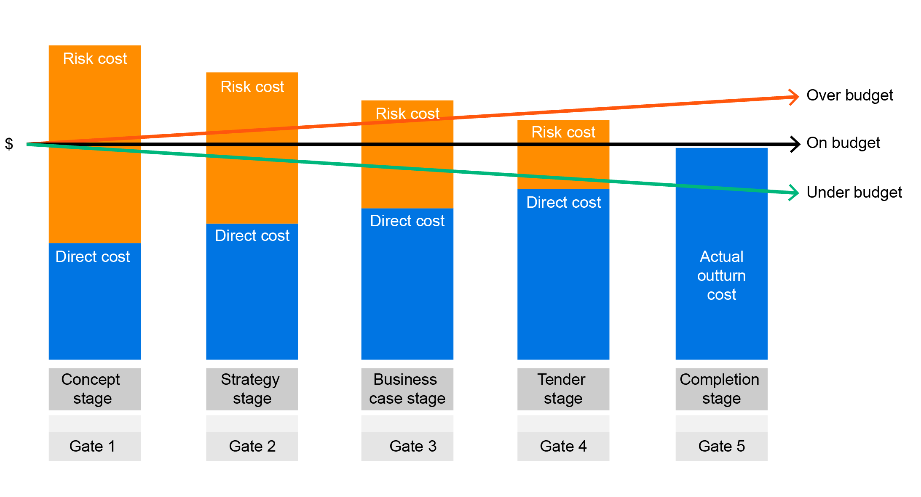
Figure 6: Project risk cost evolution

The temporary risk bank reserve is the difference between a project’s approval value (including a P95 estimate of the South East Water allocated risk) and the actual cost of the project. If additional funds are required during construction, temporary deposits from our risk bank reserve are made in accordance with our delegations of authority. Once a project is completed, the temporary deposit is returned, and the fixed deposit/withdrawal is calculated as the difference between the initial project approval and the final cost (including realised South East Water allocated risk). Figure 7 shows the risk bank movement during the current regulatory period.
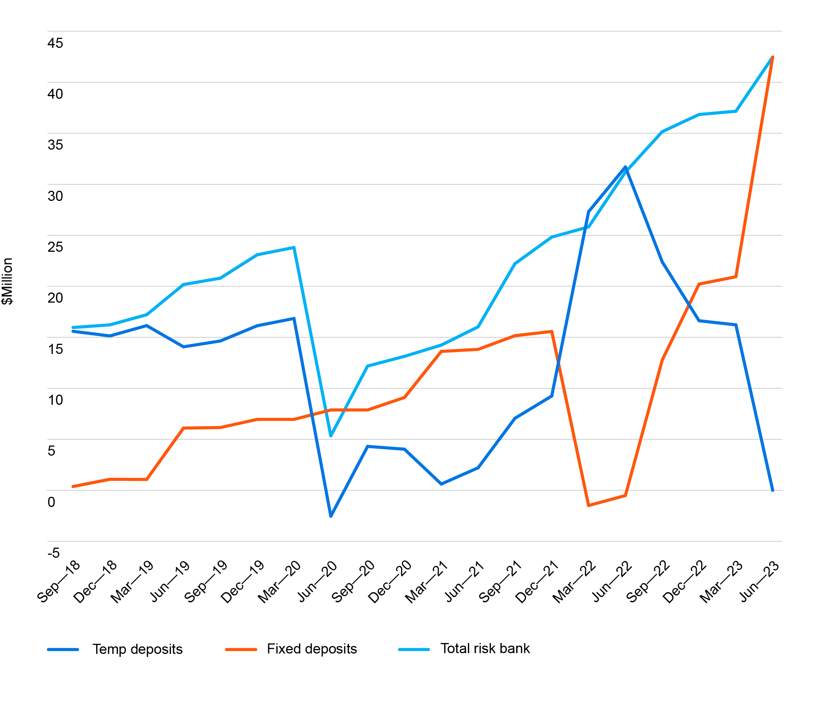
Figure 7: Price Submission 2018–23 risk bank
Using our risk bank, we have been able to forecast our capital investment program to
be delivered for 7.4% below the combined project approval values. This reduction has supported the funding of the 12% of projects that required a risk bank withdrawal.
The risk bank has enhanced our abilities to manage and fund the capital expenditure program by providing a clear understanding of the risk we realise and retire across the asset programs.
We will be applying this approach in the 2023–28 regulatory period and expanding it into an investment portfolio overview that allows us to better manage risk and deliver cost efficiencies at the portfolio level.

6.8 Capacity to deliver
We are confident of our capability and capacity to deliver our capital expenditure program of $1.92 billion, which can be demonstrated when considering our previous track record in delivering capital programs and projects. Our projected total expenditure in the current regulatory period to June 2022 is expected to be within 5% of the overall 5-year budget of $1.25 billion, despite the impact of the coronavirus (COVID-19) pandemic on the construction industry and material supply chains.
When considering expenditure increases between the regulatory periods, it is important to note that the relationship between the value of the program and the volume of works proposed is not linear. For example, the revised unit rates for 2023–28 reflect a mean annual escalation of 3.87% from the 2018–23 rates. This is 1% below the Victorian Government’s forecast of infrastructure cost escalation. Holding the volume of works constant, this requires a step change in capital expenditure of approximately 21%.
Over the 2018–23 regulatory period, we actively managed our capital investment program by regularly reviewing and reallocating resources based on our strategic priorities, asset performance, customer feedback and environmental factors.
For example, we conducted a critical asset review (as discussed in Section 6.3) of water and sewerage assets during the regulatory period that led to a revision of our investment approach to risk, and in line with environmental protection regulations and safety management requirements.

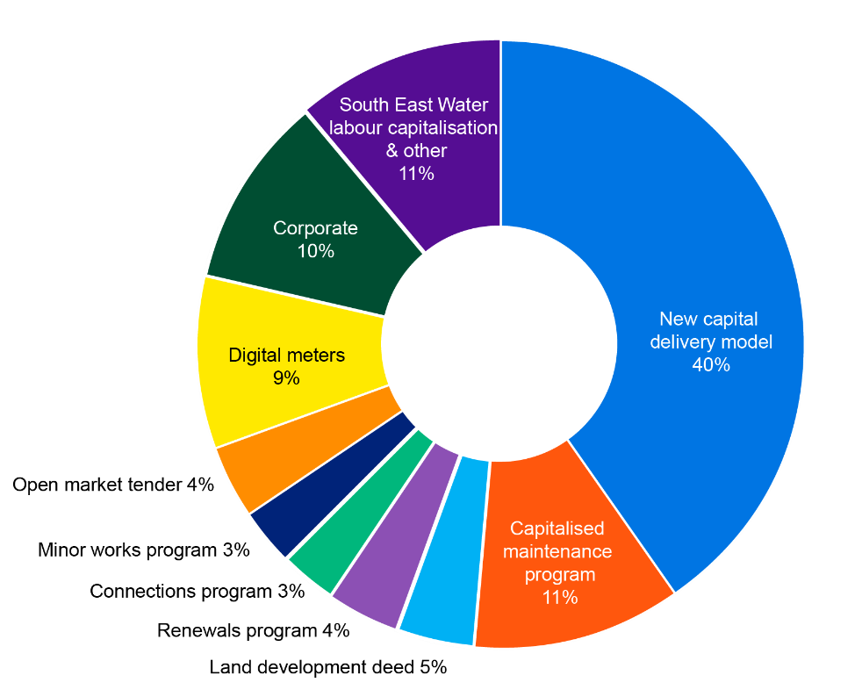
Integrated capital delivery model
Looking to the future, we are changing our partnering capital delivery model to an integrated planning and delivery model, with the capacity and capability to deliver the scope and scale of projects and programs planned for the 2023–28 regulatory period and beyond. Our new integrated capital planning and delivery model will deliver around 40% of our capital expenditure program for the 2023–28 regulatory period and will complement our existing delivery models (as shown in the pie diagram) for asset connections, renewals, maintenance, minor works, land development and internal corporate programs.
When procuring our new integrated capital planning and delivery model, we selected a 10-year contract term. The longer contract term is designed to attract contractors and consultants in what is currently considered a heated market. The longer contract term enhances certainty to attract investment and provides a long-term portfolio of projects to tender over the contract period. As the agreement is effectively an umbrella contract, it consists of multiple projects and packages of works that will be tendered throughout the program.
This ensures competition and contestability, regardless of market conditions and helps realise cost efficiencies. The contract includes mechanisms designed to ensure contestability if there is concern this is not occurring.
The new integrated capital planning and delivery model will also give us access to expert planning, engineering design, technology delivery partners, project management and supervisory resources that will enhance our capabilities in capital delivery. This is complemented by a considered and planned profile of capital expenditure delivery over the 2023–28 regulatory period to ensure we balance our work schedule with resource capacity that is supported by improvements to our capital delivery processes.

Digital utility
Lastly, as 9% of our capital investment program is associated to the digital metering project, we have taken the following actions to ensure its successful delivery:
- established a dedicated program team to oversee the delivery of customer meters. This includes all areas of procurement, governance, status reporting and financial control
- secured ‘Field Service’ partners to complete the exchange to digital meters, who will be managed by the Digital Utility group (contracts, procurement and performance)
- identified a range of experienced meter suppliers to be part of the ‘Build and Scale’ phase of the program. We will strategically procure partners to supply meters and minimise logistical and supply chain issues.

Supporting documents
Corporate Asset Management Plan
Major Projects (2023–28) Summary Report
2023–28 Capital Delivery Report
Demand Manual – Dwelling and population forecast
Concept Cost Estimating Report - June 2022
2023–28 Unit Rate Tables (2022–2023)

7. Forecast operating expenditure

Key points
- South East Water's operating expenditure is expected to be $0.7 million less than its benchmark allowance for the 2018–23 period.
- This means that South East Water expects to outperform the 2.3% cost efficiency assumption that was reflected in the current period benchmark operating expenditure allowance.
- Forecast prudent and efficient total operating expenditure for the 2023–28 period is $3,445 million, which is 6.5% less than the current period benchmark allowance (on average) over the regulatory period.
- The forecast of controllable operating expenditure includes an ambitious cost efficiency improvement rate of 2% per year, which will continue to deliver cost savings to customers going forward.

7.1 Current period outcomes

Current period performance
9 shows expected controllable operating expenditure outcomes for the 2018–23 period. Current period operating expenditure is forecast to be $0.7 million less than the benchmark operating expenditure allowance of $699 million (escalated to 2022–23).
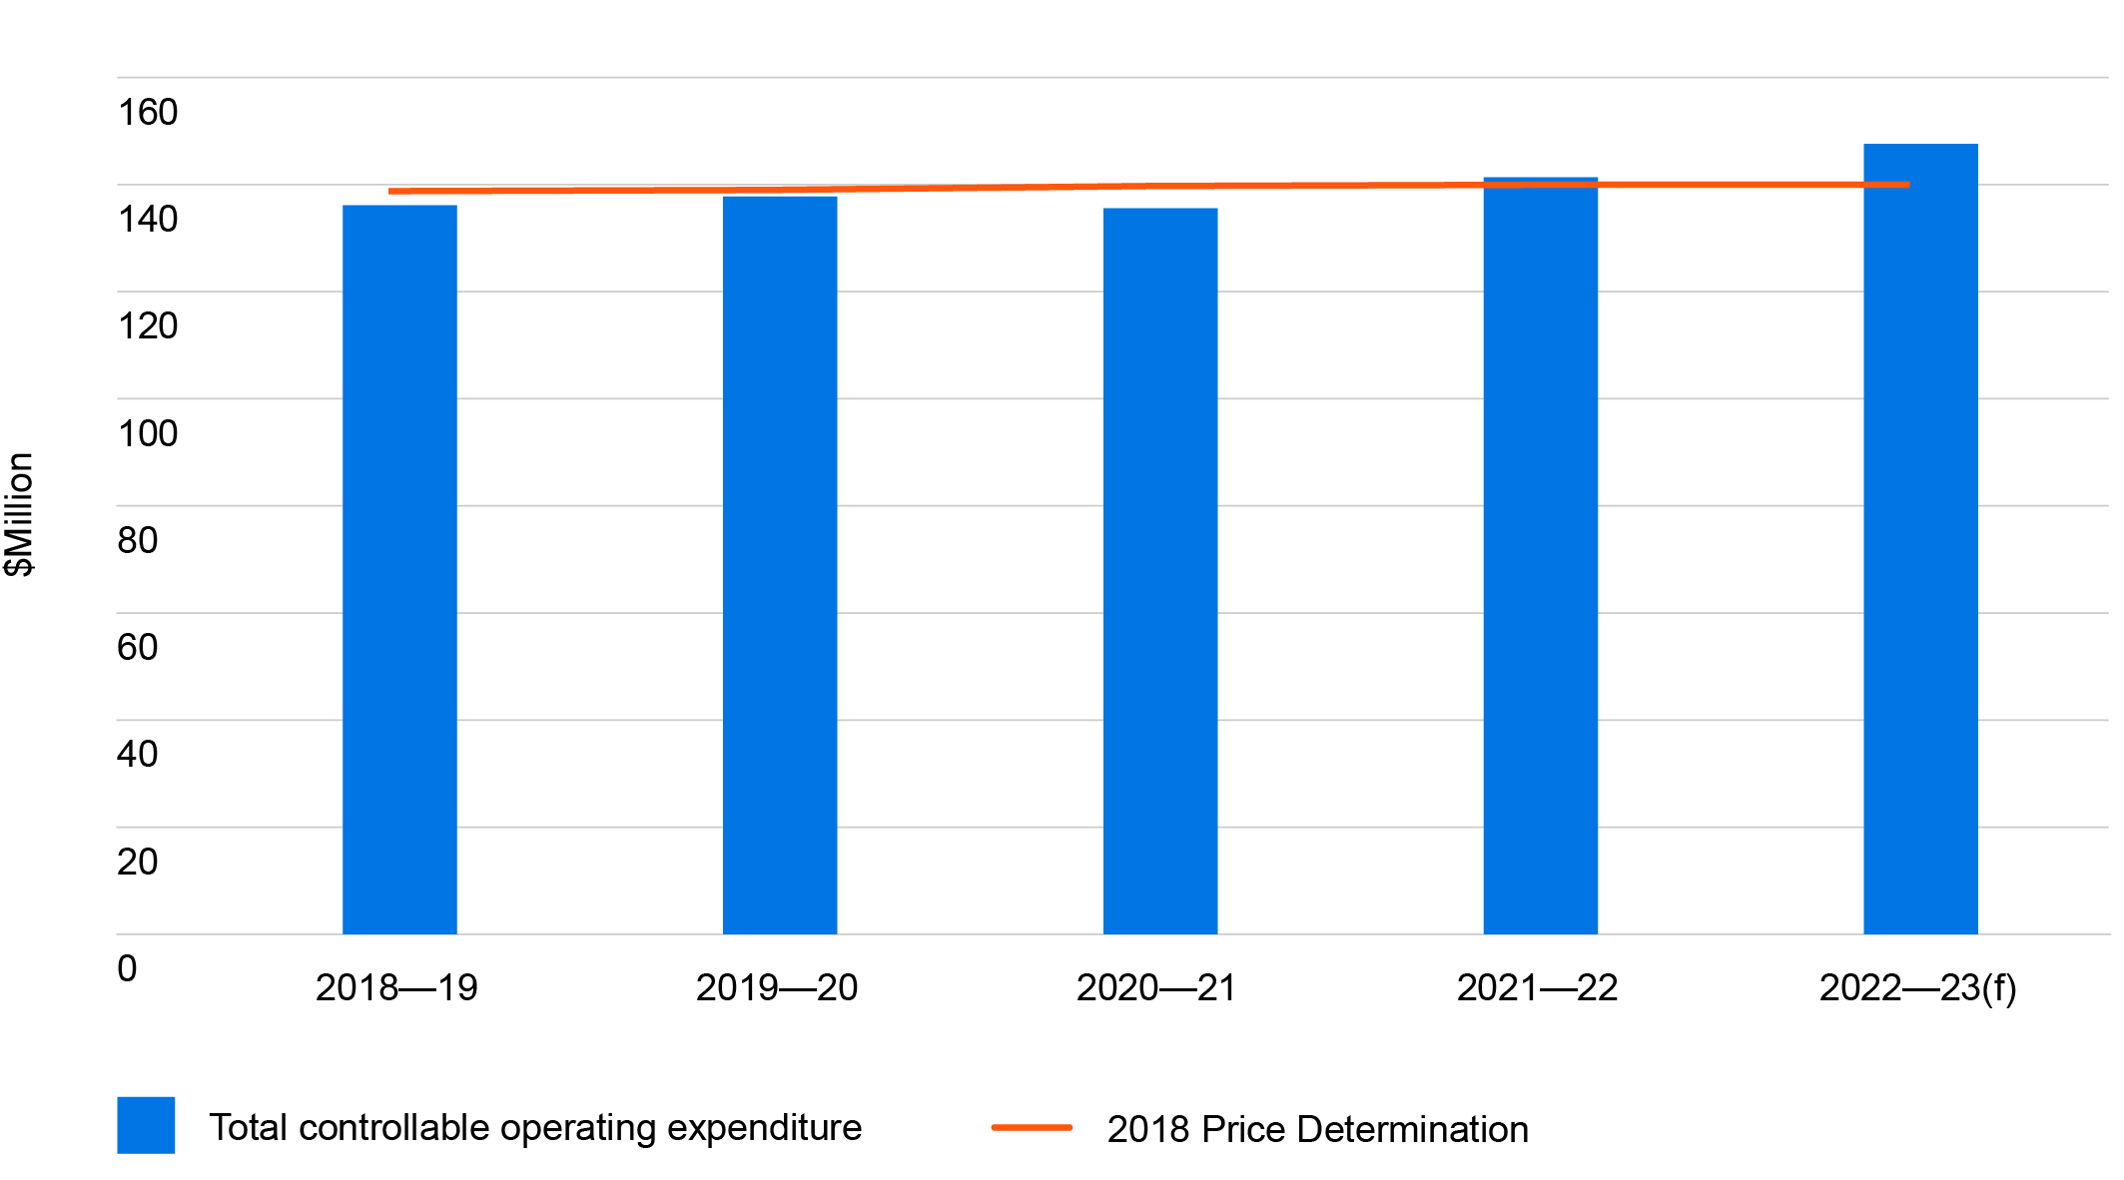
Figure 9: Operating expenditure 2018–23 compared to benchmark allowance
($million 2022–23)
Note: The actual and forecast controllable operating expenditure excludes developer costs which were previously capitalised. During the current regulatory period, following a review of the capitalisation policy, costs for developer functions which were previously capitalised were transferred to controllable operating expenditure. This was considered in the regulatory account audit process.

The efficient operating expenditure outcome for the current 2018–23 period has been achieved by:
- streamlining functions within the organisation
- introducing new technologies and innovations that helped to reduce costs.
These savings were predominantly achieved early in the regulatory period, allowing South East Water to absorb cost pressures relating to operations, maintenance and water quality activities, that arose later in the period.

Benchmarking
The efficiency of our current period performance is demonstrated by independent metropolitan and national benchmarking studies.

Metropolitan benchmarking
South East Water benchmarks favourably against other metropolitan Melbourne water corporations. This is evidenced in the National Performance Report 2020–21: Urban Water Utilities, issued by the Bureau of Meteorology. This report compares urban water utilities across Australia and shows that our operating costs per property are median or below over the 5-year period to 2020–21, compared to other metropolitan water utilities.

National benchmarking
The Water Services Association of Australia undertook a benchmarking study on
the 2019–20 operating costs of comparable water businesses. It shows that South East Water benchmarks favourably. When compared against 19 other water businesses across Australia, we have 69% (or $90 million) of operating expenses in the top quartile for efficiency. The report rated South East Water’s operating expenditure categories, including water network, wastewater network, retail, and corporate expenditure on finance, human resources, fleet and property, in the top quartile.
Water network expenditure accounts for the largest proportion of our operating expenditure. Figure 10 shows that South East Water had among the lowest water network operating expenditure per kilometre of water mains in 2019–20.

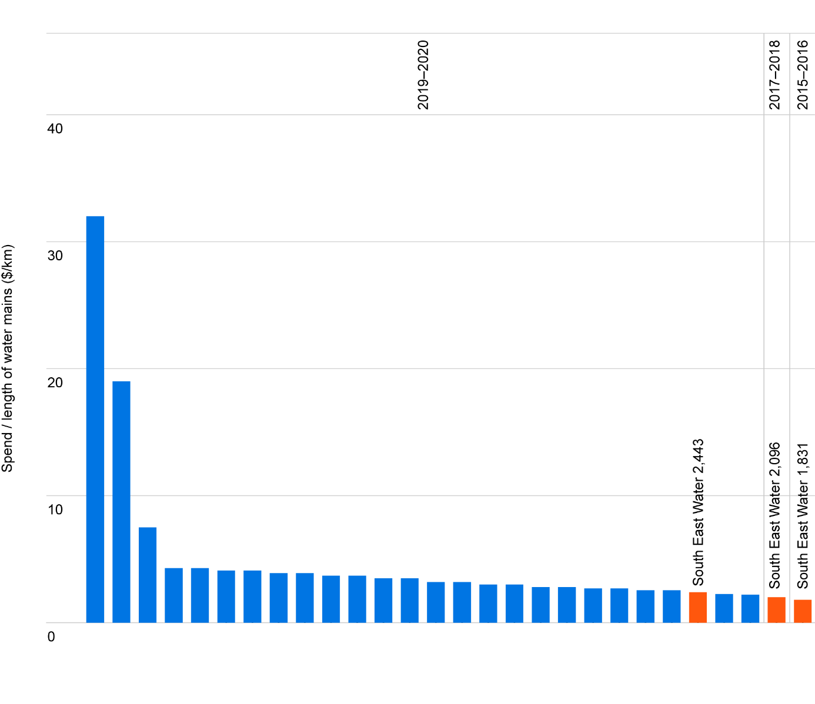
Figure 10: Water network operating expenditure per kilometre

Source: WSAA 2020, Operating Cost Benchmarking Utility Report, Final Report, December, page 11.

7.2 Approach to forecasting operating expenditure
South East Water’s controllable operating expenditure includes the day-to-day costs of running our water and sewerage network and treatment plants (such as maintenance, electricity and labour costs), as well as customer service and billing costs.
Operating expenditure outside of our control includes:
- Melbourne Water’s bulk charges for collection and treatment of drinking water and treatment of sewage
- an environmental contribution made to the Victorian Government
- other licence fees and charges.
Our approach to developing the forecast controllable operating expenditure for the 2023–28 regulatory period involved:
- using 2021–22 actual expenditure as a base
- undertaking a comprehensive review of all activities and resource requirements.
Our proposed operating expenditure for the next regulatory period commits us to a continued focus on efficiency and ongoing management of controllable operating costs. We are confident in this commitment, even with positive growth in our customer base and increasing input prices.

Cost allocation methodology
Operating expenditure is allocated to the services supplied on:
- a direct charge basis – where costs that relate directly to a specific service (water, sewerage and recycled water) are allocated in full to that service.
- an indirect charge basis – where costs which are not directly related to a specific service are allocated based on the percentage allocation of direct costs to those services.
- non-prescribed activity, which is removed for the setting of prices.

7.3 Total operating expenditure forecast
As shown in Figure 11, forecast prudent and efficient total operating expenditure for the 2023–28 period is $3,443 million, which is 6.5% less than the current period benchmark allowance (on average) over the regulatory period.
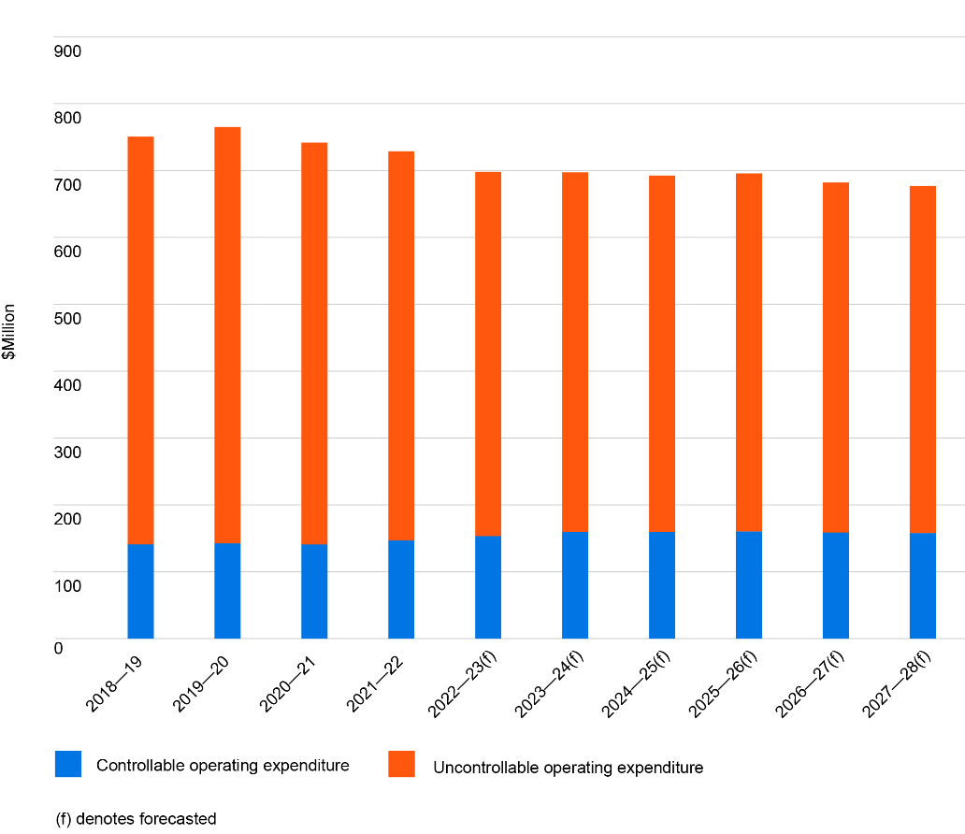
Figure 11: Total operating expenditure ($million 2022–23)
Note: The actual and forecast controllable operating expenditure includes developer costs which were previously capitalised.
Detail regarding the controllable and uncontrollable operating expenditure forecasts is provided in the remainder of this section.

Controllable operating expenditure forecast
Forecast controllable operating expenditure for the 2023–28 period is $795.6 million, shown by activity in Table 27.

Table 27: Controllable operating expenditure by activity ($million 2022–23)
 | 2023–24 | 2024–25 | 2025–26 | 2026–27 | 2027–28 | Total
Operations and maintenance | 67.52 | 66.92 | 66.67 | 66.59 | 66.51 | 334.22
Treatment | 21.07 | 21.39 | 22.34 | 21.75 | 21.93 | 108.47
Customer service and billing | 29.76 | 28.98 | 28.14 | 27.48 | 26.49 | 140.86
GSL payments | - | - | - | - | - | -
Corporate | 40.80 | 41.51 | 42.41 | 42.25 | 42.19 | 209.15
Other operating expenditure | 0.59 | 0.58 | 0.58 | 0.58 | 0.57 | 2.90
Total | 159.74 | 159.38 | 160.14 | 158.64 | 157.69 | 795.59

The build-up of the controllable operating expenditure forecast is detailed below.

Baseline operating expenditure
The baseline year for controllable operating expenditure is the 2021–22 financial year. Baseline operating expenditure is $144.4 million, which is total operating expenditure excluding:
- uncontrollable operating expenditure
- baseline operating expenditure adjustments of $2.48 million, shown in Table 28.

Table 28: Calculation of baseline operating expenditure ($million 2022–23)
Calculation of baseline operating expenditure $ million (2022–23)
Baseline operating expenditure | 728.80
Less non-controllable expenditure items
External bulk water charges | 535.00
Licence fees | 1.24
Environmental contributions | 45.67
Other non-controllable | -
Plus adjustment (as per operating expenditure items for adjustment Table) | -2.48
Adjusted baseline operating expenditure | 144.41

Table 29: Baseline operating expenditure adjustment for 2021–22 ($million 2022–23)
Item | Description | Adjustment to  the baseline  year ($m)
Customer engagement and external advice | Ongoing engagement with continued customer check-in will occur during the regulatory period. This adjustment relates to the costs associated with price submission research and external advice. | -1.26
Urban water strategy | During 2021–22, the urban water strategy, Water for Life, was developed. The expenditure for this has been removed as this strategy will last 5 years. | -0.35
Job volumes FY21–22 | The 2021–22 year had a La Niña weather pattern, which impacted activity levels. This adjustment aligns job volumes to a 3-year average or neutral weather pattern. | 0.62
Maintenance model transition costs | During 2021–22 the organisation commenced its transition to a new operations and maintenance delivery model. The costs associated with this transition have been removed from the base year expenditure. | -1.49
Total |  | -2.48

A review was also conducted on the FY2021–22 actuals to determine if coronavirus (COVID-19) had impacted the results. Following this assessment, we have determined the expenditure associated with COVID-19 in FY2021–22 to be immaterial.

Growth allowance and 2% efficiency improvement rate
An annual growth allowance and efficiency improvement rate are applied to the baseline controllable operating expenditure. Table 30 shows the growth allowance and efficiency improvement rate proposed for each year of the 2023–28 regulatory period.

Table 30: Growth rate and cost efficiency assumption
 | 2023–24 | 2024–25 | 2025–26 | 2026–27 | 2027–28 | Average
Cost efficiency improvement rate | 2.00% | 2.00% | 2.00% | 2.00% | 2.00% | 2.00%
Operating expenditure growth factor (including  an ‘uncertainty discount’) | 0.60% | 0.88% | 0.97% | 1.61% | 1.59% | 1.13%
Customer growth | 1.17% | 1.16% | 1.14% | 1.65% | 1.63% | 1.35%
Net cost efficiency improvement rate | 1.40% | 1.12% | 1.03% | 0.39% | 0.41% | 0.87%

Efficiency improvement rate
South East Water has a strong commitment to delivering ongoing efficiency savings.
As a result, an annual efficiency improvement rate of 2% is proposed, which is ahead of the ESC’s efficiency hurdle rate. This efficiency rate delivers a reduction in controllable operating expenditure of $22.5 million over the 2023–28 regulatory period.
Our efficiency-enhancing investments such as the Digital Utility program and efficient contracting arrangements will support the achievement of these efficiency savings.
Growth allowance
In previous price reviews, South East Water has based its operating expenditure growth allowance on forecast customer growth over the regulatory period. However, following the coronavirus (COVID-19) pandemic and its effect on customer growth rates, assuming a direct relationship between residential customer growth and operating expenditure growth may no longer be reasonable (as noted in the ESC’s guidance paper).
As shown in Box 1 below, both controllable operating expenditure and bulk water consumption have grown at a lower rate than customer numbers over the last 5 years.
Box 1: Relationship between controllable operating expenditure and growth
As shown in Table 31, controllable operating expenditure has grown at a lower rate (1.77% on average) than residential water customer numbers (1.90% on average) over the last 5 years, with a difference of around 0.13% per year on average.
In addition, bulk water consumption has grown at a lower rate (1.05% on average) than residential water customer numbers (1.90% on average) over the last 5 years, with a difference of around 0.85% per year on average. This has been due to the impacts of COVID-19 and a wetter climate on bulk water usage, which led to lower water consumption overall.
Table 31: Historical benchmarks
 | 2017–18 | 2018–19 | 2019–20 | 2020–21 | 2021–22 | Average growth rate
Controllable operating expenditure ($’000 2022–23) | 140,971 | 140,830 | 142,459 | 140,592 | 146,894
Number of water customers | 702,375 | 717,091 | 730,686 | 741,712 | 752,154
Bulk water (ML) | 161,067 | 162,046 | 155,247 | 154,805 | 160,399
Controllable operating expenditure year-on-year growth (%) | 4.63% | -0.10% | 1.16% | -1.31% | 4.48% | 1.77%
Number of water customers year-on-year growth (%) | 2.60% | 2.10% | 1.90% | 1.51% | 1.41% | 1.90%
Bulk water year-on-year growth (%) | 5.51% | 0.61% | -4.20% | -0.28% | 3.61% | 1.05%

This provides some evidence that the direct relationship between customer growth and operating expenditure growth may no longer hold.
To address this concern, South East Water is proposing to apply a growth allowance that is lower than forecast customer growth for the 2023–28 period. This ‘uncertainty discount’ of 0.22% on average is applied each year on expected customer growth (see Table 30). This uncertainty discount accounts for the uncertainty in forecast customer growth (based on variation between recent forecasts). This results in a proposed operating expenditure growth rate of 1.13% each year, on average. This methodology has a positive impact on the net efficiency improvement rate, providing better value to customers.

Elements of controllable operating expenditure will be absorbed
South East Water proposes to absorb the following future costs, meaning that they will not be passed onto customers:
- Postage via Australia Post (50% of bills are now sent via email each quarter, up from 25% in 2018). Efforts will be concentrated to continue migrating customers to E-Bills,
in addition to delivering process efficiencies.
- Key programs to support our outcomes from the results of customer engagement will also be absorbed within current expenditure levels. This includes:
- implementing a coordinated communications approach to help customers better understand who we are and how what we do represents value for money (for example, providing instructions/information to customers on how to avoid sewer blockages, such as through improved cooking oil and wipes disposal)
- an enhanced and expanded customer support program, to align with the proposed new customer codes
- a dedicated program to collect customer contact data, so we can increase volumes of electronic notifications to keep customers better informed about planned and emergency works.

Cost assumptions

Labour
- The forecasts maintain existing full time equivalent (FTE) workforce levels. This is possible due to efficiencies gained, as digital meters are rolled out over the period.
- The forecasts maintain existing FTE numbers for all other functions, via a reallocation of existing resources, as well as through automation of existing manual roles, supported by our digital transformation.
- No real price increases have been assumed for wages. Any wage increases beyond CPI, would be funded through efficiencies, consistent with the Victorian Government Wages Policy.

Energy
- Energy usage is forecast to grow at an average rate of 2.5% per year across all water recycling plants and assets. This reflects forecast growth assumptions for connections, and also accounts for upgrades at Lang Lang, Longwarry and Somers water recycling plants. This is somewhat offset by a decrease in usage at Boneo and Mount Martha, as a result of CHP (combined heat and power) units being installed
at these sites.
- To develop energy costs for the next regulatory period, we have used actual costs from our current contract, which provides a competitive market rate, keeping costs down until the end of 2023 when that contract expires.
- From 2023, we have adopted forecast cost assumptions based on the forecast commissioned by Intelligent Water Networks (IWN) and DELWP, and developed by Schneider Electric.
- Based on these actual and forecast costs, we predict that unit rate costs of electricity will increase by 4% in 2024 when the current contract expires and then increase by an average of 2% year on year, until peaking at a 4% increase in 2026-27.
- However, we also acknowledge that the energy market is increasingly volatile, making these forward predictions less certain. We intend to revisit these assumptions with the ESC in the near future, to ensure we have captured the most recent forecast data.

Table 32: Electricity cost forecast ($million 2022–23)
 | 2023–24 | 2024–25 | 2025–26 | 2026–27 | 2027–28 | Total
Forecast electricity costs (all sites) | 5.54 | 5.97 | 6.40 | 6.82 | 6.73 | 31.46

Chemicals
- Chemical costs are forecast to increase over the regulatory period, with the most significant increase in 2026–27 as upgraded water recycling plants are commissioned and operating with increased capacity. The increase in expenditure is a result of higher volumes used, rather than increased unit costs.
- Chemical expenditure is a small component of our controllable operating expenditure. Chemical costs are related to both the treatment of our water supply and sewage at our water recycling plants. It is critical to ensure a safe drinking water supply for our customers.
- In response to events including the Silvan water quality incident (where ‘boil water’ advisory protocols were initiated), a number of changes have been implemented in 2021–22 in relation to primary chlorination, monitoring and chlorine residuals within the network. Over the next price period, we are doubling the number of chlorinators in our network from 24 to 48. This will see a rise in chemical costs related to chlorination.
- Both Lang Lang and Longwarry water recycling plants will also be upgraded in 2025–26 to Class A and mechanical plants respectively, providing further capacity and requiring more chemical dosage.

Table 33: Chemical cost forecast ($million 2022–23)
 | 2023–24 | 2024–25 | 2025–26 | 2026–27 | 2027–28 | Total
Total chemical costs (all sites) | 1.49 | 1.54 | 1.61 | 1.75 | 1.78 | 8.17

Information Technology (IT)
- IT supports almost all of the core business functions at South East Water. Without continued investment, we will not be able to meet and maintain the needs of our customers, remain compliant with our obligations, or be able to achieve integrity of service levels.
- South East Water is embarking upon a digital transformation in response to the changing environment in which it operates, and most importantly, the needs and expectations of our customers. To support this digital transformation, we are proposing to make a proportionate investment in IT in the next regulatory period.
- The increase in operating expenditure is a result of investment in new technologies that require new licensing agreements, whereas current systems have no licensing obligations, due to them being built inhouse and on premise. The requirement for new technology stems from the necessary replacement of ageing systems, an increase in the cyber security threat landscape, an increase in cloud computing and to allow South East Water to achieve efficiency savings, through removal of manual processes.
- South East Water is proposing a step change in IT expenditure. The step change amount is included in the total IT cost shown in Table 34 below.

Table 34: Total information technology cost forecast ($million 2022–23)
 | 2023–24 | 2024–25 | 2025–26 | 2026–27 | 2027–28 | Total
Total information technology costs  (all sites) | 11.38 | 12.43 | 13.27 | 13.27 | 13.37 | 63.72

Step changes
Operating expenditure step changes totalling $96.1 million over the 5-year regulatory period are proposed. Appendix 1 explains the need for each of the step changes.

Table 35: Step changes ($million 2022–23)
 | 2023–24 | 2024–25 | 2025–26 | 2026–27 | 2027–28
Step changes
Aquarevo Water Recycling Plant operating costs | 0.13 | 0.23 | 0.23 | 0.23 | 0.23
Superannuation/taxation | 1.06 | 1.44 | 1.83 | 1.83 | 1.83
Removal of GSLs | -0.15 | -0.15 | -0.15 | -0.15 | -0.15
Digital metering | 3.17 | 2.67 | 2.06 | 1.48 | 0.56
Revised maintenance model | 4.47 | 4.47 | 4.47 | 4.47 | 4.47
New assets | 0.03 | 0.05 | 0.05 | 0.18 | 0.32
Water quality | 3.13 | 3.18 | 3.21 | 3.24 | 3.27
Climate Adapt | 0.59 | 0.29 | 0.29 | 0.29 | 0.29
IWM – Dingley | - | - | 0.32 | 0.32 | 0.32
GED | 0.18 | 0.18 | 0.18 | 0.18 | 0.18
Traditional Owner | 0.43 | 0.43 | 0.50 | 0.50 | 0.50
Water recycling plants | 1.34 | 1.78 | 2.95 | 2.42 | 2.69
Water literacy | 0.34 | 0.34 | 0.34 | 0.34 | 0.34
IT | 2.63 | 3.68 | 4.52 | 4.52 | 4.62
Total | 17.35 | 18.59 | 20.79 | 19.84 | 19.45

7.4 Uncontrollable operating expenditure
Uncontrollable operating expenditure is forecast to be $2,649 million over the 2023–28 period.

Table 36: Uncontrollable operating expenditure ($million 2022–23)
 | 2023–24 | 2024–25 | 2025–26 | 2026–27 | 2027–28
Licence fees – Essential Services Commission | 0.41 | 0.38 | 0.58 | 0.87 | 0.87
Licence fees – Department of Health | 0.07 | 0.07 | 0.07 | 0.07 | 0.07
Licence fees – Environment Protection Authority | 0.29 | 0.29 | 0.29 | 0.29 | 0.29
Environment contribution | 42.19 | 40.97 | 39.77 | 38.61 | 37.49
Melbourne Water – water | 314.43 | 307.23 | 304.73 | 297.96 | 296.29
Melbourne Water – sewerage | 178.72 | 182.76 | 188.74 | 184.37 | 183.17
Melbourne Water and TRILITY  – recycled water | 0.97 | 0.97 | 0.97 | 0.97 | 0.97
Goulburn–Murray Water – Northern Victoria Goulburn Water entitlements | 0.16 | 0.16 | 0.16 | 0.16 | 0.16
Goulburn–Murray Water – Northern Victoria Murray Water entitlements | 0.28 | 0.28 | 0.28 | 0.28 | 0.28
Total non-controllable operating expenditure | 537.52 | 533.11 | 535.60 | 523.59 | 519.59

Melbourne Water bulk charges
Bulk charges paid to Melbourne Water currently account for 70% of total operating expenditure. Melbourne Water has provided South East Water’s bulk water charge forecast for the 2023–28 regulatory period. The forecast is based on the inflation and cost of debt assumptions consistent with their regulatory model. South East Water also pays both Melbourne Water and TRILITY an annual fee for the supply of Class A recycled water.

Environmental contribution
South East Water currently makes an annual contribution to the Department of Environment, Land, Water and Planning (DELWP), funding initiatives which promote the sustainable management of water in Victoria. As shown in Table 36, over the 2023–28 period, the environmental contribution is assumed to be 5% of a water corporation’s water and sewerage annual revenue in line with current settings.

Licence fees
Licence fees consist of regulatory charges levied by the ESC, Department of Health and EPA Victoria. These regulatory fees are assumed to remain constant with the exception of the ESC licence fee which is forecast to increase.

Water entitlement fees
South East Water holds water entitlements within the Goulburn River and Murray River systems. South East Water is required to pay Goulburn Murray Water fees relating to bulk water entitlements and storage charges during the next regulatory period.

7.5 Allocation of risk
- We are prepared to accept and manage risk on behalf of customers to help drive prices down. Reliable benchmarking across similar water organisations in Australia consistently places us in the higher performing and most cost-efficient segments (see ‘benchmarking’) – demonstrating our proven ability to manage this cost risk on behalf of our customers to a very efficient level.
- The ESC has indicated that a 1.9% efficiency improvement rate would align to an ‘Advanced’ submission. We are prepared to commit to an annual efficiency improvement rate of 2%, which is higher than the ESC hurdle rate and allows us to continue to drive prices down while still delivering on a suite of customer outcomes. This efficiency rate is equal to a reduction in controllable expenditure of $22.5 million over the 5-year regulatory period.
- We are well placed to manage this risk on behalf of our customers, by stepping up our focus on efficiencies through enhancing our technology and digital capabilities.

Supporting documents
South East Water Cost Allocation Methodology (September 2022)
Step Change Documentation
WSAA 2020, Operating Cost Benchmarking Utility Report, Final Report

03
Part 3:
Prices to support delivery of outcomes

Part 3: Prices to support delivery
of outcomes
This part of our submission explains the level and structure of prices we propose,
to recover the revenue requirement needed to deliver the outcomes agreed with customers. Part 3 sets out South East Water’s proposed:
- Total revenue requirement
- Demand forecasts
- Structure of prices
- Regulatory price settings

8. Overall revenue requirement

Key points

The regulatory asset base is forecast to increase by an average of 5% per annum.

We have used straight-line depreciation to calculate our return of capital.

A 10-year trailing average approach is used to estimate the cost of debt.

We are adopting a return on equity allowance under a ‘Standard’ PREMO rating.

8.1 Revenue requirement
South East Water’s revenue requirement reflects the costs we need to recover through prices. It includes:
- return on our assets, which is the expected value of our regulatory asset base (RAB) estimated for each year of the regulatory period, multiplied by the weighted average cost of capital
- expected regulatory depreciation of new and existing assets
- expected total operating expenditure, including:
  - water and sewage bulk charges from Melbourne Water
  - South East Water’s controllable operating expenditure
  - environmental contribution and other licence fees
- estimated tax based on a 30% tax rate consistent with the ESC template, (corporate annual tax payment forecasts can be provided on request).
The following sections outline the assumptions we used to calculate our revenue requirement for the next regulatory period.
The proposed annual revenue requirement is shown in Table 37. During the next
10-year period we forecast a slight increase to the revenue requirement.

Table 37: Proposed annual revenue requirement, 2023–33 ($million 2022–23)
 | 2023–24 | 2024–25 | 2025–26 | 2026–27 | 2027–28 | 2028–29 | 2029–30 | 2030–31 | 2031–32 | 2032–33
Controllable operating  expenditure | 159.74 | 159.38 | 160.14 | 158.64 | 157.69 | 156.11 | 154.28 | 153.73 | 153.24 | 152.62
Uncontrollable operating expenditure | 537.52 | 533.11 | 535.60 | 523.59 | 519.59 | 518.32 | 517.63 | 517.07 | 516.94 | 516.54
Return on assets | 108.14 | 104.98 | 105.95 | 107.01 | 108.93 | 110.83 | 112.36 | 118.20 | 124.58 | 128.27
Regulatory depreciation of assets | 121.28 | 111.38 | 106.82 | 112.66 | 123.60 | 136.01 | 148.02 | 156.13 | 166.37 | 177.49
Adjustments from last period | – | – | – | – | – | – | – | – | – | –
Non-prescribed rev. offset revenue requirement | – | – | – | – | – | – | – | – | – | –
Tax liability | 17.56 | 14.55 | 13.12 | 15.56 | 16.46 | 18.62 | 19.61 | 19.73 | 20.17 | 21.19
Revenue requirement | 944.25 | 923.41 | 921.62 | 917.46 | 926.28 | 939.89 | 951.91 | 964.87 | 981.30 | 996.12

8.2 Forecast regulatory asset base (RAB)
The opening RAB for 2023–34 has been calculated by:
- adding actual capital expenditure from each year of the current period to the opening RAB in 2018–19
- subtracting actual customer contributions, any government contributions, asset disposals and regulatory depreciation.
We have used up-to-date forecast capital expenditure for 2022–23 to determine the 2023–24 opening RAB. We will provide updates on the 2022–23 capital expenditure forecast during the price review process, to ensure the expenditure included in the opening RAB is as accurate as possible.

Table 38: Regulatory asset base, 2017–23 ($million 2022–23)
Regulatory asset base | 2017–18 | 2018–19 | 2019–20 | 2020–21 | 2021–22 | 2022–23
Opening RAB | 3,688.82 | 3,722.24 | 3,748.27 | 3,877.01 | 3,969.83 | 4,002.99
plus gross capital expenditure | 168.65 | 227.81 | 281.93 | 253.55 | 189.93 | 295.13
less government contributions | – | – | – | – | – | 12.30
less customer contributions | 48.40 | 44.96 | 35.86 | 33.55 | 32.51 | 32.95
less proceeds from disposals | 2.35 | 90.72 | 42.20 | 42.55 | 30.64 | 1.89
less regulatory depreciation | 84.47 | 66.10 | 75.14 | 84.62 | 93.61 | 101.80
Closing asset base | 3,722.24 | 3,748.27 | 3,877.01 | 3,969.83 | 4,002.99 | 4,149.17

To calculate the closing RAB for each year of the next regulatory period, we:
- added forecast capital expenditure to the opening RAB
- subtracted customer contributions, any government contributions, regulatory depreciation and asset disposals.
South East Water continues to calculate regulatory depreciation, as per the approach used in the current regulatory period:
- existing assets are depreciated on the basis of an average asset life
- new assets are depreciated, using a straight-line approach, based on the estimated asset lives and asset utilisation for the individual asset types.
Table 39 outlines our proposed opening and closing RAB out to 2032–33. We use the average of the opening and closing RAB of each year to determine the return on assets included in the revenue requirement.

Table 39: Regulatory asset base, 2023–33 ($million 2022–23)
Regulatory asset base | 2023–24 | 2024–25 | 2025–26 | 2026–27 | 2027–28 | 2028–29 | 2029–30 | 2030–31 | 2031–32 | 2032–33
Opening RAB | 4,149.17 | 4,332.18 | 4,564.41 | 4,811.61 | 5,050.99 | 5,274.11 | 5,486.34 | 5,694.20 | 5,894.31 | 6,084.43
plus gross capital expenditure | 351.96 | 380.20 | 392.38 | 399.87 | 396.65 | 404.94 | 412.62 | 413.00 | 412.56 | 398.13
less government contributions | 12.53 | – | – | – | – | – | – | – | – | –
less customer contributions | 33.25 | 34.71 | 36.47 | 45.94 | 48.04 | 54.81 | 54.84 | 54.88 | 54.17 | 54.20
less proceeds from disposals | 1.89 | 1.89 | 1.89 | 1.89 | 1.89 | 1.89 | 1.89 | 1.89 | 1.89 | 1.89
less regulatory depreciation | 121.28 | 111.38 | 106.82 | 112.66 | 123.60 | 136.01 | 148.02 | 156.13 | 166.37 | 177.49
Closing asset base | 4,332.18 | 4,564.41 | 4,811.61 | 5,050.99 | 5,274.11 | 5,486.34 | 5,694.20 | 5,894.31 | 6,084.43 | 6,248.98

8.3 Cost of debt, return on equity, regulatory rate of return
The trailing average cost of debt is calculated as the simple average of 10 years of cost of debt that reflects the yields of the Reserve Bank of Australia 10-year BBB rated corporate bond.
South East Water is committed to managing price impacts for our customers and maintaining affordable services. As a result, we are adopting a return on equity level (of 4.1%) equivalent to a ‘Standard’ PREMO rating that can support this. This will ensure that we can deliver the outcomes that customers value and undertake the necessary investments for this to occur, while addressing the cost pressures that our customers are facing on many fronts.
To calculate the regulatory rate of return, a benchmark gearing level of 60:40 debt to equity has been applied.
Table 40: Regulatory rate of return, 2023–33 ($2022–23)
 | 2023–24 | 2024–25 | 2025–26 | 2026–27 | 2027–28
Cost of debt – real | 1.51% | 1.19% | 1.04% | 0.89% | 0.78%
Return on equity | 4.10% | 4.10% | 4.10% | 4.10% | 4.10%
Regulatory rate of return (RRR) – real | 2.55% | 2.36% | 2.26% | 2.17% | 2.11%

Supporting documents
  - ESC Regulatory model

9. Demand forecasts

Key points

South East Water’s forecasts reflect:

lower forecast growth for new residential dwellings and population than in the
Victoria in Futures (VIF)

water efficiency savings from households and the broader network as a result
of digital metering

a higher residential water consumption forecast in the short term to account for the coronavirus pandemic (COVID-19) impacts and assuming a return to drier
and hotter weather conditions

lower non-residential water consumption to account for COVID-19.

This section outlines how we have forecast demand across our entire service offering, including water, sewerage, trade waste and recycled water services. Robust analysis in this space is critical given its impact on costs, pricing and ensuring fairness for our customers.
Our demand forecasts are based on established methods adopted in previous price reviews, with residential consumption forecasts generated through an econometric model and calibrated against an industry end-use model, and other key forecasts (property numbers, sewage, recycled water and trade waste volumes/loads) produced through methods consistent with industry best practice (explained in further detail in the sections below).

9.1 Dwelling and population growth
To forecast dwelling and population growth for the 2023–28 period, we first reviewed a variety of relevant source data including:
- Victoria in Future (2021) (VIF)
- Forecasts from private demographics companies, Spatial Economics and Macroplan
- Historical growth rates
- Precinct Structure Plans (PSP) produced by the Victorian Planning Authority

In 2018–19, immediately prior to the COVID-19 lockdowns, population growth was strong and widespread within our catchment, with some of the highest growth rates in the state observed in the areas of Casey and Cardinia. Since that point growth has fallen significantly with the 2020–21 year showing a net loss of around 23,155 residents from the region and Greater Melbourne’s first negative growth in over 100 years based on the 2021 census data. In addition, interest rates are facing rapid changes and the building industry is facing cost pressures.

To address this increased uncertainty, we considered a range of forecasts prepared over time and chose to adopt Spatial Economics’ dwelling forecasts to inform our demand forecasts, revenue, and expenditure planning. Spatial Economics’ forecasts represent the most recent and detailed forecasts based on the latest available information (including the 2021 census). For the 2023–28 period, Spatial Economics forecast 52,790 new residential dwellings compared to the VIF2021 forecast of 54,235.
Table 41: New residential connections percentage growth
 |  | 2017–18 |  | 2018–19 |  | 2019–20 |  | 2020–21 |  | 2021–22 |  | 2022–23(f) |  | 2023–24(f) |  | 2024–25(f) |  | 2025–26(f) |  | 2026–27(f) |  | 2027–28(f)
Actual |  |  | 2.60% |  | 2.10% |  | 1.90% |  | 1.51% |  | 1.41%
VIF 2021 |  |  |  |  |  |  |  |  |  |  |  |  | 1.37% |  | 1.35% |  | 1.33% |  | 1.32% |  | 1.47% |  | 1.45%
Spatial Economics |  |  |  |  |  |  |  |  |  |  |  |  | 1.18% |  | 1.17% |  | 1.16% |  | 1.14% |  | 1.65% |  | 1.63%

Recycled water customer growth has been forecast based on the PSPs for the Casey and Cardinia growth areas and on forecasts provided by the Fishermans Bend Taskforce. These figures have been aligned with the Spatial Economics forecast to determine the differences in growth between recycled water customers and non-recycled water customers.
Table 42: Number of new residential customers (recycled and total)
 | 2017–18 | 2018–19 | 2019–20 | 2020–21 | 2021–22 | 2022–23(f) | 2023–24(f) | 2024–25(f) | 2025–26(f) | 2026–27(f) | 2027–28(f)
Recycled | 6,891 | 4,671 | 4,026 | 5,340 | 4,645 | 5,190 | 5,258 | 5,297 | 5,584 | 5,624 | 5,663
Total | 17,786 | 14,716 | 13,595 | 11,026 | 10,442 | 8,908 | 8,908 | 8,908 | 8,908 | 13,032 | 13,032

Non-residential customer growth is forecast as a proportion of residential customer growth, based on historical data. On this basis, non-residential customer growth is assumed to be 62% of the Spatial Economics residential dwelling percentage growth.
Table 43: Forecast year-on-year lot percentage growth
 | 2017–18 | 2018–19 | 2019–20 | 2020–21 | 2021–22 | 2022–23(f) | 2023–24(f) | 2024–25(f) | 2025–26(f) | 2026–27(f) | 2027–28(f)
Residential | 2.60% | 2.10% | 1.90% | 1.51% | 1.41% | 1.18% | 1.17% | 1.16% | 1.14% | 1.65% | 1.63%
Non-residential | 2.43% | 1.77% | 1.23% | –0.46% | 0.36% | 0.74% | 0.73% | 0.72% | 0.71% | 1.03% | 1.01%
Total | 2.58% | 2.07% | 1.84% | 1.36% | 1.33% | 1.15% | 1.14% | 1.12% | 1.11% | 1.61% | 1.58%

Figure 12: New dwellings forecast 2017–18 to 2032–33
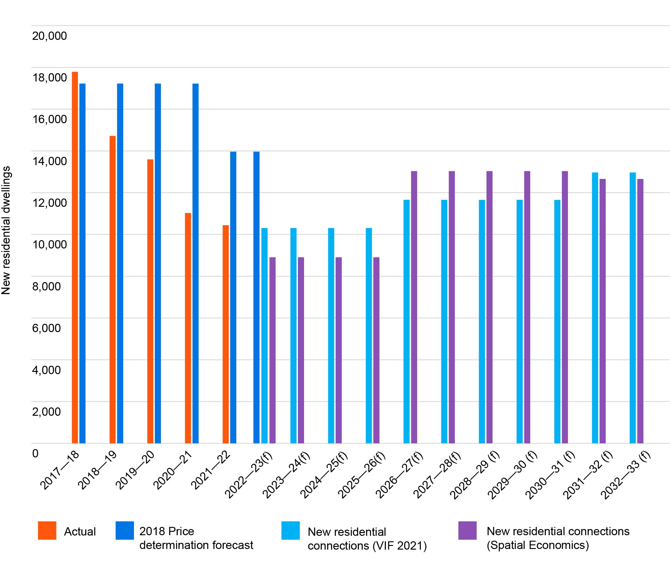

9.2 Key consumption trends and assumptions
For the last 5 years of historical data, actual demand is comparable to forecasts in aggregate. However, within each year’s forecast, there is variability largely due to weather and COVID-19 effects.
Demand exceeded forecasts in 2017–18 and 2018–19 due to high temperatures and low summer rainfall.
In the years following the emergence of COVID-19 (2019–20 to 2021–22), demand was lower than forecast, primarily driven by a reduction in non-residential water usage but also due to wetter weather, with 2019–20 recording the highest total rainfall reducing outdoor water usage.
The variability in demands reflects the trend toward greater weather variability and more frequent extreme weather events as a result of climate change. Despite such variability, actual bulk water demands have been within +/- 5% of forecasts.
Figure 13: Bulk water demand 2017–18 to 2021–22
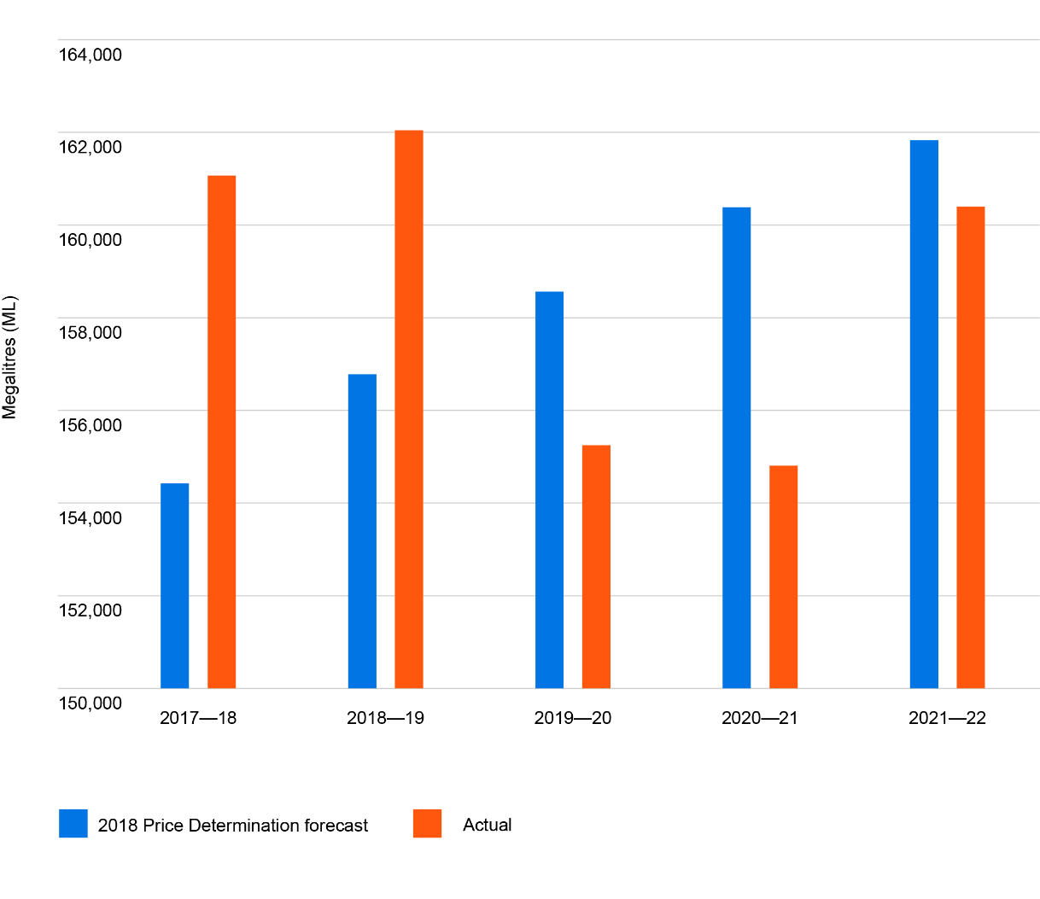

9.2.1 COVID-19
Uncertainty surrounding the COVID-19 pandemic continues to impact both residential and non-residential demands, primarily due to impacts on businesses and a change in behaviour for residential households with a greater amount of people now spending more time working from home. Having historically had a large percentage of customers travelling to the Melbourne CBD during business hours, the increase in working from home arrangements has shifted both water demand and sewerage flows back into our service area.
Employees and resource availability continue to impact our business customers’ ability to trade at pre-pandemic levels. This has led to the closure of some small businesses while also driving certain industries to record high consumption, further adding to the unpredictability of business demand. The full impact of COVID-19 on our business customers and when and how quickly they can recover is a huge unknown and something we have invested significant time with various demographers to understand better.

9.2.2 Climate variability
Climate impacts and the resulting fluctuations in temperatures and rainfall presents significant challenges for our ability to forecast bulk water demand. The variability and length of weather patterns have changed more in the current regulatory period than historically observed. However, our forecasts have remained within +/- 5%.
Initially, there was lower than expected growth due to COVID-19. Then the extreme hot and dry weather experienced through to the start of 2020 had the opposite effect, driving consumption higher, especially by residential customers.
The arrival of the La Niña weather pattern in 2022 brought with it record high levels of rainfall across spring and summer. While this held consumption lower than expected, the large amount of rain did fall in fewer events, which does not curb residential consumption behaviour as much as it does when it falls at a slower rate over a longer period. The econometric model that we have continued to evolve over the past 5 years, continues to provide us comfort that we can consider recent weather conditions and understand the impact it has on household consumption when forecasting future residential demand.

9.2.3 The impact of digital meters
To assess the potential impact of digital meters on demand, South East Water has run
3 customer behaviour-based trials.

Trial 1 continuous flow
Notifications were sent to customers whose abnormal digital meter readings might suggest a leak that they would not normally be aware of until they received a large bill at the end of the billing period. The amount of water saved was calculated by the size of the leak and the number of days before the end of the billing period (that is, the number of days the customer would have remained unaware of the leak).
Trial 2 spike in usage
Notifications were also sent to customers with abnormal digital meter readings; however, in these cases the change in water usage was smaller and therefore more likely to be the result of customer behaviour than a leak. A spike in usage was defined as an increase in usage that was greater than 32.5% of their average daily usage from the previous 3 months and excluded leaks to ensure that any change in usage was a result of behaviour.
Trial 3 customer rewards
This trial offered customers financial and non-financial incentives to save water. Notifications in the form of reminders and feedback were sent to customers twice weekly. Participants were customers with digital meters who consented to participate in the trial. Water savings were determined by changes in water usage compared to a baseline taken from the average daily water usage from the previous 28 days.
BehaviourWorks Australia (Monash University) has reviewed the experimental design of all 3 trials and produced a meta-analysis of the water saving results from the spike in usage and customer rewards trial. They have assured that the results are based on methods that are consistent with high-quality research that has avoided risks of biases in recruitment and measurement. The spike in usage trial was run by BehaviourWorks Australia. The customer rewards trial was run by the University of Melbourne. The trials’ outputs have further undergone econometric analysis undertaken by other academics.
South East Water has also run a trial to test non-revenue water savings realised from vibration sensors in the digital meter. This analysis was undertaken by Jacobs.
The total savings suggested by the trials when digital meters have been rolled out across the whole service region in 2029–30 are summarised in Table 44.

Table 44: Summary of behaviour-based trials
% of total bulk water | Continuous flow | Spike in usage | Customer rewards | Non-revenue water
Internal South East Water analysis | 3.10% | 0.50%
BehaviourWorks Australia (Monash University) |  | 0.59% | 0.57%
Econometric | 3.63% | 0.49% | 0.55%
University of Melbourne |  |  | 0.09%
Jacobs |  |  |  | 1.00%
Adopted assumption | 1.50% | 0.25% | 0.00% | 1.00%

Based on the studies’ outcomes, we have assumed that:
- behaviour change due to continuous flow detections and notifications can be expected to result in bulk water savings of 1.50%
- behaviour change due to a spike in usage notifications can be expected to result in bulk water savings of 0.25% (arising from reduced residential water usage)
- a bulk water savings of 1.00% attributable to non-revenue water.
No non-residential water usage savings have been assumed, even though it is likely to occur, as we did not have a non-residential specific trial. Based on the trials’ results and our conservative assumptions, we have assured ourselves of the quantum of expected savings.
Digital metering savings are applied to the total water demand forecast as shown in Table 45.

Table 45: Digital metering savings forecast (ML)
ML | 2023–24 | 2024–25 | 2025–26 | 2026–27 | 2027–28
Savings (residential) | 312 | 799 | 1,273 | 1,743 | 2,204
Savings (non-revenue) | - | 461 | 737 | 1,007 | 1,271
Total savings | 312 | 1,260 | 2,010 | 2,750 | 3,475

9.3 Water consumption

9.3.1 Residential potable water consumption
It is unclear to what extent COVID-19 (particularly the greater prevalence of working from home) will have lasting impacts on overall growth and settlement patterns in South East Water’s service region. It is clear, however, that these changes have translated to an increase in household usage across our region. This reflects a diversion of water consumption from the CBD to the home rather than an overall increase in consumption. This change is reflective of our customers no longer commuting to Melbourne’s CBD for work in the same numbers as prior to COVID-19.
For this reason, we are forecasting a high level of consumption within the home.
Total residential potable water consumption is forecast to grow by approximately 0.7% per annum during the 2023-28 regulatory period. This reflects the take up of more efficient household appliances, increased use of alternative water supplies and smaller garden sizes, as well as the assumed efficiencies and behaviour change realised through the rollout of digital meters.
South East Water has developed and evolved an econometric model over the past 8 years that has been validated against the end-use (iSDP) model (consistent across retailers) to prepare the residential potable water forecasts. The econometric model
uses well-established methods involving dynamic panel data models for 25 distinct customer segments (based on dwelling type, property size, tenancy and recycled water connection) to generate cohort-specific usage that can be extrapolated across our service area.
The model quantifies the impact of weather conditions and seasonal variables on water use patterns across the 25 segments which allows us to estimate residential consumption under a variety of weather conditions. These weather scenarios include modelling for ongoing hot and dry conditions, continued cold and wet, as well as an average of the past 5 to 50 years, to ensure we have a clear understanding of the possible variations and how each cohort of customers will adjust their usage based on historical patterns.
Considering recent historical weather observations, we believe that a pattern of 3 dry
and 2 wet years is the most likely scenario of the upcoming price submission periods to account for the changing climate and recent extreme weather events. For this reason,
we have chosen to use the historical weather conditions from 2014–15 to 2018–19 which reflect the most recent observations that adhere to this pattern to input into the model.
As outlined above, the key inputs for our econometric model consist of:
- current household and occupant specific data (dwelling and occupancy type, consumption, etc.)
- historical weather data (maximum temperature, total rainfall, evapotranspiration)
for all observations across our service area
- dwelling and population growth forecasts (as described in Section 9.2).
After the forecasts have been derived using the econometric model, the following adjustments are made:
- customer and network efficiencies realised through digital metering
- price elasticity and tariff reform impact.
Figure 14: Residential potable water consumption 2017–18 to 2032–33
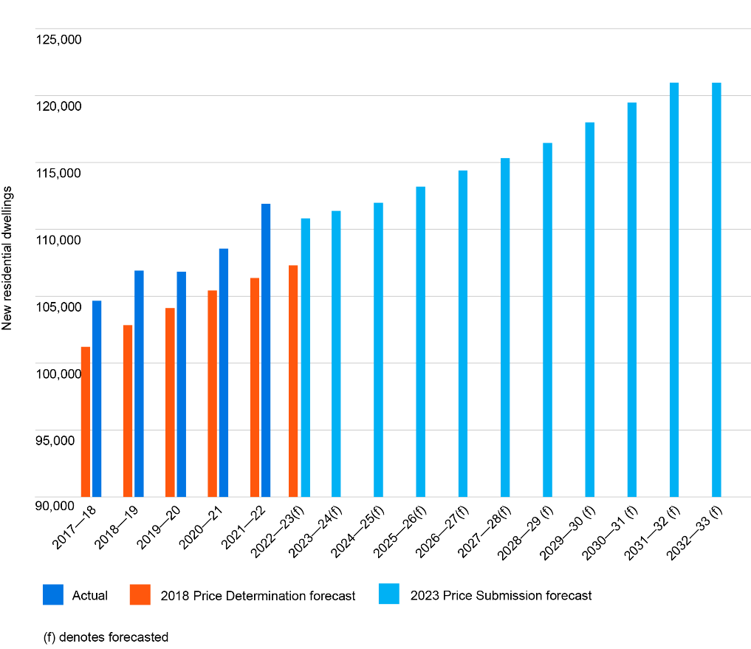
Figure 15: Residential potable water consumption (average kilolitre per customer) 2017–18 to 2032–33

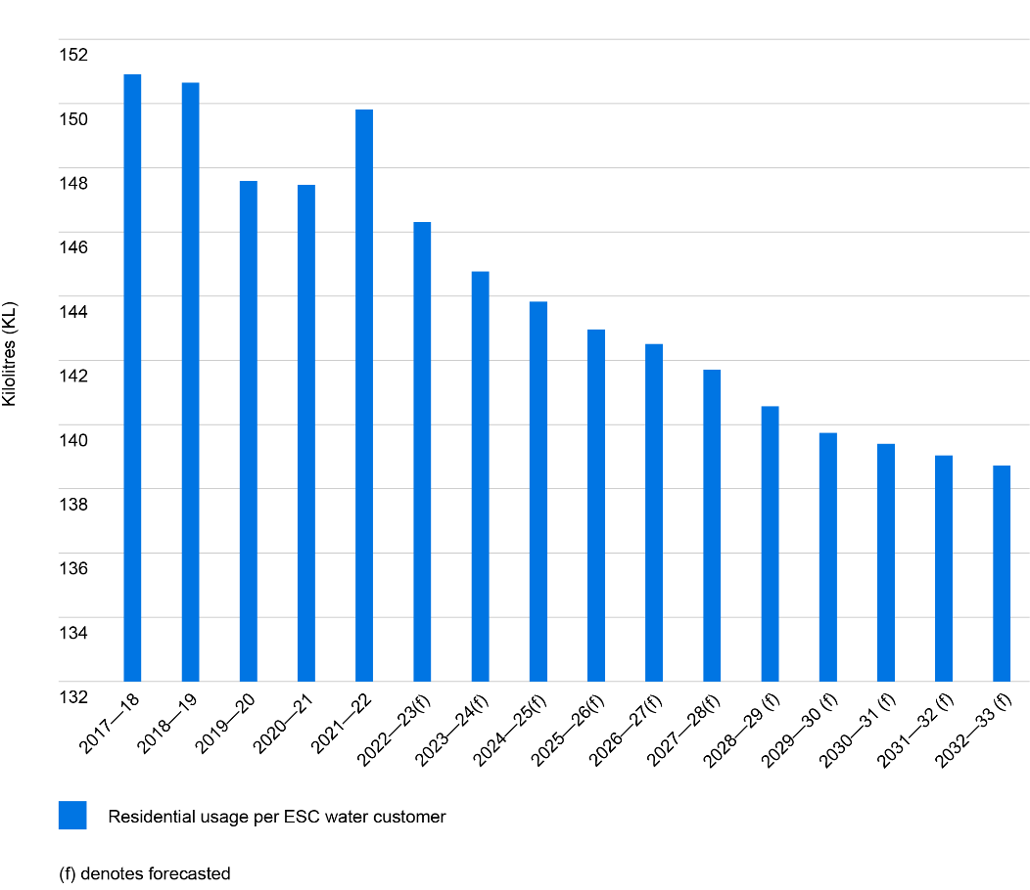

9.3.2 Non-residential potable water consumption
Due to the impacts of COVID-19, a new methodology for forecasting non-residential water usage demand has been developed. This method analyses quarterly water usage by industry segment (based on top usage, schools, councils and ANZSIC codes) of the non-residential water customer base. This segmentation by industry captures the different impacts of COVID-19 on each industry.
For all segments, a pre-COVID-19 and post-COVID-19 average usage per customer was assumed for each quarter. The difference between the 2 averages is defined to be the COVID-19 impact. It is assumed that all industry segments will return to their pre-COVID-19 average by 2025–26 at a smooth linear rate. Ten of the top usage customers have their demand forecasts estimated separately, based on interviews with those customers. Price elasticity is also applied to the forecasts (see Section 9.8).
Non-residential potable water consumption is forecast to grow by approximately 2.1% per annum during the 2023-28 regulatory period.
Figure 16: Non-residential potable water consumption 2017–18 to 2027–28

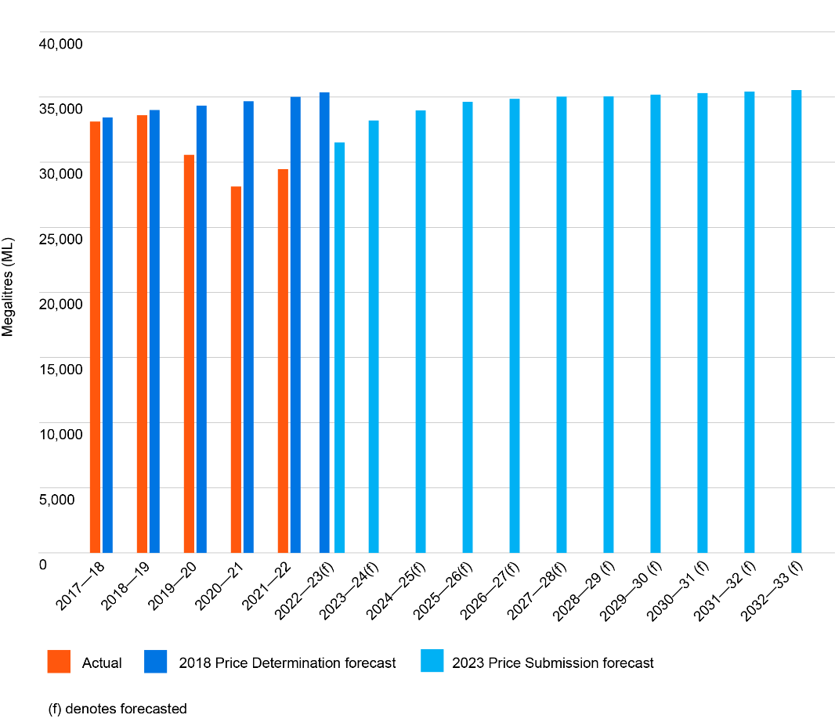

9.3.3 Non-revenue water
Non-revenue water is forecast to be around 12.6% of total bulk water based on historical averages. Due to digital metering, non-revenue water is forecast to decrease by 1% at the end of the digital metering rollout period by 2029–30. Digital metering savings are applied on the total forecast as a percentage saving based on the rollout of digital meters.

9.3.4 Alternative water
We are committed to the continued expansion of our Class A recycled water network to provide greater alternative water access for our customers and to support long-term water security.
Residential recycled water growth assumes that homes with recycled water available
use approximately 32 kilolitres each year (based on average per connection across
from 2017–18 to 2021–22), mainly for garden and toilet use, and washing machines in some homes.

9.3.5 Bulk water
Figure 17 shows the forecast trend for bulk water demand over the next 10 years. Bulk water is defined to be the total of residential, non-residential and non-revenue water with an adjustment for potable water top-up of the recycled water network. Overall demand is forecast to increase by approximately 0.86% per annum over 2023-28.
Figure 17: Bulk water demand 2017–18 to 2032–33
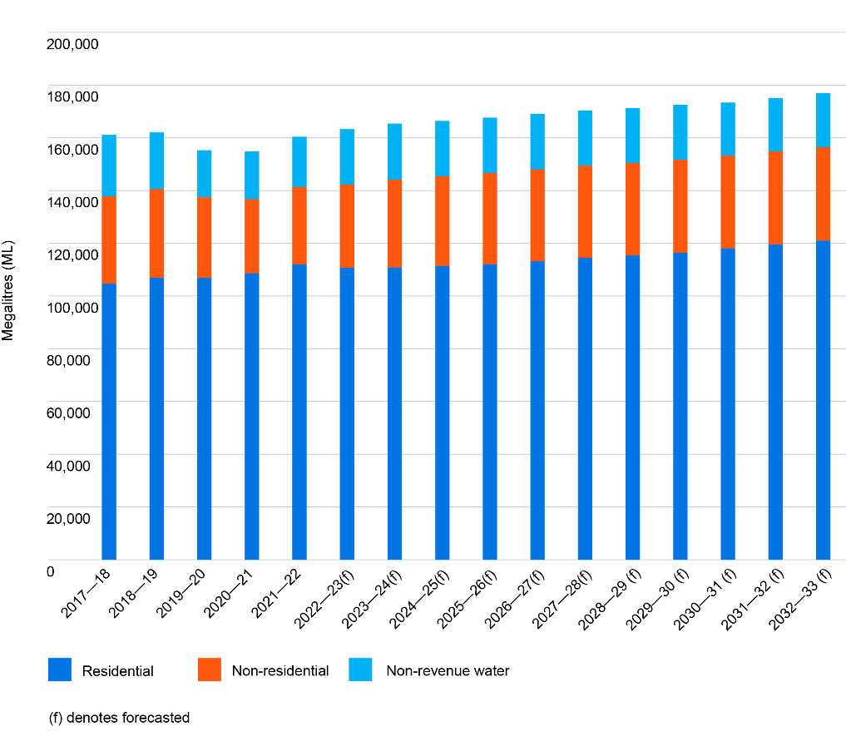

9.4 Sewage and trade waste
As we have proposed removing the residential sewage disposal charge (SDC) from the commencement of the 2023-28 regulatory period, the residential sewage forecast is no longer needed. See Sections 9.5 and 10.2 for more information.
Non-residential billable sewage volumes are difficult to estimate as there is little consistency between non-residential customers. For example, parks and gardens, commercial customers and trade waste customers all have different disposal patterns and are charged at different disposal rates. As a result, a relationship between the aggregate water consumption and billed sewage volumes has been derived for non-residential customers based on historical averages between 2017–18 and 2020–21.
Trade waste flow volumes are directly linked to the employment growth rate for each industry type, while trade waste loads are calculated from a combination of industry average concentrations and measured data. Because some trade waste industries are expected to be impacted by population growth (for example, restaurants and large food manufacturers) whereas others are not (for example, laboratories), a separate forecast for trade waste flow and loads has been adopted based on the latest employment projections from Labour Market Insights developed by the National Skills Commission who provide information on the Australian jobs market.
Table 46: Trade waste volumes and load forecast growth
Parameter | Annual growth
Trade waste volume (kL) | 1.50%
Billable Biochemical Oxygen Demand (BOD) (kg) | 1.10%
Billable suspended solids (kg) | 1.00%
Billable Total Kjeldahl Nitrogen (TKN) (kg) | 0.70%

9.5 Price elasticity and tariff reform impact
Academic literature, customer insights and anecdotal observations indicate that price elasticity is not expected to be a considerable driver of demand. This is due to the low price elasticity of demand for water.
The elasticity assumed for residential step 1 consumption is -0.05; for step 2 it is -0.10; and for non-residential consumption it is -0.09. The approach for applying elasticity is the same that has been used in previous pricing submissions.
For the purposes of demand forecasting for 2023–24 and beyond, it is assumed the average bill reduction change between 2022–23 and 2023–24 will affect demand from 2023–24 onward. The bill is used as a proxy for the price as the tariff reform of removing the residential sewage disposal charge and increasing the water usage charge will overall counteract each other.
In the regulatory period commencing 1 July 2023, we propose to remove the residential sewage disposal charge and introduce new water usage tariffs for customers who are connected to the water network and not the sewerage network.
The water usage demands for our water-only customers are based on historical trends of both the water usage of those water-only customers and the forecast number of those customers connecting to the sewerage system (refer to Demand Manual – Forecasting methodologies). The total residential water demand for customers connected to the sewer network has been adjusted to account for water-only customers’ usage.

9.6 Water supply and demand scenarios
In developing our demand forecasts, we have based our approach on the following key water supply and demand assumptions including:
- average weather conditions (understanding that in the short term, weather conditions influence residential outdoor water usage habits and use of evaporative coolers, as well as some non-residential uses)
- water savings due to digital meters
- water restrictions are unlikely due to the Victorian Desalination Plant providing a buffer against low storage levels and current storage at levels the highest they have been (for this time of the year) since the mid-1990s
- the impacts of climate change.
To enhance the robustness of our forecasts, we also considered a number of demand scenarios. These included:
- modelling differences in population/connections growth, particularly around connections forecasts
- analysing the possibility of alternative scenarios in growth, average temperatures and efficiency improvements including:
  - a ‘high’ scenario where a combination of higher growth, weak efficiency improvements, and hotter temperatures cause demand to exceed forecasts
  - a ‘low’ scenario where lower growth, strong efficiencies, and fewer than expected hot and dry periods cause lower than expected demand levels.
Figure 18 shows a sample of residential water usage scenarios where the adopted scenario which incorporates savings due to digital meter savings and the impact of price elasticity is highlighted in dark blue.

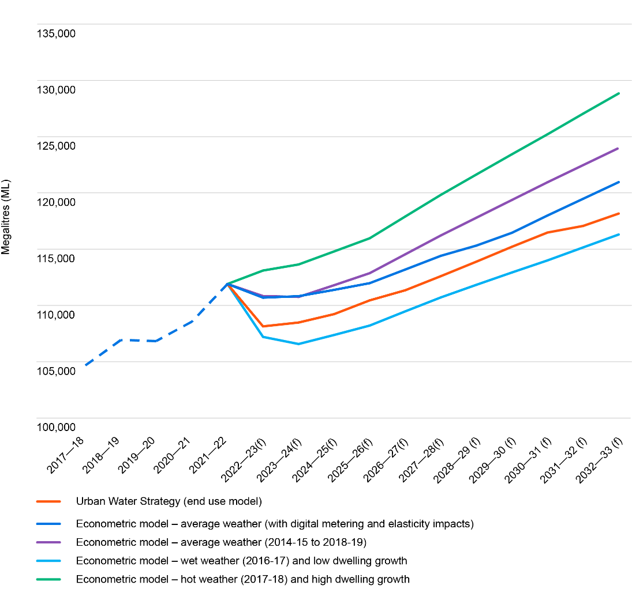
Figure 18: Residential water usage forecast scenarios

9.7 Demand forecasts and expenditure forecasts
The dwelling and population forecasts (Section 9.1) have informed the capital expenditure program, where a lower growth scenario has been adopted, as outlined in Section 6.2.
The dwelling forecasts have also informed the operating expenditure growth allowance as outlined in Section 7.3. Digital metering is expected to contribute to reducing bulk water demand and corresponding costs.
Forecast bulk charges and volumes from Melbourne Water are consistent with South East Water’s demand forecasts. Bulk water forecasts have been outlined in Section 9.3.5. Bulk sewerage forecasts are linked to bulk water forecasts and have been based on historical analysis of the last 5 years of sewer flows. Bulk trade waste forecasts have been developed in consultation with the trade waste team considering historical trade waste loads.

9.8 Summary
Tables 47 and 48 provide the total forecast number of customers who will receive water and sewerage services charges, and forecast water, sewage, recycled water and trade waste volumes to formulate prices for the next regulatory period.

Table 47: Customer number forecast
Tariff | 2022-23 | 2023-24 | 2024-25 | 2025-26 | 2026-27 | 2027-28
Number of water service charges – residential | 731,383 | 740,291 | 749,199 | 758,108 | 769,078 | 782,110
Number of water service charges – non-residential | 55,442 | 55,894 | 56,344 | 56,792 | 57,341 | 57,990
Number of sewer service charges – residential | 710,748 | 719,657 | 728,565 | 737,473 | 748,443 | 761,476
Number of sewer service charges – non-residential | 50,981 | 51,432 | 51,882 | 52,330 | 52,879 | 53,529
Trade waste risk rank 5 | 8,756 | 8,833 | 8,911 | 8,989 | 9,103 | 9,217
Trade waste risk rank 4 | 196 | 197 | 197 | 198 | 198 | 199
Trade waste risk rank 3 | 99 | 101 | 102 | 104 | 106 | 109
Trade waste risk rank 2 | 32 | 32 | 33 | 33 | 34 | 34
Trade waste risk rank 1 | 25 | 25 | 25 | 25 | 26 | 26
Bunyip water service charges – residential | 198 | 198 | 198 | 198 | 198 | 198
Bunyip water service charges – business | 110 | 110 | 110 | 110 | 110 | 110
Fire service water service charges | 20,078 | 20,396 | 20,719 | 21,047 | 21,380 | 21,718

Table 48: Volumetric forecast
Tariff | 2022-23 | 2023-24 | 2024-25 | 2025-26 | 2026-27 | 2027-28
Residential step 1 (kL) – water and sewerage customer | 84,196,509 | 82,581,796 | 83,112,299 | 83,663,715 | 84,676,023 | 85,688,185
Residential step 2 (kL) – water and sewerage customer | 26,495,774 | 25,497,668 | 25,700,547 | 25,907,787 | 26,258,371 | 26,606,945
Residential step 1 – water-only customer | N/A | 1,659,861 | 1,555,128 | 1,457,003 | 1,365,070 | 1,278,937
Residential step 2 – water-only customer | N/A | 1,085,959 | 1,017,438 | 953,240 | 893,093 | 836,741
Non-residential sales (kL) | 31,515,080 | 33,198,265 | 33,968,061 | 34,633,546 | 34,849,302 | 35,023,877
Residential SDC (kL) | 83,821,511 | N/A | N/A | N/A | N/A | N/A
Non-residential SDC (kL) | 14,575,722 | 15,354,195 | 15,710,226 | 16,018,012 | 16,117,799 | 16,198,540
Trade waste volume (kL) | 6,501,989 | 6,599,519 | 6,698,512 | 6,798,989 | 6,900,974 | 7,004,489
Billable Biochemical Oxygen Demand (BOD) (kg) | 12,394,126 | 12,530,461 | 12,668,296 | 12,807,647 | 12,948,532 | 13,090,965
Billable suspended solids (kg) | 5,220,018 | 5,272,218 | 5,324,941 | 5,378,190 | 5,431,972 | 5,486,292
Billable Total Kjeldahl Nitrogen (TKN) (kg) | 636,992 | 641,451 | 645,942 | 650,463 | 655,016 | 659,602
Customers drawing non potable water from Bunyip and Tarago open channels (kL) | 61,147 | 61,822 | 62,505 | 63,195 | 63,893 | 64,599
Volume of recycled water – residential consumer (kL) | 2,076,350 | 2,263,406 | 2,451,622 | 2,648,274 | 2,846,086 | 3,045,058

Supporting documents
Demand Manual – Forecasting methodologies
Demand Manual – Dwelling and population forecast
South East Water Region: Population Update (Spatial Economics, August 2022)
South East Water Demographic Projections: A Review of Key Assumptions (Spatial Economics, July 2022)

10. Prices and tariff structures

Key points

The average residential customer bill will decrease by 6%.

We propose to:

remove the residential sewage disposal charge

introduce water-only customer water usage tariffs

introduce a new customer contribution regime for Fishermans Bend

This section explains the prices we propose to recover the revenue needed to deliver
the services we provide to our customers. In general, apart from the tariff reform proposals, prices have decreased by around 6% to pass through the reduction in the revenue requirement.

10.1 Approach and customer consultation
South East Water jointly with Yarra Valley Water and Greater Western Water undertook tariff customer research over 15 focus groups with each, exploring the following 4 questions:
- How much of the water/wastewater charges should be fixed and how much should be based on usage?
- Should a household pay the same price for every kilolitre of water they use, or should the price increase in steps?
- Should the sewage disposal charge be removed and spread across other charges?
- Should the water service charge be related to the size of the water meter at the property?
To inform our tariff proposals, South East Water further established a tariff forum that took place over 3 evenings during April and May 2022. A representative group of 20 customers came together to deliberate on the following 2 questions:
- How much of customers’ bills do you want to be variable?
- Should South East Water remove the residential sewage disposal charge?
The tariff forum participants (20 in total) were recruited by a professional recruitment firm and were provided with an incentive payment for participating in all 3 sessions. The forum aimed to be representative of South East Water customers in terms of age, gender, home owners/tenants, household size, financial situation (where a quarter of the customers were identified as financially vulnerable), and conservative/progressive views.
The purpose of the forum was for customers to consider the 2 questions whilst considering what was best for the community overall. After being given appropriate information, time, and access to expert opinion, the panel made recommendations which reflect the community’s interests, concerns and priorities. This included providing customers with an indicative bill comparing the prices and bills associated to each tariff reform proposal.
The panel was invited to participate at the Involve level on the IAP2 Spectrum of Public Participation. This meant that for both decisions, South East Water made a promise to the panel to “work with you to ensure your concerns and aspirations are directly reflected in the alternatives developed and provide feedback on how public input influenced the decision” (IAP2, 2018).
After extensive deliberation, a consensus was reached on both decisions.
- On the fixed variable balance, the panel came to a majority position that South East Water should increase the level of variability to around 50% for owner-occupiers who use 120 kilolitres of water per year.
- The panel also reached a majority position that South East Water should remove the sewage disposal charge for residential customers.

10.2 Residential prices

Current approach
South East Water has in place fixed and variable tariffs for both water and sewerage services and variable tariffs only for recycled water.
We collect water and sewerage services charges based on property title. This means that customers with individual (or strata) titles pay a service charge for each dwelling.
For drinking water, we apply a 2-step inclining tariff where water consumption greater than 40 kilolitres in the quarter is charged the second step price.
Residential customers currently pay a sewage disposal charge on 75% of water
volumes (detached dwellings) or 85% of water volumes (multi-unit dwellings).
The recycled water usage charge is 79% of the step 1 drinking water charge. A residential recycled water service charge is not applied.

Assessment and proposed approach for 2023–28
In setting our proposed residential tariff structures for the next regulatory period, we have taken into consideration the customer forum decisions, ESC’s guidance paper requirements and the opportunities digital metering provides in terms of pricing.
Although the customer forum decided on an increase in the level of billing variability to around 50%, we have decided to keep bill variability constant (around 47%) to avoid the implications associated to rental customers receiving a bill increase.
We propose to retain the 2-step inclining tariff where water consumption greater than 40 kilolitres in the quarter will be charged the second step price. There was general agreement by our customers to retain the 2-step inclining tariff for the purposes of water conservation, equity and bill simplicity.
We have proposed removing the residential sewage disposal charge. Customers must have the ability to make decisions as to how much of a particular service they choose to consume. To do this, the service must be practicable to measure, which allows the customer to make decisions of how much of a service they consume. If a service cannot be measured (which is the case for the provision of residential volumetric sewage services), then customers are unable to respond to any price signals provided through volumetric pricing.
Removing the residential sewage disposal charge aligns to the customer tariff forum’s decision which considers this tariff proposal to promote billing simplicity, remove the inaccuracy associated to sewage disposal charging and encourage fairness.
The proposal is also favoured by the ESC’s 2023 Water Price Review guidance paper which states:
We consider the current variable sewerage tariffs for residential customers of the metropolitan water businesses are difficult for customers to understand, and not cost reflective. Given the low marginal cost of residential sewage treatment, we will consider proposals for a single fixed charge for retail sewage disposal for residential customers favourably.
Removing the residential sewage disposal charge causes a revenue shortfall that must be recovered through other tariffs. We propose reallocating the revenue shortfall to the residential variable water step tariffs. This provides a more direct price signal to customers, which will be complemented by notifications supported through digital metering, which increases the ability of customers to make decisions on how much water they choose to consume and promotes water conservation. These higher water step tariffs are also in line with long-run marginal cost estimates.
The bill impact of the increased residential variable water step tariffs is offset by the removal of the residential sewage disposal charge and price reduction of the service charges. We have sought to balance customer impacts for our water-only customers by including the introduction of a water-only tariff that is set in line with the current 2 consumption steps for the residential variable tariff. We propose to make the change in the first year of the price submission.
We consider that the proposed tariff structure change is consistent with each of the ESC’s tariff principles. The higher water step tariffs are in line with long-run marginal cost estimates. The proposed tariff change also seeks to better meet the principle of ‘customer focus’, as it will:
• Have better regard to the ability of customers to understand the tariff and being able to respond to price signals
• Deliver on customer preferences for simpler tariffs.
Table 49 outlines how the proposed tariff structure change better meets the pricing principles included in clause 11 (d) of the WIRO.

Table 49: WIRO pricing principles assessment 5
WIRO pricing principles | How tariff structure meets WIRO pricing principles
11(d) (i) enable customers or potential customers of the regulated entity to easily understand the prices charged by the regulated entity for prescribed services or the manner in which such prices are calculated, determined or otherwise regulated; | Customer engagement findings showed the current approach to calculating the sewage disposal charge is complex and difficult to understand by residential customers. Removing the sewage disposal charge will simplify bills for residential customers and make the prices charged more easily understood.
11(d) (ii) provide signals about the efficient costs of providing prescribed services to customers (either collectively or to an individual customer or class of customers) while avoiding price shocks where possible; and | Residential customers have indicated that they will respond better to the variable price signals when the variable charges are combined into a single charge, rather than having separate variable water and sewerage charges. Additionally, the tariff structure change will not result in price shock for any group of customers, as the customer bill impact will be minimal.
11(d) (iii) take into account the interests of customers of the regulated entity, including low income and vulnerable customers. | As noted above, the tariff structure change is based on feedback from residential customers on the current tariff structure.  We have also undertaken a detailed assessment of customer impacts associated with the tariff change across all SEW residential customers. We have found that there will be minimal bill impact across all residential customer segments resulting from the tariff change – see a sample of customer impacts below.

We propose to retain the current price of recycled water at 79% of the water-only residential step 1 usage charge in line with current prices.

Table 50: Proposed residential prices 2023–28 regulatory period ($2022–23)
Residential tariffs | 2022-23 | 2023-28 | P0 Percentage change
Water service charge - Residential service charge Fixed ($/year) | 83.72 | 78.88 | -5.79%
Sewerage service charge - Residential service charge Fixed ($/year) | 367.76 | 346.48 | -5.79%
Water usage charge - Residential block 1 variable ($/kL) | 2.7165 | 3.2058 | 18.01%
Water usage charge - Residential block 2 variable ($/kL) | 3.4660 | 4.0903 | 18.01%
Sewerage Disposal charge - Residential SDC Variable ($/kL) | 0.9444 | N/A | -100.00%
Water Usage charge - Residential block 1 Water-only Variable ($/kL) | 2.7165 | 2.5593 | -5.79%
Water Usage charge - Residential block 2 Water-only Variable ($/kL) | 3.4660 | 3.2654 | -5.79%
Volume of recycled water – residential consumer ($/kL) | 2.1513 | 2.0268 | -5.79%
Bunyip main race – residential customer ($/year) | 120.64 | 113.66 | -5.79%
Non potable water from Bunyip Main Race ($/kL) | 1.6592 | 1.5632 | -5.79%

10.3 Non-residential prices

Current approach
Non-residential customers are charged a single water variable rate that is set to the second step of the residential 2 step inclining tariff.
Non-residential customers are charged water and sewerage service charges based on property title. This means that customers with individual (or strata) titles pay a service charge for each dwelling. Water service charges are currently the same for residential and non-residential customers.
Non-residential customers pay a slightly higher rate for sewerage service charges and are charged a sewage disposal applied based on their industry type and projected disposal.

Assessment and proposed approach for 2023–28
We propose to retain a single water variable rate that is set between the first and second steps of the inclining tariff, in line with current prices.
In setting our proposed non-residential tariff structures for the next regulatory period, we have taken into consideration customers’ feedback around wanting certainty. In addition, we are wary of the impacts tariff reform proposals may have on small business customers post the impacts caused by COVID-19 restrictions.
During the next regulatory period, as part of Melbourne Water’s bulk tariff review, which will include an assessment of its current trade waste pollutant charges, we will also assess the allocation of revenue recovery across South East Water’s water and sewerage fixed and variable charges for non-residential customers.
Table 51 outlines proposed prices for non-residential customers for the next regulatory period which shows a P0 reduction in real terms.
Table 51: Proposed non-residential prices 2023–28 regulatory period ($2022–23)
Non-residential tariffs | 2022-23 | 2023-28 | P0 Percentage change
Water service charge - Non-residential service charge fixed ($/year) | 83.72 | 78.88 | -5.79%
Sewerage service charge - Non-residential service charge fixed ($/year) | 436.72 | 411.45 | -5.79%
Water usage charge - Non-residential variable ($/kL) | 3.4660 | 3.2654 | -5.79%
Sewerage Disposal charge - Non-residential SDC variable ($/kL) | 1.7860 | 1.6827 | -5.79%
Fire service charge ($/year) | 128.32 | 120.89 | -5.79%
Bunyip main race – Non-residential customer ($/year) | 120.64 | 113.66 | -5.79%
Fire usage charge ($/kL) | 3.4311 | 3.2654 | -4.83%

The 2023-28 volumetric water prices shown in Tables 50 and 51 do not account for the costs associated with the annual desalination water order process which is passed through to water variable tariffs for residential and non-residential customers on an annual basis through the price adjustment mechanism as outlined in South East Water Price Determination 2018 (the 2018 Price Determination). The size of the annual desalination water order will determine if a customer’s bill remains stable, increases or decreases over the 2023-28 regulatory period.

10.4 Trade waste

Current approach
Currently, South East Water has in place a set of fixed and variable trade waste charges. Fixed trade waste charges seek to recover the cost of administering and monitoring trade waste agreements. All trade waste customers are assigned a risk ranking from 1 to 5 based on their location to a treatment plant, volume, history and activity.
In addition to the Trade Waste Agreement charges, customers whose trade waste exceeds any of the following parameters are charged volumetric and quality charges
for the following:
• volume greater than 1,000 kL/year
• biochemical oxygen demand greater than 600 mg/L
• suspended solids greater than 600 mg/L
• total Kjeldahl nitrogen (greater than 50 mg/L).

Assessment and proposed approach for 2023–28
To inform our assessment of trade waste prices for the 2023–28 regulatory period, we assessed the costs to service trade waste customers and to test whether these costs align with revenue currently being recovered from trade waste customers.
To estimate the costs to service trade waste customers, we allocated costs to trade waste services using direct trade waste costs where available, including trade waste operating costs and Melbourne Water bulk trade waste charges. Where direct trade waste costs were not clearly separated from sewerage costs, we made an allocation of sewerage costs to trade waste, based on trade waste volumes as a portion of total sewage volumes.
This assessment showed that trade waste costs are consistent with current revenue being recovered through trade waste charges.
Given this, we propose to maintain the trade waste agreement, volume and load charges at current levels and apply CPI only over the 2023–28 regulatory period.
During the next regulatory period, as part of Melbourne Water’s bulk tariff review, which will include an assessment of its current trade waste pollutant charges, we will also assess the allocation of revenue recovery across South East Water’s fixed and variable charges to ensure they remain cost reflective.

Table 52: Proposed Trade Waste prices 2023–28 regulatory period ($2022–23)
Trade waste tariffs | 2022-23 | 2023-28 | P0 Percentage change
Trade waste risk rank 5 ($/year) | 465.04 | 438.13 | -5.79%
Trade waste risk rank 4 ($/year) | 2666.44 | 2512.15 | -5.79%
Trade waste risk rank 3 ($/year) | 5332.92 | 5024.34 | -5.79%
Trade waste risk rank 2 ($/year) | 7999.48 | 7536.60 | -5.79%
Trade waste risk rank 1 ($/year) | 15999.00 | 15073.24 | -5.79%
Trade waste volume ($/kL) | 1.0433 | 0.9829 | -5.79%
Billable Biochemical Oxygen Demand (BOD) ($/kg) | 1.0312 | 0.9715 | -5.79%
Billable suspended solids ($/kg) | 0.5782 | 0.5447 | -5.79%
Billable Total Kjeldahl Nitrogen (TKN) ($/kg) | 2.2656 | 2.1345 | -5.79%
Trade waste application fee (per application) | 62.00 | 58.41 | -5.79%
Food waste – hospital and other institutions (per bed) | 55.32 | 52.12 | -5.79%

10.5 New customer contributions and backlog charges

Current approach
South East Water is responsible for the delivery of assets that cater for growth within its service area. NCCs (new customer contributions) are charged to developers by service on a per lot basis. These charges are intended to recover a contribution to infrastructure costs being driven by new customers. In the current regulatory period, separate NCC charges for water, sewerage and recycled water are applied to new customers in the Casey and Cardinia growth areas, with separate charges for ‘other areas’. The ‘other areas’ charge also extends to lots less than 300m² in size in the Casey and Cardinia growth areas. South East Water’s current growth area NCCs included in the 2018 Price Determination were reviewed against the ESC’s pricing principles, using the ESC’s Net Incremental Cost model.

Assessment and proposed approach for 2023–28
As part of its 2023 Price Submission, South East Water has undertaken a review of its current NCC charges. We have used the ESC’s net incremental cost model to inform our assessment.
For the 2023–28 regulatory period, we propose to increase the growth area NCC charges for the Casey and Cardinia areas for sewerage and recycled water. We have reviewed the net incremental cost for each service and found that overall, the net incremental cost is forecast to be materially higher than current charges in both the Casey and Cardinia areas. The increases are largely being driven by increases in recycled water infrastructure costs.
However, to minimise price increases, we are proposing to set 2023–28 charges below the net incremental cost to align with the current combined NCC for each area. We also note that the connection of recycled water customers in Casey and Cardinia is providing broader benefits to South East Water customers through reducing their drinking water demand. Therefore, we consider it reasonable to balance the recovery of recycled water costs between new and existing customers.
Currently, South East Water applies the NCCs for ‘other areas’ to lot sizes 300m² or less that are located in the Casey and Cardinia regions. For the 2023–28 regulatory period, we propose to remove this policy as the relationship between lot size and the cost to connect has diminished.
For the next regulatory period, we propose to introduce a new growth area NCC charge for the Fishermans Bend precinct. We have undertaken an assessment of the incremental costs and revenues for the area across water, sewerage and recycled water services which equals to around $13,000 per lot when you include recycled water assets that would otherwise be funded by developers.
We propose to apportion around 30% of the incremental costs to a combined NCC (titled Integrated Water) that aligns to the distributional benefits that will be realised by the Fishermans Bend community, with the remaining benefits (and costs) going to the broader community. The NCC will be phased in over 2 regulatory periods to mitigate customer impacts and to align with the development of the recycled water treatment plant and realisation of benefits. The proposed NCC will also recover the cost of recycled water assets that would have previously been funded by developers.
We have undertaken a net incremental cost assessment for ‘other areas’. As part of this assessment, we have included an allocation of forecast renewals and compliance capital expenditure to new customers. We have also included an allocation of historical renewals costs, net of regulatory depreciation and new customer contributions, dating back from 2013–14 to these customers. When assets in existing areas are renewed, they are generally augmented to cater for growth. We consider including an allocation of asset renewal costs in NCCs for ‘other areas’, reflects a more equitable share of cost recovery between existing and new customers of the infrastructure required to service these areas.
Our net incremental cost assessment supports increasing the ‘other areas’ NCC. We therefore propose increasing the ‘other areas’ NCC charges by 5% per annum over the 2023–28 regulatory period.
Table 53 outlines our proposed set of NCCs for the 2023–28 regulatory period.
Table 53: Proposed NCCs 2023–28 regulatory period ($2022–23)
NCC area | Service | 2022–23 | 2023–24 | P0(%) | 2027–28 | Price path (%) p.a.
Casey | Water | $1,214.47 | $813.00 | -33% | $988.19 | 5%
 | Sewer | $775.09 | $955.00 | 23% | $1,160.79 | 5%
 | Recycled Water | $1,750.07 | $2,157.00 | 23% | $2,621.83 | 5%
 | Total | $3,739.63 | $3,925.00 | 5% | $4,770.81 | 5%
Cardinia | Water | $1,710.82 | $813.00 | -52% | $988.19 | 5%
 | Sewer | $1,224.46 | $1,670.00 | 36% | $2,029.88 | 5%
 | Recycled Water | $1,902.75 | $2,595.00 | 36% | $3,154.22 | 5%
 | Total | $4,838.03 | $5,078.00 | 5% | $6,172.29 | 5%
Other areas | Water | $775.09 | $813.00 | 5% | $988.19 | 5%
 | Sewer | $775.09 | $813.00 | 5% | $988.19 | 5%
 | Recycled Water | $775.09 | $813.00 | 5% | $988.19 | 5%
 | Total | $2,325.27 | $2,439.00 | 5% | $2,964.57 | 5%
Fishermans Bend | Water | $775.09 | N/A | N/A | N/A | N/A
 | Sewer | $775.09 | N/A | N/A | N/A | N/A
 | Recycled Water | $775.09 | N/A | N/A | N/A | N/A
 | Integrated Water | N/A | $2,439.00 | 5% | $2,964.60 | 5%
 | Total | $2,325.27 | $2,441.53 | 5% | $2,967.70 | 5%

Applying New Customer Contributions to non-residential lots
In recognition of the amount of capacity required to service each connection where a new non-residential lot is created, that is, 25-millimetre water connection or greater, the NCCs (Water, Sewer, Recycled Water or Integrated Water if the lot is applicable to the Fishermans Bend precinct) payable will be the indicative multiple of the applicable NCC and the number of equivalent 20-millimetre connections. Table 54 shows the indicative meter size relationships to maximum possible delivery volumes and the relevant ratio that will be applied to each meter size connection.
Table 54: Indicative meter size relationships to maximum possible delivery volumes
Meter diameter mm | Pi value | Pipe area  (Area = Pi r²) sq. mm | Indicative ratio to 20 mm meter
20 | 3.1415 | 314.16 | 1.00
25 |  | 490.87 | 1.56
32 |  | 804.25 | 2.56
40 |  | 1256.64 | 4.00
50 |  | 1963.50 | 6.25
80 |  | 5026.55 | 16.00
100 |  | 7853.98 | 25.00
150 |  | 17671.46 | 56.25
200 |  | 31415.93 | 100.00

10.6 Incremental financing costs

Current approach
In accordance with section 4.3 of its 2018 Price Determination, South East Water currently charges incremental financing costs (IFCs) for any development which is brought forward more than 12 months beyond its planned timeframe. These charges are in addition to any new customer contributions required for the development. Actual revenue from brought-forward charges is netted off the regulatory asset base as a developer contribution when prices are reset for the following regulatory period.

Assessment and proposed approach for 2023–28
Under the current approach, applying IFC charges to every development brought forward greater than 12 months can result in additional administrative burden to South East Water, in some cases for little benefit, particularly for developments that are brought forward only 1–2 years. Given that there is often some movement in the timing of actual growth costs within a regulatory period compared with the timing of growth capital expenditure forecasts used to set prices, a development which is brought forward within a regulatory period may also not result in a material incremental financing cost shortfall for South East Water.
On this basis, we propose to only charge IFCs for developments that are being brought forward from outside the 2023–28 regulatory period. This would therefore only apply to infrastructure that was not incorporated in the 2023–28 period prices. We note that this approach remains consistent with section 4.3 of our 2018 Price Determination and our proposed change in approach can be applied through updating our Land Development Policy.

10.7 Peninsula ECO backlog charges

Current approach
South East Water currently charges a brought forward per connection charge for backlog sewerage connections on the Mornington Peninsula for properties that choose to connect earlier than originally scheduled, referred to as Peninsula ECO (early connection option) charges. Current charges are set in accordance with the pricing principles in Schedule 4.4 of its 2018 Price Determination and have been calculated as a percentage of the net incremental cost to connect backlog customers.

Assessment and proposed approach for 2023–28
We have undertaken an assessment of our approach to Peninsula ECO charges for the 2023–28 regulatory period. This has included a review of options, including updating the current charges to reflect the timing of the original connection dates, as well as options for simplifying the charging structure.
For the Rye and Blairgowrie areas, as their original connection timings were 2020 and 2025, we propose to no longer apply ECO charges in these areas. These areas will be charged the standard backlog charge, resulting in a reduction in the backlog charge for Rye and Blairgowrie. South East Water will consider the declaration of these areas as serviced for sewerage services under paragraph 144(1)(b) of the Water Act over the 2023–28 regulatory period with the option to introduce declaration from 1 July 2028 to mitigate customer impacts.
For the remaining areas of Sorrento, Portsea, St Andrews Beach and Point Leo, we have updated the ECO charge for each of the areas to apply from 2023–28, by applying the methodology outlined in our 2018 Price Determination. To simplify Peninsula ECO charges for new sewerage customers in these areas, we propose to set the charge based on an average of the Sorrento area and the Portsea, St Andrews Beach and Point Leo areas. This results in a single Peninsula ECO charge of $3,971 (2022–23) to be applied across all remaining areas.
We consider having a single Peninsula ECO charge to be simpler to communicate to customers while still providing a reasonable recovery of costs from those customers opting to connect earlier than the original connection date. This approach will also result in a reduction in the Peninsula ECO charge for the remaining areas. This may also encourage higher connections to the sewerage system, which will deliver increased environmental benefits to the region.

Table 55: Proposed Peninsula ECO charges 2023–28 regulatory period ($2022–23)
Area | 2022-23 | 2023-28 | P0 Percentage change
Rye | $2,749.00 | $2,500.00 | -9.06%
Blairgowrie | $4,352.00 | $2,500.00 | -42.56%
Portsea | $7,701.00 | $3,971.00 | -48.44%
Sorrento | $6,293.00 | $3,971.00 | -36.90%
St Andrews Beach | $7,701.00 | $3,971.00 | -48.44%
Point Leo | $7,701.00 | $3,971.00 | -48.44%

10.8 Miscellaneous charges
We have reviewed our major miscellaneous charges to ensure these proposed prices are consistent with ESC principles.
Table 56 outlines the proposed top 10 miscellaneous charges by forecast revenue for the next regulatory period which have been separately forecasted in the regulatory model.
Table 56: Miscellaneous charges ($2022–23)
Miscellaneous Charge | 2022-23 | 2023-24 | P0 (%) | PPM Year 2 | PPM Year 3 | PPM Year 4 | PPM Year 5
Dry tapping - drinking water 20mm | $455.13 | $444.38 | -2.36% | 0.00% | -15.19% | 0.00% | 0.00%
Dry tapping - drinking & Recycled 20mm (installed in the same visit) | N/A | $866.25 | N/A | 0.00% | -22.73% | 0.00% | 0.00%
20mm digital meter (including installation) | N/A | $210.42 | N/A | 0.00% | 0.00% | 0.00% | 0.00%
20mm main to meter - short side | N/A | $2,233.63 | N/A | 0.00% | 0.00% | 0.00% | 0.00%
Information Statements - Electronic / Manual lodgement | $34.77 | $27.70 | -20.34% | 0.00% | 0.00% | 0.00% | 0.00%
Single residential recycled water plumbing inspection fee | $375.14 | $377.12 | 0.53% | 0.00% | 0.00% | 0.00% | 0.00%
20mm main to meter - long side | N/A | $3,049.37 | N/A | 0.00% | 0.00% | 0.00% | 0.00%
Plumbing application fee | N/A | $296.41 | N/A | 0.00% | 0.00% | 0.00% | 0.00%
80mm-150mm wet tapping on mains ≤ 150mm | $2,139.37 | $2,247.69 | 5.06% | 0.00% | 0.00% | 0.00% | 0.00%
Sewerage application fee | $62.00 | $71.05 | 14.59% | 0.00% | 0.00% | 0.00% | 0.00%
Non-core miscellaneous services | Actual cost reflective of pricing principles

10.9 Customer bill impacts
Tables 57 and 58 provide a sample of residential and non-residential customer impacts proposed for the next regulatory period, with the average residential customer receiving a 6.07% real bill reduction excluding the impacts associated to future desalination water order costs. To help manage bill impacts for customers we have increased our debt management strategy by $1.5m per annum for the next regulatory period. This is accounted for in the revenue not collected allowance.

Table 57: Residential customer bill impacts ($2022–23)
Residential customer | Usage per year (kl) | 2022-23 annual bill | 2023-24 annual bill | $ change | % change
Owner occupier - Small user | 76 | $711.76 | $669.00 | -$42.77 | -6.01%
Owner occupier - Average user | 150 | $966.95 | $908.28 | -$58.66 | -6.07%
Owner occupier - Large user | 300 | $1,583.85 | $1,510.92 | -$72.93 | -4.60%
Tenant - Small user | 76 | $260.28 | $243.64 | -$16.64 | -6.39%
Tenant - Average user | 150 | $515.47 | $482.93 | -$32.54 | -6.31%
Tenant - Large user | 300 | $1,132.37 | $1,085.57 | -$46.80 | -4.13%
Owner occupier - Water-only customer | 150 | $492.94 | $464.42 | -$28.52 | -5.79%
Landlord | N/A | $451.48 | $425.36 | -$26.12 | -5.79%

Table 58: Non-residential customer bill impacts ($2022–23)
Non-residential customer | Usage per year (kl) | 2022-23 annual bill | 2023-24 annual bill | $ change | % change
Non-residential customer - Small | 150 | $1,281.45 | $1,207.30 | -$74.15 | -5.79%
Non-residential customer - Medium | 1,000 | $5,593.84 | $5,270.16 | -$323.68 | -5.79%
Non-residential customer - Large | 10,000 | $51,254.44 | $48,288.68 | -$2,965.76 | -5.79%

Supporting documents
- Melbourne Metropolitan Water Tariff Review Focus Group Report, February 2022
- South East Water Tariff Forum Report, May 2022

11. Regulatory settings

Key points

We propose to:

retain the current tariff basket price control for core water, sewerage and trade waste charges

retain the current price cap for new customer contributions and miscellaneous charges

retain a 5-year regulatory period
- retain the annual price adjustment mechanisms.

11.1 Form of price control
South East Water proposes to retain its current tariff basket for core water, sewerage and trade waste charges, and its price cap for new customer contributions and miscellaneous charges for the 2023–28 regulatory period.
Under the tariff basket, price increases for individual tariffs will be limited to 3% per annum in real terms (that is, excluding inflation). If we seek to increase individual prices above the 3% constraint, it is proposed that the 2018 Price Determination requirements apply, including ESC approval and further justification of the proposal, supported by a new tariff strategy.
The tariff basket approach during the current regulatory period provided South East Water the flexibility to rebalance prices without over-collecting revenue.
In particular, it allowed South East Water to:
- rebalance prices between homeowners and tenants when homeowners saw a bill decrease due to the decreasing cost of debt and tenants were seeing a bill increase due to the desalination water order
- recover revenue through fixed prices when South East Water decided to keep variable prices flat during 2020–21 to protect vulnerable customers during
COVID-19
- pass through changes of Melbourne Water’s variable bulk costs due to Melbourne Water’s 2021 price review.
The tariff basket approach, combined with our demand forecasts, balances demand and revenue risk more to South East Water, rather than customers, and provides price certainty to customers.
The price cap approach provides customers with the certainty of prices for new customer contributions and miscellaneous charges.
The following tariffs will be under the tariff basket services as per Part A of Schedule 2
in the 2018 Price Determination:
- Water service charge – Residential service charge fixed ($/year)
- Sewerage service charge – Residential service charge fixed ($/year)
- Water usage charge – Residential block 1 variable ($/kL)
- Water usage charge – Residential block 2 variable ($/kL)
- Water usage charge – Residential block 1 water-only variable ($/kL)
- Water usage charge – Residential block 2 water-only variable ($/kL)
- Volume of recycled water – Residential consumer ($/kL)
- Bunyip Main Race – Residential customer ($/year)
- Non-drinking water from Bunyip Main Race ($/kL)
- Water service charge – Non-residential service charge fixed ($/year)
- Sewerage service charge – Non-residential service charge fixed ($/year)
- Water usage charge – Non-residential variable ($/kL)
- Sewerage disposal charge – Non-residential SDC variable ($/kL)
- Fire service charge – All declared serviced properties ($/year)
- Bunyip Main Race – Non-residential customer ($/year)
- Fire Service – Metered Customer Usage Charge (per kL)
- Trade waste risk rank 5 ($/year)
- Trade waste risk rank 4 ($/year)
- Trade waste risk rank 3 ($/year)
- Trade waste risk rank 2 ($/year)
- Trade waste risk rank 1 ($/year)
- Trade waste volume ($/kL)
- Billable Biochemical Oxygen Demand (BOD) ($/kg)
- Billable suspended solids ($/kg)
- Billable Total Kjeldahl Nitrogen (TKN) ($/kg)
The following tariffs will be under the price cap services as per Part B of Schedule 2 in the 2018 Price Determination:
- New customer contributions
- Trade waste application fee (per application)
- Food waste – hospital and other institutions (per bed)
- Dry tapping - drinking water 20mm
- Dry tapping - drinking & recycled water 20mm (installed in the same visit)
- 20mm digital meter (including installation)
- 20mm main to meter - short side
- Information Statements - Electronic / Manual lodgement
- Single residential recycled water plumbing inspection fee
- 20mm main to meter - long side
- Plumbing application fee
- 80mm-150mm wet tapping on mains ≤ 150mm
- Sewerage application fee
- Non-core miscellaneous charges at actual cost, reflective of pricing principles

11.2 Length of regulatory period
South East Water proposes a 5-year regulatory period from 1 July 2023 to 30 June 2028. This is consistent with the ESC’s default regulatory period.

11.3 Price adjustments
Consistent with the current period, we proposed to retain our annual price adjustments contained in South East Water’s 2018 Price Determination, which allows for:
- annual desalination water orders and changes to the security charge
- pass through of other annual changes to Melbourne Water’s bulk water and sewerage prices, including its cost of debt adjustments
- an adjustment for South East Water’s rolling 10-year average cost of debt.

In addition to these annual price adjustment mechanisms, we propose that section 4 of South East Water’s 2018 Price Determination be retained to mitigate any material financial impacts that result from events which are uncertain or unforeseen.
Appendices

Appendix 1: Operating expenditure step changes
The proposed step changes reflect the outcome of an extensive review of South East Water’s operating cost requirements for the next regulatory period.
A critical part of this review was to align expenditure to delivering the outcomes that we have agreed with customers, and which we know are highly valued. Table 59 shows the alignment between proposed step changes and meeting agreed customer outcomes.
Table 59: Operating expenditure step changes overview
Step change | Customer outcome | Community panel Recommendation
Digital Metering | - Warn me, inform me  - Make my experience better | 5. Digital meter rollout
Maintenance Model | - Get the basics right, always  - Warn me, inform me | 2. Reliable service across  the whole network
Water Quality | - Get the basics right, always | 1. Water security  (quality and quantity)
Information Technology | - Get the basics right, always  - Make my experience better | 2. Reliable service across  the whole network  7. Delivery of innovative and  best service methodology
Aquarevo Water Recycling Plant operating costs | - Support my community,  protect my environment | 1. Water security  (quality and quantity)  7. Delivery of innovative and  best service methodology
General Environmental Duty | - Support my community,  protect my environment | 1. Reliable service across  the whole network
Water recycling plants | - Get the basics right, always | 2. Reliable service across  the whole network
New Assets | - Get the basics right, always | 2. Reliable service across  the whole network
IWM – Dingley | - Get the basics right, always  - Support my community, protect my environment | 1. Water security  (quality and quantity)
Climate Adapt | - Get the basics right, always  - Support my community, protect my environment | 1. Water security  (quality and quantity)  2. Reliable service across  the whole network
Water Literacy | - Make my experience better | 3. Water Security Awareness
Traditional Owner Engagement | - Support my community, protect my environment | 3. Water Security Awareness
Payroll tax and superannuation guarantee | - Get the basics right, always | 2. Reliable service across  the whole network

We consider that the following items meet the criteria for a step change for the next regulatory period. Further details for each of the step changes are provided in individual step change supporting documents.

Digital metering
The introduction of digital meters will improve the provision of services by South East Water while providing tangible benefits, which will drive lower prices for customers over the longer term, as demonstrated in the business case. This project is forecast to increase operating costs over the next regulatory period as detailed in Table 60 below.
Cost increases are expected in areas such as telecommunication service provider costs, IoT and data analytics platforms and customer engagement to provide education and drive behaviour change. This will be largely offset by savings achieved by reducing labour costs in manual meter reading, billing and accounts, efficiencies realised in network maintenance due to more planned rather than unplanned maintenance and a reduction in non-revenue water losses due to early leak detection.

Table 60: Digital metering ($million 2022–23)
2023–24 | 2024–25 | 2025–26 | 2026–27 | 2027–28 | Total
3.17 | 2.67 | 2.06 | 1.48 | 0.56 | 9.94

Maintenance model
Following a competitive tender process, South East Water has entered into a contract for maintenance services, effective in October 2022, for a period of 5 years. This will replace the current contract, which has been in operation since 2013.
The maintenance model step change reflects the incremental cost to South East Water of the maintenance services provided under the new contract.
The new maintenance model enables improved future performance of South East Water through both the competition elements of the model (the higher performing partner in a workstream has the opportunity to win more work) and the collaboration elements of the model (partners working together and with South East Water to improve performance).
South East Water has refined and streamlined the workstreams, increasing scopes of work to better align with the capability of its partners and provide improved economies
of scale. An example of this is the combining of water and sewer into one stream, effectively reducing management and administrative levels. Further, the increased scope will effectively reduce South East Water’s reliance on small, independent contractors, leading to further economies of scale.
The maintenance model tendering process delivers the least cost outcome over the
5-year contract period and the highest value for money proposition.

Table 61: Maintenance model ($million 2022–23)
2023–24 | 2024–25 | 2025–26 | 2026–27 | 2027–28 | Total
4.47 | 4.47 | 4.47 | 4.47 | 4.47 | 22.35

Water quality
Following 3 water quality incidents in 2020 and 2021, South East Water has been working closely with the Department of Health to address any gaps in water quality management. Increased expenditure is required to implement the following actions:
- an expedited tank cleaning process
- chlorination strategy to achieve a minimum residual level of chlorine in the network which includes doubling the chlorination units in the network, increased sampling and improved monitoring via the installation of new technology capable of monitoring chlorine at all drinking tanks in the network
- reinstatement of water mains cleaning and flushing program

Table 62: Water quality ($million 2022–23)
2023–24 | 2024–25 | 2025–26 | 2026–27 | 2027–28 | Total
3.13 | 3.18 | 3.21 | 3.24 | 3.27 | 16.03

Information Technology
The proposed step change is a result of investment in new technologies that require new licensing agreements, whereas current systems have no licensing obligations due to them being built inhouse and on premise.
The requirement for new technology stems from ageing systems that necessitate replacement, an increase in the security threat landscape, an increase in cloud computing and to allow South East Water to achieve efficiency through removal of manual processes. The step changes also include additional allowance for IT security to continue to monitor and manage cyber security threats.

Table 63: Information Technology ($million 2022–23)
2023–24 | 2024–25 | 2025–26 | 2026–27 | 2027–28 | Total
2.63 | 3.68 | 4.52 | 4.52 | 4.62 | 19.97

Aquarevo Water Recycling Plant operating costs
Currently, Aquarevo is supplied with recycled water from the nearby Eastern Irrigation Scheme pipeline, but it is proposed to construct a local water recycling plant within the estate. This will collect all the wastewater from the estate via a pressure sewer network, and treat it to produce Class A recycled water, which will be returned to the houses where it can be used for toilet flushing, irrigation and in washing machines. The plant is required to be constructed following a commitment to customers as part of the land sales process and to enable the enclosing of the water cycle within the development.

Table 64: Aquarevo Water Recycling Plant operating costs ($million 2022–23)
2023–24 | 2024–25 | 2025–26 | 2026–27 | 2027–28 | Total
0.13 | 0.23 | 0.23 | 0.23 | 0.23 | 1.04

General environmental duty
New environmental protection regulations came into effect in 2021 (Environment Protection Regulations 2021 (Vic)) which impose a greater duty upon South East Water in respect of its risk management approach to the environment. The financial impact of this duty has been calculated in accordance with the Regulatory Impact Statement, commissioned by EPA Victoria. The costs associated with the new regulations are mainly comprised of compliance and reporting activities, permits and licences which will be allocated to relevant capital projects. The step change sought is to fund an additional FTE to manage and oversee compliance with the new regulations.

Table 65: General Environmental Duty ($million 2022–23)
2023–24 | 2024–25 | 2025–26 | 2026–27 | 2027–28 | Total
0.18 | 0.18 | 0.18 | 0.18 | 0.18 | 0.90

Water recycling plants
South East Water manages 8 water recycling plants. A detailed review of existing infrastructure and capacity alongside growth forecasts indicates the need to upgrade assets to continue to meet customer service levels and regulatory compliance requirements. Upgrades will take place at Lang Lang, Longwarry, Mount Martha and Somers water recycling plants. These capital upgrades will in turn have an impact on ongoing operational costs. The step change is comprised of costs associated with sludge management, mechanical and electrical maintenance, laboratory sampling and testing, chemicals, energy and labour.

Table 66: Water recycling plants ($million 2022–23)
2023–24 | 2024–25 | 2025–26 | 2026–27 | 2027–28 | Total
1.34 | 1.78 | 2.95 | 2.42 | 2.69 | 11.18

New assets
This step change is to allow for the additional operating expenditure associated with the development of 10 new pumping stations, planned to service growth within the 2023–28 price period. The operating expenditure is comprised of electricity and mechanical and electrical maintenance costs over that period.

Table 67: New assets ($million 2022–23)
2023–24 | 2024–25 | 2025–26 | 2026–27 | 2027–28 | Total
0.03 | 0.05 | 0.05 | 0.18 | 0.32 | 0.63

Integrated Water Management – Dingley Recycled Water Scheme
In their 2022 budget, the Victorian Government has allocated funding to partner with South East Water to deliver the Dingley Recycled Water Scheme. The scheme will bring recycled water from the Eastern treatment plant to 4 local government areas within the South East water service area. This step change represents the operating costs associated with this project, from the time of trunk main construction.

Table 68: IWM – Dingley ($million 2022–23)
2023–24 | 2024–25 | 2025–26 | 2026–27 | 2027–28 | Total
- | - | 0.32 | 0.32 | 0.32 | 0.95

Climate Adapt
In 2019, significantly improved climate data became available and more comprehensive governance guidance was issued by DELWP to water corporations which charged board members with a duty of care in relation to climate change. Utilising this data and acting upon the guidance, South East Water completed a comprehensive climate risk identification and assessment project built on South East Water’s previous risk assessments. The proposed step change pertains to costs associated with actions from that assessment, in the areas of strategic asset management, strategic water resource management, and business resilience and emergency response planning.

Table 69: Climate Adapt ($million 2022–23)
2023–24 | 2024–25 | 2025–26 | 2026–27 | 2027–28 | Total
0.59 | 0.29 | 0.29 | 0.29 | 0.29 | 1.75

Payroll tax surcharge and Superannuation Guarantee
Following the Royal Commission into Victoria’s mental health system, a mental health and wellbeing surcharge was implemented as a revenue mechanism to provide a stable and dedicated form of additional funding for the mental health system. The surcharge is 0.5% of Victorian taxable wages over $10 million.
Additionally, the rate of superannuation payable to employees in South East Water’s base year is 10%. The superannuation guarantee rate is proposed to increase to 12% by the end of the regulatory period.

Table 70: Payroll tax surcharge and Superannuation Guarantee ($million 2022–23)
2023–24 | 2024–25 | 2025–26 | 2026–27 | 2027–28 | Total
1.06 | 1.44 | 1.83 | 1.83 | 1.83 | 7.99

Water literacy
This step change is proposed to support the development and execution of our water literacy strategy, to build community water knowledge, as agreed with our community panel.

Table 71: Water literacy ($million 2022–23)
2023–24 | 2024–25 | 2025–26 | 2026–27 | 2027–28 | Total
0.34 | 0.34 | 0.34 | 0.34 | 0.34 | 1.68

Traditional Owners engagement
Legal and policy requirements to formally engage Traditional Owners (TOs) have increased since ‘Water for Victoria’ was introduced in 2016 and amendments to the Water Act in 2019, and are continuing to increase over the medium term. South East Water recognises the knowledge and the rights of Traditional Owners and is keen to better learn from and work with them to realise self determination.
An Aboriginal Employment and Engagement external review undertaken in early 2022 identified investment required to increase internal Cultural Competency and additional resourcing for guidance on engaging Traditional Owner and Community groups and provide greater consistency in our First Nations community engagement. The ESC’s Getting to Fair strategy has raised the importance of providing support for First Nations customers who are among the most vulnerable members of our community and can often experience financial difficulties.
The Yoorrook Justice Commission interim report in June 2022 identified the water sector needs to continue to address Traditional Owner rights and amplify their voices in land and water management, and for all Victorian Government bodies to increase the cultural competency of their employees dealing with First Nations community members and Traditional Owners.
The Central and Gippsland Region Sustainable Water Strategy (CGRSWS) and the Water is Life draft roadmap provide policy guidance for the water sector to strengthen the role of Traditional Owners. To achieve these objectives, funding is required to support the capacity of Traditional Owner groups to collaborate in land and water decision managing and to work on water and land management project opportunities. The Greater Melbourne Urban Water and System Strategy (GMUWSS) – Water for Life, responds to the policy in the CGRSWS and among the priority actions, one of our top priorities is to engage Traditional Owners in water and land planning and management.
Table 72: Traditional Owners engagement ($million 2022–23)
2023–24 | 2024–25 | 2025–26 | 2026–27 | 2027–28 | Total
0.43 | 0.43 | 0.50 | 0.50 | 0.50 | 2.35

Removal of GSL costs
As discussed in the ‘Outcomes’ section, we are proposing to absorb costs associated with the proposed GSL scheme and not include this in our revenue requirement allowance, resulting in a negative step change as outlined in Table 73.
Table 73: Removal of GSLs ($million 2022–23)
2023–24 | 2024–25 | 2025–26 | 2026–27 | 2027–28 | Total
-0.15 | -0.15 | -0.15 | -0.15 | -0.15 | -0.73

Appendix 2 – Major projects (2018–23) summary report
PROJECT 1: Ballarto Road East Sewer Pump Station Delivery Performance
Major service: Sewerage
Asset category: Pipelines/network
Driver: Growth
Description: The project includes a new sewer pump station, a new gravity sewer and new/extended rising mains, as follows:
- Construction of a new sewer pump station at Ballarto Rd East
- Construction of a 525/675 mm dia. gravity sewer from McCormacks Rd down to the new Ballarto Rd East sewer pump station
- Construction of a 300 mm diameter rising main connecting the new Ballarto Rd East sewer pump station to the existing Clyde Creek sewer pump station
Construction of a 450 mm dia. Clyde Creek rising main extension along Berwick Cranbourne Road to maintenance hole TTE9.
Customer outcome: Get the basics right, always
Objective: The Ballarto Road East Sewer Pump Station is required to provide sewerage services to the majority of the McPherson Precinct within the Clyde sewerage catchment.
Benefits: This project will ensure that new development can be connected to safe and reliable sewerage services, protecting human health and the environment.
2018–2023 estimate $ submitted to ESC: $23.8m – $13.8m within 2018–23 ($26.3m P95)
What estimate was based on: Business Case approved in May 2017, expressed in Real $s as of 1 January 2018, with $23.8m expected to be incurred within the 2018–23 price period
Estimate confidence: P50
2018–2023 ESC Determination $: $13.8m within 2018–23, $10m within 2013–18
Business case $: $26.3m – P95, board Approved May 2017
Reason for change/difference between 2018 and 2023 ESC Determination $ and business case $: No change
Actuals/Forecast $ (30 June 2023) expenditure within 2018–23:
Pound Road South (McPherson) – $14.2m (plus $2.2m completed in 2023–28)
including gravity sewers, pump station and rising main to Clyde Creek PS
Land Acquisition and other costs – $1.4m
Clyde Creek Stage 2 rising main – $0.7m (plus $3.3m completed in 2013–18)
2018–23 total – $16.3m (plus $5.5m in PS3)
Reason for change/difference between business case $ and Actuals/Forecast $ (30 June 2023): The delayed Clyde Creek South PSP approval resulted in all spend occurring in 2018–23 rather than being spread between 2013–18 and 2018–23 planned.
Overall savings due to alternate Clyde SRM alignment
Negotiated alignment along MWC drainage easement
Actuals at 2022/23 (Q1): Within 2018–23 = $16.8m, with a total project expenditure including 2013–18 of $21.8m
Project spend end date: 2021/2022 – with a total expenditure of $21.8m, $4.5m below the approved business case
Project status: Completed late, that is, project was completed within period but later than original scheduled completion date.
Project update: The Ballarto Rd East sewer pump station and gravity sewers are located within the McPherson Precinct Structure Plan (PSP) which was scheduled for release in mid to late 2017. However, the PSP was ultimately not approved until December 2018 at which point it was renamed Cardinia Creek PSP. This delayed PSP approval by the Victorian Planning Authority (VPA) limited the amount of work that could be completed prior to the start of 2018–23 to the Clyde Creek stage 2 rising main and investigation works, design and tendering for the rest to the scheme, increasing the proportion of works within 2018–23.
The project overcame several challenges including delays resulting from Cultural Heritage Management Plan approvals, land acquisition for the pump station site, negotiations with developers about pipeline alignments and challenging ground conditions.
The ultimate success of the project was in significant part due to comprehensive engagement with industry including the key developers in the precinct and other authorities including the VPA. A number of workshops were held with the developers and their consultants to agree access and alignments through various land holdings. This allowed issues to be resolved collectively to the benefit of all parties.
Challenging geotechnical conditions were identified as a key risk on the project. To mitigate this risk South East Water undertook significant geotechnical investigations during the tender phase in collaboration with the tenderers. Of significant concern was unstable and waterlogged ground conditions spanning the works area. This detailed investigation allowed the design and construct tenderers to optimise the sewer design. Reducing sewer grades and upsizing the sewer allowed the sewer to be constructed at a shallower depth. This resulted in significant savings on the project and removed the risk of geotechnical latent conditions.
Significant savings (~$1m) were also achieved on the Clyde Creek Stage 2 rising main by realigning the rising main through the Meridian Estate. This opportunity only arose following the detailed engagement during the developer workshops.
The pump station and rising main were commissioned during the 2019–20 year. Note that some defect rectification works occurred in the following year. The delayed commissioning reflected the delayed PSP approval.
Ultimately the design, construction and commissioning of this critical infrastructure was completed within the period without significant delay to development both within this PSP and the adjacent Clyde Creek PSP which was approved in advance of Cardinia Creek PSP. The project achieved that aim despite some issues achieving final completion and defect rectification due to wet ground and contractor resource constraints during the COVID-19 pandemic. The land development industry have highlighted this project as a benchmark of proactive engagement with industry to achieve outcomes.
Indicative self-assessment score: 3 – Largely consistent with or exceeded the 2018–23 commitment
Assessment rationale: The project was delivered within the required timeframe at a cost saving of $4.5m. The actual 2018–23 expenditure was slightly higher than planned ($16.8m compared to a P50 allowance of $13.8m) due to the delayed PSP approval.
The additional expenditure within the period was able to be funded from savings within
the Sewer Growth program. An assessment of largely consistent with or exceeding the 2018–23 commitment was applied in consideration of:
- The extent of industry engagement, providing real cost savings to our customers demonstrating our commitment to get the basics right, always.
- The delivered infrastructure achieved the objective to provide sewerage services
to the majority of the McPherson Precinct within the Clyde sewerage catchment and ensuring that new development can be connected to safe and reliable sewerage services, protecting human health and the environment
- The unfunded 2018–23 expenditure resulting from the delayed PSP approval was accommodated within the sewer growth budget
- The project was delivered under budget within the period without significant delay to development (resulted in a 17% saving on the approved business case).

PROJECT 2: Boneo Treatment Plant Delivery Performance
Major service: Sewerage
Asset category: Treatment
Driver: Growth. Significant growth in the catchment, particularly due to the Peninsula ECO backlog sewerage program, necessitates an increase in treatment plant capacity
Description: The project is a major upgrade of the Boneo Water Recycling Plant. It addresses current and projected capacity constraints arising from growth in the number of properties connected to the sewer network. The upgrade is required to augment both the solid and liquid treatment processes.
Customer outcome: Get the basics right, always
Objective: To provide sufficient treatment capacity to accommodate growth cost effectively and ensure compliance with the plant’s EPA licence.
Benefits: The works will provide adequate treatment capacity to 2035 with only moderate works required to provide capacity to ultimate catchment development in 2050.
2018–2023 estimate $ submitted to ESC: $103.5m
What estimate was based on: Estimate was based on reference design utilising high-rate anaerobic activated lagoon (HRAL) technology (similar to that used at WTP) which includes construction of a large ponds (with an embankment level of 6–8m), which had the design capacity to service flows up to 2035 from which point additional works would be required potentially including a further large pond.
Estimate confidence: P50
2018–2023 ESC determination $: $103.5m
Business case $: $135m
Reason for change/difference between 2018 and 2023 ESC determination $ and business case $: The challenges associated to geotechnical conditions and COVID restrictions led to a total construction cost of around $150m to complete the Boneo Treatment Plant.
Actuals/Forecast $ (30 June 2023) expenditure within 2018–23: $150.3
Project spend end date: 2021/22
Project status: Completed late, that is, project was completed within period but later than original scheduled completion date.
Project update: The project was initially scheduled for completion by December 2020 but was extended to March 2021 due to geotechnical risks and some COVID-19 implications. This extension was prior to the full realisation of the implications associated to COVID-19. Because of COVID-19 restrictions the construction phase was extended again by a further 12 months with the project being delivered in March 2022.
The additional costs required to construct the Boneo treatment upgrade has been offset by the installation of greater capacity that has deferred the need for additional works by 15 years and the growth program ‘risk bank’ savings (calculated at a P95 estimate) realised from South East Water’s management of portfolio investments at the program level.
During construction, the project encountered geotechnical issues associated to soft ground and water table issues. These geotechnical issues led to a reopening of the contract which caused ambient claims of around $14m.
The project was further constrained by implications associated to COVID-19 restrictions which included the issuing of public health orders that led to changes in work site work practices and international labour and equipment challenges. These changes caused time delays that increased the project costs by around $5m.
Indicative self-assessment score: 2 – Generally consistent with the 2018–23 commitment

PROJECT 3: Clayton East and West Catchment Capacity Improvement Works delivery performance
Major service: Sewerage
Asset category: Pipelines/network
Driver: Growth
Description: Hydraulic modelling had identified that the Clayton and Clayton West branch sewers experience significant surcharging and predicted spills in the network during wet weather events. Without upgrade, the network was considered at risk of uncontrolled spills during wet weather from various manholes within the upstream catchments of the 2 branch sewers. This risk was forecast to increase overtime.
The following capacity upgrade of the Clayton East and West sewer network was identified and included in Price Submission 2018–23.
- Clayton West branch – 800kL wet weather storage ($4.9m)
- Clayton branch – 1,850 DN375 gravity Monash Uni BS duplication ($12.6m)
However, through the Price Submission review process, South East Water made the decision that cost recovery of the Clayton East and West Capacity Improvement Works would not be included in the 2018–23 price period. Further investigation works would be undertaken, and a lower cost alternative was to be sought. If the project was confirmed to be required within the price submission, cost recovery would either start in the following regulatory period or be achieved from cost efficiencies from within the Sewer Growth program.
Customer outcome: Get the basics right, always
Objective: Prevent future wet weather spills. Ensure safe and reliable sewerage services.
Benefits: Protect human health and the environment
2018–2023 estimate $ submitted to ESC: $0 recovery of the $17.5m estimate
What estimate was based on: The original cost estimate was based on a concept design in real dollars as of 1 January 2018. It was expected to be incurred wholly within the 2018–23 period prior to South East Water’s decision not to seek cost recovery.
Estimate confidence: P50 (2018)
2018–2023 ESC determination $: $0
Business case $: $0.22m (P95)
Reason for change/difference between 2018 and 2023 ESC determination $ and business case $: Funding was provided from the 2018–23 sewer growth modelling budget to update and recalibrate the hydraulic model, install additional BlokAid flow monitoring devices and complete options assessments.
Actuals/Forecast $ (30 June 2023): $0.18m (P95)
Reason for change/difference between business case $ and Actuals/Forecast $ (30 June 2023): Investigation works completed within budget
Actuals at 2022/23 (Q1): $0.18m (P95)
Project spend end date: 2021
Project status: Deferred, that is, the entire project has been rescheduled, either within the current pricing period or a future period
Project update: One of the main drivers of the decision to not seek funding was the uncertainty of system performance during wet weather. The previous model was calibrated using rainfall events less than 1 in 5-year average recurrence interval, thereby requiring a higher degree of extrapolation of wet weather response. As such it was decided that although the highlighted deficiencies were noted, due to uncertainty, further work was to be conducted prior to committing to capital works.
Funding was allocated from the Sewer Growth modelling budget to update the hydraulic model, forecast catchment growth and apply the rainfall model. Field monitoring captured a wide range of wet weather events providing improved confidence in the model’s wet weather calibration. Added to this revised Australian Rainfall and Runoff (ARR) 2016–19 data resulted in a significant change to wet weather performance in comparison with ARR 1987. As a result, analysis of the updated model showed a significant reduction of deficiencies across the sewer network. The investigations determined the overall scope of works required to ensure the catchment complies with the 18.13 % Annual Exceedance Probability (AEP) containment standard, as stipulated in the State Environment Protection Policy (Waters for Victoria) 2018, to have reduced significantly. A ‘do nothing’ option was explored, however due to the predicted spills being uncontrolled, this option was discounted.
An options assessment was conducted to determine the optimal solution. During this phase, it was re-confirmed that works in Clayton would need to be shortly followed by augmentation works in the Westall catchment due to the proposed diversion of flows along the Clayton branch sewer.
Concurrently an options assessment was completed for the Mile Creek and Westall catchments. This provided the opportunity to consider a more ‘Regional Strategy’ for the 3 catchments, which would include staged works delivered in such a way to minimise the overall scope of works and in turn the financial obligation, while also maximising the capacity and operation of existing and proposed assets (deferment of works). This ‘Regional Strategy’ and the resulting works in each of the 3 catchments were workshopped with numerous internal and external stakeholders via Multi Criteria Assessments, culminating in a preferred option for each of the 3 catchments.

A review in network flow monitoring utilising BlokAids found that although surcharging during wet weather was observed, the flows in the sewer did not reach overflow levels.
As such, the Price Submission 2018–23 Clayton East and West scope of works has been amended and successfully deferred. The area will continue to be continuously monitored using BlokAids.
Indicative self-assessment score: 2 – Largely consistent with or exceeded the 2018–23 commitment
Assessment rationale: South East Water’s decision not to seek funding for the scope of works proposed in price submission 2018–23 proved to be a sound decision. The following investigations were successfully completed within the period:
- updated and calibrated hydraulic model with high wet weather performance
- application of the revised ARR rainfall model, including climate change scenarios
- installation of additional BlokAid devices and continuous flow monitoring
- implementation of a revised regional strategy for the Clayton, Mile Creek and Westall Catchments.
The regional servicing strategy has allowed the deferral of significant upgrade works. In the Clayton catchment these are now not required until Price Submission 6 (2032). This catchment will continue to be monitored to ensure performance reflects that predicted in the modelling.
The customer outcome of Get the basics right, always was successfully achieved by undertaking comprehensive investigation works, applying a revised regional strategy and installing additional BlokAid devices.
The objective to prevent future wet weather spills and ensure safe and reliable sewerage services was achieved, protecting human health and the environment.

PROJECT 4: Digital Utility program (including digital capability pilot) delivery performance
Major service: Water
Asset category: Corporate
Drivers:
- Improvements/compliance
- Customer water saving efforts are recognised and rewarded
- Clarity of billing for the customer and avoidance of bill shock
- Responsive access to information for customers
- Provision of information and control
- Digital Transformation of the Utility which algins to customer expectations
- Manage supply and demand of water, meet Melbourne’s population growth, cope with drier climates and climate change
- Reduce wastage and losses
- Adoption of emerging technologies, innovation and renewal of outdated infrastructure
- Informed strategic asset management of utility assets
Description: The digital platform is the seamless integration of Internet of Things enabled devices inclusive of digital water meters, communications card, Internet of Things carrier services and end to end Digital IT solution. From a customer perspective, the integrated solution provides customers with water, billing and other related information including high usage alerts via a variety of digital and traditional communication channels. From a utility perspective, the solution integrates with utility systems such as meter data management, analytics platform and other enterprise level systems to provide data on the water network. The preferred option reduces water loss, improves customer information and network efficiency.

Customer outcome: Supports all 5 customer outcomes
Objectives:
- Deliver customer value through digital self-service, real-time alerts, customer analytics, Smart billing and predictive demand forecasting
- Enable improved environmental sustainability inclusive of leak detection, Integrated water management, IoT-enabled data, energy management and support carbon emission neutrality
- Improve network operation and capital efficiency through a digital platform suite of enabling tools inclusive of asset analytics, ubiquitous IoT communications coverage, mobile workforce, digital metering, machine learning and a safer workplace.
Benefits:
- Minimise the impact of high-water usage costs on customers
- Improved customer satisfaction
- Minimise upward pressure on water prices
Project status: Completed late, that is, project was completed within period, but later than original scheduled completion date
The Digital Utility program and its ‘Core Capability’ phase (the ‘pilot’) were approved as part of the 2018–23 price determination. A capital expenditure budget of $10.1 million (2018 dollars) was included for the pilot which provided for the necessary IT infrastructure and labour as well as the purchase and deployment of 10,000 digital meters. A series of success criteria were developed for this program, which included efforts to de-risk the technology and to demonstrate that digital metering was a mature and viable solution that could be scaled in the future.
The actual expenditure of the pilot was $13.1 million in nominal terms, giving an overspend of ~ $3 million. This could be accounted for due to the slightly expanded scope (an additional 3,000 meters for direct replacement of failing legacy meters in high-rise buildings) as well as some initial supply chain delays that resulted in higher project/resource costs. While some of this could not be controlled (that is, coronavirus (COVID-19) causing supply chain issues), measures were taken to minimise the impact including for example the strategy to have a multi-vendor approach. The pilot was otherwise completed on time and met or exceeded the agreed success criteria.
Indicative self-assessment score: Generally consistent with the 2018–23 commitment
Assessment rationale: The 2018–23 customer outcomes that were aligned to this project were delivered and quantifiable in the form of:
- Warn me, inform me: Customers with digital meters that had internal leaks were notified electronically, allowing fast rectification of the issue and the prevention of bill shock and wasted water.
- Make my experience better: Abnormal water usage increases (that were not related to leaks) were also alerted to customers, prompting them to improve the management of their household water usage.
- Get the basics right, always: Accurate, automated billing meant less estimated reads (and subsequently less contact centre calls for queries/complaints)
- Support my community, protect our environment: The water savings achieved through (i) customer behaviour change and leak identification and (ii) non-revenue (wasted) water due to network losses both demonstrated efficient water resource management.
- Fair and affordable for all: The pilot led to a better understanding of the vendor landscape for meters, telecommunications and IT infrastructure. With each of these services market tested during the pilot, future procurement strategies will allow the best customer value to be obtained.
Other direct benefits of the pilot included:
- demonstrating a viable end-to-end solution for digital metering
- reducing risks across a range of areas including technology and supply chain
- development of more efficient back-office processes that will ultimately reduce costs and improve customer satisfaction
- refining cost and benefit assumptions that will ultimately underpin any future meter deployment business cases

With the success of the pilot, and due to approximately 40% of our existing mechanical meter fleet being end-of-life, the decision was taken to bring forward the next phase of the Digital Metering program (the ‘Build and Scale’ phase). The fundamental technology was already in place from the pilot phase, so the increased scope would primarily relate to increasing the deployment from 10,000 meters to ~ 100,000 meters. The bring forward of the ‘Build and Scale’ phase supports the realisation of the benefits provided by digital metering which includes the deferral of major water supply augmentations.

PROJECT 5: Elster Creek Catchment improvements delivery performance
Major service: Sewerage
Asset category: Pipelines/network
Driver: Growth
Description: The following upgrades were identified within the catchment totalling $33.2m:
- Elster Creek branch and Allnut Park branch Upgrade $9.3m
- Centre Road branch and Higgins Road SPS Upgrade $12.4m
- Tucker Road branch Upgrade $7.4m
- Tucker Road SPS Catchment Upgrade $4.1m
However, through the price submission review process South East Water made the decision that:
- cost recovery of the Elster Creek Capacity Improvement Works would not be included in Price Submission 2018–23
- further investigation works would be undertaken, and a lower cost alternative was to be sought.
If the project was confirmed to be required within the price submission, cost recovery would either start in the following regulatory period or be achieved from cost efficiencies from within the Sewer Growth program
Customer outcome: Get the basics right, always
Objective: To improve the sewer network capacity of the Elster Creek catchment to cater for the expected >50% increase in residential households to 2051.
Prevent future wet weather spills. Ensure safe and reliable sewerage services.
Benefits: Protect human health and the environment
2018–2023 estimate $ submitted to ESC: $0 recovery of the $33.2m estimate
What estimate was based on: The original estimate was based on a concept design in real dollars as of 1 January 2018 and was expected to be incurred wholly within the Price Submission 2018–23 period prior to South East Water’s decision not to seek cost recovery.
Estimate confidence: P50
2018–2023 ESC determination $: $0
Business case $: $14.1m – P95 board Approval, July 2021
Reason for change/difference between 2018 and 2023 ESC determination $ and business case $: Revised scope and servicing strategy developed as detailed in the Project Update to ESC section below.
Actuals/Forecast $ (30 June 2023): $9.8m
Reason for change/difference between business case $ and Actuals/Forecast $ (30 June 2023): Extensive investigation works completed within the Price Submission period resolved that some works were required within the period to achieve the objective. The scope of works however was significantly optimised and reduced. As a zero-cost recovery was approved this project was funded through savings in the sewer growth program. Further details are provided in the project update below. The project is scheduled to be 90% complete at the completion of 2018–23.
Actuals at 2022/23 (Q1): $1.4m
Project spend end date: 2023/2024 (Q1) – $10.95m forecast final cost (33% below approved BC)
Project status: Deferred, that is, the entire project has been rescheduled, either within the current pricing period or a future period
Project update: Hydraulic modelling completed prior to Price Submission 2018–23 had identified that sewers within the Murray Road, Tucker Road, Higgins Road and Mortimore Street sub-catchments of the wider Elster Creek sewerage catchment, experience significant surcharging and predicted spills in the current network during wet weather events. Without upgrade, the network was at risk of uncontrolled spills during wet weather events from various manholes. The level of risk increasing over time, as customer connections are expected to grow to approximately 49,000 by 2056.
Field observations supported the hydraulic modelling that the system is nearing capacity. Consequently, a capacity upgrade of the Elster Creek sewer network was deemed to be required and was included as a Top 10 project in Price Submission 2018–23.
Through the price submission review process South East Water made the decision that cost recovery of the Elster Creek Sewer Capacity Upgrade Works would not be included in Price Submission 2018–23. A lower cost alternative was to be sought and if the project were confirmed to be required within the price submission, cost recovery would either start in the following regulatory period or be achieved from cost efficiencies from within the Sewer Growth program.
Funding was allocated within the Price Submission 2018–23 budget to revise the Elster Creek hydraulic model and undertake further investigation. The revised Australian Rainfall and Runoff (ARR) 2016–19 data was applied to the model, including climate change scenarios which resulted in a significant change to wet weather performance in comparison with ARR 1987. Field monitoring also captured a wide range of wet weather events providing improved confidence in the model’s wet weather calibration. Analysis of the updated model showed a significant reduction of deficiencies across the sewer network, when compared to analysis of the model used for Price Submission 2018–23.
Investigations completed within the period determined and optimised the revised scope of works required to ensure the catchment complies with the 18.13% Annual Exceedance Probability (AEP) containment standard, as stipulated in the State Environment Protection Policy (Waters for Victoria) 2018.
Figure 19 below shows the original scope ($33.2m – P50) proposed to be delivered in Price Submission 2018–23 in blue. The revised scope of upgrades required in the catchment are shown in red and green with timings noted. These represent a significant reduction in the required works. Stage 1 works (red) are required within the period. Board approval was sought in July of 2021 to complete these works at a cost of $14.1m (P95). Stage 2, Murray Rd is required in Price Submission 2023–28. Stage 3, Mortimore St is not required until 2035.
The revised scope was achieved by applying the revised rainfall standard, which was released in 2020, extensive field monitoring providing improved confidence in the model’s wet weather calibration, and optimisation of the proposed works. The revised scope represents a significant saving to our customers.
Figure 19: Elster Creek Sewer Capacity Upgrade Works with 2018–23 proposed upgrades versus those now assessed as required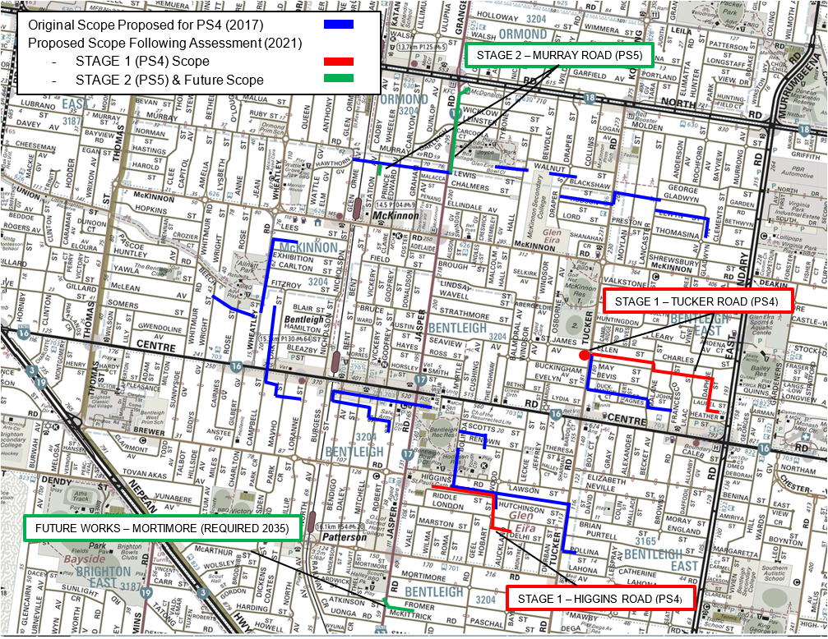
A ‘do nothing’ option was also explored, however due to the majority of predicted spills being uncontrolled, this option was discounted.
The capacity upgrades are to be delivered in 3 stages:

Stage 1 Works (2018–23): Tucker & Higgins
- Installation of 900-metre DN300 relief sewer between East Boundary Road and Tucker Road
- Installation of a 320-kilolitre detention storage at the Tucker Road Pump Station.
- Installation of 525-metre DN300 relief sewer along Hobart Street and Higgins Road.
These works have been awarded; detailed designs are complete with works commencing onsite. Expected completion 2022/23 (Q1)

Stage 2 Works (2028-33): Murray Rd
Installation of 450-metre DN450 diversion sewer between Murray Road and North Road, discharging into Melbourne Water’s CIS.

Future Works (2035): The Mortimore Street Pump Station Sub-Catchment requires the installation of 140-metre DN300 relief sewer between Fromer Street and Mortimore Street. This upgrade has been assessed as being required by 2035 and as such has been deferred. System performance will continue to be monitored using BlokAids.
Indicative self-assessment score: Generally consistent with Price Submission 2018–23
Assessment rationale: Through the planning investigations South East Water have been able to reduce the required 2018–23 scope from a P50 of $33.5 million (5.5 km) to a P50 of $12.2 million (1.5 km) with Murray Road works deferred until PS6. Capacity upgrades in the Mortimore Street sub-catchment were assessed to not be required until 2035.
South East Water’s decision to not seek funding for the scope of works proposed in Price Submission 2018–23 but instead seek a lower cost alternative has proved to be a sound decision resulting in reduced capital expenditure to address the system deficiencies.
The $14.1m P95 budget to complete the works was allocated from savings within the Sewer Growth program. An assessment of generally consistent with the 2018–23 commitment was applied in consideration of:
- The extent of investigations demonstrating our commitment to get the basics right, always.
- The revised and significantly reduced solution achieves the objective to improve network capacity, prevent future wet weather spills and ensure safe and reliable sewerage services with a high degree of confidence including under climate change scenarios.
- The unfunded 2018–23 expenditure was accommodated within the sewer growth budget
- The project is forecast to be 90% complete within the period, this delay was triggered by the need to apply the revised rainfall standard which was not available till 2020.
- The project is forecast to be completed in Q1 2023/24 at a forecast cost of $10.95m (representing a 33% saving on the approved business case).

PROJECT 6: Fishermans Bend land purchase
Major service: Recycled water
Asset category: Corporate
Driver: Improvement/compliance
Description: Purchase land to build a future water recycling plant to service the Fishermans Bend redevelopment area and meet the needs of the Fishermans Bend Framework Plan
Customer outcome: Support my community, protect our environment
Objective: The land purchase is a key enabler of the IWM servicing strategy. Government policy through Water for Victoria and more specifically the draft Fishermans Bend Framework Plan supports this approach.
Benefits: The land will provide the location for the proposed Fishermans Bend Water Recycling Plant
2018–2023 estimate $ submitted to ESC: $30.5m
What estimate was based on: The estimate was based on recent sales values (2018) in the Fishermans Bend employment area of approximately $2000 per square meter for a minimum land area of 1.5 Ha
Estimate confidence: P50
2018–2023 ESC determination $: $30.5m
Business case $: $35m (up to $38 million)
Reason for change/difference between 2018 and 2023 ESC determination $ and business case $: The board approved that up to $38 million (subject to Government Land Monitor approval) would be appropriate to secure the preferred site for the Fishermans Bend Water Recycling Plant at 10-28 and 21-51 Sardine Street Port Melbourne.
Suitable land is limited within the Fishermans Bend Employment Precinct. The increase beyond $35 million was necessitated to remain competitive in a supply constrained market
Actuals/Forecast $ (30 June 2023): $46.5m
Reason for change/difference between business case $ and Actuals/Forecast $ (30 June 2023): The anticipated cost to secure our preferred site at Sardine Street via compulsory acquisition is estimated at $38 million.
A site adjacent to Sardine Street has been offered for sale. Strategic procurement of this site to support the development of the water recycling plant has been endorsed. The estimated cost of securing this site is $8.5 million.
Actuals at 2022/23 (Q1): $0
Project spend end date: Q4 2022/23
Project status: Delayed, that is, either the project start was delayed, or completion will be later than scheduled
Project update: South East Water’s IWM servicing strategy was approved by board in 2017. It includes an 18 ML/day water recycling plant (sewer mining plant) to treat extracted sewage to Class A recycled water with the first stage due to commence operation in 2030. In conjunction with the Fishermans Bend Taskforce (Department Jobs, Precincts and Regions), Melbourne Water, City of Melbourne, City of Port Phillip and the Cooperative Research Centre for Water Sensitive Cities, South East Water developed a joint Water Sensitive City (WSC) strategy for Fishermans Bend. The WSC strategy includes our IWM servicing strategy which includes a water recycling plant within the precincts. The WSC strategy has been released by the Victorian Government.
The expected timing for land purchase to house the water recycling plant was in the fourth year of the current pricing period (2018–2023) with the sewage extraction works, main recycled water network and the initial construction of water recycling plant scheduled to commence from 2026.
In 2017 specialist consultant support to buy land via negotiation commenced but due to a shortage of land for sale, was unsuccessful. The land acquisition process was expanded by a targeted Expression of Interest (EoI) campaign in 2020. The EoI process identified parcels of land within the National Employment and Innovation Cluster (NEIC) at 10-28 and 21-51 Sardine Street Port Melbourne as the preferred location to establish the water recycling plant. The preferred site is close to the sewage extraction location and meets all water recycling plant site requirements and is endorsed by the Fishermans Bend Taskforce.
At the end of 2021, after obtaining all necessary approvals to transact with the vendor of our preferred site, the land was sold to another party. The South East Water Board approved on 17 December 2021 to progress to compulsory acquisition of the preferred site to enable timely land acquisition. The anticipated timeframe to complete the compulsory acquisition is to have the Planning Scheme Amendment gazetted in January 2023, serve Notice of Intention to Acquire to the landowner in February and publish the notice of Acquisition (South East Water owns the land) in April 2023.
In June 2022, a property that is directly next to our preferred site became available. The property is located at 30-32 and 34-38 Network Drive and has a combined land area of 2141 m2 (the preferred site has a land area of 20,779 m2 for comparison). Although the Network Drive property is too small to accommodate the ultimate water recycling plant, there is significant strategic benefit to acquiring this property as well. The key benefits to acquiring the property to support the development of the water recycling plant is the opportunity to square up the overall land holding with the preferred site for more efficient water recycling plant development and avoiding the significant risk of establishing a sensitive use within the current building or sensitive use development adjacent to our proposed water recycling plant. Securing this site will have further benefit to South East Water by preventing the new owner of our preferred site procuring this site as well, thereby increasing the costs and risk of us procuring the preferred site via compulsory acquisition.
Further, South East Water procuring land in Fishermans Bend will demonstrate our eagerness and commitment to realising the Fishermans Bend Integrated Water Management (IWM) objectives and will send a strong signal to the local community, developers and other landowners.
The acquisition of the Network Drive sites is anticipated to be completed by October 2022.
Indicative self-assessment score: Generally consistent with Price Submission 2018–23
Assessment rationale: Securing land in the Fishermans Bend employment area has remained challenging. Despite using several acquisition strategies to secure land such as by stealth and an open Expression of Interest campaign. South East Water selected a preferred site for the water recycling plant at 10-28 and 21-51 Sardine Street Port Melbourne and entered into negotiations with the vendor. Unfortunately, South East Water was unsuccessful and in late 2021 the site was sold to another party. After several unsuccessful attempts to communicate with the new owners South East Water is now progressing with compulsory Acquisition of 10-28 and 21-51 sardine Street with an aim to take possession of the land in 2023. This would be approximately twelve months after the initial scheduled date of Q4 2021–22.
More recently a site adjacent to our preferred site became available. South East Water is undertaking to procure this site for strategic reasons to support the development of the water recycling plant. Acquisition of this site will avoid establishment of potentially sensitive use and will allow for more efficient development of our preferred site.

PROJECT 7: Hanna Street Catchment improvement delivery performance
Major service: Sewerage
Asset category: Pipelines/network
Driver: Growth
Description: The project includes new sewerage assets to improve the capacity of the Hanna Street and Wells Street branch sewers including:
- duplication of 130m of 570mmID gravity sewer along Palmerston Crescent and Stead Street with connection to Melbourne Water South Yarra Main
- extension of duplication across Kings Way to provide future connection point for subsequent Hanna Street project stages.
Customer outcome: Get the basics right, always
Objective: Prevent wet weather spills and decrease dry weather surcharging in the Hanna Street and Wells Street branch sewers
Benefits: Protect human health and the environment
2018–2023 estimate $ submitted to ESC: $11m
What estimate was based on: This cost is stated in Real $ as of 1 January 2018 and is expected to be incurred wholly within the Price Submission 2018–23 period.
Estimate confidence: P50
2018–2023 ESC determination $: $11m
Business case $: $14.4m – P95 board Approval, March 2021 ($13.1m – P50)
Reason for change/difference between 2018 and 2023 ESC determination $ and business case $: The increased scope, complexity and necessary sequencing of the works within the catchment have resulted in Stage 1 ($14.4m) being the only works to be delivered within the catchment in Price Submission 2018–23.
The increase was funded from the total 2018–23 allocation of $15.4m for the Hanna/Wells St catchments. The revised Stage 1 scope is necessary to facilitate future stages safely and practically in 2023–28.
Actuals/Forecast $ (30 June 2023): $12.0m
Reason for change/difference between business case $ and Actuals/Forecast $ (30 June 2023): Project is forecast to be completed within the Business Case approval
Stage 1 works will be completed in 2023/2024 (Q2)
Actuals at2022/23 (Q1): $1.48m
Project spend end date: 2023/2024 (Q2) – $13.9m
Project status: Delayed, that is, either the project start was delayed, or completion will be later than scheduled
Project update: The scope of works identified during the preparation for Price Submission 2018–23 included the construction of 130m of 570mmID sewer under Kingsway service road connecting to existing Melbourne Water maintenance hole in addition to installing a pumping station which would discharge into the existing Casino rising main within 2018–23.
Detailed investigations undertaken between 2018 and 2020 to develop a functional design established that both of the short-listed options were in fact not viable due to a combination of updated growth forecasts, the adoption of revised rainfall and runoff models and clashes with Melbourne Water’s drainage network.
A significant update and calibration of the network hydraulic model has led to improved confidence in the model’s wet weather calibration due to the wide range of wet weather events captured during the field monitoring as well as provided the opportunity to ensure compliance across the network when taking into consideration the new rainfall standards and climate change scenarios. The system performance has also been supported by operational knowledge and BlokAid data in the region providing additional confidence in its outputs. This has resulted in a revised scope of works to be undertaken in a staged approach.
Stage 1 (2018–23 top 10) – $14.4m P95, board Approved
Construction of a new 4.8m diameter maintenance hole 13.2m deep on Melbourne Water’s South Yarra Main, largely due to safety concerns with connecting to the existing brick structure and constructing 280m of DN900mm sewer to divert flows away from the heavily congested King’s Way.
Stage 2 (2023–28 top 10) – $70.3m P95, board Approved
The second stage requires a 220l/s pumping station to be installed along with 1.9 kilometres of DN450–DN750mm sewers to cater for the high growth proposed in the upper reaches of the system in the Southbank area.
An additional advantage of the updated works is that they also provide the ability for the future cross connection with downstream portions of the 125-year-old Hanna Street branch sewer if required due to its deteriorating conditions.
Indicative self-assessment score: Generally consistent with Price Submission 2018–23
Assessment rationale: Planning investigations have been undertaken by South East Water within the period to confirm the revised strategy which has had to accommodate increased forecast growth and resulting flows in the upper reaches of the catchment. This increased infrastructure requirement has necessitated a staged approach to the delivery of this scheme to ensure upgrades can be completed prudently and safely.
The complexities of Stages 1 and 2 of the project has required significant investigation works to develop functional designs considering community impacts as well as the safety and constructability of the proposed assets.
The $15.4m Hanna and Wells St catchment 2018–23 budget was prioritised to deliver Stage 1 of the Hanna St scheme at a value of $14.1m (P95). Stage 2 has been approved by the South East Water Board and is included as a top 10 project for delivery in Price Submission 2023–28.
The Stage 1 upgrade not only alleviates the dry weather surcharging in the lower reaches of the network, and thus reduces the likelihood of asset failure within Kings Way but also provides the outlet for Stage 2 which addresses the wet weather spill deficiencies. The location of the existing sewer within Kings Way means that a collapse as a result of daily surcharging would result in extremely high cost to repair and significant disruption to the community.
An assessment of generally consistent with the 2018–23 commitment was applied in consideration of:
- the extent of investigations demonstrating our commitment to get the basics right, always.
- the stage 1 project will achieve the objective to decrease dry weather surcharging in the Hanna Street and Wells Street branch sewers.
- even though Stage 2 is required to prevent wet weather spills, it must be proceeded by Stage 1.
- the project is forecast to be 85% complete within the period. This delay was a result of the need to verify the revised scheme, complete extensive geotechnical investigations and service proving to de-risk the tender phase and to obtain the necessary stakeholder approvals and customer engagement.
The project is forecast to be completed within the Business Case budget in Q2 2023/24.

PROJECT 8: Pakenham East branch sewer delivery performance
Major service: Sewerage
Asset category: Pipelines/network
Driver: Growth
Description: The preferred option to service the Pakenham East Growth Area is a new DN300 5.2-kilometre gravity branch sewer starting at Princes Freeway on the southern boundary of the growth area and connecting to the existing Peet Street branch sewer at maintenance hole PEE10 for onward transmission to the Pakenham Water Recycling Plant as shown in the Drawing Plan.
Customer outcome: Get the basics right, always
Objective: The objective of the Pakenham East branch sewer is to provide sewerage services to the majority of the Pakenham East Growth Area.
Benefits: This project will ensure that new development can be connected to safe and reliable sewerage services, protecting human health and the environment.
2018–2023 estimate $ submitted to ESC: $15.2m
What estimate was based on: This cost is stated at the P50 level, in Real dollars as of 1 January 2018, and is expected to be incurred wholly within the Price Submission 2018–23.
Estimate confidence: P50
2018–2023 ESC determination $: $15.2m (P50)
Business case $: $21.9m (P95), board approved September 2019
Reason for change/difference between 2018 and 2023 ESC determination $ and business case $: The Pakenham East PSP lot forecast was 3,980 at the time of the submission, this increased to 7150 lots before PSP approval requiring an increase to the proposed branch sewer diameter.
Actuals/Forecast $ (30 June 2023): $16.8m
Reason for change/difference between business case $ and Actuals/Forecast $ (30 June 2023): Delayed PSP approval resulted in a later start to the project, the project will not be completed until the first year of 2023–28. Land access issues are also contributing to the extended project duration. The costs increase from the P50 2018–23 allowance to the approve business case is largely attributable to the upsize of the main from DN300 to DN500 and above.
Actuals at 2022/23 (Q1): $2.84m
Project spend end date: 2023/2024 (Q2) – $18.65m
The project is currently forecast to be delivered at a $3.2m saving from the approved business case.
Project status: Delayed, that is, either the project start was delayed, or completion will be later than scheduled
Project update: At the time of the 2018–23 submission the Victorian Planning Authority/Cardinia Council were forecasting the release of the Precinct Structure Plan (PSP) for Pakenham East by December 2018. The project investment timing reflected this timeframe. The Pakenham East PSP was however not approved until January 2021 after lengthy delays which have pushed the completion of this project outside the current regulatory period. The official award of the tender was issued in late April 2021. Construction works are progressing well and is scheduled to be completed during the first year of Price Submission 5.
To mitigate some of the delays caused by the PSP approval South East Water undertook on a comprehensive engagement with industry including the key developers in the precinct and other authorities including the VPA using the same approach that was successfully employed on the Ballarto Rd East SPS project. An optimised delivery strategy was developed, functional designs prepared, and the project tendered in readiness for PSP approval. This allowed South East Water to reduce some of the schedule impacts from the late PSP approval. The project was awarded in early 2021.
The design, construction and commissioning of this critical infrastructure although extending beyond is expected to be completed without delay to development. Works are currently scheduled for completion in the first year of 2023–28.
Indicative self-assessment score: Generally consistent with Price Submission 2018–23
Assessment rationale: The project though delayed is forecast to be delivered at a cost saving of $3.2m.
The additional forecast expenditure has been funded from savings within the Sewer Growth program. An assessment of generally consistent with the PS18 commitment was applied in consideration of:
- the extent of industry engagement completed to streamline the approval process and ensure all requirements are met demonstrating to our customers demonstrating our commitment to get the basics right, always.
- the delivered infrastructure will achieve the objective to provide sewerage services to the majority of the Pakenham East growth area and ensuring that new development can be connected to safe and reliable sewerage services, protecting human health and the environment
- the unfunded 2018–23 expenditure resulting from significantly increased lot densities was accommodated within the sewer growth budget
- the project is forecast to be delivered under budget without significant delay to development (resulted in a 15% saving on the approved business case).

PROJECT 9: Pakenham Regional Plant – land purchase
Major service: Sewerage
Asset category: Sewer treatment
Driver: Growth
Description: Purchase land in the Pakenham East Growth area
Customer outcome: Get the basics right, always
Objective: To ensure there is sufficient land to provide cost-effective future treatment services to the rapidly growing area while not creating unacceptable amenity issues associated with noise and/or odour
2018–2023 estimate $ submitted to ESC: $11m
What estimate was based on: A Strategic Review was completed by South East Water to support the servicing of the Casey Clyde Region. This was presented and approved by the South East Water Board in 2017. It identified 3 options including:
- Full centralised treatment
- Regional treatment built on a new site
- Local treatment plant built in the Casey Clyde Region
The whole of community costs were considered, and an MCA completed. The option for purchasing the new site and building a Regional treatment plant.
The original land estimate was based on recent sales at the time.
Estimate confidence: P50
2018–2023 ESC determination $: $15.2m
Reason for change/difference between 2018 and 2023 ESC determination $ and business case $: The landowner was approached in 2018/19 to discuss the purchase of the land. This offer was rejected, and negotiations stalled.
A kerbside land valuation was undertaken in 2020 which confirmed the purchase price of $10.7m.
South East Water undertook a detailed Master Planning for the Regional Plant. This process considered building on the existing Pakenham treatment plant or building the facility on the land. This highlighted a potential saving of $145m and support the pursuit of the land purchase.
DARMS Property have been engaged to pursue the purchase of the land on behalf of South East Water.
There is potential for the land to be purchased in 2018–23. However, if compulsory acquisition is required then the land purchase will be pushed out to 2023–24.
Actuals/Forecast $ (30 June 2023): $210,000
Reason for change/difference between business case $ and Actuals/Forecast $ (30 June 2023): The money forecast to be spent is the engagement of the consultant to support the purchase of the property.
Actuals at 2022/23 (Q1): $50,000
Project spend end date: 2023/2024 (Q4)
Project status: Delayed, that is, either the project start was delayed, or completion will be later than scheduled
Project update: South East Water has confirmed that master planning for the site and the need for purchase of the site. A strategy is being developed to purchase the land. If this is unsuccessful then compulsory accusation will be required. This delay has occurred due to the need to validate the strategic direction with the master planning work for the South East Regional Biofactory.
Indicative self-assessment score: Not consistent with the 2018–23 commitment

PROJECT 10: Water Recycling Plants Sludge Drying Pans and Stockpile Areas upgrades delivery performance
Major service: Sewerage
Asset category: Treatment
Driver: Renewals (Reliability)
The sludge drying and stockpile areas at a number of water recycling plants require relining on a regular basis to minimise possible environmental contamination.
Description: The project encompasses the development and implementation of a relining strategy for the sludge drying pans (SDP) and sludge stockpile areas (SSA) at South East Water’s water recycling plants over the next 5 years.
This project included cement treated crushed rock (CTCR) lining of the drying pans and stockpile areas at Boneo, Mount Martha, Somers and Pakenham.
Customer outcome: Get the basics right, always
Objective: To implement the optimal strategy for relining the sludge drying pans and sludge storage areas across South East Water’s water recycling plants.
2018–2023 estimate $ submitted to ESC: $10.2m in –of a total of $11.8m completed over 2013–18 and 2018–23.
What estimate was based on: Business Case approved May 2018. This cost is stated at the P50 level, in Real $ as of 1 January 2018, and of this amount, $10.2m was expected to be incurred within the 2018–23 regulatory period.
Estimate confidence: P50
2018–2023 ESC determination $: $10.2m
Business case: $11.8m (P50) of which $10.2m was expected within 2018–23
$12.5m (P95)
Reason for change/difference between 2018 and 2023 ESC determination $ and business case $: No change
Actuals/Forecast $ (30 June 2023): $8.4m
Reason for change/difference between business case $ and Actuals/Forecast $ (30 June 2023): While the original program was optimised to reduce impact to water recycling plant operations and achieve delivery efficiencies, the overall program was achieved.
Actuals at 2022/23 (Q1):
Boneo – $140,000
Mount Martha – $4.94m
Pakenham – $805,000
Somers – $2.5m
Total $8.4m
Project spend end date: 2022/2023 (Q1) – $8.4m actual costs within the period of the $10.2m P50 allowance.
Project status: Completed on time, that is, the project was completed by original scheduled completion date (incl. early completion).
Project update: The program has encountered significant challenges including:
- Higher-than-average rainfall periods extending into the drier months
- Water recycling plants lockdowns to protect critical functions during the coronavirus (COVID-19) pandemic
- Changing EPA regulations relating to the disposal of contaminated spoil
The works schedule was modified to ensure optimised delivery efficiencies and critically to avoid impact the safe operation of the water recycling plants. Ground contamination and revised EPA regulations and EPA waste classification have created some challenges in classifying and disposing of excavated materials. This required design optimisation to minimise offsite disposal by reducing cut to fill ratios across the program. The program has delivered high quality infrastructure without impact to the water recycling plants despite access constraints during the COVID-19 pandemic.
The challenges have been successfully overcome with the program delivered on schedule and within budget. Budget savings were achieved in part due to the optimisation of the delivery program.
South East Water’s water recycling plant reliability engineer assessed the performance of the upgrades as follows:
- CTCR linings are performing well as expected, for example the pans at Blind Bight have negligible wear after harvesting and Pakenham pan5 has had 3 harvests now exhibiting only a few minor potholes which can be easily patched. Overall CTCR wear is minimal which seems to suggest at this relatively early stage that the expectant CTCR liner life of 20 years should be met
- This is in comparison to the previous state of excessive clay layer losses and high repair cost
- Clay integrity (underneath the CTCR wearing layer) is now protected preventing contamination to environment
- Biosolids volume has been reduced by 30% as it can be harvested without contamination by the clay liner
- Reduced volumes results in reduced transport and re-use costs
Sludge drying time appears to be faster than the old clay linings due to the heat from the CTCR surface and improved booming and turning
Indicative self-assessment score: Largely consistent with or exceeded the 2018–23 commitment
Assessment rationale: The project was delivered ahead of schedule and within the allocated P50 budget.
An assessment of largely consistent with or exceeding the 2018–23 commitment was applied in consideration of:
- The program of upgrades has been delivered on time, under the P50 budget and to
a high standard demonstrating our commitment to get the basics right, always.
- The objective to implement the optimal strategy for relining the SDPs and SSAs across South East Water’s treatment plants has been achieved
- Investigations suggest that benefits have been realised with upgrades allowing the SDP and SSA assets to be maintained in a cost-effective manner while minimising environmental impacts.

Appendix 3 – Performance self-assessment framework

Our approach
This framework was designed to build upon the existing customer outcomes and major projects reporting, in order to provide a
true and robust reflection of our performance and the overall value we deliver to customers. It consists of 5 performance elements, identified in response to the guiding questions provided in the ESC final guidance paper for the 2023–28 Price Submission as shown below in figure 20.

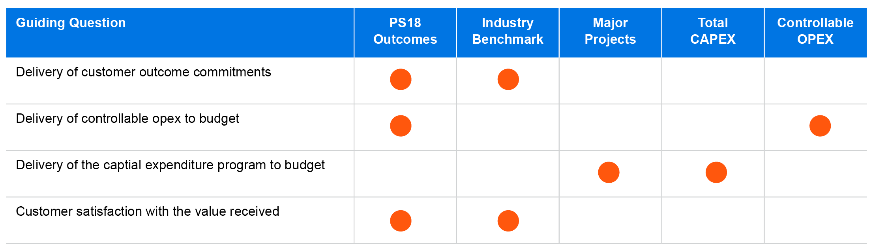
Figure 20: ESC guiding questions (performance)

Scoring methodology
Each of the 5 performance elements covered in this self-assessment framework has been scored using the ESC Scoring Methodology shown in Table 74, as detailed in the guidance paper.​ Using the scoring system outlined for each element, a PREMO rating is assigned by converting the element result to a percentage and referencing the table pictured to convert the percentage to an ESC score and thereby a Rating. ​The individual element rating scores are then totaled to determine which range the result falls into. It is this range that assigns our indicative overall rating for this element of (P)REMO.
Table 74: ESC scoring methodology
Range | Score | Rating | %
Leading
20 | 4 | Very confident the element is 'Leading' | 100%
19 | 3.75 | Confident the element is 'Leading' | 94%
Advanced
18.75 | 3.5 | Very confident the element is 'Advanced' | 88%
 | 3.25 | Confident the element is 'Advanced' | 81%
14.5 | 3 | Satisfied the element is 'Advanced' | 75%
 | 2.75 | Reasonably confident the element is 'Advanced' | 69%
Standard
14.25 | 2.5 | Very confident the element is 'Standard' | 63%
 | 2.25 | Confident the element is 'Standard' | 56%
9.5 | 2 | Satisfied the element is 'Standard' | 50%
 | 1.75 | Reasonably confident the element is 'Standard' | 44%
Basic
9.25 | 1.5 | Very confident the element is 'Basic' | 38%
 | 1.25 | Confident the element is 'Basic' | 31%
5 | 1 | Satisfied the element is 'Basic' | 25%

2018–23 customer outcomes
The first element uses the existing Customer Outcomes Reporting Framework that was established as part of the 2018 submission. The framework consists of annual targets and tolerance bands assigned to each output measure that are used to assess performance individually, as well as collectively at the overall customer outcome level. ​

Each output measure was assessed for performance during the 2021–22 financial year using a 3-tiered scoring system:

1 – outside both the target and the tolerance band
​2 – outside the target but within the tolerance band ​
​3 – within the target.

The element is individually rated 3.5 out of 4: Very confident the element is ‘Advanced’.

Table 75: Customer outcomes performance
Measure | Target | T 'Band | Result | Score
Get the basics right, always
Number of Safe Drinking Water Regulations non-compliance incidents (water sampling and audits) | 0 | 5 | 0 | 3
Number of water quality complaints per 100 customers | 0.18 | 0.20 | 0.12 | 3
Number of customers receiving greater than 5 unplanned water supply interruptions | 532 | 559 | 0 | 3
Number of customers receiving 3 or more sewerage blockages | 17 | 46 | 21 | 2
Warn me, inform me
Percentage of customers notified per unplanned water supply interruption (as a percentage of total customer affected) | 59% | 54% | 72% | 3
Average duration of unplanned water supply interruptions | 88 | 92.9 | 79.2 | 3
Percentage of unplanned customer interruptions that are in peak hours | 27.6% | 30.5% | 26.6% | 3
Planned water interruptions restored within notification period | 98% | 96% | 99% | 3
Fair and affordable for all
Operating cost per property (residential and non-residential). | $150 | $154 | $151 | 2
Customers supported by South East Water Assist program | 6,147 | 5,993 | 7,102 | 3
Average level of debt upon entry to South East Water Assist program | $800 | $900 | $650 | 3
Make my experience better
Customers satisfied (rating of 6 or above out of 10) via SEW's post-interaction survey | 85% | 80% | 82% | 2
Customers who consider SEW provides value for money (rating of 6 or above out of 10) via SEW's post interaction survey | 71% | 66% | 72% | 3
Total complaints per 100 customers | 0.38 | 0.42 | 0.57 | 1
Support my community, protect my environment
Total net CO2 emissions | 28,609 | 32,900 | 27,556 | 3
Number of EPA reportable sewer spills | 20 | 23 | 11 | 3
Percentage of customers in designated greenfield areas receiving recycled water (residential only) | 78% | 70% | 74% | 2
Volume of recycled water as a percentage of total water supplied to designated greenfield areas | 18% | 16% | 16% | 2

Industry benchmark
The second element uses the ESC Water Performance Report and the independent customer perception surveys conducted
each year across all Victorian water retailers. Sixteen metrics were selected from the report, based on alignment with our customer outcomes, plus the 4 customer perception measures, to allow us to assess our performance against the industry in a consistent and independently audited manner.

Given the availability and consistency of these metrics, a 5-year average was calculated from all Victorian water businesses and used to gauge our performance over the same period, using a 2-tiered scoring system: ​
​
1 – equal to or outside the state average​
​2 – better than the state average

The element is individually rated 3.5 out of 4: Very confident the element is ‘Advanced’.

Customer sentiment
This component draws from the ESC customer perception surveys that have been conducted annually since the commencement of the 2018–23 regulatory period. Results differ from the remainder of the measure referenced in that they are only a 4-year average and include the most recent 2021–22 years’ results not available for the Water Performance Report at the time of completion.

Table 76: Customer sentiment (4-year average)
Customer perception survey | Result | State avg. | Score
How customers rated their water business for overall satisfaction | 7.2 | 6.8 | 2
How customers rated their water business for value for money | 6.6 | 6.2 | 2
How customers rated their water business for trust | 7.0 | 6.6 | 2
How customers rated their water business for reputation in the community | 7.0 | 6.6 | 2

Table 77 below shows our performance against a selected set of indicators from the annual ESC Water Performance Report. The assessment consists of a 5-year average from 2016–17 and 2020–21, which is the most up-to-date release of these metrics at the time of preparing the assessment.

Table 77: ESC Water Performance Report measures
Water Performance Report measure | Result | State average | Score
Water quality complaints – all causes (per 100 customers) | 0.21 | 0.26 | 2
Complaints received by water business [total] (per 100 customers) | 0.47 | 0.60 | 2
Hardship grants approved (per 100 customers) | 0.06 | 0.49 | 1
Average debt level (residential) - restrictions | 1,437 | 1,343 | 1
Residential customers with instalment plans (per 100 customers) | 4.8 | 6.1 | 1
Average annual household consumption (kilolitres per household) | 148 | 186 | 2
Owner occupiers — average household bills ($, nominal) | 983 | 1,093 | 2
Tenants — average household bills ($, nominal) | 493 | 340 | 1
Historic net greenhouse gas emissions (equivalent tonnes of CO2) | 39,105 | 25,007 | 1
Microbiological water quality (per cent of customers receiving drinking water meeting E. coli requirements) | 99.998 | 99.8674 | 2
Bursts and leaks (per 100km water main) | 30.66 | 24.48 | 1
Average duration of unplanned interruptions (minutes) | 86.42 | 103.1 | 2
Planned customer water supply interruption frequency in peak hours (interruptions per customer) | 0.010 | 0.005 | 1
Unplanned water supply interruptions restored within 5 hours (per cent) | 97.9 | 97.4 | 2
Sewer blockages (per 100 kilometres of sewer main) | 18.1 | 18.8 | 2
Sewer spills to customer property (per 100 customers) | 0.07 | 0.09 | 2

Major projects
This third element was selected to assess the performance of the top-10 major projects from the 2018–23 submission. Given the complexity and different profile of these projects, the decision was made to conduct the assessment around the customer, the intended outcome and benefit delivered against the 2018 commitment.​

Each assessment was conducted by the project manager and consisted of a brief summary of all key aspects of the project including time, budget and customer benefits, plus any changes to scope and an explanation of any deviation from the 2018–23 commitments. Assessments and project summaries were then reviewed by our Group and General Managers and presented to our Strategic Asset Management Committee (SAMC), to endorse the final result for each from a 3-tiered scoring system:
1 – not consistent with the 2018–23 commitment​
​2 – generally consistent with the 2018-23 commitment​
​3 – largely consistent with or exceeded the 2018-23 commitment

The element is individually rated 3 out of 4: Satisfied the element is ‘Advanced’.

Table 78: Major projects performance
Project name | Project status | GM score | SAMC score
Pakenham East sewer servicing | Delayed | 2 | 2
Ballarto Road East sewer pump station | Completed late | 3 | 3
Digital capability pilot | Completed on time | 2 | 2
Boneo Water Recycling Plant upgrade | Completed late | 2 | 2
Land purchase 1 (Fishermans Bend) | Delayed | 2 | 2
Water recycling plant drying pan and stockpile area upgrades | Completed on time | 3 | 3
Land purchase 2 (Pakenham Water Recycling Plant) | Delayed | 1 | 1
Hanna Street sewerage capacity improvements | Delayed | 2 | 2
Elster Creek sewer catchment capacity improvement works | Deferred | 2 | 2
Clayton East and West sewer catchment capacity improvement works | Deferred | 3 | 3

More information on these projects can be found in Appendix 2.

Total capital expenditure (CAPEX)
The fourth element was selected to assess the overall delivery of the capital expenditure program against the 2018 Price Determination ($2017—18), acknowledging the need for strategic redirection of funds to ensure the greatest value is delivered. We believe this is part of being a good asset manager and presents another perspective on the business’s ability to achieve customer commitments and deliver against service standards and expectations.​

This assessment covers the entire 2018–23 regulatory period expenditure (4 actuals + 1 forecast) and assigns a rating based on the variance between actual and the 2018 Price Determination in $2017—18 using the scoring criteria below:

1 – outside +/- 20% 2 - within +/- 20% 3 - within +/- 17.5% ​
4 – within +/- 15% 5 - within +/- 12.5% 6 - within +/- 10%​
7 – within +/- 7.5% 8 - within +/- 5% 9 - within +/- 2.5%

Table 79: Capital expenditure performance ($2017–18)
Determination $M | 2018—19 actual | 2019—20 actual | 2020—21 actual | 2021—22 actual | 2022—23 forecast | Total spend | Variance | Score
$1,112.03 | $203.17 | $251.44 | $226.13 | $169.39 | $263.21 | $1,113.33 | 0.1% | 9

The element is individually rated 4 out of 4: Very confident the element is ‘Leading’.

Controllable operating expenditure (OPEX)
The fifth element to be assessed is the total controllable operating expenditure across the 2018–23 regulatory period, excluding Melbourne Water bulk costs, environmental contributions and licence fees ($2017—18). This element will influence how we meet the efficiency hurdle rate and is a great metric to show how savings realised from the current regulatory period can be locked in and carried forward to the next.​

As with capital expenditure, this assessment covers the entire 2018–23 regulatory period expenditure (4 actuals + 1 forecast) and assigns a rating based on the variance between actual and the 2018 Price Determination in $2017—18 using the criteria below:

1 – Expenditure exceeded the 2018–23 allowance without demonstrated value improvements for customers ​
​2 – Expenditure is in line with the 2018–23 allowance and any variance justified​
3 – Underspent against the 2018–23 allowance and maintained outcomes

Table 80: Controllable operating expenditure ($2017–18)
Determination $M | 2018—19 actual | 2019—20 actual | 2020—21 actual | 2021—22 actual | 2022—23 forecast | Total spend | Variance | Score
$623.55 | $121.42 | $122.88 | $120.90 | $126.09 | $131.65 | $622.94 | -0.1% | 3

The element is individually rated 4 out of 4: Very confident the element is ‘Leading’.

Overall (P)REMO rating
The final step in arriving at the overall PREMO rating is the aggregation of scores from the 5 performance elements. Each element is given equal weighting (20%) toward the overall result as we believe all are seen as equal in the eyes of the customer, the ESC and our business and should all be delivered against in order to be considered successful.​
With a maximum possible score of 4 per element, the overall result is out of 20 and is placed within the appropriate ‘range’ from the ESC Scoring Framework table. This, therefore, sets the overall rating and final result for the (P)REMO self-assessment of performance to inform our 2023–28 submission.

Table 81: Overall (P)REMO rating
Methodology | Element result |  | Aggregate rating
Performance against 2018–23 customer outcomes including tolerance bands | 3.50 | Very confident the element is 'Advanced' | 18.00 | Confident the element is 'Advanced'
Water Performance Report - comparison against state averages for same or like KPIs | 3.50 | Very confident the element is 'Advanced'
Assessment of delivery against our top 10 major projects from the 2018–23 Price Submission | 3.00 | Satisfied the element is 'Advanced'
Total capital expenditure vs 2018 Price Determination | 4.00 | Very confident the element is 'Leading'
Total controllable operating expenditure vs 2018 Price Determination | 4.00 | Very confident the element is 'Leading'

The overall rating awarded is 18 out of 20: Confident the element is ‘Advanced’.

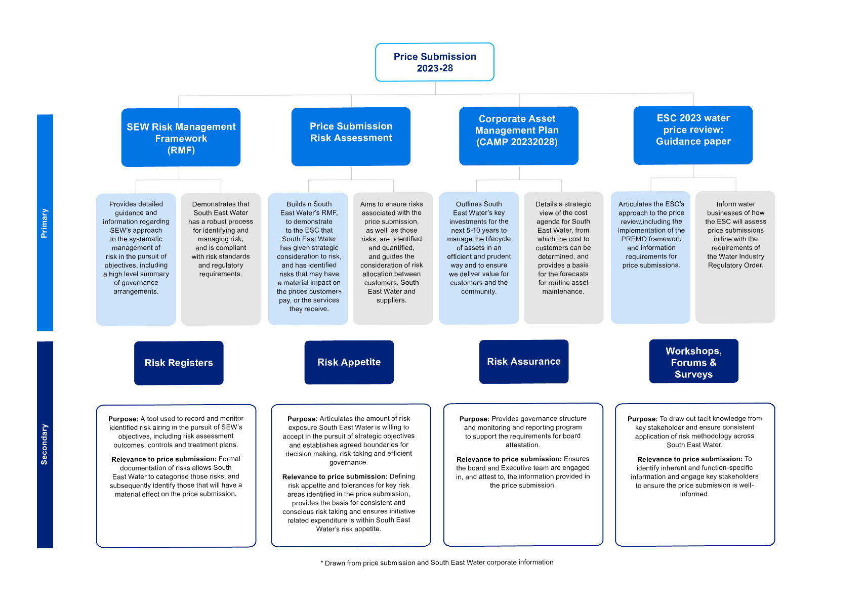
Appendix 4: Mapping of risk information sources

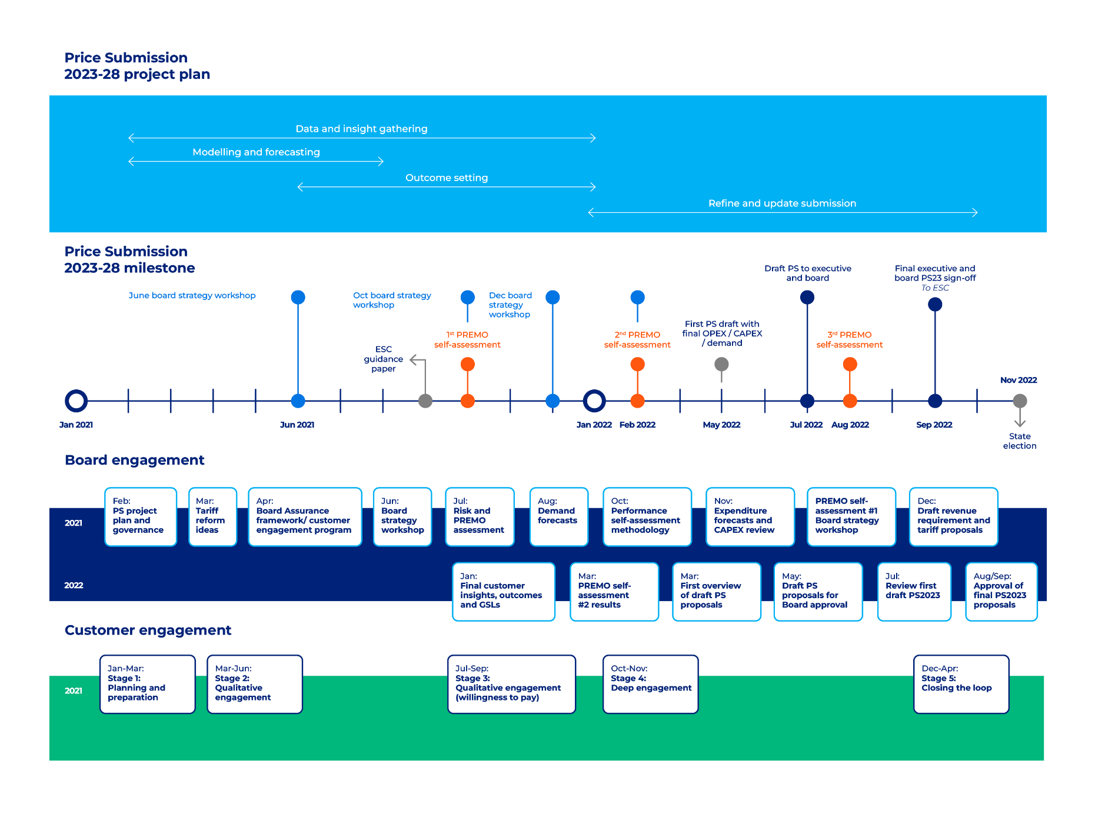
Appendix 5: Board and executive assurance program

The
southeastwater.com.au

How to get in touch
Email support@southeastwater.com.au
General account enquiries 13 18 51
South East Water Assist 9552 3540
Hearing and speech impaired services
TTY 13 36 77 (ask for 13 18 51)
Interpreter service (all languages) 9209 0130

Follow us

This does not include the reduction to 2022-23 water variable tariffs to account for the cancellation of the desalination water order.
Essential Services Commission (2021), 2023 Water Price Review, Guidance paper, 26 October, page 88.
Noting that the customer perception measures are only available for the 4 years from 2018-19.
Target based on a 10-year average to account for climate variability
The benefits from digital metering will be shared across all retailers. How these benefits are distributed will be considered via Melbourne Water’s cost allocation model and DELWPs current policy review associated to bulk entitlement arrangements.
The top 10 project are at different stages of development so their scope is subject to change. Their final scope will be defined on completion of optioneering, functional design and risk assessments.
Current and post-investment risk ratings have been determined in accordance with our enterprise risk management framework outlined in Section 5. Further details are contained in the Major Project Summaries for our top 10 projects.
Circular economy initiatives being considered include converting organic waste to energy; recovery of nutrients for use as fertiliser; production of biochar from biosolids as a means of carbon sequestration; and building on already existing recycled water networks to supply additional water to the Casey–Cardinia region.
Fishermans Bend Framework – a strategic plan for the development of Fishermans Bend to 2050 (DELWP, 2018)
The Minister’s Letter of Expectations 2022–23 states: “South East Water will also support the government to deliver the Water Sensitive Cities Strategy for Fishermans Bend. This includes fulfilling its responsibility to deliver the water recycling plant and distribution network, which will enhance water security and support urban cooling and greening.”
The total cost is the amount South East Water is investing in this project. The Victorian Government is contributing an additional $24.8 million from the Victorian Budget 2022–23.
The Dingley Green Wedge encompasses 46 sites (businesses and open spaces) across Keysborough (City of Greater of Dandenong), Dingley and Heatherton (City of Kingston), Clayton South (City of Monash), Sandringham and Cheltenham (City of Bayside).
Integrated Water Management Forums
Refer to Appendix 2 for an overview of the project delivery performance for the Boneo Treatment Plant Upgrade.
Vasilis Sarafidis (Frontier Econometrics) and Jan Ditzen (Free University of Bozen-Bolzano)
These results are not comparable as the different analysis was based on different time periods of the trial. The University of Melbourne’s analysis is taken to be the most accurate as they analysed over the entire length of the 12-week trial.
https://labourmarketinsights.gov.au/
KPMG, Pricing for Demand Management, WSAA, March 2004
KPMG, Pricing for Demand Management, WSAA, March 2004
ACIL Tasman, Pricing for Water Conservation in the Non Residential Urban Sector, Smart Water Fund, February 2007
Essential Services Commission (2021), Water Price Review 2023: Guidance paper, 26 October; page 53.
https://www.esc.vic.gov.au/sites/default/files/documents/Melbourne-Water-price-review-2021-Final-decision-20210622.pdf
This approach to account for historical costs within New Customer Contributions is consistent with the methodologies accepted by SKM in its assessment of NCCs proposed by urban water businesses for the ESC in the 2013 price review. SKM, New Customer Contributions - Review Capital and Operating Expenditure – Expenditure Assessment Report – Metropolitan Urban water businesses, p.6-7.
The ratio may change slightly pending the meter type supplied to a property.
Department of Environment, Land, Water and Planning, Managing Climate Change Risk Guidance for Board Members and Executives of Water Corporations and Catchment Management Authorities, June 2019.

