Better Practice in Responding to Family Violence Handbook: Summary
  - An overview of the principles and actions that can support essential services providers to provide family violence assistance that is safe and effective
  - 4 September 2025

This is a summary version of the Better Practice in Responding to Family Violence Handbook: Exploring ways essential services providers can provide family violence assistance that is safe and effective. It provides an overview of the principles and actions that can support our regulated sectors to build safe and effective responses to family violence through better practice approaches and continuous improvement.
Read the complete handbook on our website, which includes:
- further details on the principles and actions
- case studies of business practice
- lived experience insights
- a list of resources to support businesses.

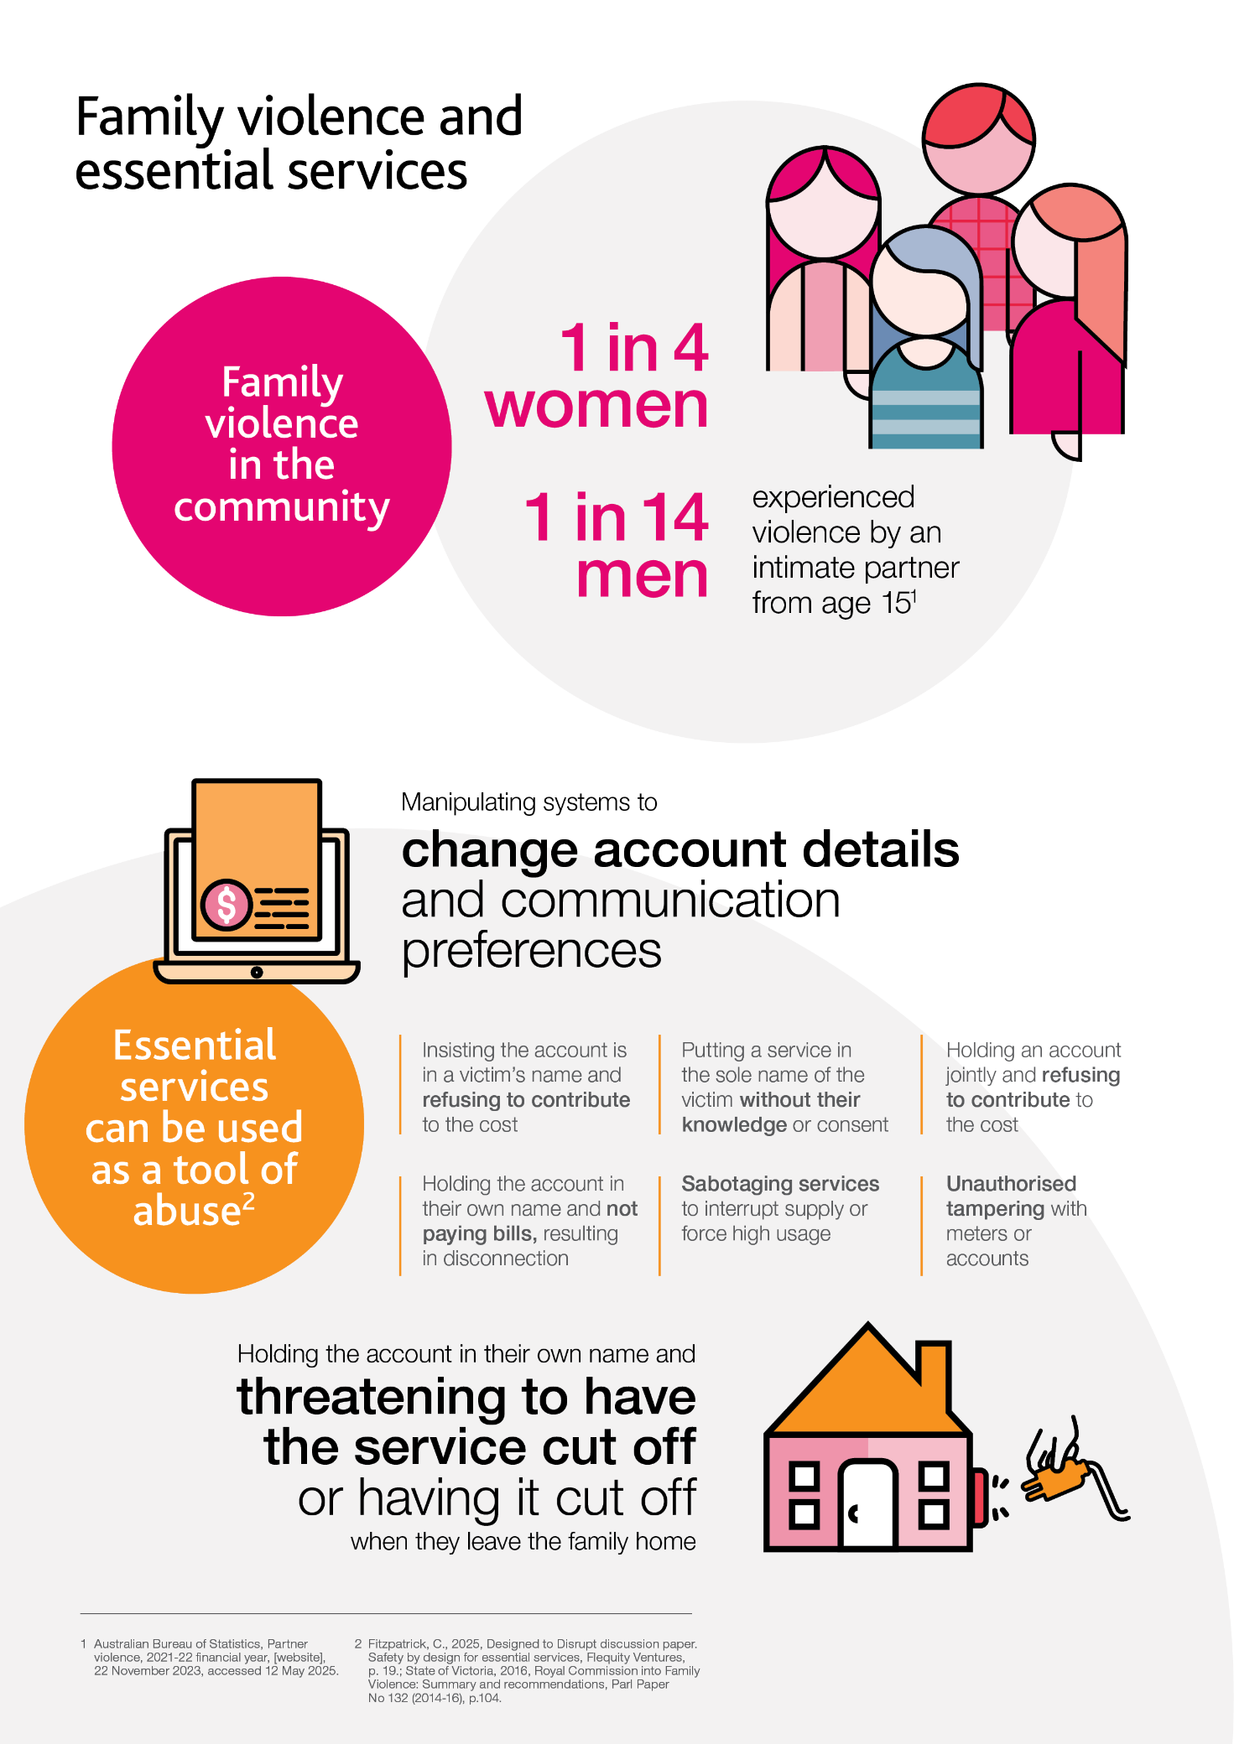
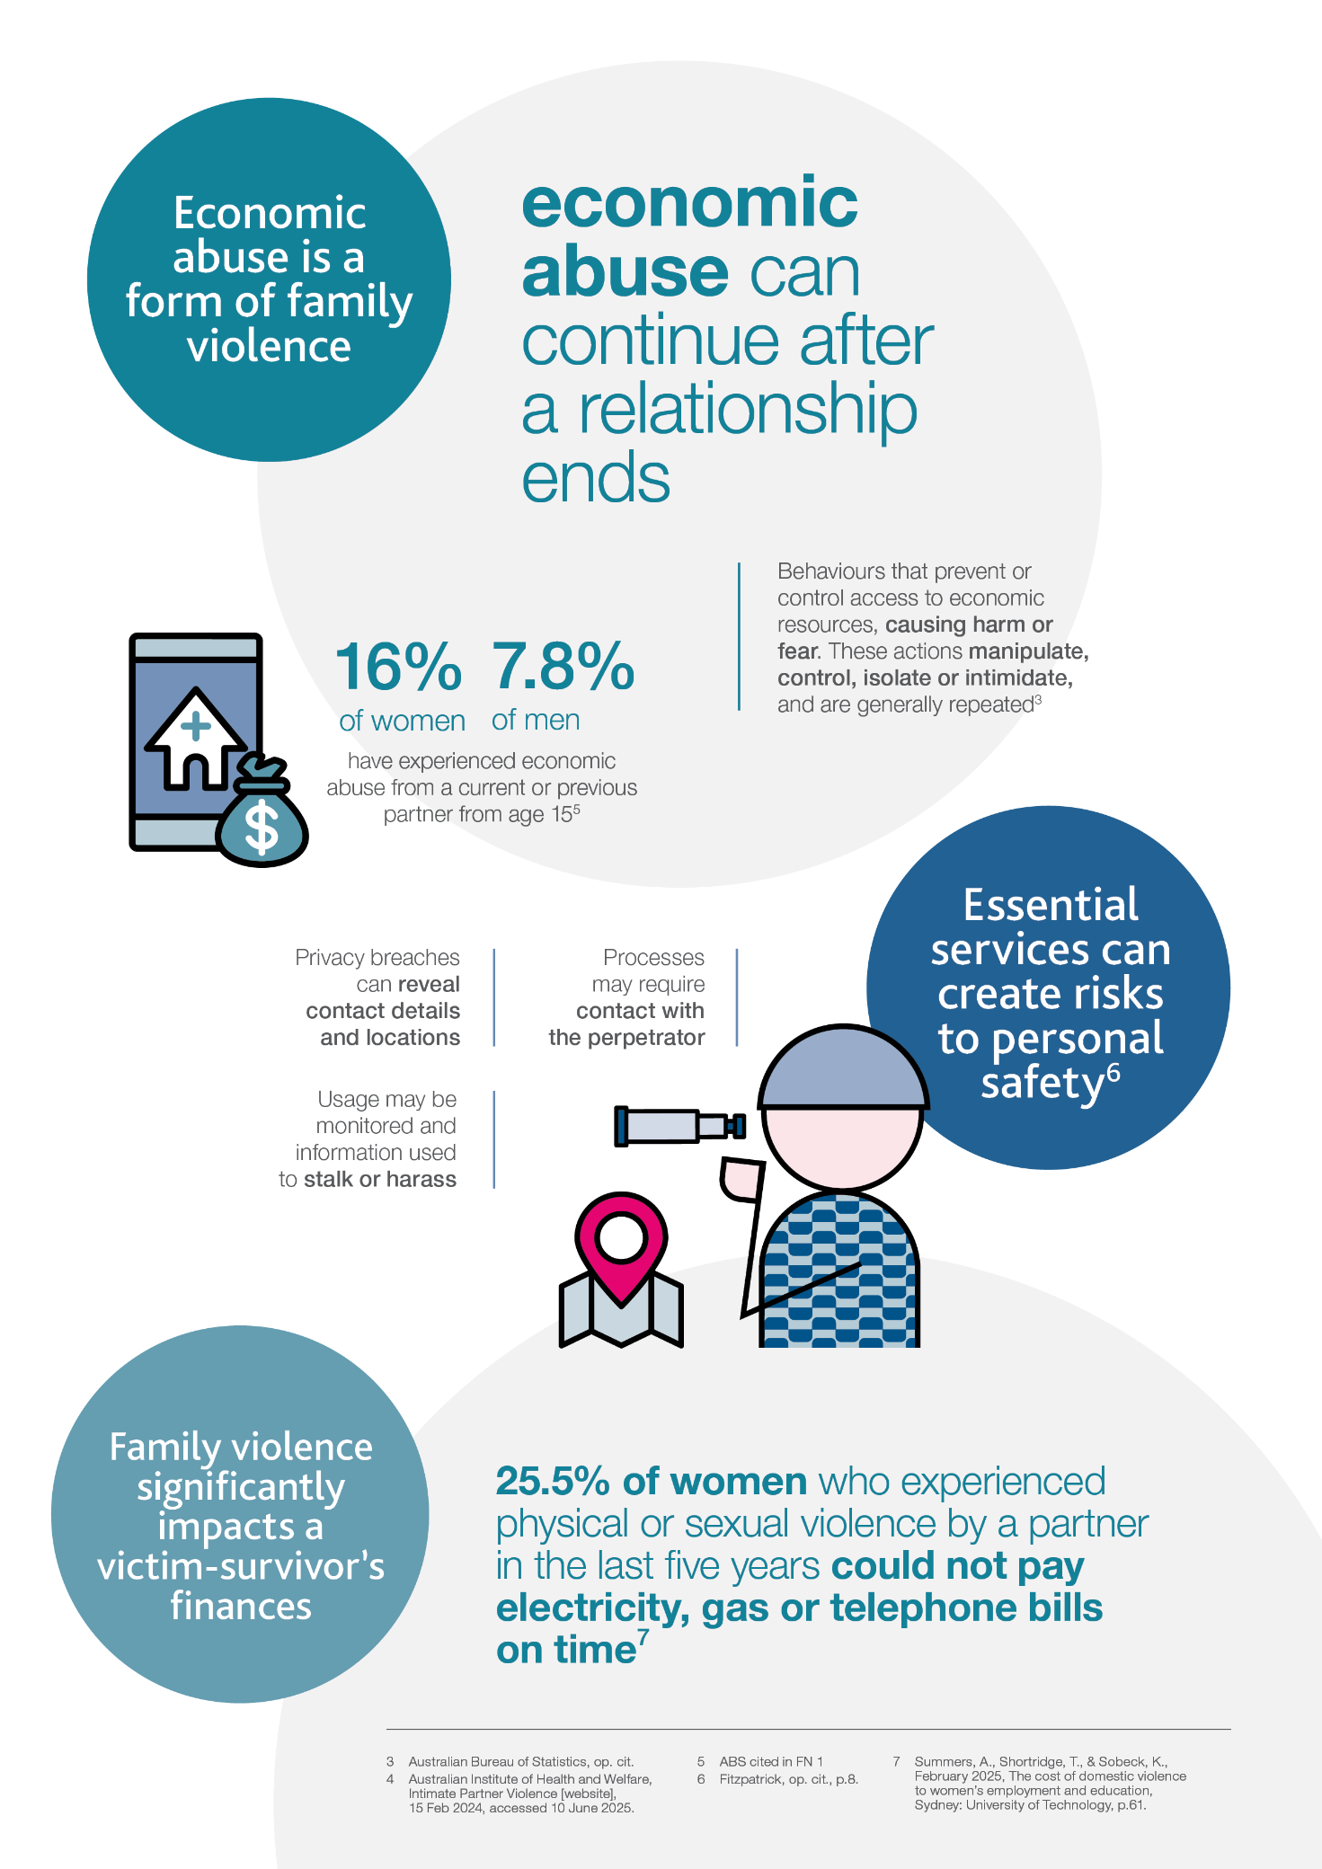

Better practice principles and actions
Five better practice principles provide a framework for essential services providers to improve their responses to family violence. The principles:
- Highlight the cultural and behaviour changes that support businesses to develop and build on safe, flexible and appropriate family violence responses.
- Should be considered together, there is no hierarchy to how they should be read or actioned.
- Are designed to support businesses at any stage of their family violence work.
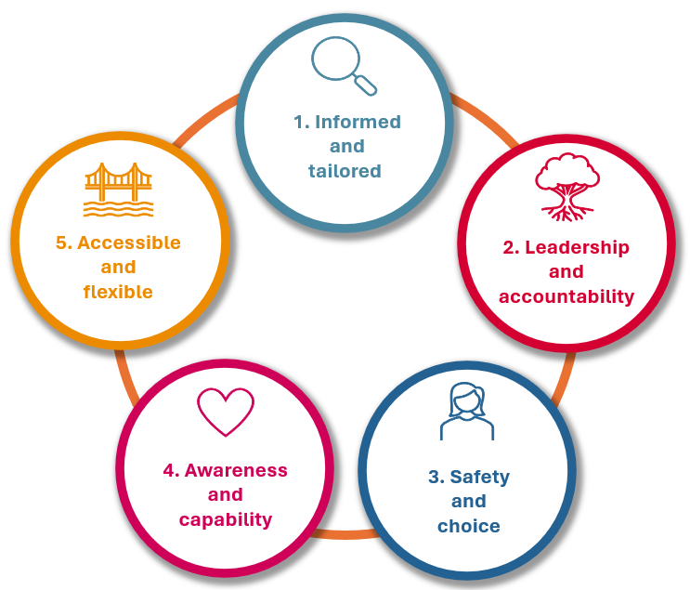
The practical actions under each principle can support businesses to build capability within their organisation.
Figure 1: Principles to support better practice responses to family violence


Principle 1: Informed and tailored

Businesses should ensure their family violence work is informed by experts and tailored to the needs of the organisation.
“That constant commitment to continuous improvement … I think we can only acknowledge and address the barriers when we’re hearing what the barriers are from those who are affected.”
– Survivor advocate
Seeking advice from specialist family violence organisations and trained family violence survivor advocates can help businesses understand the impact of their policies.
Advice from experts will:
- help identify areas of potential risk and improvement
- anticipate future behaviour of people using violence
- support businesses to find and tailor solutions that work.
Each business will need to tailor their approach to meet their unique needs, including size, customer base and geographic reach. We encourage businesses to share and collaborate on this work. Ongoing learning and sharing can support businesses to improve their individual responses as well as improving capability across the water and energy sectors.
 | Actions to support better practice
 | 1.1 Safely seek expert advice to inform the approach
 | 1.2 Tailor the approach to the organisation’s needs
 | 1.3 Learn from others and share experiences


Principle 2: Leadership and accountability

Business leaders have an important role to play in fostering a
whole-of-organisation commitment to responding to family violence and holding the organisation to account.
“I think what is absolutely necessary is that there is a whole-of-company, trauma-informed response and that is not just a one-off training session.”
– Victim-survivor
Strong, visible and ongoing leadership is the foundation of a good business response. Clear and consistent messaging and an ongoing focus on culture, knowledge and systems across the business builds organisational understanding of the issues and how the business can improve responses to customers and staff.
A whole-of-organisation view of family violence risks can:
- help prevent harm by identifying and closing gaps in systems
- support the design of an appropriate response to customers.
Policies for staff and customers are an important way for businesses to communicate the support that is available, how to access it, and how the business will respond to people using violence. They send a clear message about the importance of the issue to the business. Seeking expert advice when developing or reviewing policies can ensure they meet better practice standards and incorporate current knowledge about family violence harm.
Leadership and accountability work is ongoing. Establishing regular monitoring, reporting and evaluation can ensure businesses are prepared to improve and adapt as systems and technologies change.
 | Actions to support better practice
 | 2.1 Senior leaders set the tone
 | 2.2 Consider all relevant functions of the business
 | 2.3 Develop a safety by design approach to understand and mitigate risks
 | 2.4 Embed cultural and systems change
 | 2.5 Develop policies for staff as well as customers
 | 2.6 Consider appropriate responses to people using violence
 | 2.7 Develop ongoing monitoring, reporting and evaluation


Principle 3: Safety and choice

Businesses need to provide safe and flexible support options that prioritise customer choice. An empathetic response that promotes customer agency can make a positive difference to a customer’s experience.
“They [utilities providers] need to understand that it is a forever thing we have to deal with. We can be OK this year, but next year things might happen, and we’re triggered back to that same mind frame. That’s something that every single service provider needs to understand - it’s not a linear effect. It goes up and down, and it goes sideways.”
– Victim-survivor
Businesses should understand the ongoing and long-term impacts of family violence and consider how they best support customers at different stages of their experience of family violence.
Customers will feel more confident to reach out for help if they know they will be believed. A better practice response does not require evidence of family violence, and businesses should ensure they have processes that reduce the need for a customer to retell their story.
Support options should always be agreed with the customer. They should include options that address the financial impacts of family violence and options to protect customers’ private and confidential information. Careful consideration should be given for how to address these matters for customers with joint accounts. Customers will benefit when a business prioritises customer safety and provides flexible support options to meet their individual needs.
 | Actions to support better practice
 | 3.1 Understand the immediate and long-term impacts of family violence
 | 3.2 Show empathy to victim-survivors
 | 3.3 Support the agency of victim-survivors
 | 3.4 Avoid requiring evidence of family violence
 | 3.5 Avoid repeat disclosure
 | - Protect private and confidential information
 | 3.7 Respond to the financial impacts of family violence


Principle 4: Awareness and capability

A whole-of-organisation approach to family violence awareness, training and capability building can support early detection of family violence and support employees to respond safely and appropriately.
“You know, we’ve all got different various levels of domestic violence and these essential service customer services people at the end of the phone are not expected to be our counsellors, nor do we want them to be our counsellors. However, if essential service providers have some sort of training of some sort for them to identify … As soon as we just say we are a domestic violence lived experienced person on the phone ... as soon as the customer service individual hears that, then they already have a specific set, you know, guidelines from their employer that … this is the way we deal with this.”
– Victim-survivor
Business leaders need to build a culture of awareness to effectively support staff and customers affected by family violence. Selecting a training provider with expertise in family violence can ensure training is informed by current better practice knowledge.
A tailored training approach can support implementation of the business’s family violence policy. Training for leaders can help with effective policy development and implementation and improves support for staff. Specific training for customer-focused roles can support staff to respond appropriately to customers and can contribute to more consistent customer experiences.
Training should help staff understand their role and responsibilities, and when to refer customers for further support.
Both customers and staff benefit when staff are well-trained and supported to do this work:
- Customers can feel confident that the business understands family violence and will provide appropriate and flexible support.
- Staff will feel confident and clear about how they can help and know that their wellbeing is a priority for the business.
 | Actions to support better practice
 | 4.1 Educate, train and support employees
 | 4.2 Tailor training for customer-focused and senior roles
 | 4.3 Support staff to understand their role and limitations


Principle 5: Accessible and flexible

Energy and water businesses should recognise and address the factors which increase the likelihood of experiencing family violence and which can make accessing services more difficult.
“I wasn’t aware of the options that existed with my utility company. It was my social worker who let me know and facilitated that process. I don’t think I could have disclosed to somebody on the phone at the time.”
– Victim-survivor
To provide inclusive support, businesses should consider the diversity of customer needs and how they can best communicate with and support all customers. Accessible and flexible support means customers have options:
- how they reach out and communicate with the business
- the support that is available to them.
It is important that businesses can provide safe and appropriate referrals to customers to link them in with other support available in the community.
Businesses should understand the barriers to disclosure and engagement that customers face and take action to reduce these barriers. When customers understand that practical family violence informed support is available, they can feel more confident to reach out for help.
 | Actions to support better practice
 | 5.1 Understand the gendered nature of family violence
 | 5.2 Provide support that is inclusive for all Victorians
 | 5.3 Provider referrals to expert support services
 | 5.4 Promote the options available to customers
 | 5.5 Address barriers to disclosure and engagement

