Berrybank 2 Wind Farm
Technical Description

BERRYBANK 2
Wind Farm

Table of Contents
Contents
BERRYBANK 2 1
Table of Contents 2
1. Main Characteristics and Magnitudes of the Project 3
2. Preferred Wind Turbine Supplier 4
2.1. Vestas 4
2.2. Technical Aspects of the Preferred Wind Turbines 4
2.2.1. General Description 4
2.3. Platforms Track Record 8
2.3.1. Vestas 4 MW platform 8
2.4. Grid Connection 8
2.5. Wind Farm Control System 8
2.6. Business Case Certainty 9
2.7. Type Certificates 9
3. Balance of Plant 10
3.1. Civil Works 10
3.1.1. Accesses and Interior thoroughfares 10
3.1.2. Crane Pads & Hardstand Areas 11
3.1.3. Wind Turbines Foundations 11
3.2. Electrical Works 12
3.2.1. Acronyms and Symbol List 14
3.2.2. Wind Farm Reticulation System 14
3.2.3. MV Cables 14
3.2.4. Fiber-Optic Cables 15
3.2.5. Earthing System 15
3.2.6. Cable Trenches 15
3.3. Substation Substructures 16
3.3.1. Wind Farm Control and Switchgear Building (WFCSB) 16
3.3.2. MV Switchgear 17
3.3.2.1. General Design Criteria 17
3.3.2.2. MV Switchgear Technical Data 17
3.3.2.3. Step-up transformer MV Busbar 18
3.3.2.4. Grounding transformer 18
3.3.2.5. MV Capacitor Banks 18
3.3.2.6. Unit Auxiliary Transformer 19
3.3.2.7. LV Switchboards 19
3.3.2.8. 110 VDC System 19
3.3.2.9. 48 VDC System 20
3.3.2.10. Emergency Gen-set 20
3.3.2.11. Protection, Control and Metering Panels 20
3.3.2.12. Simplified Schematic 21
4. Annexes 21

Main Characteristics and Magnitudes of the Project
The land upon which the Victoria Berrybank 2 Wind Farm is constructed is located 130km west of Melbourne, 12km north of lake Corangamite, and lies near Berrybank and Werneth localities (Australia). Berrybank locality is located on the Hamilton Highway.
Distances to Berrybank 2 Wind Farm are the following:
  - 48 km to the north-east is located Ballarat
  - 130 km to the east is located Melbourne
  - 76 km to the east is located Geelong and Bahia Port Phillip
  - 103 km to the south west is located Warnnambool
The site pertains entirely within the Corangamite Shire Council and Golden Plains Shire Council.
The area is generally very flat. The development site covers multiple agricultural land parcels and covers an approximate area of 5034 ha.

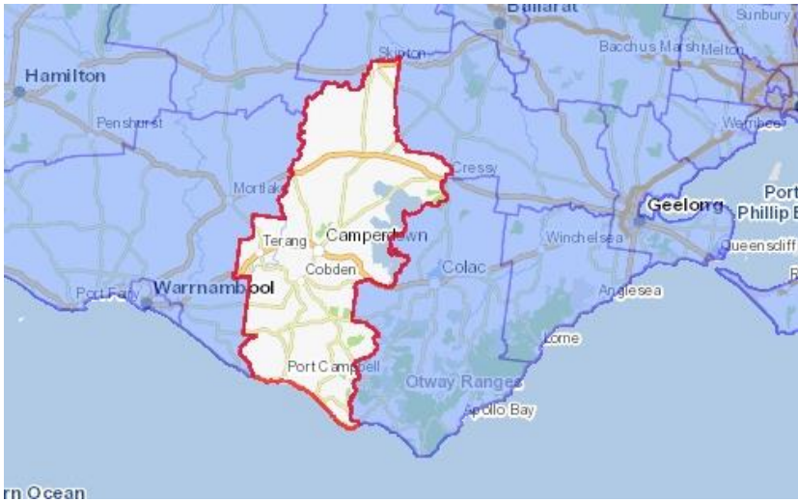
Image 1: Berrybank 2 location
Once built, the project will comprise of a number of main elements as described below:
  - 26 wind turbines with a total tip height up to 180 m, a maximum rotor diameter of up to 136 m and unit power rating of up to 4.2 MW;
  - 26 gravity-type foundations, each one made of steel-reinforced concrete, with an approximate volume of 473 m3 and 43 Tonnes of steel per foundation;
  - Internal unsealed tracks for turbine access (20 km in total);
  - 26 hardstand areas of 945 m2 each and 26 lay-down area of 975 m2 each, adjacent to every WTG location to store the different WTGs components prior to assembly and erection (tower sections, nacelle, hub and blades), to allow for crane operations during WTGs assembly and erection, to operate and maintain the wind turbines during the wind farm lifespan and to allow for their final decommissioning.
  - Upgrades to local road infrastructure (roads intersection upgrade, etc.);
  - An underground electrical and communication cable network linking turbines to each other and to the proposed substation. The electrical reticulation network will be composed of 60 km of 33 kV underground power cables;
  - An electrical 33/220 kV substation connecting the wind farm to the high voltage transmission grid (cut-in of the existing Terang-Ballarat 220 kV transmission line);
  - A temporary concrete batching plant to supply concrete for the foundations of the turbines and other associated structures.
  - Obstacle lighting to selected turbines;
  - A wind farm substation control room and facilities building.
After an extensive on-site wind monitoring campaign lasting more than 6 years with four monitoring masts installed across the site (1x40 m, 1x60 m, 1x80 m and 1x60 m), GPGA firmly believes that the wind resource is extremely well characterized for this site. Following a number of thorough analyses of the collected set of wind data, an average net production from this site, using the most efficient technology available from Vestas has been estimated at 390 GWh/year .

Preferred Wind Turbine Supplier
Berrybank 2 Wind Farm (the Project) will involve the construction, commissioning, operation, and decommissioning of 26 wind turbines and associated infrastructure, with a total generation capacity of up to 109.2 MW¹.
In order to select the preferred turbine for the Project, the Proponent and its related entities within the Naturgy Group carried out a rigorous tender process, involving several Tier-1 wind turbine suppliers. As a result of this tender process, the Proponent has appointed Vestas as its Preferred Bidder.

Vestas
Vestas is a leading company within the wind energy industry, exclusively dedicated to this sector. Vestas brings 35 years of experience producing wind turbines and a cumulative installed wind power globally (74 countries) in excess of 69,000 MW with more than 49,000 MW currently in service.
Vestas has its own wind turbine design and development capacity, and is vertically integrated. The company covers the entire process of design, manufacturing, assembly, logistics, installation, commissioning and maintenance of wind generators. The company has manufacturing capacity in the major wind power markets (Europe, the United States, China, India and Brazil).

Technical Aspects of the Preferred Wind Turbines

General Description
The V136-4.2 MW Vestas wind turbines forms part of the latest evolution of the Vestas 4 MW platform that was introduced in 2010. Over 14 GW of the 4 MW platform has been installed all over the world onshore and offshore making it one of the most flexible and trustworthy turbine platforms on the market.
Increasing the generator rating of the V136 from 3.6MW to 4.2MW enables Vestas and GPG to maximize production of the Berrybank 2 Wind Farm while staying within the permit restrictions.

¹ This generation capacity is the equivalent capacity at the HV transmission grid connection point, once maximum load electrical losses (WTGs power transformers, MV reticulation network and substation power transformer) have been considered.

With the expected heavy competition in mind, this optimization lowers the Cost of Energy and improves GPG’s competitiveness in the VRET auction process.
The V136-4.2 MW wind turbine is an upwind three-blade rotor, with a rotor diameter of 136 meters. The generator is rated at 4.2 MW, and placed on top of a 112-meter steel tower. The wind turbines are regulated by an independent pitch control system in each blade and have an active yaw system. The control system allows the wind turbine to be operated at variable speed, maximizing the power produced at all times and minimizing the loads and noise.
Refer to Table 2.2.1 and Figure 2.2.1 for general specifications and for main components of the turbines nacelles respectively.

 |  | V136‐4,2 MW | 3.4M122
GENERAL  DATA | Control | Variable Pitch and Speed | Variable Pitch and Speed
 | Noise Control | VMP Controller/blades with serrated trailing edges | Low‐noise trailing edges
 | Temperature Range | ‐20C to +45C | ‐20C to +35C
 | Environmental Options | Versions available for high‐ altitude sites (up to 2,000m asl), dusty and high‐corrosion environments | Versions available for high‐ altitude sites (up to 2,000m asl), dusty and high‐corrosion environments
BLADES | Material | Fibreglass reinforced epoxy, carbon fibres and solid metal  tip | Glass‐fibre reinforced plastic
GEARBOX | Type | 2 planetary stages + 1 helical stage | Three‐stage planetary/spur  gear system
GENERATOR | Type | Asynchronous induction generator with cage rotor | Asynchronous double‐fed  generator
 | Voltage | 750 V AC | 950 V AC
 | Frequency | 50 Hz / 60 Hz | 50 Hz / 60 Hz
 | Protection Class | IP54 | IP54
 | Power Factor | 0,90 CAP ‐ 0.88 IND at full load | 0.95 CAP – 0.95 IND throughout the power range
Table 2.2.1 - General Specification for WTGs models under consideration

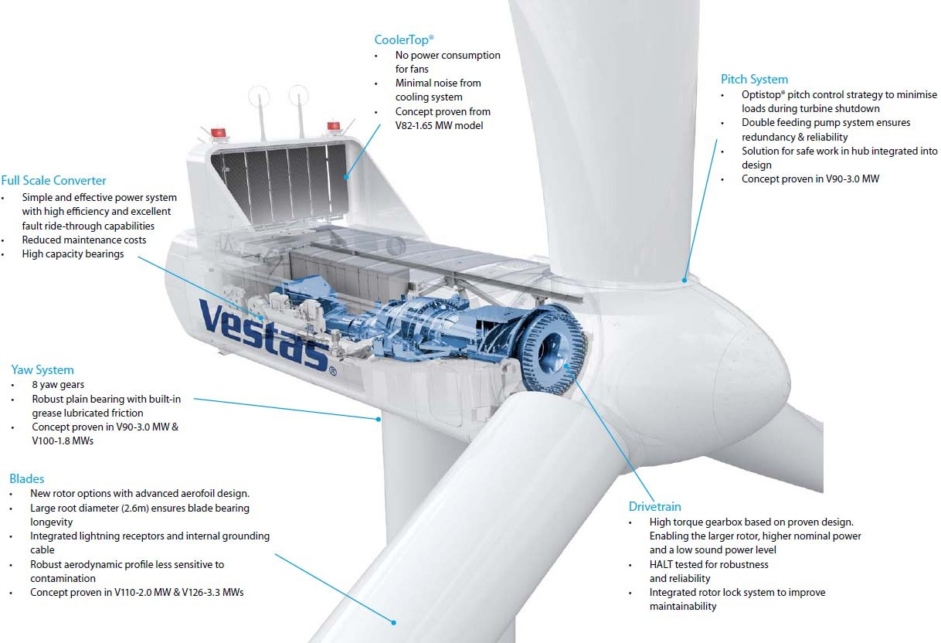
Figure 2.2.1 - Main Components of the Turbine Nacelles

The energy input from the wind to the turbine is adjusted by pitching the blades according to the control strategy. The pitch system also works as the primary brake system by pitching the blades out of the wind. This causes the rotor to idle. Double-row four-point contact ball bearings are used to connect the blades to the hub. The pitch system relies on hydraulics and uses a cylinder to pitch each blade. Hydraulic power is supplied to the cylinder from the hydraulic power unit in the nacelle through the main gearbox and the main shaft via a rotating transfer. Hydraulic accumulators inside the rotor hub ensure sufficient power to pitch the turbine in case of failure.
The hub supports the three blades and transfers the reaction forces to the main bearing and the torque to the gearbox. The hub structure also supports the blade bearings and pitch cylinder.
The main gearbox transmits rotational torque from the rotor to the generator. The main gearbox consists of planetary stages combined with helical stages (number of stages depending on particular manufacturing design), torque arms, and vibration dampers. Torque is transmitted from the high-speed shaft to the generator via a flexible composite coupling, located behind the disc brake. The disc brake is installed directly on the high-speed shaft.
The yaw system is designed to keep the turbine rotor upwind of the tower. The nacelle is installed on the yaw plate, which is bolted to the turbine tower. The yaw bearing system is a plain bearing system with built-in friction. Asynchronous yaw motors with brakes enable the nacelle to rotate on top of the tower.
The turbine controller receives information about the wind direction from the wind sensor located on the top and rear of the nacelle.

Tubular towers with flange connections, certified according to relevant type approvals, are available in different standard heights. Magnets provide load support in horizontal direction and internals, such as platforms and ladders, are supported vertically (in gravitational direction) by mechanical connections.
The nacelle cover is made of fiberglass. Hatches are positioned in the floor for lowering or hoisting equipment to the nacelle and evacuation of personnel. The roof is equipped with wind sensors and skylights that can be opened from inside the nacelle to access the roof and from outside to access the nacelle. The nacelle cover is installed on the girder structure. Access from the tower to the nacelle is made through the yaw system. The nacelle bedplate is in two parts and consists of a cast-iron front part and a girder structure rear part. The front of the nacelle bedplate is the foundation for the drive train and transmits forces from the rotor to the tower through the yaw system. The bottom surface is machined and connected to the yaw bearing and the yaw gears are bolted to the front nacelle bedplate. The nacelle bedplate carries the crane girders through vertical beams positioned along the site of the nacelle. Lower beams of the girder structure are connected at the rear end. The rear part of the bedplate serves as foundation for controller panels, the generator, and transformer.
The cooling of the main components (gearbox, hydraulic power pack and VCS converter) in the turbine nacelle is maintained by a water-cooling system. The generator is air cooled by nacelle air and the medium-voltage (MV) transformer is equipped with forced-air cooling.
The generator is an asynchronous double-fed unit with 4 poles, coil rotor and slip rings. It is highly efficient and is cooled by an air-air exchanger. The control system permits operation at variable speeds using the rotor intensity frequency control.
The characteristics and functions introduced by this generator are:
- Synchronous behaviour toward the grid.
- Optimal operation at any wind speed, maximizing production and minimizing loads and noise, thanks to variable speed operation.
- Control of active and reactive power via control of amplitude and rotor current phase.
- Smooth connection and disconnection from the electrical grid.
The generator is protected against short-circuits and overloads. The temperature is monitored continuously via probes at points on the stator, bearings and the slip ring box.
The high-voltage cable runs from the transformer in the nacelle down the tower to the switchgear located in the bottom of the tower. This cable is four-core, rubber-insulated and halogen-free.
The transformer is located in a separate locked room in the back of the nacelle. The transformer is a three-phase, two-winding, dry-type transformer that is self-extinguishing.
The products development strategy from the manufacturer is to continually optimise their technology in order to deliver increased value to their customers and a lower Cost of Energy. This focus on optimising previous turbine platforms technologies has resulted in the current release of the V136-4.2 MW models, which are considered optimum for the available wind resource at the Berrybank 2 site, and has led the Proponent to increase its main figures regarding generation and net equivalent hours for the Project.

Platforms Track Record

Vestas 4 MW platform
The Vestas 4 MW platform is well proven within the Vestas fleet of wind turbine technologies. Refer to Table 2.3.1 for more details on the worldwide track record from Vestas.

Australia and Worldwide experience
Installed power globally (GW) | +145
Number of countries with presence | 75
Installed power in for the offered platform (MW) | 13000
Number of wind farms in Australia | 27
Numbrer of WTGs installed in Australia for the offered platform | 152
Total installed power or under construction in Australia (MW) | 2507
Number of WTGs installed or under construction in Australia | 1552
Table 2.3.1 - Track Record of Vestas wind turbine technologies

Grid Connection
Vestas turbine platforms have been operating on several wind farms in Australia for more than a decade and have demonstrated grid compliance across a wide range of networks globally, proving to be very resilient generation systems.
In addition, Vestas has carried out rigorous assessments of their turbine models against the Australian Grid Code and they are very confident in the grid performance of the previously described platforms with their robust and reliable response to the strict National Electricity Rules criteria.

Wind Farm Control System
Wind turbines of the preferred platforms will be typically controlled by a Power Plant Controller (PPC) system.
The PPC controls the output and behaviour of a wind power plant measured at the Point of Connection to the electricity grid, by controlling wind turbines and third-party compensation equipment. The PPC output commands are generated by site-specific control algorithms based on local grid code requirements, grid measurements, and plant reference set points from the operator or from utility companies.

The main PPC features can be classified into six main categories:
- Control and Supervision Features: the PPC provides control and supervision features for supporting wind power plant solutions for grid compliance, including grid supervision, voltage and frequency control, fast run back, active and reactive power control, power factor control, low-voltage ride through coordination, feeder power limiter, line droop compensation, etc. The PPC is capable of controlling wind turbines by communicating directly with each of them.
- Project-Specific Control: including set-point, ramping, switching between control modes, time-scheduled control, etc.
- Data Logging: the PPC includes the logging of wind turbine data and control loop data. The logged data contains information on current turbine production, actual set points and status of control specific variables. This data is typically logged at 1-second intervals, stored for 30 days and can be retrieved for performance evaluation. The PPC also provides transient fault recording through the grid measurement system for post- fault analysis.
- Grid Measurements: the PPC provides grid measurement features for measuring voltage, frequency, active and reactive power and power factor levels. The grid measurement system has on-board, continuous logging of all parameters including rms, harmonics, waveforms, flicker and frequency for extended periods of time.
- Scalability: a PPC consists of a cabinet containing communication equipment, control equipment, power supplies, data logger and grid measurement equipment. The
configuration is scalable if the wind farm had future stages or it interfaced with more than one main transformer, etc.
- External Communication Interfaces: the control system provides the ability to exchange control signals (such as set points, run back signal, etc.) between the wind power plant and external sources.
The PPC system and the SCADA will allow the Proponent to connect the Berrybank 2 Wind Farm to the proposed Renewable Energy Centre at Canberra, providing total remote control over the installation.

Business Case Certainty
Already having proven several design evolutions as well as delivering high availability levels, Vestas wind turbine models proposed for Berrybank 2 Wind Farm take the reduction of cost and business risk to a new level. This also allowed the Proponent to provide a competitive Proposal to participate in the 5th and last ACT Renewable Energy Auction.
The high level of availability of the platform allows the Project to forecast confidently and strengthens the business case for investment, whilst their design and performance ensure energy production from low to medium-wind onshore sites at the lowest cost. The reliable design of these turbines minimises downtime – helping to give the best possible return on investment.
In consideration of the maturity and the established track record of the Vestas 4.2 MW turbine platforms across the world, and the existing operating wind turbine infrastructure of the manufacturer, it is acknowledged and accepted they will all be a very good fit for the Berrybank 2 Wind Farm and low-risk for the investment.

Type Certificates
All of these turbine platforms will be required to hold Type Certifications in accordance with IEC 61400 standard.
The provisional type certificate for the V136 4.2 will be available prior to turbine committed ex- works date.
The final IEC Type Certificate will be available prior to end of reliability testing and commissioning of the first- turbine.

Balance of Plant

Civil Works
The civil engineering work contemplated in this project is composed of the following infrastructure elements:
- Accesses and interior thoroughfares
- Wind turbine foundations and assembly hardstand areas
- Trenches for cables (included in electrical project)

Accesses and Interior thoroughfares
The interior thoroughfares are expected to cover a total length of some 20 km. These roads are distinguished between accesses to wind turbines with existing roads to repair (unsealed) and new roads (5m width); and roads of emergency break barriers (3.5 m width).

Design criteria:
      - The layout maintains all the existing roads in the area that are still useable, but it’s necessary to make some improvements or modifications to them.
      - New roads are opened up for execution and service of the wind farm, only when the pre- existing ones cannot be used, with the criteria being opening up the minimum possible number of kilometres of roadways and consequently reducing environmental and landscape impact.
      - The density of the network is the indispensable minimum.

Maximum gradient is 12%, minimum gradient of 0.5% in order to allow drainage and maximum gradient into reverse driving is 3%.
The Road longitudinal radii (convex or concave) is minimum 600 (six hundred) metres in all cases.
In sharp curves, the width of the surface has been increased in accordance with the criteria established for transport access, as following:
      - Width of straight road: 5 mtrs
      - Width of Curves/Bends : 6.0 mtrs

In sharp curves radii is minimum 54 metres; in this case criteria about free over sweeping areas and width roads are following:

The geo-technical and constructions characteristics of the interior roads are as follows: 5m wide, with a section composed of 0.20 m of roadbase material, compacted to 98% of modificated Proctor; 2:1 banks.
The general fill/formation material varies in thickness between 0.15m and 0.5m (maximum 1m) and serves to raise the pavement above potentially poor subgrade conditions and water-soaked ground.
Measures have been incorporated in the design, including the provision of drainage, pavement cross fall, elevated formation and appropriate grading requirements for the granular pavement, to encourage water runoff and reduce the potential for water to infiltrate and soften the pavement subgrade and general fill/formation material.
Anyway, for weak subgrade in subsurface soils, for CBR < 3%, it is proposed the use of geogrid and geotextile as capping over poor subgrade conditions and weak foundation soils.

Crane Pads & Hardstand Areas
Dimensions are approximately 42m length in road direction and 22.5m width for hardstand area. 65 m length and 15m width for lay-down area. The hardstand area’s maximum lateral gradient is very limited. Crane pads section is the same as roads section. It is only a matter of compacting and levelling lay – down areas without additional treatments (the same properties are not required as on the assembly platforms).
In the image below appears the expected Crane Pad & Hardstand Area, including its relative position with Wind Turbine Foundation.

Wind Turbines Foundations
The wind turbines’ foundations have been designed to support the forces derived from the action of the wind and the operation of the turbines themselves. Furthermore, they have been adapted to the geo-technical characteristics of the land upon which they are to be located.
Dimensions could have any changes during detailed construction engineering.
The basic foundation design consists of a 20.60m diameter circular base with a variable depth, central pedestal and anchor cage. The depth is 0.50m at the exterior and 2.40m near pedestal. The pedestal has a 6.0m diameter and his upper surface is 0.25 meters above the ground level. The base of foundation (including 0.10 of blinding concrete) is 2.80m below the ground level.

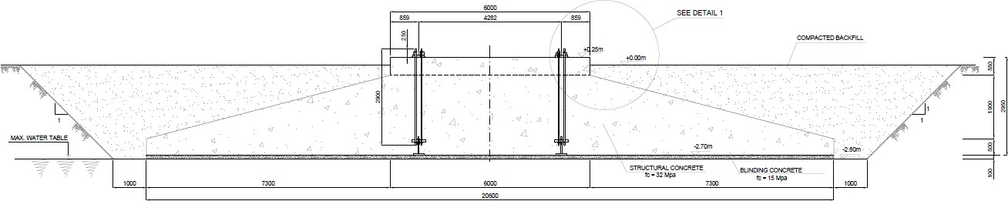

The foundation has been designed without considering the effect of the groundwater, thus the water table level must be under the bottom surface of the foundation.
Both the base and the pedestal are to be made from f’c=32 Mpa reinforced concrete. Reinforcing steel is D500N (fy=500MPa).
Foundations are always to be built on excavated lands. Under no circumstances may they be totally or partially supported on landfills.

Electrical Works
The Berrybank 2 Wind Power Plant is formed by 26 wind turbine generators. Each wind turbine is rated up to 4,2 MW. The Balance of Plant consists basically of an underground reticulation system designed to collect power from the wind turbine generators and bring power back to a centrally located substation.
Wind Farm BOP comprises the following components and systems:
- Wind turbines grounding system.

- Wind farm reticulation system:
  - MV cables.
  - FO cables.
  - Grounding cables.
  - Cable trenches.
- Substation substructures, (mainly MV and LV systems):
  - Wind farm control and switchgear building and auxiliaries.
  - Collector substation MV switchgears.
  - Grounding transformers.
  - MV capacitor banks.
  - Substation auxiliary systems:
    - Auxiliary transformer.
    - LV Panels.
    - DC system.
    - Emergency gen-set.
    - MV Protection, control and metering panels.

On the other hand, Wind Farm BOP limits are defined by the following components and systems:
- Wind turbine drivetrain substructures, essentially wind turbine generators, converters, step-up transformers and wind turbine MV Switchgears. These components belong to the Wind Turbine package. MV Switchgear cable bushings establish one of the limits of the MV cables reticulation system.
- Meteorological towers.
- Collector Substation: Switchyard, step-up transformers, control, protection and communication systems. These systems belong to the Substation and Interconnection to the HV transmission network packages. Basically the boundaries with the WPP BOP are defined as the following ones:
  - Connection points at the substation earthing system.
  - MV bushings at the SUT (MV busbars when applicable).
  - Control, protection, metering and communication connections in substation panels, according to the protection, metering, control and communication topologies defined and agreed by the GMO.

Acronyms and Symbol List
BOP: Balance of Plant.
WPP: Wind Power Plant
WTG: Wind Turbine Generator.
OEM: Original Equipment Manufacturer. GMO: Grid Manager and Operator.
HV: High Voltage.
MV: Medium Voltage.
LV: Low Voltage.
DC: Direct Current.
FO: Fiber Optic.
SWG: Switchgear.
SUT: Step-Up Transformer.
WFCSB: Wind Farm Control and Switchgear Building. SAS: Substation Automation System.
SCADA: Supervisory Control and Data Acquisition System. RTU: Remote Terminal Unit.
VT: Voltage Transformer.
CT: Current Transformer.

Wind Farm Reticulation System
Wind farm reticulation system consists of a group of 33 kV circuits, which connects the wind farm turbines to the collector substation by means of underground 33 kV MV cables. Wind farm reticulation system is formed by sixteen 33 kV circuits divided in three MV Busbars.
MV cables, FO communication cables and grounding cables will be installed directly buried in trenches.

MV Cables
The power circuits for the interconnection between the different transformers of the wind turbines and the Collector Substation will be made of aluminium conductor 33 kV MV cables. Cable construction will follow the applicable standards. In general terms, MV cables shall be:
      - Stranded compacted aluminum conductor.
      - Semi-conductive conductor screen.
      - XLPE insulation.
      - Semi-conductive insulation screen.
      - Heavy-duty copper wire screen.
      - Low smoke zero halogen sheath.
      - Cables formation:
      - Single-core cables.
      - Three-core cables.
      - Single-core cables in triplex formation.
      - Rated voltage: 33 kV.

Cables shall be selected according with the type of installation, the circuit current carrying capacity, the short-circuit contributions, the system power losses and system voltage drops considerations. Cables shall be suitable for the operating environmental conditions. Where applicable, cables shall comply the following requirements:
      - Termites resistant.
      - Rodent resistant.
      - Water blocking protection.
      - Chemical attack resistant.
      - UV resistant.
      - Mechanical damage considerations.
      - Fire protection considerations.

Fiber-Optic Cables
Wind turbines, meteo station towers and collector substation are networked for communication in a Fiber-Optic topology defined by the WTG OEM.
The FO cables must be provided with at least eight fibers. The fibers, single-mode or multi- mode type, depends on the length of the circuit (according to the wind farm layout) and on the OEM considerations.

Earthing System
The wind farm earthing system consists of the wind turbines ground electrodes, the “reticulation” grounding cables and the ground electrode corresponding to the Wind Farm Control and Switchgear Building (WFCSB).
Wind turbine ground electrodes shall be designed considering the soil conductivity and following the WTG OEM specifications. The electrode is placed in the wind turbines foundation excavations, and it is made of bare copper wires. Conductor cross-section shall comply with OEM specification, in any case, minimum conductor cross-sectional area shall be 50 mm2. A previous design is shown at reference drawing “Earthing System for Wind Turbine”.
All the wind turbine ground electrodes are connected through the “reticulation” grounding cables to the Collector Substation. These cables are made of bare copper wires installed in cable trenches. Minimum conductor cross-sectional area shall be at least 50 mm2.

Cable Trenches
MV cables, FO cables and grounding cables from wind turbines to the Collector Substation are installed directly buried in trenches. Cable trenches will be designed and carried out in accordance with the corresponding electricity regulations. WPP cable reticulation system considers different types of trenches installation:

      - Conventional cable trenches (carried out by excavators). More than one cable circuit is installed in the trench. This solution

shall be taken into account when several circuits have to be installed in parallel (for example, the final path to the collector substation).
      - Cable trenches carried out by trencher machines. One cable circuit is installed in the trench. When different circuits are defined in parallel, different cable trenches shall be placed in parallel. Distance between trenches is about 2 m.
      - Cable trenches for road crossings. This solution is similar to the “conventional cable trenches” one but in this case, cables are installed inside PE or PVC conduits encased in concrete. One spare conduit shall be provided per each cable system (one related to the MV circuits and one related to the FO cables).

When applicable, cable trenches designed for major road crossings (highway) or railroad crossings will be considered.
More information about cable trenches is shown in the reference drawing “Typical Cable Trenches. Sections and details”.

Substation Substructures

Wind Farm Control and Switchgear Building (WFCSB)
In general terms, the Wind Farm Control and Switchgear Building has been defined as a prefabricated electric building. WFCSB shall be made of metal enclosure, prefabricated, modular, transportable building. WFCSB shall be factory assembled, fully equipped, pre-wired and factory tested.
WFCSB shall be designed and constructed for outdoor use under wind, seismic and other environmental conditions of the site. WFCSB, including associated services, shall satisfy local authorities and comply with all relevant Acts, Regulations, Ordinances and Codes.
WFCSB shall be segregated in different rooms: At least, Control room, DC room and Switchgear room.
WFCSB shall be provided with the following ancillary systems:
- HVAC Systems.
- Fire protection system.
- Security Systems.
- Voice and data networks.
- Indoor, Outdoor, and Emergency lights.
- Switches and Receptacles.
- Grounding and equipotential earthing system.
- Lightning protection system.

WFCSB shall contain the following electrical and control equipment:
- MV Switchgears.
- DC system.
- LV switchboards.
- Measuring system and revenue metering panels.
- WPP and Substation protection and control panels.
- Substation and OEM´s SCADA panels.
wCommunication panels and fibre optic marshalling.

MV Switchgear
The MV Switchgear collects all the WTG circuits, the incoming circuits to the substation step- up transformers and the outgoing feeders to the capacitor banks and the auxiliary transformer (when necessary).
MV Switchgear is divided in several busbars according to optimised layout. The MV switchgear shall be placed indoors, inside the switchgear room at the WFCSB.

General Design Criteria
The MV Switchgear shall be a factory-assembled, type-tested, metal-enclosed, gas-insulated switchgear (SF6) for indoor installation.
The MV switchgear shall be designed with partition class PM (metallic partition), loss of service continuity type LSC 2, internal arc classification IAC A FLR 31,5 kA - 1s, manufactured and tested according to the requirements in Standard IEC 62271-200. Provided with mechanical interlocks to prevent mal-operation.
MV panels are divided in four independent MV compartments. A great degree of partitioning shall be achieved in order to avoid damage spreading in case of an eventual failure. In general terms, partitioning could be defined as following:
        - Low Voltage compartment: Is separated from the MV area and is located at the top part of the switchgear. It shall be provided with protection relays, programmable multi-transducers and the rest of the LV auxiliary protection and control elements.
        - Busbars compartment: Busbar module could be SF6 gas insulated type or solid insulated type. It should be located in the top rear part of the switchgear.
        - Circuit Breaker compartment: SF6 insulated tank containing the circuit breaker and the disconnector switch. It is located in the central part of the switchgear
        - MV Cables connection compartment: It is placed in the lower part of the switchgear, accessible from the front area. Provided with capacitive voltage detecting system.

Protection and control architecture (instrument transformers, protection relays, etc.) shall comply the metering and protection specifications of the GMO. A preliminary architecture is shown in the single line diagram “General Single Line Diagram”.

MV Switchgear Technical Data
        - System Voltage: 33 kV.
        - Rated Frequency: 50 Hz.
        - Rated Voltage: 36 kV.
        - Rated short-duration power-frequency withstand voltage: 70 kV.
        - Rated lightning impulse withstand voltage: 170 kV (peak).
        - Rated normal current busbar system: 2500 A.
        - Rated normal current incoming feeder: 2500 A.

        - Rated normal current outgoing feeders: 630 A.
        - Rated short-time withstand current, 3 s: 31,5 kA.
        - Rated short-circuit breaking current: 31,5 kA.
        - Rated short-circuit making current: 80 kA (peak).
        - Degree of protection: IP65 (Primary part), IP3X (Secondary part).

Step-up transformer MV Busbar
MV cables from the MV Switchgear incoming cubicle shall be connected to the SUT through a MV busbar system. MV cables from the grounding transformer shall be also connected in the busbar system. Busbars shall be sized according with the step-up transformer nominal power and shall withstand the most adverse short-circuit conditions. Busbar system shall be provided with copper bars, 36 kV surge arresters, 36 kV outdoor insulators, expansion connectors, galvanized steel structures, cable supports, anchors and all the necessary ancillary materials.

Grounding transformer
MV neutral point shall be created by means of a zigzag winding earthing transformer. Two types could be considered: Oil-filled hermetically sealed transformer or oil-filled transformer with radiators and expansion tank. Earthing transformer shall fulfil the following requirements:
        - System Voltage: 33 kV.
        - Rated Frequency: 60 Hz.
        - Rated Voltage: 36 kV - 70 / 170 kV BIL.
        - Neutral current: 500 A – 30 sec.
        - Current transformers provided in the phase terminals and in the neutral terminal for protection purpose.
        - Outdoor installation.

MV Capacitor Banks
To improve the wind farm Power Factor, capacitor banks shall be installed in the 33 kV system. In a preliminary design, two fixed capacitor banks, rated 4 MVAr each one, shall be provided at each busbar. Capacitor banks shall fulfil the following requirements:
        - System Voltage: 33 kV.
        - Rated Frequency: 60 Hz.
        - Rated Voltage: 36 kV - 70 / 170 kV BIL.
        - Rated Power per capacitor bank: 4 MVAr (preliminary estimation).
        - Outdoor installation.
        - Capacitors arrangement: The capacitor units are connected in double star arrangement. Depending on the rated voltage and power of the capacitor units, they will be fitted with internal fuses.
        - Capacitor banks shall include the following components:
          - Enclosure for outdoor installation.
          - Three single-phase inrush current limiting reactors.
          - One unbalance current transformer.
          - Unbalance current relays (two relays must be used for banks using capacitors with internal fuses, one relay

only for banks using capacitor units without internal fuses).
          - Two quick discharge coils.
        - Power factor controller relay, installed in a local panel inside the switchgear room at WFCSB.

Unit Auxiliary Transformer
3 Phase MV/LV distribution transformer oil-filled with oil conservator or hermetically sealed type. Outdoor installation, near to the WFCSB.
The MVA rating of the auxiliary transformer shall be defined to exceed the sum of the maximum calculated simultaneous load of the whole system plus a 10% margin, with temperature rise not exceeding limits given according with the standards and considering the worst environmental conditions.
The auxiliary transformer shall fulfil the following characteristics:
- Installation: Outdoor.
- Rated power: To be defined.
- Rated voltage: 36 kV.
- Voltage ratio: 33000 / 415 V.
- Vector group: Dyn11.
- Rated frequency: 60 Hz.
- Type of cooling: ONAN.

LV Switchboards
All the LV switchboards necessary for the WPP auxiliary systems ((including distribution supplies to Collector Substation when applicable) shall be considered. The switchboard assemblies shall be modular, segregated in compartments according at least to form 2b, suitable for indoor installation, designed manufactured and tested to meet the requirements of IEC 61439. The cabinets shall be at least IP31 protected.
All the circuits shall be protected by the means of thermal magnetic circuit breakers. Open air circuit breakers, moulded case circuit breakers, miniature circuit breakers, residual current devices, etc. shall be considered according with the circuit characteristics.
Main incoming feeder shall be provided with a programmable multi-metering transducer and the necessary CT’s and VT’s. At least the following measurements shall be provided: V, A, W, VAr, kWh (3ph, 4wires) and kVAr (3ph, 4wires).

110 VDC System
Two 100% redundant DC systems shall be supplied installed inside WFCSB. Each DC system shall be designed to fulfil the emergency needs of the complete system. Each DC system shall be physically independent, and it is equipped with the following components:
        - A battery charger.
        - A stationary battery.
        - A distribution switchboard.

The batteries shall be low maintenance and low gas emissions type. The required minimum autonomy shall be at least 120 minutes. The batteries shall be provided with a free-standing metal enclosure. Batteries installation shall comply the applicable regulations
The chargers shall be current limited and shall have constant output voltage. The size of the battery chargers shall be selected in order to supply simultaneously the maximum DC load demand of the distribution switchboard while charging the battery at equalization voltage plus a 10% margin.
The charger and the distribution switchboard of each DC system shall be integrated in a common group of adjacent cabinets. On the front of the cabinets there shall be a mimic diagram showing the battery, the charger and the distribution switchboard.
The cabinets shall comply with IEC 61439. The distribution switchboard shall have a 2b type compartment arrangement. The cabinets shall be at least IP31 protected.

48 VDC System
When applicable, two 100% redundant DC systems shall be supplied installed inside WFCSB. Each DC system shall be designed to fulfil the emergency needs of the complete system. The 48 VDC system shall be designed following the same guidelines defined for the 110 VDC system.

Emergency Gen-set
One emergency diesel generator set shall be provided to supply back-up power to WPP essential auxiliary loads. Emergency gen-set shall be installed outdoors, near to the WFCSB.
The gen-set shall be sized for base continuous rating at the required apparent power, duty class S10 as per IEC 60034-22. The emergency gen-set shall have a spare power margin of 10% over the total power absorbed by all emergency supplied services.
Its start-up and operation must be totally autonomous. The whole assembly shall be prepared for automatic start-up, remotely or locally, and it shall be automatically connected to the emergency services busbar in the event of a blackout. The emergency gen-set autonomy is estimated in 8 hours.
The emergency diesel generator shall be placed outdoors, provided with a weather protected, sound attenuated canopy.

Protection, Control and Metering Panels
WPP and Substation protection, control and metering panels shall be designed in in full compliance with the GMO requirements and specific local regulations.
Protection relays shall be numerical multifunction relays with integrated protection, control, communication, operating and monitoring functions. Protection relays shall be installed in the protection and control panels (substation) and in the LV compartments of the MV SWG cubicles (WPP). Protection functions and protections redundancy shall comply the specifications of the GMO.
Metering devices shall be a multifunction high precision energy meters, for revenue metering application, installed in the metering panel-boards.
The architecture design and the amount of instrument transformers, ratios, burdens, and accuracy classes shall comply the metering and protection specifications of the GMO.

Simplified Schematic
For ease of interpretation, a simplified Generation System Schematic representing the Berrybank 2 Wind Farm electrical infrastructure from the MV reticulation network to the Point of Connection to the Transmission Grid is illustrated here:

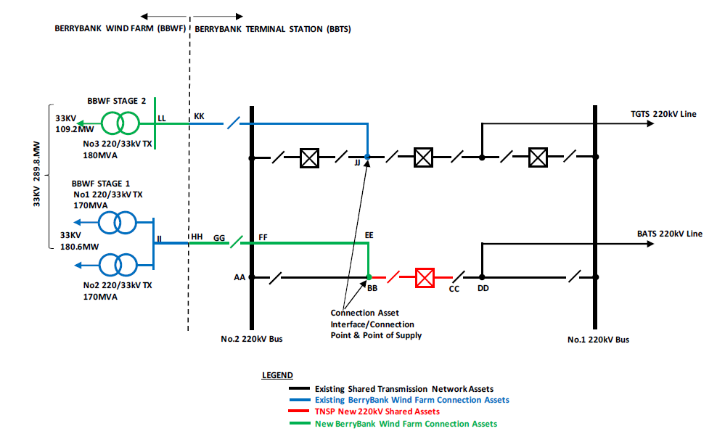

Annexes
Following drawings have been included in the annex:
- Substation & Location Plan
- General Layout
- Wind Farm Topographic Map
- Parcels & Boundaries
- SLD Switching substation
- SLD Switching substation
- SLD Wind Farm
- SLD Wind Farm-Protections

