Making sure you are on the best energy plan can be complicated. Some market practices make it more difficult, whether intentional or not.

Same-name messaging may puzzle consumers
Switching to the best offer can be complicated. Retailers who have different plans with the same name make switching to the best offer harder. This happens because some retailers update prices, but use the same plan name, when competing for new customers. This practice can be puzzling for existing customers. They may receive a Best Offer message indicating they could make savings, by switching to a plan with the same name as their current plan.
Right now, around 360,000 Victorian consumers are on older, more expensive versions of same-named plans. These consumers give up hundreds of dollars of savings every year.
The commission expects that recent changes to energy consumer rules will address the ‘same name, different prices’ issue. From 1 October 2026, retailers must have processes for consumers to switch to the best offer that achieve an effective outcome. These will not be effective unless they are simple and accessible. We expect retailers to design systems and publish new offers which clearly identify different plans – this will make it easier for consumers to switch.
Why do plans with the same name but different prices exist?
Energy retailers release new plans with cheaper rates to compete for customers. Creating a new plan name each time might have some cost. Energy retailers may consider it more efficient to re-use an existing plan name.
This means a consumer’s Best Offer message may indicate they could save on a market offer with the same name as their current plan. This does not change eligibility for switching to the retailer’s best offer. But, it makes it more difficult.

Consumers miss out on as much as $430 per year on same-named plans
Of the ten most popular consumer energy plans, six have cheaper successors with the same name. The cost difference is highest for consumers on a version of a plan that is at least three years old. This reflects a widening of the gap between older plans and their newest version, as retailers change prices each year.
Depending on the plan and its age, consumers with typical electricity usage are paying up to an extra $430 per year compared to the latest version of their plan.
Figure 1: Mean annual extra cost over newest version of plan with same name, by plan age
(Sources: Customer billing data, Victorian Energy Compare)
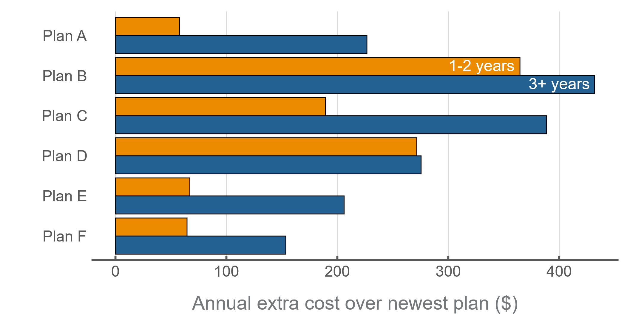
Many consumers are on older versions of plans with the same name. These consumers do not switch regularly, and ‘same name’ Best Offer messaging can make it harder for them to switch to the best offer.
For some plans, over 75 per cent of consumers are on older, more expensive versions. These consumers are paying higher prices than they would be if they were on the newest version of the same-named plan.
Figure 2: Distribution of customers on current and older version of plan with same name
(Sources: Customer billing data, Victorian Energy Compare)
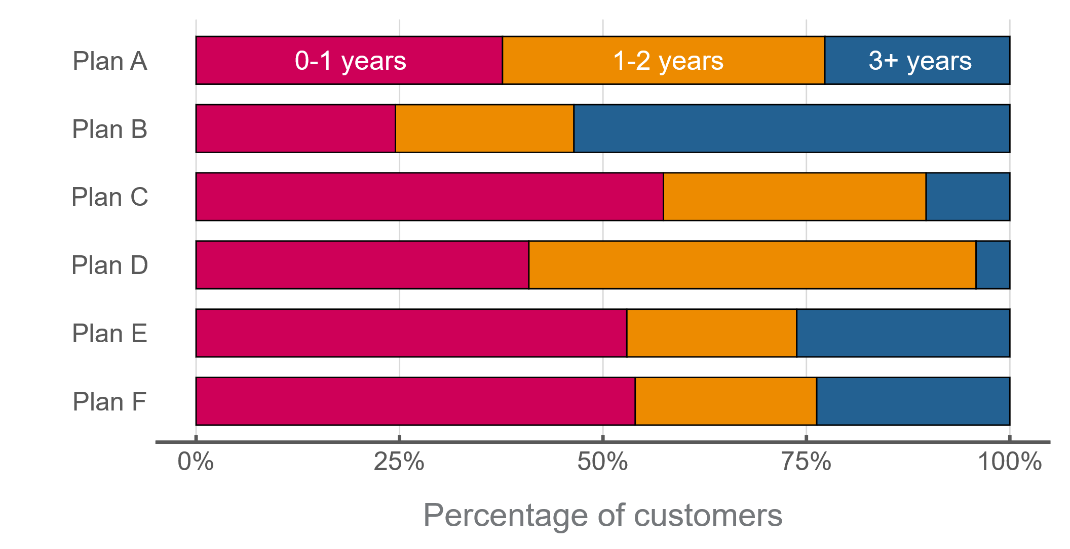

We expect our new rules will address this issue
CHOICE first highlighted this issue by submitting a designated complaint to the Australian Competition and Consumer Commission (ACCC) in May 2025. The complaint refers to retailers using identical plan names to represent plans with different prices. The ACCC recognised that the issues CHOICE raised are significant market issues, which may cause consumer harm.
The commission recently reviewed Victoria’s energy rules. In September 2025, we published our final decision paper on reforms to the Energy Retail Code of Practice (ERCoP).
Commencing 1 October 2026, one reform will require retailers to have processes that are effective in helping customers switch to their best offer. A process will only be effective if it is both simple and accessible. We consider this new rule requires retailers to design systems and publish new offers that clearly differentiate plans, to make switching to the best offer easier for consumers.
Re-using plan names undermines simplicity and accessibility, resulting in consumer harm. It makes switching to the best offer difficult for many consumers, particularly those experiencing vulnerability.
We have also introduced other reforms to help consumers switch to their retailer’s best offer. These will support those finding it hard to switch to a retailer’s best offer due to ‘same name’ messaging.
- From 1 July 2026, retailers must ensure that all small customers on contracts older than four years are paying a reasonable price for their energy.
- From 1 October 2026, retailers must automatically switch customers experiencing payment difficulty to their retailer’s best offer.
We expect these will support customers on older plans that have the same name as newer, cheaper plans to pay less for their energy.
The commission will monitor how retailers meet their obligations to make switching to the best offer simpler and more accessible for consumers.




Calculated based on flat tariff consumer outcomes with Victoria’s eight largest retailers.
The obligation focuses on retailers to have systems that make it easy for a customer to understand and switch. Retailers are not required to have digital systems that can compare a customer’s current plan with other plans.
Calculated extra costs involve an annual usage assumption of 4,000kWh and a comparison of prices paid by consumers in Q4 2024 to same-named offers in the quarter. In some cases, consumers may be affected by the same name, different prices issue when their plan is less than one year old.
ACCC (August 2025), Potentially misleading practices around retail energy plans
The ACCC has noted publicly that the review and law reform processes currently underway by the commission and the Australian Energy Regulator (AER) will most effectively address the issues raised by CHOICE relating to the use of identical plan names in Better or Best Offer messaging with different rates. A recent decision by the AER requires retailers that elect to re-use plan names to provide additional information below ‘Better Offer’ messages.

